PROCESSES VS THREADS DESIGN

COMP 8005

Spenser Lee A00925785

Contents

State Chart Diagram 3

Pseudo Code 4

# State Chart Diagram

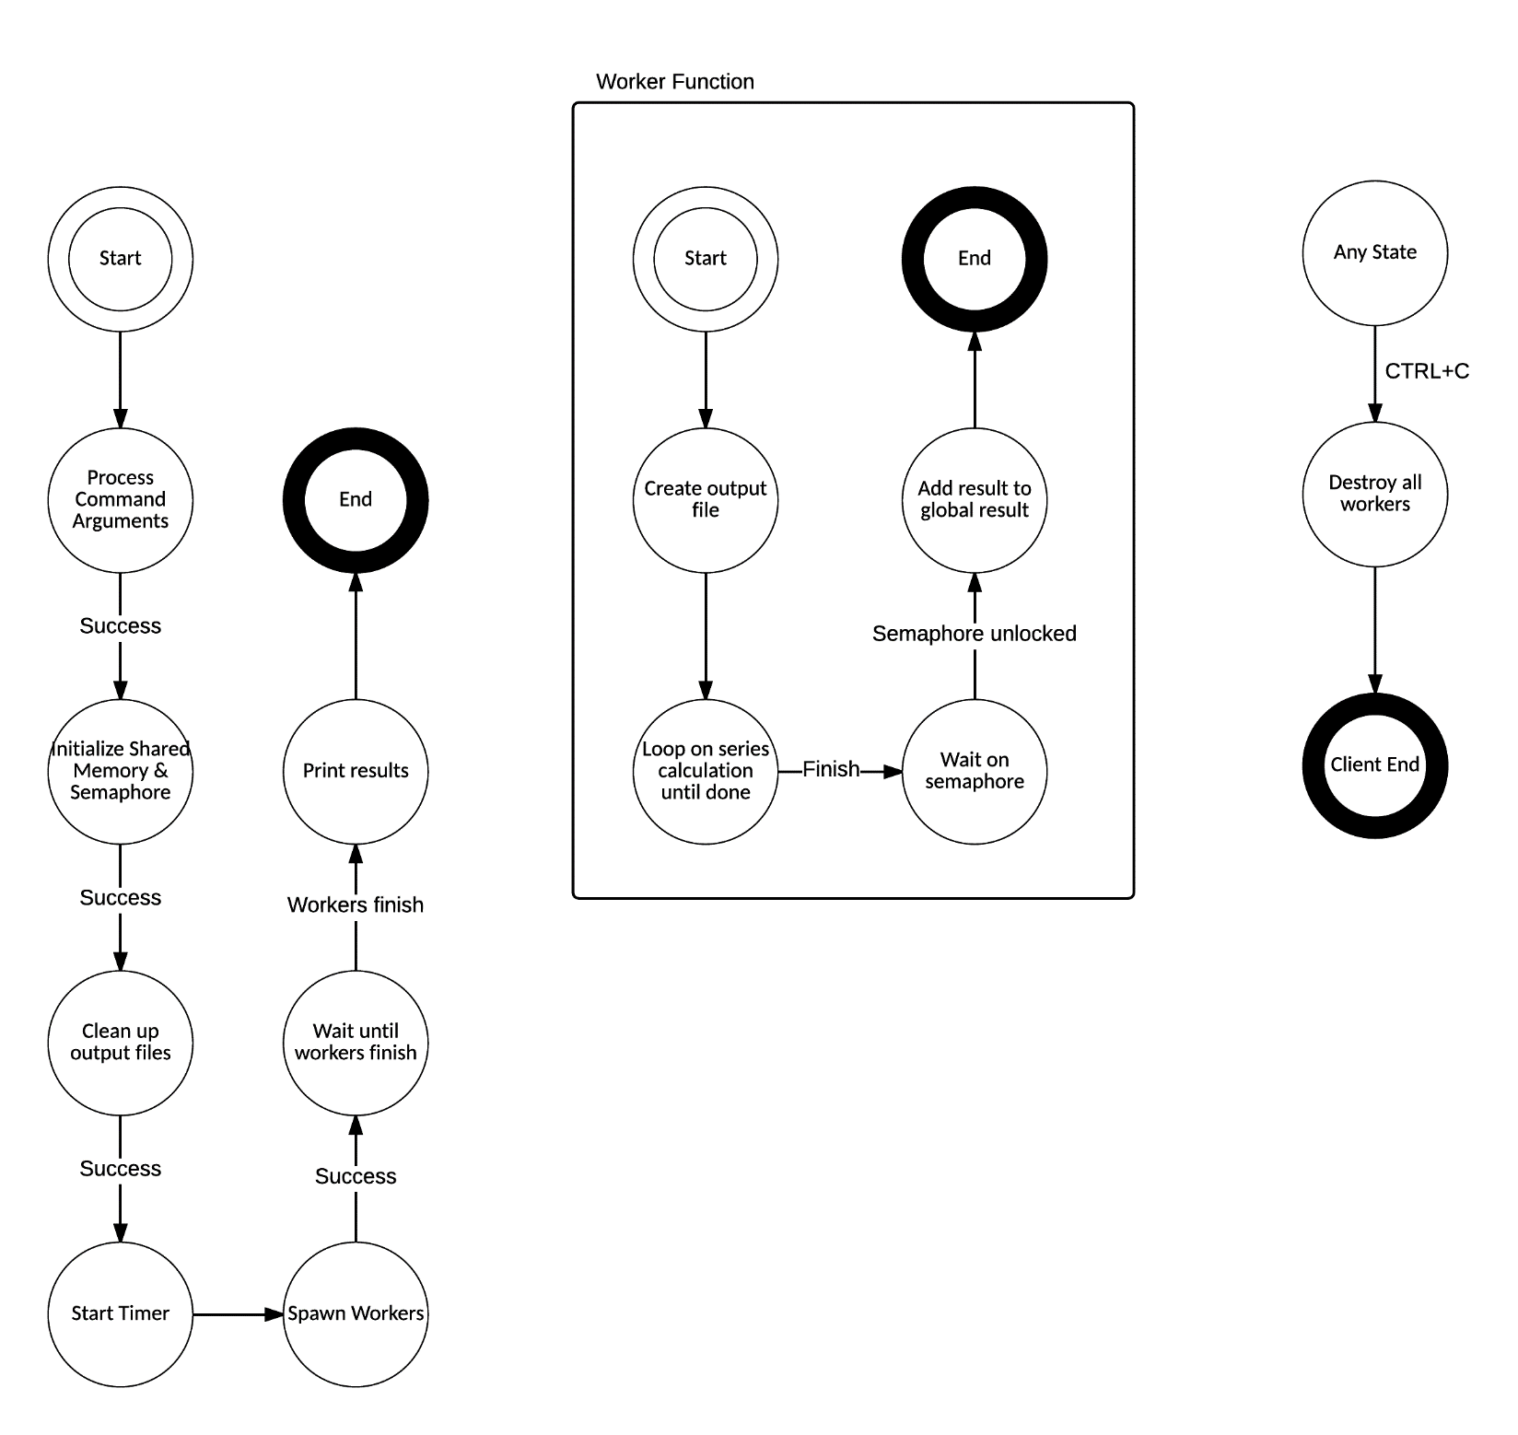

# Pseudo Code

**Process Command Arguments**

argp library parse call

**Initialize**

open name semaphore

map global result variable

initialize global result variable

**Clean Up Output**

if output is enabled

if output directory not created

create output directory

if results file exists

delete old output files

**Start Timer**

initialize timer

set start time

**Spawn Workers**

totalworkers = number of process * number of threads

workeriterations = totaliterations / totalworkers

start iteration = 0

for each process

fork

if child

if threading

for number of threads per process

create thread of Worker Function

increment start iteration

for number of threads per process

join to child process

else

Worker Function

exit

if parent

if threading

increment start iteration by num iterations per worker * num threads per worker

else

increment start iteration by num iterations per worker

**Worker Function NOTE: this is where the Taylor Series is implemented**

if start is even

sign = -1

else

sign = 1

denominator = 3 + 2*start

create out file

for number of iterations

result = result + (sign * (1/denominator))

denominator += 2

sign *= -1

wait for semaphore

lock semaphore

global result += result

unlock semaphore

**Wait Until Workers Finish**

wait for child processes to finish before continue

**Print Results**

set finish time

print 4 * (1 + global result)

print actual pi

print finish time - start time