Low-Code Page System

Simple Low-Code Project System Design

STATUS  Proposed |  | OWNER  LowCode project |  | LAST UPDATED  August 5, 2026

Authors | Knowledge-base design record
Reviewers | To be assigned
Related docs | Simple low-code project technical selection; ADR-013
Scope | Page editing, preview, configuration persistence, and minimum backend architecture for an individual or small team

1. Abstract
This design targets a simple low-code project for an individual or small team. It validates visual page editing, page configuration persistence, and page preview with limited infrastructure cost. The system consists of a Vue 3 editor, a FastAPI monolithic application, and SQLite, connected through HTTP and JSON. Page configuration is stored as a project-owned component tree and property model, and the same configuration is reused in edit and preview modes.
The design prioritizes development speed, verifiable behavior, and an upgrade path. Phase one does not cover microservices, complex permissions, multi-tenancy, plugin marketplaces, file services, or complex domain modeling. A custom component metadata layer isolates the configuration from the component library, while versioned JSON preserves page data. System complexity is driven by real usage rather than speculative future needs.

2. Goals and Non-Goals
Goals | Non-goals
Prioritize development speed and rapidly validate the edit, save, and preview loop. | Do not introduce microservices or complex enterprise infrastructure prematurely.
Use custom component metadata to isolate configuration from the underlying component library. | Do not expose every raw component-library property as a stable contract.
Store component trees, properties, styles, and child relationships as JSON. | Do not implement complex grids, responsive layout, or a freeform canvas in phase one.
Keep an evolution path from SQLite and a monolith to larger-scale architecture. | Do not pre-model users, tenants, plugins, or files solely for speculative future needs.

3. Background and Problem Statement
A simple low-code project must support both page editing and page runtime. Directly exposing the underlying component library would bind stored configuration to that library, while introducing microservices, caching, message queues, or a complex domain layer at the beginning would raise validation cost and slow iteration. The design therefore balances rapid validation with a clear upgrade path.
The system boundary consists of the visual editor, page APIs, and page configuration storage. The editor handles component-tree operations, property editing, and preview. The backend handles page creation, retrieval, update, deletion, and configuration persistence. SQLite stores page records. The implementation must decouple low-code configuration from the concrete UI library and keep edit and preview modes semantically aligned.

4. Proposed Architecture

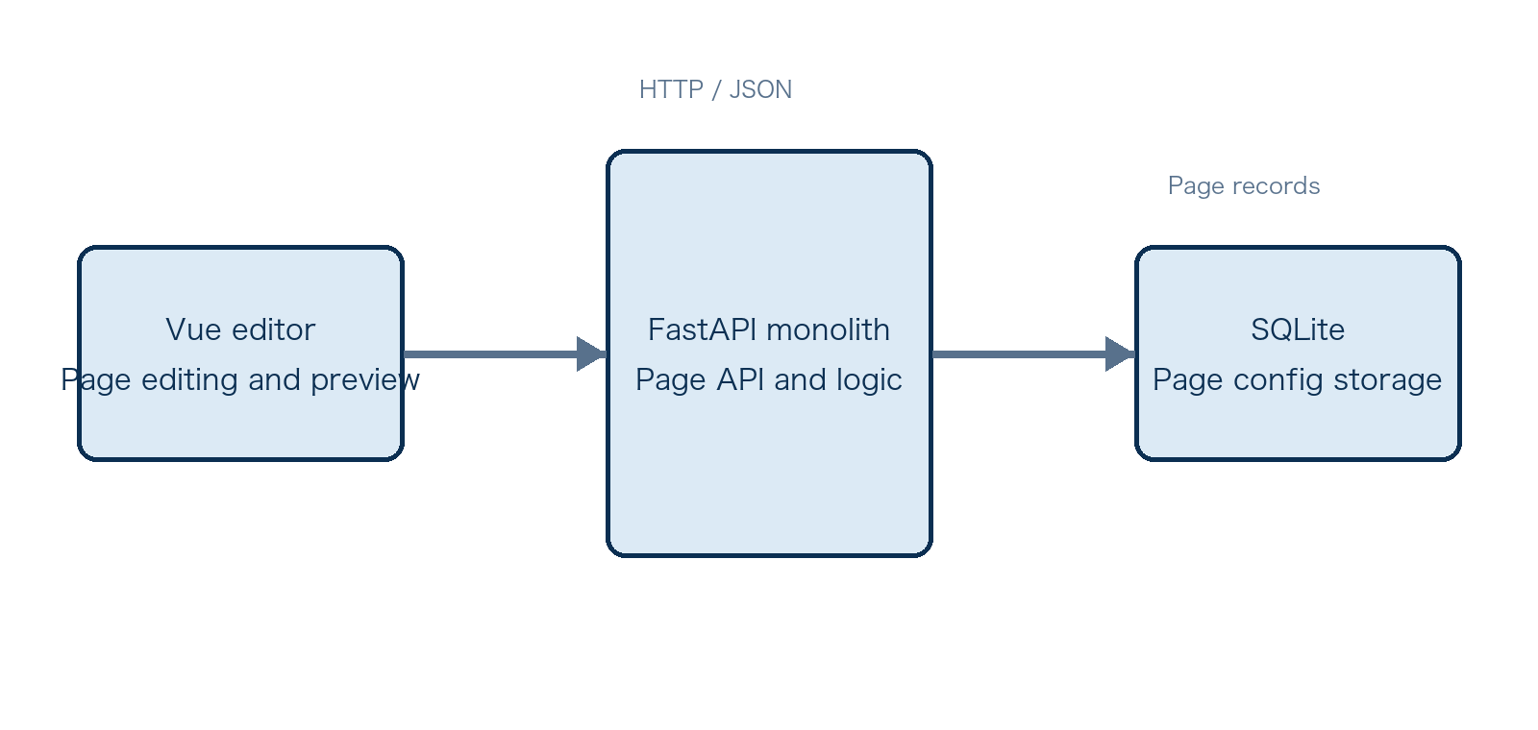
Figure 1. Simple low-code project system architecture.

Core components

Component | Responsibility | Primary storage | Failure behavior
Vue editor | Page editing, component-tree operations, property editing, and preview. | Browser runtime state | Preserve the current edit session and show an error when editor state fails.
Component metadata adapter | Defines component types, property editors, defaults, events, and child capability. | Project code and metadata | Reject configuration that cannot be explained without metadata.
FastAPI page API | Provides page create, read, update, delete, and configuration read/write operations. | In-memory request models | Return a clear validation error and do not write to the database.
SQLite page store | Persists page name, configuration, and lifecycle timestamps. | pages table | Return failure and never claim success when a write fails.
Page preview renderer | Generates the runtime page from the same component configuration. | schema_json | Show a diagnosable error for an unknown component or invalid property.

5. Request Lifecycle
- A page creation or edit request enters the page API from the Vue editor; preview consumes the same component configuration held by the editor.
- The backend validates request shape and uses Pydantic models to constrain page names, component trees, and property structures. The source design does not define authentication or authorization, so phase one assumes a single user or a controlled environment.
- The service loads the page record and its schema_json, then resolves the configuration using component types, property metadata, and default values.
- The page service executes create, read, update, or delete operations. The editor updates page state from the API result, and the preview renderer recursively renders the component tree.
- The API returns success only after the page configuration is written to the SQLite pages record. schema_json is the durable representation of the component tree, properties, and styles.
- The source design does not define retry, timeout, or concurrent-write policies. Request timeouts, update conflicts, and failure recovery must be specified before implementation.
- The backend returns page data or an operation result. The system should emit necessary error logs and basic request metrics; detailed monitoring targets remain an operational follow-up.

6. API and Data Contracts

Primary data contract

Field | Type | Required | Description
id | Identifier | Yes | Primary identifier for locating a page record through the API.
name | Text | Yes | Display name; length and uniqueness rules remain to be defined.
schema_json | JSON | Yes | Complete component tree, properties, styles, and children configuration.
created_at | Timestamp | Yes | Page creation time.
updated_at | Timestamp | Yes | Time of the most recent successful update.
components[].type | Text | Yes | Component type; it must resolve through component metadata.
components[].props/style/children | Object or array | No | Component properties, positioning styles, and nested children; structure version remains to be defined.

Contract guarantees

- The page API must return success only after the page record is successfully written, preventing callers from observing a false success for a non-durable state.
- The page record uses id as its primary identifier, with created_at and updated_at for lifecycle timestamps. The source design does not define a concurrent-update version, so ordering rules remain to be added.
- The component id, type, props, style, and children fields in schema_json form the structured page configuration input. Configuration changes should add a version field and preserve a compatibility strategy.
- The page record is the source of truth for the current project page configuration. It is not the source of truth for user identity, published versions, file resources, or cross-tenant data.
The versioned schema or interface definition is published at
Project design documentation and backend request models; before release, publish an independently maintained versioned interface definition.

7. Consistency, Idempotency, and Replay

Phase one uses a monolithic application and SQLite, with each page-record write as the boundary for a configuration update. Idempotency keys, duplicate submissions, concurrent editing conflicts, and replay are not defined in the source design and must not be treated as existing guarantees. If multi-user use is introduced, add version checks or explicitly adopt last-write-wins, and make schema_json migrations possible through versioned data.
Scenario | Expected behavior | Reasoning
Repeated update request | Use the page state from the successful write. | No idempotency key is defined; duplicate side effects must be clarified before implementation.
Database write fails | Return failure and do not update the caller to success. | Prevents the editor from holding state that differs from persistence.
Timeout or partial failure | Apply a timeout and retry policy to be defined. | The design does not define retry boundaries; automatic retry cannot be assumed.
Configuration structure changes | Handle through schema versions and migration rules. | Prevents non-diagnosable differences between old and new preview configurations.

8. Security and Privacy Considerations

- The source design does not include user accounts, authentication, authorization, or tenant boundaries. Phase one should limit deployment and access to a controlled environment, and add identity and page access controls before multi-user use.
- Page configuration may contain business text and component properties. Logs should not emit the complete schema_json by default; record page identifiers, operation types, and error summaries instead.
- The current technology choice does not introduce external secrets or a separate authentication service. If databases, object storage, or third-party services are added, define credential storage and access controls.
- Administrative, migration, and debugging tools should be disabled by default or restricted to controlled environments. Debug interfaces must not bypass page-data validation.
- The source design does not define retention, deletion, residency, or audit requirements. Before production or multi-user use, add data lifecycle and operational audit rules.

9. Operational Readiness
Signal | SLO or alert | Owner | Launch gate
Page operation success rate | Metrics and alert threshold to be defined | Project maintainer | Recommended
API response time | Percentile target and timeout to be defined | Project maintainer | Recommended
Validation and database error rate | Thresholds by error type to be defined | Project maintainer | Recommended
Configuration compatibility | Validate old and new schema parsing before release | Project maintainer | Required
Backup and recovery validation | Add backup frequency and recovery drills before production | Project maintainer | Required
Rollout constraint: validate in a controlled environment first; use real scale to decide on PostgreSQL, container deployment, or service decomposition.

10. Alternatives Considered

Alternative | Why it was considered | Why it was not selected
Expose Arco Design Vue properties directly | Fast implementation with less adapter code. | Binds page configuration to the component library and raises replacement cost.
Split into microservices from the beginning | Creates independent extension and deployment boundaries. | No clear benefit at this scale; adds infrastructure and validation cost.
Start with PostgreSQL | Better fit for multiple users and larger data volumes. | SQLite covers the minimum validation loop with less operational overhead.
Introduce a complex domain and repository layer early | Creates theoretically stronger boundaries. | The current business is simple; abstraction would delay validation and add maintenance cost.

11. Open Questions
- Should page configuration include a schema version, and who owns migration of older versions?
- For multi-user use, should updates use last-write-wins, optimistic locking, or collaborative editing?
- Should preview have an independent runtime, or should it continue to reuse the editor rendering pipeline?
- Which authentication, permission, audit, and backup requirements must be added before production deployment?

12. Decision and Next Steps
Adopt the minimum monolithic architecture of Vue 3, Arco Design Vue, FastAPI, and SQLite. Use apps/web and apps/api as separate runnable applications, isolate low-code configuration from the underlying component library through custom component metadata, and store page configuration as JSON. First complete the create, read, update, delete, and preview loop, then add configuration versioning, interface documentation, basic error monitoring, and controlled deployment validation. Introduce PostgreSQL, authentication, containers, or service decomposition only when multi-user use, data growth, or a clear performance boundary justifies it.
Milestone | Deliverable | Exit criteria
M1 | Implement the editor, page API, and SQLite persistence skeleton. | Pages can be created, read, updated, and deleted.
M2 | Complete component metadata, schema_json, and the page preview loop. | Edit and preview use the same configuration and pass basic acceptance checks.
M3 | Add interface definitions, configuration versioning, and basic error monitoring. | Migration, failure messaging, and key errors are verifiable.
M4 | Run a controlled trial and assess evolution needs. | Real data volume and concurrency determine whether to upgrade storage, deployment, or permissions.

Use footnotes for definitions, assumptions, or terms that need precision without interrupting the main narrative.

