Udacity Artificial Intelligence Nano-Degree

3 AI Planning Historical Developments

Andrew Sperazza

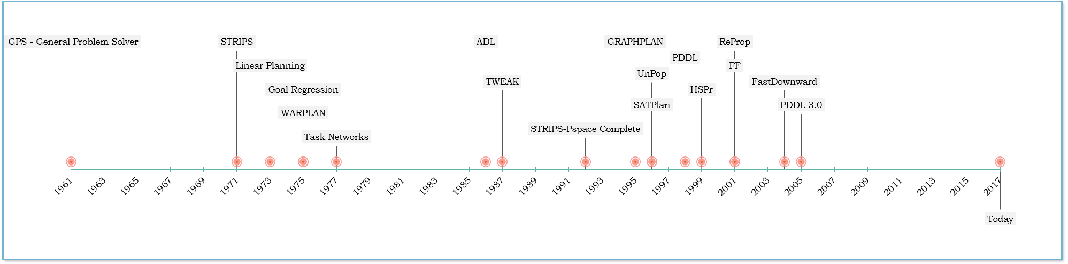

*Timeline of key AI Planning historical developments*

## Introduction

Artificial Intelligence planning has a history in modern computing that started in the 1960’s with the General Problem Solver. The needs of planning were originally derived from robotics, scheduling and similar domains. Over the course of its development, there has been both evolution change as well as revolutionary algorithms. This paper will describe 3 key developments that had large impacts on AI planning: STRIPS, GRAPHPLAN, and Fast-Forward (FF).

## STRIPS (Stanford Research Institute Problem Solver)

In the early 1970s, researchers at Stanford developed a mobile robot(Shakey) that can perform actions on its environment (Nilsson[1]). The robot it was able sense its environment, move, and push objects. It could plan sequences to accomplish these tasks. The ability of the robot to plan and perform actions provided motivation into the various planning algorithms that AI utilizes, such as STRIPS (Fikes and Nilsson[2]), among others.

The STRIPS algorithm was an early attempt at solving a problem that allowed the robot to move, this limited set of requirements met the needs of the robot, but created a rather serial approach to solving the problem at hand. The STRIPS algorithm assumed there was only one action at a time, and it was in a closed environment (one that would never change unless it was in the plan). STRIPS used a set of rules that incorporated the following structure:

IF (PRE_CONDITION is TRUE):

REMOVE(_deletions)  
 ADD (_additions)

Even with its limitations, STRIPS laid the foundation for most of the AI planning solution for many years. The very simplistic operational model was a good foundation for further AI researches, as it was understood quickly and easily adaptable and improved upon.

## GRAPHPLAN

More than 20 years after STRIPS was first introduced as a planning algorithm, GRAPHPLAN was developed, during these years, most planning research was done using “plan-space search”. The largest source of inefficiency in search algorithms is the branching factor, which GRAPHPLAN reduces by using a planning graph data structure. It is possible that the bigger contribution of GRAPHPLAN was the creation of the planning graph data structure. The planning graph is a structure where each level in the graph corresponds to a time-step in the plan. A planning graph reduces the complexity of a planning problem from exponential to polynomial time.

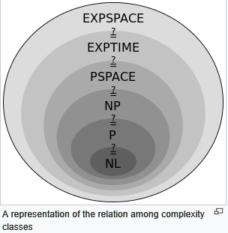

*Source:Wikipedia PSPACE[3]*

Planning graphs is not a path through the graph, it is a representation of the flow in the network flow sense[4], which provides a substantial improvement in the running time. The GRAPHPLAN algorithm uses the planning graph to guide its search for an optimal plan. GRAPHPLAN guarantees it will find the shortest plan among independent actions that may happen in parallel, if one exists.

GRAPHPLAN created in 1995, outperformed previous planners by orders of magnitude, and inspired researches to think about different frameworks for solving planning problems. GRAPHPLAN, and the use of planning graph was indeed the foundation of further AI Planning innovations such as IPP, STAN,SGP,BlackBOX, Medic,FF, and FastDownload[5].

## Fast Forward(FF)

Fast Forward (FF) relies on forward search in the state space, with goal distance estimate heuristic[6]. FF was the most successful automatic planner in the AIPS-2000 planning competition. FF achieves its performance by utilizing a planning graph and relaxing the planning problem (ignoring parts). This relaxation is done by ignoring the delete lists of all the actions, which can be accomplished in polynomial time. An example of relaxation is:

|  |  |  |  |  |
| --- | --- | --- | --- | --- |
|  |  |  |  |  |
| Action (A,B): |  |  | Action (A,B): |  |
| PRE( preA,preB) |  |  | PRE( preA,preB) |  |
| ADD:(addA,addB) | 🡺 Problem Relaxation | 🡺 | ADD:(addA,addB) |  |
| DEL(delA,delB) |  |  | **DEL()** |  |

FF is a successor of the HSP system, introduced in 1997 by Bonet, Loerincs & Geffner. Many of today’s state-of-the-art planning systems are based on heuristic search which was popularized by FF. AI planning was influenced by FF’s which computed relaxed problems at at a very fast speed, this speed differential let to the research of such future AI planning algorithms as Fast Downward[7].

1. N.J. Nilsson, Shakey the Robot, SRI Tech. Note 323, Menlo Park, CA (1984).
2. R.E. Fikes and N.J. Nilsson, STRIPS: a new approach to the application of theorem proving to problem solving, Artif Intell. 2 (1981) 189-208.
3. https://en.wikipedia.org/wiki/PSPACE
4. Blum, Furst, (1997):Fast Planning Through Planning Graph Analysis
5. Fern, Oregon State University, *https://web.engr.oregonstate.edu/~afern/classes/cs533/notes/graphplan.pptx*
6. Joffmann (2001): FF:The Fast-Forward Planning System, Albert Ludwigs University
7. Helmert (2006): The Fast Downward Planning System, Journal of Artificial Intelligence Research 26 (2006) 191-246