Monthly Status Reporting
(monthlyReporting.zip)

This Package contains several scripts for automated generation of VMware vCenter/ESX status lists. The possibilities include fetching information about virtual machines, virtual machine hosts, virtual machine-templates, data storages and virtual networks. Also the opportunities for automatic mail dispatchment and a cleanup functionality for removing old reports is implemented.
This program is distributed in the hope that it will be useful but without _any_ warranty; without even the implied warranty of merchantability or fitness for a particular purpose.

Developer:

Name: Sven Sperner
Mail: cethss@gmail.com

Contents:

Package Contents 2
Requirements 3
Supported Platforms 3
Installation 4
Configuration 7
Scripts 9
Credential files 12
Log files 13
Report files 16
- Examples of lists 16
- Summary example 18
- Report mail example 19
Epilogue 19

Package Contents:

Creds\ directory for connection credentials
contains pre defined credential files
Logs\ directory for log files
contains example log files
Reports\ directory for saved reports-subdirectories
Reports\%date% subdirectories for generated reports at %date%
contains example report lists
configuration.ini configuration file
getReports.bat batch script for task scheduler – complete job
starts “main.ps1” with preloaded PowerCLI
main.ps1 main power shell script using the others
(connect to vCenter, fetch information, disconnect)
commonFunctions.ps1 power shell script sourced by the others
with common functions (read config, connect, …)
fetchDatastores.ps1 power shell script run by “main.ps1”
fetching data store information from vCenter
fetchHosts.ps1 power shell script run by “main.ps1”
fetching vm-host information from vCenter
fetchMachines.ps1 power shell script run by “main.ps1”
fetching virtual machine information from vCenter
fetchNetworks.ps1 power shell script run by “main.ps1”
fetching network information from vCenter
fetchTemplates.ps1 power shell script run by “main.ps1”
fetching template information from vCenter
sendReports.ps1 power shell script run by “main.ps1”
sending reports via mail
tidyUp.ps1 power shell script run by “main.ps1”
removing old report files and folder
Readme.docx this readme

Requirements:

- Windows Client
- .NET Framework 2.0, 3.0 or 3.5 with Service Pack 1
(without ServicePack1 some operations might take long to complete)
- Windows Power Shell 2.0 (earlier versions not tested)
- VMware PowerCLI 5.0.1 (earlier versions not tested)
- Communication over tcp port 443 in both directions
from Windows client to vCenter server

Supported Platforms:

Windows:
- Windows 7
- Windows 2008 Server
- Windows Vista
- Windows XP Service Pack 2
- Windows Server 2003 Service Pack 2

VMware:
- VMware ESXi 5.0
- vCenter Server 5.0
- VMware ESX 4.1 / vCenter Server 4.1
- VMware ESXi 4.1
- VMware ESX 4.0 Update 2 / vCenter Server 4.0 Update 2
- VMware ESX 4.0 Update 1 / vCenter Server 4.0 Update1
- VMware ESX 4.0i Update 1
- VMware VirtualCenter 2.5 Update 6
- VMware ESX 3.5 Update 5
- VMware ESXi 3.5 Update 5
- VMware ESX 3.0.3 Update1

Installation

1. For the fastest way of installation simply unzip the file “monthlyReporting.zip” into the root directory of drive C. Then “C:\monthlyReporting” will be present. Every other drive and path combination (without whitespaces) is possible but then the configuration file has to be modified (see the configuration section of this readme).

2. Create a new scheduled Task (System Tools -> Scheduled Tasks -> Add Scheduled Task):

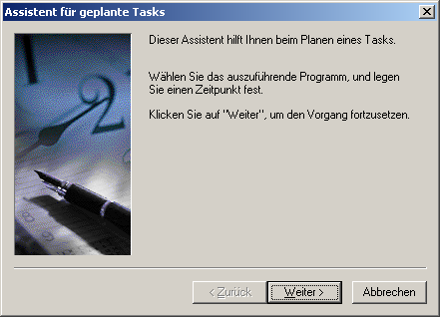
Step 1: -> Next
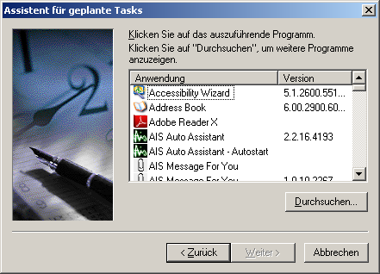
Step 2: -> Browse
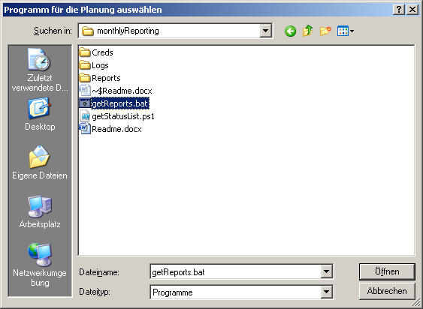
Step 3: Select "C:\monthlyReports\getReports.bat" -> Open
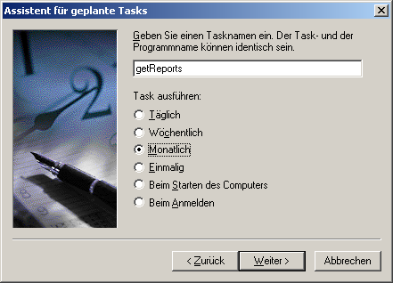
Step 4: Check "Monthly" -> Next

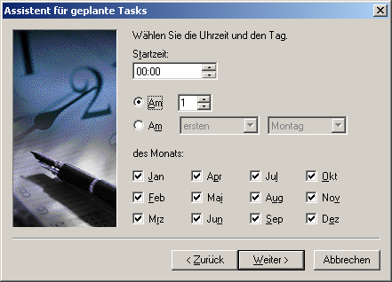
Step 5: Start time: "00.00"; Day "1"; Every Month -> Next
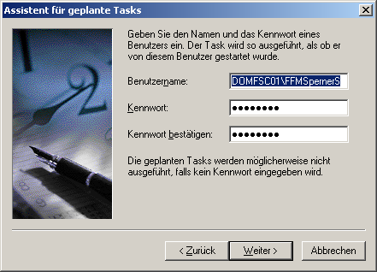
Step 6: Enter Username & Password -> Next
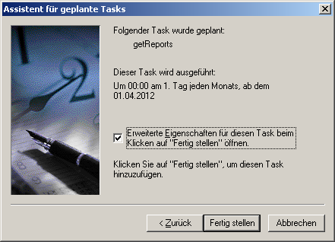
Step 7: -> Finish
Configuration

This file is a programs-global configuration file for the monthlyReporting package to have all configurable options at one place. In here are some shared variables grouped into sections to be able to configure the most necessary parameters like path of installation and mailing options. The default name of the configuration file is “configuration.ini”. The name of the configuration file is irrelevant, because the scripts are designed to find an .ini file whatever the name of it is actual. The limitation is that there should be only one configuration file, because the Power Shell scripts would ignore any other than the first. If you installed into a custom folder you have to change the installPath options value from “C:\monthlyReporting\” to your chosen path. All available parameters are:

Section [PowerCLI] - PowerCLI specific options
Path to VMwares PowerCLI console file (will be preloaded with Power Shell)
psConsoleFile=C:\Programme\VMware\Infrastructure\vSphere PowerCLI\vim.psc1

Section [Install] - Installation specific options
Path of the packages installation
installPath=C:\monthlyReporting

Section [Subdirs] - Specification of subdirectory names
Subdirectory name for saved credential files
credsDir=Creds
Subdirectory name for at runtime generated log files
logsDir=Logs
Subdirectory name for generated and then saved status lists and summaries
reportDir=Reports

Section [Scripts] - Specification of script names
Name of the Power Shell script with the main routine
mainRoutineFile=main.ps1
Name of the Power Shell script for fetching the data store lists
getDatastoresFile=getDatastoresList.ps1
Name of the Power Shell script for fetching the host lists
getHostsFile=getHostsList.ps1
Name of the Power Shell script for fetching the virtual machine lists
getMachinesFile=getMachinesList.ps1
Name of the Power Shell script for fetching the network lists
getNetworksFile=getNetworksList.ps1
Name of the Power Shell script for fetching the template lists
getTemplatesFile=getTemplatesList.ps1
Name of the Power Shell script for sending all lists via email
sendReportsFile=sendReports.ps1
Name of the Power Shell script for cleaning outdated reports
tidyUpFile=tidyUp.ps1

Section [Cleanup] - Intervals for holding generated files
Interval to remove old log files in days
logsOlderThanDays=100
Interval to remove old report files in days
reportsOlderThanDays =100
Section [Mail] - Options for sending report mails
Name or ip-address of mail server
server= server.company.net
Dispatcher mail address
from=Reporting_DoNotReply DoNotRreply@anymail.com

Section [Recipient-{All,Hosts,Machines,Templates,Datastores,Networks,VMreport}]
Sections for specifying different mail recipient groups for receiving all or just a group of report lists. In every of these groups any number of receiver addresses is supported.
The options name is irrelevant, but no duplicates are allowed, examples:
address1=Max.Mustermann.000@mail.com
address2=Max.Mustermann.001@mail.com
address77=Max.Mustermann.002@mail.com
mailadr9=Max.Mustermann.003@mail.com
mailrcv=Max.Mustermann.004@mail.com
foo=Max.Mustermann.005@mail.com
foobar=Max.Mustermann.006@mail.com
foo0815foo=Max.Mustermann.007@mail.com

Section [Recipient-Al]
Recipients in this group will receive every generated report list plus the log file
address1=
Section [Recipient-Datastores]
Recipients in this group will receive data store and drive spread lists
address1=
Section [Recipient-Hosts]
Recipients in this group will receive virtual machine host lists
address1=
Section [Recipient-Machines]
Recipients in this group will receive virtual machine lists and summaries
address1=
Section [Recipient-Networks]
Recipients in this group will receive network, net host & net spread lists
address1=
Section [Recipient-Templates]
Recipients in this group will receive template lists and summaries
address1=
Section [Recipient-VMreport]
Recipients in this group will receive virtual machine lists & summaries without CVC
address1=

Scripts

All scripts begin with some lines of comments followed by some code for reading the needed configurable options from the configuration file (configuration.ini). These options can (some should) be changed for your needs in the configuration file.

getReports.bat:
A batch script which can be used from within a command line or by a scheduled task.
It´s more or less just a wrapper script for main.ps1. It starts a Power Shell with preloaded PowerCLI extension and executes in it the main routine script and log the output.
Lines beginning with “REM” are comments. Used parameters passed by configuration:
%psConsoleFile% = C:\Programme\VMware\Infrastructure\vSphere PowerCLI\vim.psc1
%installPath% = C:\monthlyReporting
%logsDir% = (%installPath%)\Logs\
%mainRoutineFile% = (%installPath%)\main.ps1

main.ps1:
A Power Shell script using VMwares PowerCLI extension
This script includes the main routine of the package. It is responsible for connecting to a vCenter server, fetching all desired lists, disconnecting, cleaning outdated files & folders and sending emails.
Started without a parameter it connects to every server where credentials are present for in the credentials subdirectory and then fetches any kind of lists.
Parameters:
-vCenter a wildcard for a vCenter server respectively their credentials
i.e.: xyz -> Creds\*xyz*
-reportType the type of report which should get fetched
datastores -> datastores + drivespread
hosts -> vm hosts (vCenter / ESX(i))
machines -> virtual machines
networks -> networks, netspreads, nethosts
templates -> virtual machine templates
-onlySend for only sending actual report files
-onlyTidy for only cleaning outdated report files and folders
-dontSend do everything except sending emails
-dontTidy do everything except removing old files or folders
Lines beginning with “#” are comments. Used parameters passed by configuration:
$confTable["Install"]["installPath"] = C:\monthlyReporting
$confTable["Subdirs"]["credsDir"] = (%installPath%)\Creds
$confTable["Subdirs"]["logsDir"] = (%installPath%)\Logs

commonFunctions.ps1:
A Power Shell script using VMwares PowerCLI extension to be sourced in another
In this script are some common used functions for the other Power Shell scripts.
Every script which wants to use them must source this file: “. .\commonFunctions.ps1”.
The common functions are:
  - getConfigurationFile find configuration file - searching for .ini
  - readConfiguration reading the configuration file into a table
  - readCredentials reading a credential, .xml, file
  - connect2Server connect to a vCenter/ESX(i) server
  - disconnectFromServer close an established server connection

fetchDatastores.ps1:
A Power Shell script using VMwares PowerCLI extension
Prerequisite of this script is an established connection to a vCenter/ESX(i) server.
For an established connection information about the data stores and virtual machines registered in the vCenter are fetched and a data store status & a virtual machine to data store spread list will be generated.
Lines beginning with “#” are comments. Used parameters passed by configuration:
$confTable["Subdirs"]["reportDir"] = (%installPath%)\Reports

fetchHosts.ps1:
A Power Shell script using VMwares PowerCLI extension
Prerequisite of this script is an established connection to a vCenter/ESX(i) server.
For an established connection information about the virtual machine-hosts registered in the vCenter are fetched and a status will be generated.
Lines beginning with “#” are comments. Used parameters passed by configuration:
$confTable["Subdirs"]["reportDir"] = (%installPath%)\Reports

fetchNetworks.ps1:
A Power Shell script using VMwares PowerCLI extension
Prerequisite of this script is an established connection to a vCenter/ESX(i) server.
For an established connection information about the virtual networks, virtual machine hosts & virtual machines registered in the vCenter are fetched and a network status, a host to network spread & a virtual machine to network spread list will be generated.
Lines beginning with “#” are comments. Used parameters passed by configuration:
$confTable["Subdirs"]["reportDir"] = (%installPath%)\Reports

fetchMachines.ps1:
A Power Shell script using VMwares PowerCLI extension
Prerequisite of this script is an established connection to a vCenter/ESX(i) server.
For an established connection information about the virtual machines registered in the vCenter are fetched and a status list & a summary will be generated.
Lines beginning with “#” are comments. Used parameters passed by configuration:
$confTable["Subdirs"]["reportDir"] = (%installPath%)\Reports

fetchTemplates.ps1:
A Power Shell script using VMwares PowerCLI extension
Prerequisite of this script is an established connection to a vCenter/ESX(i) server.
For an established connection information about the virtual machine templates registered in the vCenter are fetched and a status list & a summary will be generated.
Lines beginning with “#” are comments. Used parameters passed by configuration:
$confTable["Subdirs"]["reportDir"] = (%installPath%)\Reports

sendReports.ps1:
A Power Shell script using standard Power Shell commands
The script sends the generated reports as attachments via an automatic generated email.
Recipients are segmented into groups defined in the configuration file.
Groups:
Recipient-All Receiver which get all reports plus the log file
Recipient-Datastores Receiver which get data store reports
Recipient-Hosts Receiver which get host reports
Recipient-Machines Receiver which get virtual machine reports
Recipient-Networks Receiver which get network reports
Recipient-Templates Receiver which get template reports
Recipient-VMreport Receiver which get virtual machine reports without CVC
Lines beginning with “#” are comments. Used parameters passed by configuration:
$confTable["Install"]["installPath"] = C:\monthlyReporting
$confTable["Subdirs"]["reportDir"]= (%installPath%)\Reports
$confTable["Subdirs"]["logsDir"] =(%installPath%)\Logs\
$confTable["Mail"]["server"] = server.company.net
$confTable["Mail"]["from"] =NoReply <Reporting_DoNotRreply@anymail.com>
$confTable["Recipient-{All,Hosts,Machines,Templates,Datastores,Networks}"]["*"]

tidyUp.ps1:
A Power Shell script using standard Power Shell commands
The Script removes old status lists and log files after defined periods of days.
Lines beginning with “#” are comments. Used parameters passed by configuration:
$confTable["Install"]["installPath"] = C:\monthlyReporting
$confTable["Subdirs"]["reportDir"]= (%installPath%)\Reports
$confTable["Subdirs"]["logsDir"] =(%installPath%)\Logs\
$confTable["Cleanup"]["logsOlderThanDays"]=10
$confTable["Cleanup"]["reportsOlderThanDays"]=10

Credential files

These are files in XML format used to authenticate with a vCenter server containing
- Server name or IP-Address
- Users login name
- Users password as hash
By default the credential files are stored below the %credsDir% subdirectory of the installation definable in the configuration file.
They can be generated with the following PowerCLI command line
New-VICredentialStoreItem -Host <name/ip> -User <user> -Password <pass> -file <file>
The pre-defined credential files in this package were generated for the user “readonly”.
To use them the readonly-user must be available with his standard password.
Example of a credential file:

<?xml version="1.0" encoding="UTF-8"?>
<viCredentials>
<version>2.0</version>
<passwordEntry>
<host>server.company.net</host>
<username>username</username>
<password>{encrypted password}</password>
</passwordEntry>
</viCredentials>

Log files

The most interesting actions performed by the scripts are logged below the %logsDir% subdirectory definable in the configuration file. The filename includes the date when the script is run and the extension “.log”. Log files will automatically be removed after the %logsOlderThanDays% period defined in the configuration file.

Report files

Status lists (hosts, virtual machines, templates, datastore & networks) are saved in semicolon separated CVS table format ready to be opened in MS-Excel.
For virtual machines and vm templates also a summary with counted operating systems is saved as an ascii text file.

Filenames:
Hosts
HostsList_<servername/-address>_<date>_<time>.csv
Virtual machines
VMsList_<servername/-address>_<date>_<time>.csv
VMsList_<servername/-address>_<date>_<time>.csv.summary.txt
Templates
TemplatesList_<servername/-address>_<date>_<time>.csv
TemplatesList_<servername/-address>_<date>_<time>.csv.summary.txt
Datastores
Datastores List_<servername/-address>_<date>_<time>.csv
DriveSpreadList_<servername/-address>_<date>_<time>.csv
Networks
NetworksList_<servername/-address>_<date>_<time>.csv
NetHostList_<servername/-address>_<date>_<time>.csv
NetSpreadList_<servername/-address>_<date>_<time>.csv

Epilogue

The power shell script could easily be adapted to catch more or less information.
Feel free to report any statements, feature requests, optimizations or bugs to cethss@gmail.com

