# Assignment Steps

I read the assignment, noted the main questions to be answered and watched all the videos and read the book chapter. I wrote this document in parallel to the noting discussion question answers as I went along.

# Discussion

* What are the benefits of putting built-in Python command into functions?
  + You don’t hae to recreate things that exist, it makes the code more portable and easier for other people to understand
* What are the benefits of using structured error handling?
  + Its easier than creating a whole new error handing method, and its easier to port and for other people to understand.
* What are the differences between a text file and a binary file?
  + A text file is written in common English (or whatever appropriate language) a binary file uses bytes which are often viewed as ascii characters which do not correspond to readable text.
* How is the Exception class used?
  + To handle errors caused by user input, or other changes users might make to the code. Provides more
* How do you "derive" a new class from the Exception class?
  + You can take the other exception classes to catch more specific types of errors. When the except block finds a matchin class it uses that.
* When might you create a class derived from the Exception class?
  + When you want to catch more specific errors
* What is the Markdown language?
  + A way of writing product documentation
* How do you use Markdown on a GitHub webpage?
  + A way of formatting the webpage

Now that you have reviewed the websites and videos, **modify** a new script that manages a "ToDo list." This project is like the last one, but different enough to be a challenge.

**I have provided a starting template to I want you to modify and use for your program** called "Assigment06_Starter.py". Currently the code loads data from a file into a Python List of Dictionary objects. However, the code only uses a few functions, and **your job is to add more functions to organize the code.** You may note that it is both easier and harder to work with someone else's code, and that is part of the assignment.

## 5.1 Create a folder

I’m using a somewhat different folder structure because I am working on multiple classes

## 5.2 Create a new project in PyCharm

I’m actually using MS Virtual Studio. I hope that’s ok. I’ve been using my work laptop and they don’t like me to download too many things. I’m confident that I get the idea of the IDEs and how they function.

## 5.3 Add code to your Script

## 5.4 Run Your Script

As mentioned, this is run in the MS Visual Studio IDE

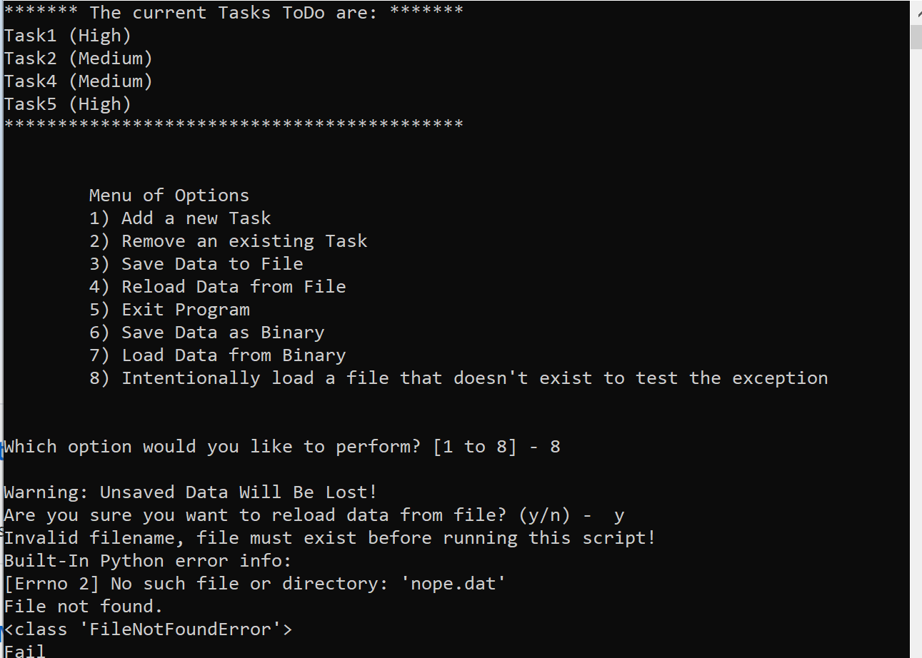

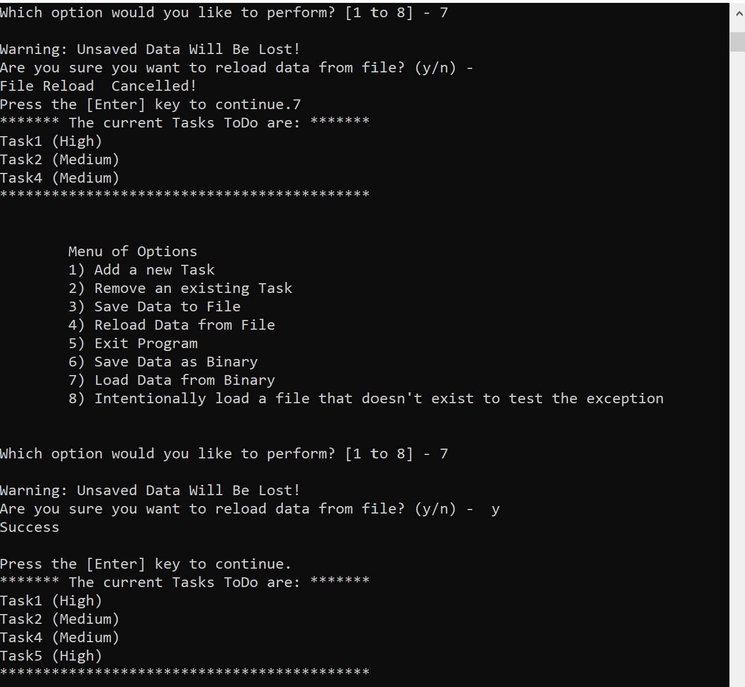

It looks the same in the command prompt.

# 6 Document your knowledge

I took the ToDo list from the last class and added in the pickling and exceptions. I made a specific action to make a test faile. This works pretty similarly to C++, although I’m not aware of a parallel for the pickle function.

# 7 Post your Files to GitHub

<https://github.com/speroni1/IntroToProg-Python-Mod06>