# Assignment Steps

I read the assignment, noted the main questions to be answered and watched all the videos and read the book chapter. I wrote this document in parallel to the noting discussion question answers as I went along.

# Discussion

* What is the difference between a class and the objects made from a class?
  + The class is the script that defines what the functions and data are included, the Objects are the specific instances which include actual data.
* What are the components that make up the standard pattern of a class?
  + Fields, Constructors, Properties, Methods
* What is the purpose of a class constructor?
  + Used to create
* When do you use the keyword "self?"
  + This is similar to “this” in c++, when a ctor or method in the class references the class itself.
* When do you use the keyword "@staticmethod?"
  + When you want to make a function that can be accessed without using a class instance.
* How are fields and attributes and property functions related?
  + Each define data for the class, the attributes are set with the constructor while the files are not. The properties are used to modify the attributes.
* What is the difference between a property and a method?
  + Property is specifically for using a
* Why do you include a docstring in a class?
* What is the difference between Git and GitHub?
  + Git is a version control system, Github is a cloud server.
* What is GitHub Desktop?
  + A downloadable application to access github

Now that you have reviewed the websites and videos, **modify** a new script that manages a "ToDo list." This project is like the last one, but different enough to be a challenge.

**I have provided a starting template to I want you to modify and use for your program** called "Assigment06_Starter.py". Currently the code loads data from a file into a Python List of Dictionary objects. However, the code only uses a few functions, and **your job is to add more functions to organize the code.** You may note that it is both easier and harder to work with someone else's code, and that is part of the assignment.

## 5.1 Create a folder

I’m using a somewhat different folder structure because I am working on multiple classes

## 5.2 Create a new project in PyCharm

I’m actually using MS Virtual Studio. I hope that’s ok. I’ve been using my work laptop and they don’t like me to download too many things. I’m confident that I get the idea of the IDEs and how they function.

## 5.3 Add code to your Script

I have provided starter code in the file called, "Assigment08-Starter.py" on Canvas. Currently, the code does nothing, but it does include pseudo-code (Listing 1). Your task is to read and understand the pseudo-code, then add code to make the application work. Make sure to include error handling!

## 5.4 Run Your Script

As mentioned, this is run in the MS Visual Studio IDE

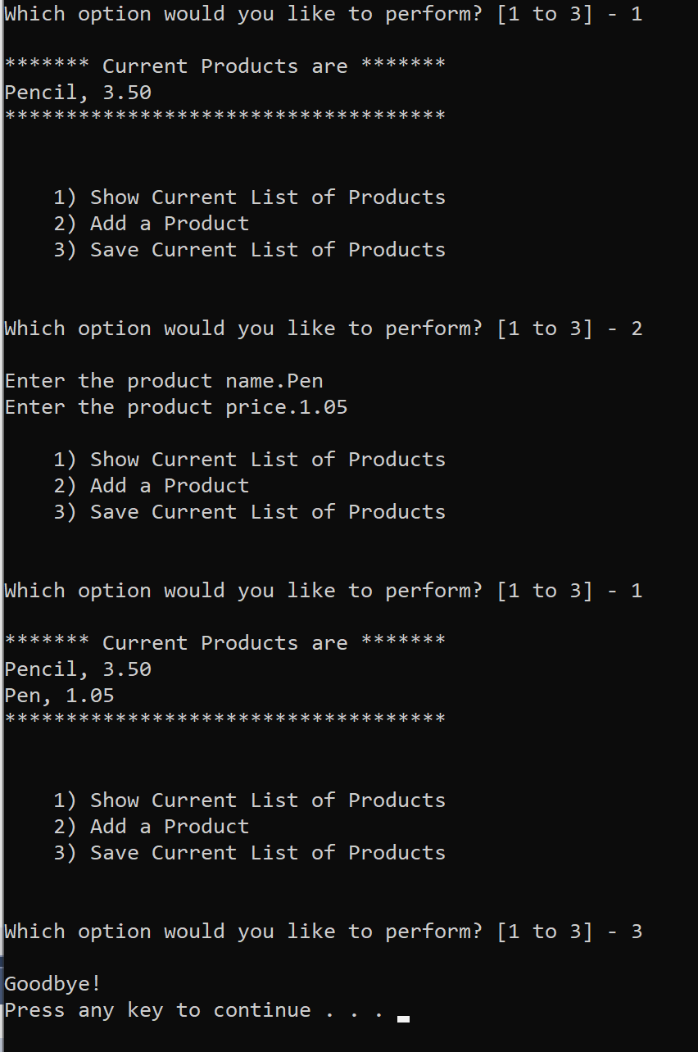

It looks the same in the command prompt.

# 6 Document your knowledge

I modeled this off of the priorities list, but modified to fit the current assignment for the use of classes to handle some data.

# 7 Post your Files to GitHub

https://github.com/speroni1/IntroToProg-Python-Mod08