# Assignment Steps

I read the assignment, noted the main questions to be answered and watched all the videos and read the book chapter. I wrote this document in parallel to the noting discussion question answers as I went along.

# Discussion

* What is the difference between a list and a dictionary?
  + The list uses indices and the dictionary uses keys
* What is the difference between an index and a key
  + An index is a number/int and a key is char
* How do you read data from a file into a list
  + Reading each line in using a for loop and the .split command.
* How do you read data from a file into a dictionary
  + Put it into a list and then put the list elements into the dictionary
* What is the programming pattern called “separation of concerns”
  + To make your code resuable and easy to understand
* How would you use a function to organize your code?
  + Functions take specific inputs and return specific outputs, can also be helpful for the same set of operations that may have to happen multiple times in a script
* Why is a script template useful?
  + Helps with professionalism and consistency.
* Why is error handling using Try-Except recommended?
  + Can help catch expected error types and inform the user. Can control with the users see.
* What is GitHub and why is it used?
  + A document repository for saving and sharing code.

# Assignment

Now that you have reviewed the websites and videos, **modify** a new script that manages a "ToDo list." This project is like the last one, but different enough to be a challenge.

The "ToDo" file will contain two columns of data, "Task" and "Priority." Load the columns into a Python Dictionary object. Each **dictionary object represents one row of data**, and these rows must be added to a Python ***List* object to create a table of data** (**Like Lab 5-2**).

**I have provided a starting template to I want you to modify and use for your program**. You will note that it is both easier and harder to work with someone else's template and code, and that is part of the assignment.

## 5.1 Create a folder

I’m using a somewhat different folder structure because I am working on multiple classes

## 5.2 Create a new project in PyCharm

I’m actually using MS Virtual Studio. I hope that’s ok. I’ve been using my work laptop and they don’t like me to download too many things. I’m confident that I get the idea of the IDEs and how they function.

## 5.3 Create a Python Script

Add code to your script that will perform that assignment’s task. I suggest you start by adding the header and some pseudo-code.

# -- Data -- #

# declare variables and constants

objFileName = "ToDoList.txt" # An object that represents a file

objFile = None

strData = "" # A row of text data from the file

dicRow = {} # A row of data separated into elements of a dictionary {Task,Priority}

lstTable = [] # A list that acts as a 'table' of rows

strMenu = "" # A menu of user options

strChoice = "" # A Capture the user option selection

# -- Processing -- #

# Step 1 - When the program starts, load the any data you have

# in a text file called ToDoList.txt into a python list of dictionaries rows (like Lab 5-2)

objFile = open(objFileName, "r")

for row in objFile:

lstRow = row.split(",")

dicRow ={"Task":lstRow[0],"Priority":lstRow[1].strip()}

lstTable.append(dicRow)

# -- Input/Output -- #

# Step 2 - Display a menu of choices to the user

while(True):

print("""

Menu of Options

1) Show current data

2) Add a new item.

3) Remove an existing item.

4) Save Data to File

5) Exit Program

""")

strChoice = str(input("Which option would you like to perform? [1 to 5] - "))

print() # adding a new line for looks

# Step 3 - Show the current items in the table

if (strChoice.strip() == '1'):

for row in lstTable:

print(row["Task"] + ", " + row["Priority"])

continue

# Step 4 - Add a new item to the list/Table

elif (strChoice.strip() == '2'):

task = input("Enter a task: ")

priority = input("Enter the task priority: ")

dicRow = {"Task":task,"Priority":priority}

lstTable.append(dicRow)

continue

# Step 5 - Remove a new item from the list/Table

elif (strChoice.strip() == '3'):

item = int(input("Enter the number of the item on the list to be removed: "))

lstTable.pop(item)

continue

# Step 6 - Save tasks to the ToDoToDoList.txt file

elif (strChoice.strip() == '4'):

objFile = open(objFileName,"w")

for row in lstTable:

objFile.write(row["Task"] +", "+row["Priority"]+"\n")

objFile.close()

continue

# Step 7 - Exit program

elif (strChoice.strip() == '5'):

break # and Exit the program

## 5.4 Run Your Script

As mentioned, this is run in the MS Visual Studio IDE

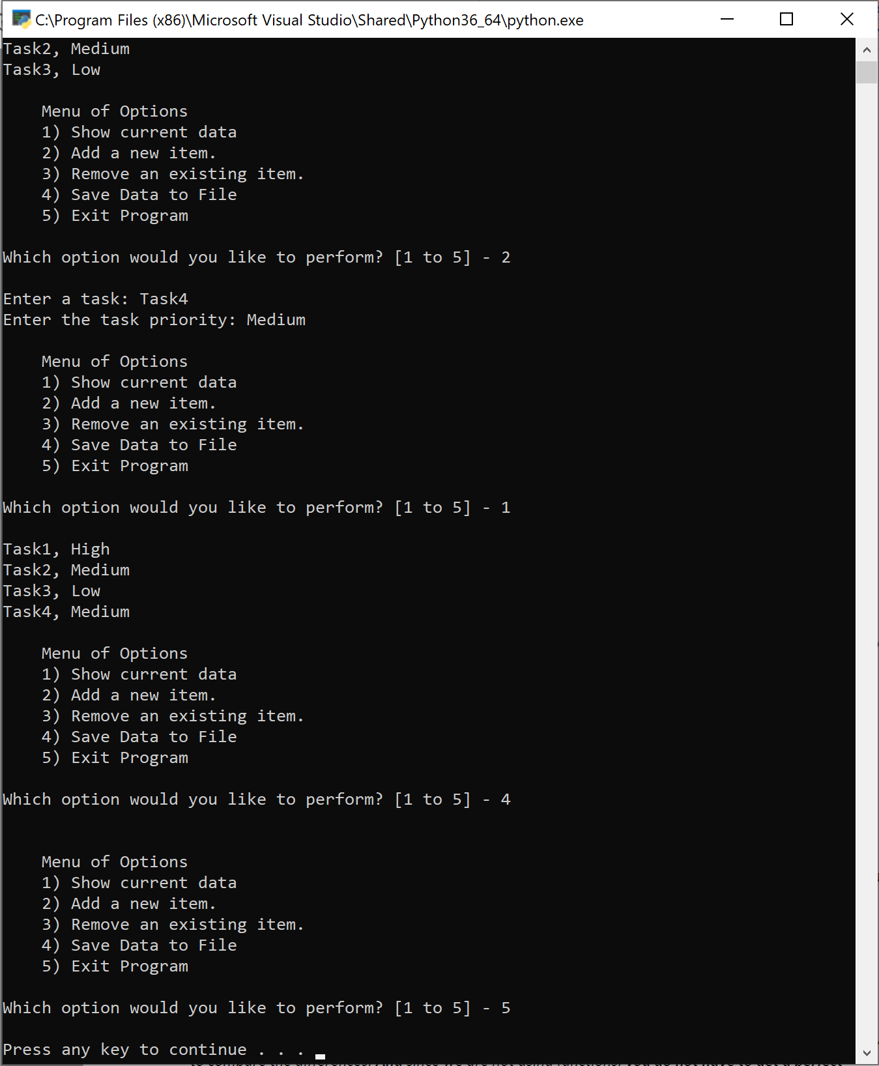

It looks the same in the command prompt.

# 6 Document your knowledge

The dictionaries in python work like the maps in c++. Basically the same as the lists in python, but with the key instead of the index. Offers slightly different capabilities. Otherwise was about the same as the last assignment. Needed to learn a little new syntax.

# 7 Post your Files to GitHub

Done.