“What Now?” Design

Dr. Chen: Senior Project I

Team Members:
Ethan Janovich
Lavender Wilson
Samuel Persinger

Instructor Comments/Evaluation

Table of Contents
Abstract……………………………………………………………………………………….…5
Document Description…………………………………………………………………………6-7
Purpose and Use…………………………………………………………………………6
Ties to specification document………………………………………………………….6
Intended Audience……………………………………………………………………6-7
Block Diagram……………………………………………………………………………………8
Design Details…………………………………………………………………………………9-23
System Modules and responsibilities………………………………………………….9-11
Architectural Diagram………….……………………………………………….9
Module Cohesion………………………………………………………………10
Module Coupling……………………………………………………………10-11
Design Analysis……………………………………………………………………11-12
Data Flow……………………………………………………………………11-12
Design Organization…………………………………………………………………12-14
Class Descriptions…………………………………………………………12-14
Functional Description……………….……………………………………………14-22
Parameters (Input, Output, Return)…………………………………………14-20
Modules Used…………………………………………………………………20
Files Accessed…………………………………………………………………20
Real-time Requirements…………………………………………………………20
Messages……………………………………………………………………20-21
Narrative/PDL………………………………………………………………21-22
Language/Reuse/Portability…………………………………………………………22-23
Implementation Timeline………………………………………………………………………23
Design Testing………………………………………………………………………………23-24
Appendix A: Technical Glossary……………………………………………………………25-26
Appendix B: Team Details………………………………………………………………………27
Appendix C: Workflow Authentication…………………………………………………………28
Appendix D: Writing Center Report……………………………………………………………29

Abstract
Our project, “What Now?”, is an interactive scheduling assistant that can be used to easily and efficiently create and update the user’s schedule. The project serves as an effective time management tool that will improve one’s productivity and help them stay organized. We will use a variety of Python libraries, such as Kivy, for a user-friendly interface, and CoquiTTS, for text to speech modifications. Other AI libraries will be used for text generation and summarization. Using these different libraries, our project will scan documents for a solid base schedule and take voice or manual input to modify it quickly. This design document provides an overview of the project’s functionality, system features, and design for the developers.

Description
Purpose and use:
The purpose of this document is to outline the project’s design and define how the requirements will be implemented for the developers. The development team may use this document as a guide to the overall design and implementation of this project. This design document will show the functions and programming language needed in detail to ensure the success of this project.
Ties to specification Document:
This document can be seen as an extension of the specifications document that goes more in depth about the structure and functions of the program for the use of the development team. Like the specifications document, this design document discusses the programming language and libraries that will be used in the production of “What Now?”, as well as the classes and data flow of the program.
Intended audience:
The intended audience for the “What Now?” project is college students who have a lot on their plate during an important part of their lives. Many students have trouble organizing their time, but any student with a busy schedule can use this program to better manage their time. This project will have a simple and straightforward user interface, making it easy to use for everyone, including those who are not tech-savvy. This project could also be used by non-students, but not all features will be available to them (Document scanning only works for syllabi).

Block Diagram
“What Now?” Will be downloadable on computers with Windows or Linux operating systems and android mobile phones. Internet access will be required to download this software. Once downloaded and ran, the user will be met with a simple and clear user interface that will prompt them to scan an a document (syllabus), which text will be extracted from. The text will then be sent from the Document scanner/Listener to the Command Interpreter Class that will send the information in a proper format to the Schedule class for modifications to the user’s schedule. The details of the newly created/updated events will be Displayed to the user through the User Interface. The user can then continue modifying and/or viewing their schedule.
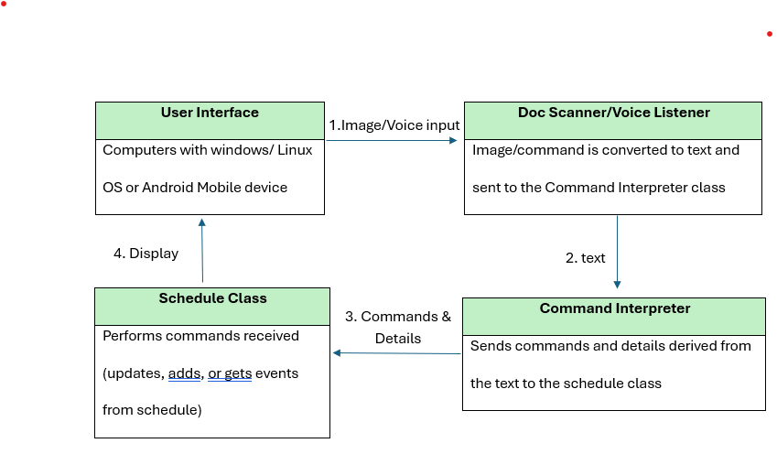
Figure 1: Block Diagram
Design Details
System Modules and Responsibilities:
Architectural Diagram:

User Device

Input: image, voice, text
Schedule

GUI

Schedule
Text
Functional Modules
Interpreter module
Text (command)
Figure 2: Architectural Diagram
Schedule Module

Module Cohesion:
The modules in our project consist of classes with similar capabilities working together to advance to the next module. For example, the classes that involve scanning documents, extracting text, and converting voice to text make up one module. These classes, which include DocumentScanner, VoiceListener, and Command interpreter, handle input from the user and send that information to one another and to another module that is used for modifying the schedule and event details, as well as displaying the information that the user needs and wants to view.
The Module responsible for modification and displaying consists of the Schedule class and other data structures that hold the event information, such as CalendarEvent. It also consists of the built in Calendar Class that will work with the GUI to display the schedule to the user. This module will need to receive commands from the first module, and after performing those commands, communicate with the GUI module for a neat and easy to read display. For this project to be a success, these modules must communicate effectively.
Module Coupling:
The user will only be able to interact with the GUI module, by clicking buttons, submitting files (syllabi), speaking, or typing. The GUI will give that information to another module to interpret it. If the user submits a file, this module’s document scanner class will scan it. If the user clicks the button to speak, this module’s voice listener class will listen, etc. After this module receives that input, it will interpret the user’s commands and send it off to the following module responsible for performing them.
The schedule class will receive these commands, that are now in a form it can understand, and act on them -- examples include creating new events, modifying events, and deleting them. The Schedule class and Calendar class will work together to build the schedule. Once the schedule is built, the Calendar class will send all of it’s information to the GUI for it to be displayed. If the Calendar class did not receive all of the necessary details of an event such as date and time, the schedule class will tell the GUI to prompt the user for that missing information, and the cycle continues.
Design Analysis:
Data Flow Analysis:
The dataflow of “What Now?” is largely handled by the Clarify_Detail function, that receives text (either from the document scanner or the Voice Recognition’s “Listen” function) and then sends the proper commands to the schedule class. The user can scan a document that will then be interpreted by Clarify_Detail, which will give the schedule class all the details of events that need to be created. Then, the user can speak to the program to view, update, or add an event, which is shown in the data flow diagram below.
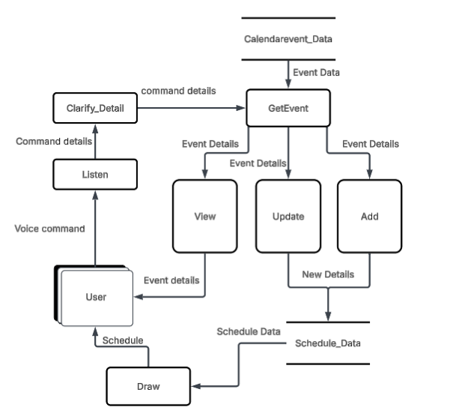
Figure 3: Data flow diagram for voice commands in the “What Now?” project.

Design Organization:
Class Descriptions and Members:
Class name: VoiceListener
Class Description: Uses the system's microphone to transform speech into text.
Data Members: text (string)
Function Members: listen(), getText()

Class name: DocumentScanner
Class Description : This class uses the system's microphone to store a short recording of the user's request to the program, and then converts it into text.
Data Members: text (string)
Function Members: scanDocument(), getText()

Class name: CommandInterpreter
Class Description : This class uses more text input to create one or more commands to distribute to various classes. This class functions as the main actor in modifying and gaining information about the schedule.
Data Members: text (string), commands (List[Command])
Function Members: interpretText(), clarifyDetail()

Class name: Schedule
Class Description: This class manages the user's events.
Data Members: events (List[CalendarEvent))
Function Members: retrieveEvent(), modifyEvent(), addEvent()

Class name: Calendar
Class Description: This class is responsible for containing the information about the displayed calendar, as well as drawing it.
Data Members: type (enum)
Function Members: draw(), changeType()

Class name: CalendarEvent
Class Description: This class is a container for the data for a single event in a user's schedule.
Data Members: type (enum), name (string), description (string), start_date (Date), end_date (Date), start_time (Time), end_time (Time)
Function Members: getDetails(), setDetails()

Class name: Date
Class Description: This class is a representation of one day from a calendar year.
Data Members: day (tuple(int, string)), month (tuple(int, string)), year (int)
Function Members: getDate(), setDate()

Class name: Time
Class Description: This class is a representation of one time in a day.
Data Members: hour (int), minute (int)
Function Members: getTime(), setTime()

Functional Description:
Parameters (input, output, return):
VoiceListener Class
listen()
Input: This function takes no input
Output: This function has no output
Return parameter: Returns the text transcription of the recording
Types: The data types in this function are a .wav file
getText()
Input: This function takes no input
Output: This function has no output
Return parameter: Returns the text transcription of the recording
Types: The data types in this function are a .wav file
DocumentScanner
scanDocument()
Input: Image of document, or no input
Output: This function has no output
Return parameter: Extracted text from provided or scanned document
Types: The data types in this function are either the provided image in the form of a png or jpeg and the string of extracted text.
getText()
Input: This function takes no input
Output: This function has no output
Return parameter: Returns the text transcription of the schedule
Types: The data types in this function are an image file
CommandInterpreter
interpretText()
Input: text input from VoiceListener or DocumentScanner
Output: This function has no output
Return parameter: Command(s) created from the text input
Types: The data types in this function are the string from the text input and then our custom Command type for what command to execute.
clarifyDetail()
Input: Incorrect/Improper/Malformed Command(s) from interpretText
Output: This function has no output
Return parameter: Fixed Command(s)
Types: The data types in this function are the string from the text input and then Command.
Schedule
retrieveEvent()
Input: Search Term
Output: This function has no output
Return parameter: List of CalendarEvents that are sorted by relevance
Types: The data types in this function are the string from the text input and the CalendarEvents for the list of returned events.
modifyEvent()
Input: Event to modify, fields to modify, omitted fields will be ignored
Output: This function has no output
Return parameter: Error or success code
Types: The data types in this function are the strings for the input and the Event to modify.
addEvent()
Input: Event to add
Output: This function has no output
Return parameter: Error or success code
Types: The data types in this function are the Event it is adding to the calendar
Calendar
draw()
Input: This function takes no input
Output: This function has no output
Return parameter: Error or success code
Types: This function has no types associated with it
changeType()
Input: Type of calendar view ("yearly", "monthly", "weekly", and "daily")
Output: This function has no output
Return parameter: Error or success code
Types: The data types in this function are the enum for type ("yearly", "monthly", "weekly", and "daily").
CalendarEvent
getDetails()
Input: This function takes no input
Output: This function has no output
Return parameter: Returns all the details of the event: type, name, description, start_date, end_date, start_time, end_time.
Types: The data types in this function are a tuple for the event details return
setDetails()
Input: type, name, description, start_date, end_date, start_time,and end_time of event.
Output: This function has no output
Return parameter: Error or success cod
Types: The data types in this function are enums, strings, Date, and Time
Date
getDate()
Input: This function takes no input
Output: This function has no outputs
Return parameter: Returns the date from the class as a tuple.
Types: The data types in this function are a tuple for the date return
setDate()
Input: The day, month, and year
Output: This function has no outputs
Return parameter: Error or success code.
Types: The data types in this function are integers
Time
getTime()
Input: This function takes no input
Output: This function has no outputs
Return parameter: Returns the time from the class as a tuple.
Types: The data types in this function are a tuple for the time return
setTime()
Input: Hour and minute
Output: This function has no outputs
Return parameter: Error or success code
Types: The data types in this function are integers
Modules Used:
The application will use the classes listed above in the Class Description and Members section. We will also be using classes from all included libraries we will be using, including: Kivy, KivyMd, PyAudio, SpeechRecognition, CoquiTTS, langchain, and ollama.
Files Accessed:
The application will store files on the device for the purpose of saving calendars between sessions. It may also collect data during the testing phase to better help us troubleshoot and bug fix.
Real-time Requirements:
The application will store files on the device for the purpose of saving calendars between sessions. It may also collect data during the testing phase to better help us troubleshoot and bug fix.
Messages:
The application will not transmit messages.
Narrative/PDL:
Calendar View Page
- Change Viewtype
  - View types
    - Day
    - Week
    - Month
    - Year
- Add/Edit events manually
  - Add/Edit Event Screen
    - Event Fields
      - Name
      - Type
      - Description
      - Start Date
      - End Date
      - Start time
      - End time
- Document Scanner Page
  - Upload document/Take photo of document
    - Clarify missing/ambiguous details as needed
- Voice Command Page
  - Speak commands
    - Clarify missing/ambiguous details as needed
Language/Reuse/Portability:
Out of all the many programming languages and libraries available for creating apps, the best way to develop this project quickly for the platforms that are expected to be supported is to use a library that supports packaging for many platforms. Other aspects of a language that suits this project are simplicity, ease of use, and popularity.
In order to fulfill these qualities, the project will be developed using Python and many of its libraries -- for reuse and portability, primarily Python's Kivy framework, which can package apps for nearly every platform, including those that we chose for this project (Windows 10-11, Android, and Linux). Python is easy to develop on any platform due to its popularity, and according to GeeksForGeeks (2024), “ Python code, written once, can be executed on any system where the Python interpreter is installed”, so team members will not have to worry about cross-compatibility between code written on different operating systems.
Another benefit of Kivy specifically is that it is easy to package an app for distribution on Android app stores, such as the Google Play store. There are only a few extra steps required to achieve this in the packaging process.
Along with the ease-of-use of Python and Kivy, the team is also already familiar with Python, further cementing it as a good tool for this project's development.
Implementation Timeline:
Item | January | February | March | April | May
Component Design
Component Composition and Validation
System Validation
Adjustments
Unit Testing

Design Testing:
Design testing will take place throughout the development and implementation process. Once a component of the project is finished, it will be singled out during the initial rounds of testing to ensure that it is functioning properly. Then, subsequent rounds of testing will be performed on its integration with the entire system as more and more components are integrated.
Once all components have been integrated, then the entire system can be validated and tested. To speed up this process, several smaller programs may be constructed which can create larger sets of testing data (in the case of this project: events, commands, input strings, and audio files).
Once system-wide testing is nearing completion, user testing will be performed by the developers and other acquaintances with varying levels of technical knowledge in order to improve the user experience in any ways that were missed in the prior testing steps.

References
GeeksforGeeks. (2024, August 23). Why Python is called a cross-platform language. GeeksforGeeks.https://www.geeksforgeeks.org/python/why-python-is-called-a-cross-platform-language/

Appendix A
GUI – A Graphical User Interface (GUI) is a way for users to interact with the application, including, but not limited to, elements such as buttons, menus, and windows.
LLM - Acronym for "Large Language Model." Associated with the variety of general-purpose text-generation chatbots, such as OpenAI's ChatGPT, Google's Gemini, or Anthropic's Claude.
OCR - Acronym for "Optical Character Recognition." A process used to transform text within an image into digital text.
AI - Acronym for "Artificial Intelligence." Encapsulates a wide range of technologies which aim to emulate intelligence, whether through explicit programming or implicit means (for example, a neural network).
EXE File- An executable file that contains a program that can be run on a device with a Windows operating system.
AppImage File - An executable file that contains a program that can be run on a device with a Linux operating system.
APK File- An executable file that contains a program that can be run on a device with an Android operating system.
Event – A field in the program that will hold information such as date, time, name, priority and details.
Class – A programming tool used to make multiple objects with the same attributes.
Class Diagram – A diagram to show how the different classes in a program interact with one another.
Library or Libraries - Programming tooling developed for the purpose of simplifying and quickening the development process. Common examples are modules that simplify handling input and output within programs.
Python - A widespread programming language with a large variety of support.
IDE – Acronym for “Integrated Development Environment”. A software application for programming that combines tools such as a code editor and compiler into a single interface for developers.

Appendix B
This document was produced as a result of a combined effort under the leadership of Samuel Persinger. Work on the document was spread across multiple weeks, and members read other sections, but the primary responsibilities are as follows:
- Ethan Janovich: Table of Contents, Abstract, Purpose and Use, Ties to specifications document, Intended Audience, Dataflow Analysis, Block Diagram, Module Cohesion, Module coupling, Architectural diagram
- Lavender Wilson: Design Organization, Language/Reuse/Portability, Implementation Timeline, Design Testing, Appendices A-D
- Samuel Persinger: Functional Description
All other contributions to this document were added via virtual communications over the several weeks this document was written. Feedback between members was shared through several channels, including on the document itself (removed before finalization) and through other means of online and in-person communication.

Appendix C
I, Lavender Wilson, attest that this document and its details represent the specification for the "What Now?" project, and that I have completed work in accordance with Appendix B.
Signature: Date: 11/14/2025
I, Ethan Janovich, attest that this document and its details represent the specification for the "What Now?" project, and that I have completed work in accordance with Appendix B.
Signature: 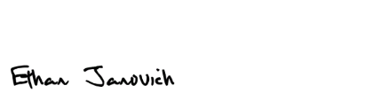 Date: 11/142025
I, Samuel Persinger, attest that this document and its details represent the specification for the "What Now?" project, and that I have completed work in accordance with Appendix B.
Signature:  Date: 11/14/202

Appendix D: Writing Center Report
Date: 12/09/2025
Author: Tatiana Kostovny
Report:
We looked over the Senior Design Project document. Most of the errors throughout the document were sentences that needed to be reworded or reviewed. I would read the document over again to make sure there are no missing words in sentences and that everything sounds correct. Other than that, I did not notice any grammatical errors or formatting errors.

