What now?
CMSC 4900
Fall 2025

Project Requirements

Ethan Janovich
Lavender Wilson
Samuel Persinger

Instructor comments and Evaluation:

Table of Contents
Abstract.........................................................................................................................4
Introduction................................................................................................................4-6
Background/Overview.......................................................................................4-5
Project Objective.................................................................................................5
Constituents Details & Dynamics......................................................................5-6
Application Domain........................................................................................................6
Project Context....................................................................................................6
Initial Business Model................................................................................................6-10
Operational Environment..................................................................................6-7
Description of Data Sources.................................................................................7
Use Case UML Diagrams.................................................................................8-10
Initial Requirements.................................................................................................10-12
Functional....................................................................................................11-12
Nonfunctional...................................................................................................12
Documentation..................................................................................................12
Testing and Revisions....................................................................................................13
References...................................................................................................................14
Appendix A: Technical Glossary................................................................................15-16
Appendix B: Team Details..............................................................................................16
Appendix C: Workflow Authentication...........................................................................17
Appendix D: Writing Center Report ...............................................................................18

Abstract
The “What Now?” project is meant to develop an interactive schedule with Python, using various libraries such as Kivy, for a solid multi-platform user interface, CoquiTTS for text to speech, and other AI libraries for text generation and summarization. By combining these libraries, the program will be able to scan current schedules and allow users to make quick and easy updates with voice input, focusing on a user-friendly experience. “What Now?” will give its users a practical solution to organizing their time and keeping them on track with minimal manual input. This document outlines the requirements, functionalities, and the technology used to implement this scheduling assistant.

Introduction

Background/Overview
Time management is an important part of life that many people struggle with. With poor time management skills, tasks can pile up and lead to missed deadlines and increased stress. As Sarah Zoloth of the national society of high-school scholars notes, “Procrastination can put you in a pickle and make things a lot more difficult than they have to be. Time management has been shown to be beneficial in a whole range of ways” (Zoloth, 2023). She then goes on to state multiple benefits of effective time management, such as allowing high productivity, effective decision making, and decreased stress. The use of artificial intelligence in this project allows for smarter and easier scheduling, instead of being forced to manually input data, which can be time consuming. Due to AI’s growing popularity and use in everyday technology, the AI features will keep up with modern expectations. By implementing document scanning and voice input features, this project offers a solution to easier time management, reducing effort while still meeting the user’s needs.

Project Objective
The objective of the “What Now?” project is to enhance and simplify one’s time management by implementing document scanning and voice input using AI. This program will be able to interpret documents, extract important information, create events, and add those events to the user’s schedule. Existing events can be added to by other documents or by voice commands. The voice command features will nearly eliminate all manual input, allowing users to update, add, or remove tasks, leading to a quick, simple, and user-friendly time-management system.

Constituents Details & Dynamics
Our team is composed of three individuals, all of which will be required to put forth reliable effort in this project. Each member has leadership roles throughout the time allotted for the project based on what they are confident in, and the leader of each portion of the project will be responsible for making sure their tasks are completed to the best of our team’s ability. The members’ names, majors, and leadership roles are in the table below.
Team member: | Major: | Leadership Phase:
Ethan Janovich | CS | Presentation
Lavender Wilson | CS | Requirements/Analysis
Samuel Persinger | CS | Design, Implementation

Application Domain

Project Context
"What Now?" intends to be an alternative to traditional calendar and scheduling services by shifting the focus of the user experience from more visual/manual to more aural/automatic. There are few calendar services who support this type of interaction (editing schedule and details using conversation, transforming scanned documents into events or reminders) as a first-class one -- this style of data communication/interaction with non-human systems is a relatively new phenomenon, and so its use in scheduling has not yet been explored in-depth.

Initial Business Model

Operational Environment
"What Now?" is intended to target individuals with busy schedules who prefer to speak and listen to speech to communicate information rather than through writing and reading. This environment means that the user experience with talking and speech production must be simple, seamless, easy to use, and flexible -- the environment includes a wide range of communication styles, differing levels of technology intuition, and differing levels of frustration/patience, all of which will need to be taken into consideration when designing this project.

Description of Data Sources
This project will primarily make use of audio input devices (mobile phone microphones, USB microphones, etc.) to take user input to add to and modify a user’s schedule. This data can, and likely will, contain sensitive user data, so it should not be stored in plaintext (whether that be on-device or as a part of a separate relational database). Instead, this data should be encrypted so that, in the event that a device is compromised, any sensitive data is inaccessible.

Use Case UML Diagrams
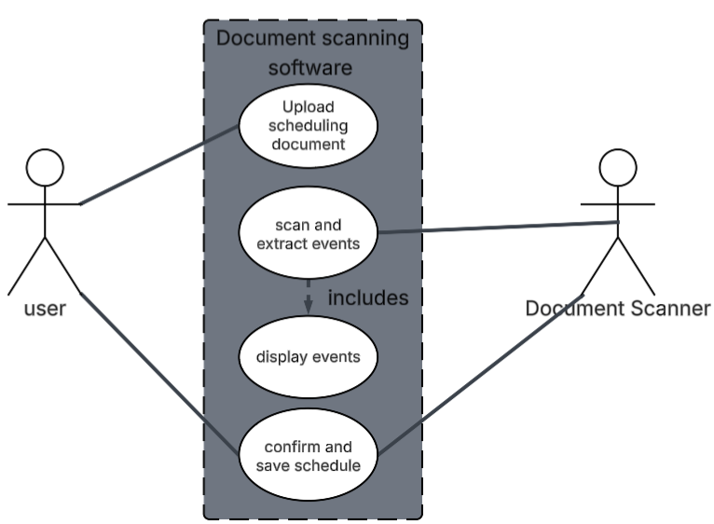
Figure 1: Use case UML diagram for document scanning.
Description: To begin building a schedule, the user can upload a scheduling document, which the document scanning software will scan and extract information from to build the user’s schedule. It will display that information to the user, who may then verify and decide if they want the software to save that schedule or not.

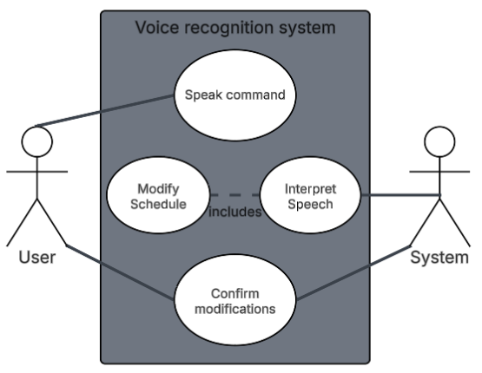
Figure 2: Use case UML diagram for Voice Recognition.
Description: When a user wants to modify their schedule, they can say what they want to update -- whether that be adding, deleting, or modifying an event. The voice recognition software will interpret the user’s speech to make changes to the schedule. Once finished, the user will be able to confirm or discard the modifications, and the system will act accordingly (either save changes or revert to the previously saved schedule).

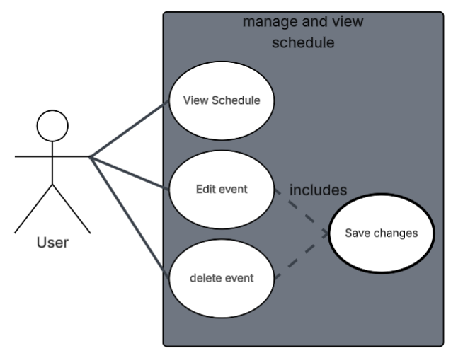
Figure 3: Use case UML diagram managing and viewing schedule
Description: This use case allows the user to view, edit, or delete events manually. The user can open the schedule to view upcoming events and modify them as needed, the updates will be made in real time, and the user can make sure they are done correctly before saving.

Initial Requirements
The requirement for this project is a cross-platform application that will operate on both mobile devices and computers. The system will utilize LLMs and other artificial intelligence software to assist users in generating and managing their schedules. By analyzing user-provided documents such as syllabi, event flyers, and personal/work schedules, as well as by processing voice commands, the application will automatically create, organize, and maintain calendar events.

Functional
The application must be capable of storing user data, including schedules, settings, and uploaded documents, in a lightweight and persistent database. The system must also save and apply user preferences, such as notification settings and calendar view options.
The application will include full calendar functionality, allowing users to create, edit, and delete events manually or through voice commands. It will support multiple viewing modes, such as daily, weekly, and monthly views. Events will be categorized based upon their assigned importance level. Notifications and reminders must be sent on user-defined time preferences to ensure important events are not missed.
The software will allow users to upload a variety of different documents, including syllabi, event flyers, and work/personal schedules. These documents will be processed using OCR to extract relevant information. Once the important information (event titles, dates, descriptions, places, and deadlines) is extracted, an event will be created and added to the user's schedule. A summary of the event will be generated, and the user will be prompted to elaborate on any missing information.
While the software will support normal use with buttons and prompts, voice input will be treated as a first-class interaction in use of the application. The software will need to support voice-based communication, allowing the user to execute voice commands to perform scheduling actions, such as adding new events or checking upcoming events/tasks. The application will also utilize TTS technology, allowing it to reply to the user and respond audibly to user requests, enabling a hands-free experience.

Nonfunctional
The project has a few non-functional requirements; they pertain to the device that the user will use to interact with the application. Since the application is cross-platform, this will be either a computer or a mobile device. The application will, as such, be optimized to support both targets while maintaining consistent functionality and appearance. The processing power required will be moderately high due to artificial intelligence components. It will be expected to run on mid-range devices released between 2023 and 2024, as well as on newer models. To ensure consistent performance, the system will dynamically load the AI-related modules only when needed. This selective loading will minimize unnecessary strain on the device hardware and preserve memory and battery resources. These requirements will allow “What Now?” to remain accessible and efficient across the hardware we are targeting.

Documentation
- Proposal Document
- Requirements Document
- Specifications Document
- Design Document
- Project Log
- User Manual

Testing and Revisions
This document, like all documents and work throughout this project, has been completed by all the group members, each contributing an equal amount of work spread throughout the entire project. Collaboration on these documents as well as on other parts of the project happens through the application Discord. Our group has created a workspace in the application that allows us to share documents and text feedback, as well as general communication about the project. We also collaborate with live view editing on Microsoft Word for the Web, which allows us to comment and watch in real time as other members work on their respective parts.

References

Zoloth, S. (2023, December 2). Time management: What is it and why is it important? NSHSS. https://www.nshss.org/resources/blog/blog-posts/time-management-what-is-it-and-why-is-it-important/

Appendix A: Technical Glossary
AI - Acronym for "Artificial Intelligence." Encapsulates a wide range of technologies which aim to emulate intelligence, whether through explicit programming or implicit means (for example, a neural network).
Cross-Platform - Capable of being run on several or many different modern operating systems. The most common platforms include Microsoft's Windows, Apple's MacOS and iOS, Google's Android, and Linux.
Database - A digital collection of data organized into rows and columns. They are typically contained within a server, and are regularly backed up to prevent data loss in the event of an unexpected shutdown.
Library or Libraries - Programming tooling developed for the purpose of simplifying and quickening the development process. Common examples are modules that simplify handling input and output within programs.
LLM - Acronym for "Large Language Model." Associated with the variety of general-purpose text-generation chatbots, such as OpenAI's ChatGPT, Google's Gemini, or Anthropic's Claude.
OCR - Acronym for "Optical Character Recognition." A process used to transform text within an image into digital text.
Python - A widespread programming language with a large variety of support.
TTS - Acronym for "Text to Speech." Software that takes digital text as input and outputs an audio file of a computer-generated voice speaking the inputted text.
UML Diagram - Acronym for "Unified Modeling Language" diagram. A type of diagram that outlines processes involved in the use-cases for a software product.

Appendix B: Team Details
This document was produced as a result of a combined effort under the leadership of Lavender Wilson. Work on the document was spread across multiple weeks, and members read other sections, but the primary responsibilities are as follows:
- Ethan Janovich: Abstract, Introduction (Background/Overview, Project Objective, Constituents Details), Initial Business Model (Use Case UML Diagrams), Citations
- Lavender Wilson: Outline setup/Table of Contents, Application Domain (Project Context), Initial Business Model (Operational Environment, Description of Data Sources), Appendices A-C
- Samuel Persinger: Initial Requirements (Functional, Nonfunctional, Documentation), Testing and Revisions
All other contributions to this document were added via virtual communications over the several weeks this document was written. Feedback between members was shared through several channels, including on the document itself (removed before finalization) and through other means of online and in-person communication.

Appendix C: Workflow Authentication
I, Lavender Wilson, attest that this document and its details represent the functional requirements for the "What Now?" project.
Signature: Date: 10/13/2025

I, Ethan Janovich, attest that this document and its details represent the functional requirements for the "What Now?" project.
Signature:  Date: 10/13/25

I, Samuel Persinger, attest that this document and its details represent the functional requirements for the "What Now?" project.
Signature:  Date: 10/13/2025

Appendix D: Writing Center Report
Lavender came in with a senior project, which they emailed me earlier so I could take a look before they arrived. Noticed that the in text citation was incomplete, requiring either a page number (MLA) or Publication year (APA) for completion. The Reference needs a hanging indent done to it, which can be done directly from world from the paragraphs area. Several pages also had no started indents which were pointed out. Otherwise, document read easily, and no noticeable mistakes were seen.

