What Now?
Pennwest California
CMSC 4900: Senior Project I

Specification Document

Ethan Janovich
Lavender Wilson
Samuel Persinger

Instructor Comments/Evaluation

Table of Contents
Abstract……………………………………………………………………………………….…5
Document Description…………………………………………………………………………5-6
Purpose and Use…………………………………………………………………………5
Intended Audience………………………………………………………………………6
System Description……………………………………………………………………………6-10
Overview…………………………………………………………………………………6
Environment and Constraints…………………………………………………………7-8
End User Profile………….………………………………………………………7
User Interaction…………………………………………………………………7
Hardware Constraints……………………………………………………………7
Software Constraints……………………………………………………………8
Time Constraints…………………………………………………………………8
Cost Constraints…………………………………………………………………8
Other Concerns………………………………………………………………….8
Acceptance test Criteria…………………………………………………………………9
Testers……………………………………………………………………………9
Criteria for User Acceptance……………………………………………………9
Integration of Separate Parts and Installation…………………………………………9-10
System Modeling……………………………………………………………………………10-15
Functional: Use Cases………………………………………………………………10-11
Entity: Class Diagrams………………………………………………………………11-13
Class Descriptions/Attributes ………………………………………………12-13
Dynamic: Statechart…………………………………………………………………14-15
States…………………………………………………………………………14-15
Transitions………………………………………………………………………15
Dataflow Diagram…………………………………………………………………………16-18
Components Needed……………………………………………………………………………19
Appendix A: Technical Glossary……………………………………………………………20-21
Appendix B: Team Details………………………………………………………………………22
Appendix C: Workflow Authentication…………………………………………………………23
Appendix D: Writing Center Report……………………………………………………………24

Abstract
Our project, “What Now?”, is an interactive scheduling assistant that can be used to easily and efficiently create and update the user’s schedule. The project serves as an effective time management tool that will improve one’s productivity and help them stay organized. We will use a variety of Python libraries, such as Kivy, for a user-friendly interface, and CoquiTTS, for text to speech modifications. Other AI libraries will be used for text generation and summarization. Using these different libraries, our project will scan documents for a solid base schedule and take voice or manual input to modify it quickly. This specifications document provides an overview of the project’s functionality, system features, and design for both the users and developers.

Document Description

Purpose and Use:
The purpose of this document is to outline the project’s scope and define its specific requirements. These requirements include the project’s functionality and system requirements, but are not limited to those specifications. The specifications defined in this document will become a binding contract between the development team and the client, once agreed upon. The client can dispute the details in this document, so the product can more accurately represent their vision of the requirements for the project.

Intended Audience:
The intended audience for this document includes the client as well as the development team. This document was created by the developers to confirm the outline of the project’s scope. It shows the client what exactly they have in mind for the functionality and cost associated with this product. This document should be viewed as a set of guidelines that need to be followed throughout the entirety of the product’s development. All uncertainty about this document must be addressed immediately as this is a binding contract.

System Description

Overview:
“What Now?” will be a software application for scheduling and planning events. It will include an emphasis on using voice control and photo scanning to make scheduling easier and more seamless. To utilize all features of the application, a microphone and camera are recommended; however, the rest of the features will still work without it. The application will allow the user to upload pictures, take photos, and use voice commands, along with other conventional software controls, to add and schedule events. Using LLM and OCR technologies, we can scan documents and use voice commands to add dates to the user's calendar.

Environment and Constraints:

End User Profile
The most likely users of the “What Now?” project are primarily college students and young adults who have had trouble organizing their time and staying on top of their schedules, but anyone with a busy schedule can use the program to better manage their time. This project will be simple to use with a straightforward user-interface, so even if someone is not tech-savvy, they will have an easy time understanding how to use this project to their advantage.

User Interaction
Users will require a desktop device, laptop, smartphone, or tablet. Speakers and a microphone will be suggested to access the software's full feature set. The software will require an internet connection.

Hardware Constraints
Due to the integration of AI-driven features, the hardware requirements for “What Now?” are slightly higher than those of a standard scheduling application. The software will target 64-bit operating systems with a minimum of 8 GB of RAM and a recommended 16 GB or more for optimal performance. Desktop support will include Windows 10/11 and 64-bit Linux distributions. For mobile devices, a minimum of 4 GB of RAM will be required, with 8 GB recommended to ensure smooth operation of AI processing tasks. The application will support the Android operating system for mobile deployment.

Software Constraints
The software constraints will be the operating systems that we will support. Supported operating systems will be Windows 10/11, 64-bit Linux distributions, and Android phones.

Time Constraints
The time constraints of the project will be an academic semester, so it will be about 15 weeks. We will distribute the workload across the members of the group so that none of us are overloaded with tasks. We estimate that the project will be able to be finished within the scope of the semester.

Cost Constraints
There will be no cost restraints as the members of the group all own laptop computers to do development and testing on. Testing for mobile devices will be done either on a real device or within a device emulator on the testing laptop computers.

Other Concerns
No other concerns.

Acceptance Test Criteria:

Testers
“What Now?” will be tested by us as we develop it. At later stages we may also employ the help of external testers, such as family or friends. This will be done to make sure that features are tested as we implement them, and then the entire application is seen by fresh eyes at the very end.

Criteria for User Acceptance
User acceptance of the “What Now?” software will be when a customer can use all the features within the application. Including:
- Uploading syllabi to scan for events/schedules
- Manually add events
- Edit calendar events
- View calendar events (daily, weekly, or monthly)
- Use voice commands to add, edit, or view events
- Notify user of upcoming events, if time permits

Integration of Separate Parts and Installation:
“What Now?” will be a Python application packaged for distribution on Windows 10/11, 64-bit Linux distributions, and Android devices. For Windows it will be packaged into an EXE file, for Linux it will be an AppImage file to allow it to run on different distributions, and for Android it will be packaged into an APK file.

System Modeling

Functional: Use Cases
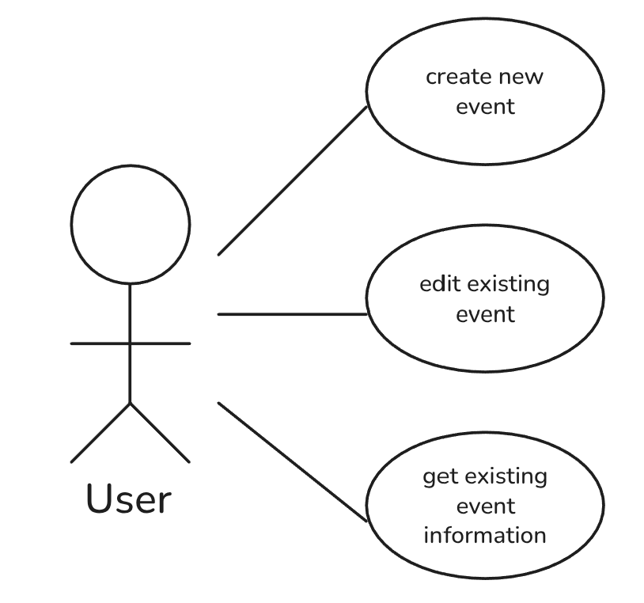
Figure 1: Three Uses Cases of WhatNow?

Create New Event Scenario:
- User speaks to the app with information about a new event they want to add to their calendar
- App creates a new calendar event using details from the input, prompting the user for missing/unclear information
- App adds the newly created event to the schedule

Edit Existing Event Scenario:
- User speaks to the app about an existing event they want to modify
- App searches and finds the event that the user is talking about
- App copies the existing event and makes changes according to the input, aurally prompting the user for any unclear/missing information
- App replaces the existing event with the adjusted copy

Get Existing Event Information Scenario:
- User asks app about specific event or about date range (ex. upcoming, next month, etc.)
- App gathers relevant information about said event
- App relays information about event(s) aurally to user

Entity: Class Diagrams
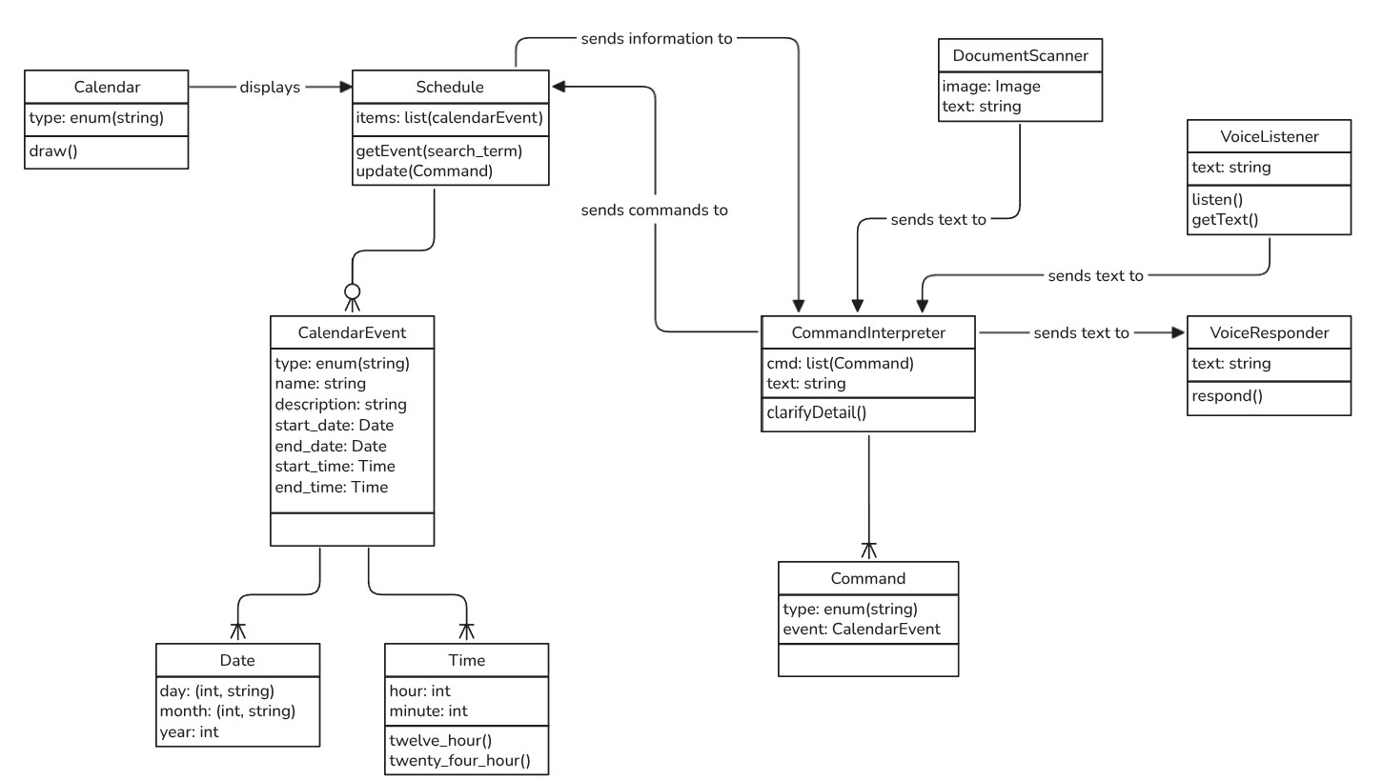Figure 2: Class Diagram

Class Descriptions
Calendar: Displays a visual calendar based on the user's schedule.
- type: one of "yearly", "monthly", "weekly", and "daily"
Schedule: Holds and manages a user's events and event information.
- items: A list of CalendarEvents, sorted first by date, then by start time, then by end time
CalendarEvent: Holds information about one event in a user's schedule.
- type: One of "event", "reminder", and "assignment"
- name: A short name for the event
- description: Optional; a longer description of the event
- start_date: The start date of the event
- end_date: The end date of the event
- start_time: The start time of the event
- end_time: The end time of the event
Date: Holds a single date.
- day: A 2-tuple containing the day of the month (integer) and week (string)
- month: A 2-tuple containing the month of the year (integer and string)
- year: Year (integer)
Time: Holds a single time (day basis).
- hour: Hour of the day (24hr format)
- minute: Minute of the hour
DocumentScanner: Transforms an image of a document into a text description including all relevant details
- image: The image to interpret
- text: The text decoded and summarized from the image
CommandInterpreter: Turns text received from VoiceListener into a command for the schedule as well as creating and sending text to VoiceResponder
- cmd: List of commands; single text input can result in multiple commands
- text: Buffer/placeholder for input (STT) and output (TTS) text
Command: Represents an action to be performed regarding a specific event.
- type: One of "info", "edit", and "new"
- event: The specific event to act upon; must be an exact match when needed
VoiceListener: Uses the device's microphone to record audio and turn it into text.
- text: The result after performing a TTS algorithm on an audio source
VoiceResponder: Transforms inputted text into an audio recording and plays it through the system's speakers.
- text: The text to be turned into audio

Dynamic: Statechart
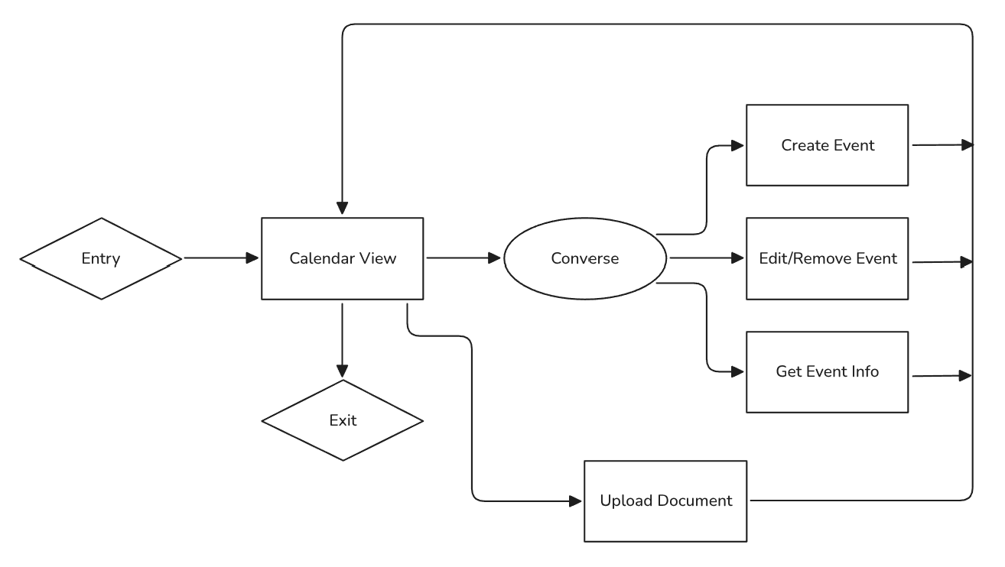Figure 3: General Flow of WhatNow? App

States
Calendar View: A typical visual view of the user's schedule. From this view, the user can converse with the app to make additions/adjustments to their schedule, or they can upload a document.
Converse: User and the app exchange words to convey information and make adjustments to the user's schedule.
Upload Document: User takes or uploads a picture of a document, and the app will attempt to determine relevant information about the time(s), date(s), and nature of said document. The app makes use of aural communication to fill in any missing information, and can suggest names and descriptions.
Create Event: User specifies information about a new event aurally to add to their schedule; the app will prompt for missing information, then add the event to the user's schedule upon confirmation.
Edit/Remove Event: User specifies an event to make modifications to or remove; app interprets meaning, asks for clarification if necessary, and performs the requested modification(s).
Get Event Info: User asks for specific or broad information about events/the schedule, the app responds with appropriate amount of details related to the user's query.

Transitions
Users move between states by interacting with the app, whether that be aurally (going through the Converse state) or visually (using the calendar UI or by scanning a document).

Dataflow Diagrams
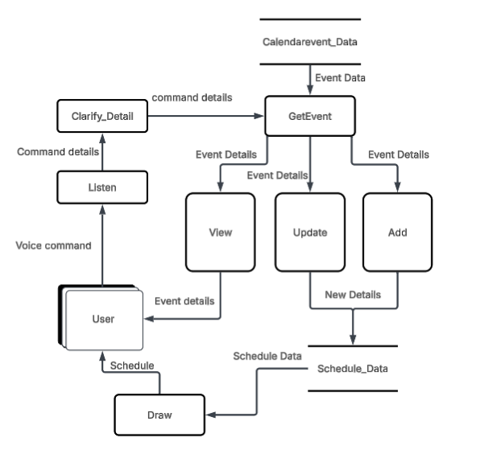
Figure 4. Dataflow Diagram for “What Now?”
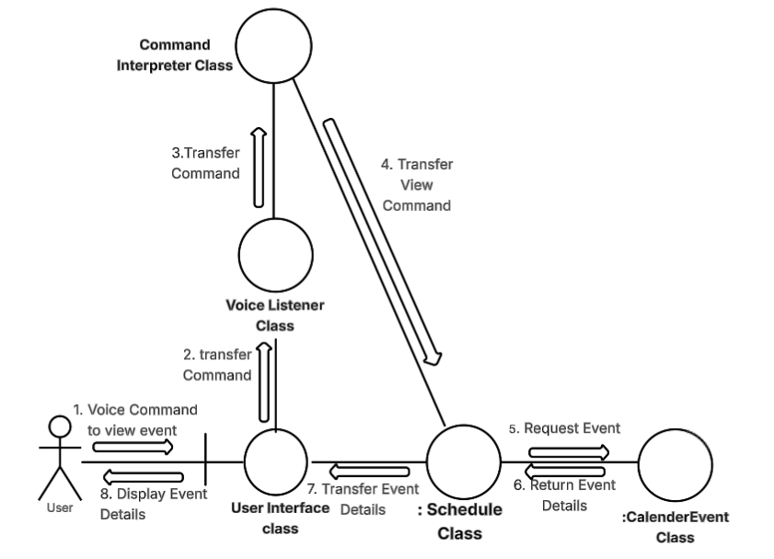

Figure 5. Collaboration Diagram for Viewing an Event
Item 1. The user voices a command to view an event to the User Interface class.
Item 2. The User Interface class transfers that command to the Voice Listener class.
Item 3. After turning the voice command to text, the Voice Listener class transfers that command to the Command interpreter Class.
Item 4. The Command Interpreter class determines what was requested by the user and transfers the command (view an event) to the Schedule class.
Item 5. The Schedule class requests the event’s details from the CalendarEvent class.
Item 6. The CalendarEvent class searches for the event and returns the event details to the Schedule class.
Item 7. The Schedule class transfers the event details to the User Interface class.
Item 8. The User Interface class displays the details of the requested event to the user.

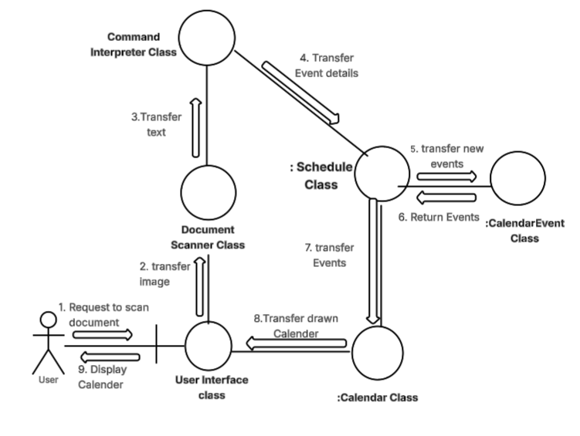
Figure 6. Collaboration Diagram for document scanning.
Item 1. User inputs image of a document and sends a request for scanning to User Interface.
Item 2. User Interface class transfers the image to the Document Scanner class.
Item 3. The Document Scanner class extracts the text from the document and transfers it to the Command Interpreter class.
Item 4. The Command Interpreter transfers the command to update schedule and the details of the events to the Schedule class.
Item 5. Schedule class transfers the new events and details to the CalendarEvent class.
Item 6. After creating the new events, CalendarEvent class returns them to the Schedule class.
Item 7. Schedule class transfers the events to the Calendar class.
Item 8. Calendar class transfers the drawn calendar to the User Interface class.
Item 9. The User Interface class displays the Calendar to the User.

Components Needed
A computer or mobile device with internet access will be needed to use this application. A microphone and camera on those devices will be needed for “What Now?” to be used to its full potential but are not technically required as users can manually input their schedules without document scanning or voice input. For development, a Python IDE along with various libraries previously mentioned in this document will be used to create a GUI application that will be developed over the course of this project’s duration. These components coming together will support the project’s design and implementation throughout its development life cycle.

Appendix A: Technical Glossary
GUI – A Graphical User Interface (GUI) is a way for users to interact with the application, including, but not limited to, elements such as buttons, menus, and windows.
LLM - Acronym for "Large Language Model." Associated with the variety of general-purpose text-generation chatbots, such as OpenAI's ChatGPT, Google's Gemini, or Anthropic's Claude.
OCR - Acronym for "Optical Character Recognition." A process used to transform text within an image into digital text.
AI - Acronym for "Artificial Intelligence." Encapsulates a wide range of technologies which aim to emulate intelligence, whether through explicit programming or implicit means (for example, a neural network).
EXE File- An executable file that contains a program that can be run on a device with a Windows operating system.
AppImage File - An executable file that contains a program that can be run on a device with a Linux operating system.
APK File- An executable file that contains a program that can be run on a device with an Android operating system.
Event – A field in the program that will hold information such as date, time, name, priority and details.
Class – A programming tool used to make multiple objects with the same attributes.
Class Diagram – A diagram to show how the different classes in a program interact with one another.
Library or Libraries - Programming tooling developed for the purpose of simplifying and quickening the development process. Common examples are modules that simplify handling input and output within programs.
Python - A widespread programming language with a large variety of support.
IDE – Acronym for “Integrated Development Environment”. A software application for programming that combines tools such as a code editor and compiler into a single interface for developers.

Appendix B: Team Details
This document was produced as a result of a combined effort under the leadership of Lavender Wilson. Work on the document was spread across multiple weeks, and members read other sections, but the primary responsibilities are as follows:
- Ethan Janovich: Table of Contents, Abstract, Document Description, Dataflow Diagram, Components Needed, Appendix A.
- Lavender Wilson: Outline setup, Appendices B-D, System Modeling
- Samuel Persinger: System Description
All other contributions to this document were added via virtual communications over the several weeks this document was written. Feedback between members was shared through several channels, including on the document itself (removed before finalization) and through other means of online and in-person communication.

Appendix C: Workflow Authentication
I, Lavender Wilson, attest that this document and its details represent the specification for the "What Now?" project, and that I have completed work in accordance with Appendix B.
Signature: Date: 11/14/2025
I, Ethan Janovich, attest that this document and its details represent the specification for the "What Now?" project, and that I have completed work in accordance with Appendix B.
Signature:  Date: 11/142025
I, Samuel Persinger, attest that this document and its details represent the specification for the "What Now?" project, and that I have completed work in accordance with Appendix B.
Signature:  Date: 11/14/2025

Appendix D: Writing Center Report
Date: 11/14/2025
Author: Lexi Josephs
Report:
While reviewing this document, I did not notice any glaring grammatical or organizational issues. Only a few small proofreading errors were noticed and discussed with the client, Samuel Persinger.

