# A Sierpinski Gasket in JavaScript and Java

Stephan Peters

Colorado State University Global

24FB-CSC405-1: Graphics and Visualization

Jennifer Marquez

25 August 2024

## **A Sierpinski Gasket in JavaScript and Java**

A Sierpinski Gasket is a fractal, self-similar geometric figure that is created by iteratively removing the middle triangle from an equilateral triangle. The process starts with an equilateral triangle, and at each iteration, the middle triangle is removed, leaving three smaller equilateral triangles. This process continues indefinitely, resulting in a pattern that appears to be infinitely detailed. The Sierpinski Gasket is named after the Polish mathematician Wacław Sierpiński, who introduced it in 1915 (Mazurkiewicz & Sierpiński, 1920). It is a classic example of a fractal, which is a shape that exhibits self-similarity at different scales. The Sierpinski Gasket is also known as the Sierpinski Triangle, Sierpinski's Triangle, or the Koch Snowflake. See Shannon & Bardzell, 2019.

The code included in this package creates Sierpinski Gaskets using JavaScript utilizing Graphics Language Shader Language (GLSL) and Java utilizing a simple standard draw package. The core HTML and JavaScript code is in the root directory, the Java code is included in the ./src directory.

## The Rendering of the Gasket

In the JavaScript version included in this package creates a 3D Sierpinski Gasket using GLSL. The image is rendered in a buffer, then displayed on the screen so the user only sees the finished gasket and does not see the gasket being formed. The Java version creates a 2D gasket using Turtle-like commands and the rendering can be viewed as it is drawn if the CPU is slow enough to see this. Running the Java program in debug mode pausing at each iteration allows a user to see each recursive iteration as the triangle is formed. It does not complete an individual triangle in the gasket until the program reaches the required number of iterations, in this case seven. See Figure 1, which shows the completion of the first triangle in the pattern at the lower left portion of the image.

### Figure 1

*A 2D Sierpinski Gasket during formation.*

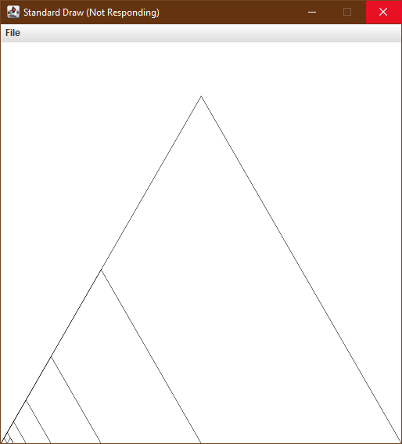

Figure 1 shows the triangle being constructed after eight iterations of the code shown on the next page, which what constructs each triangle:

line(x, y, x + size, y);

line(x, y, (2 * x + size) / 2.0, y + theodorusConstant * size / 2);

line(x + size, y, (2 * x + size) / 2.0, y + theodorusConstant * size / 2);

triangle(x, y, size / 2.0, n - 1);

triangle((2 * x + size) / 2.0, (y + y) / 2.0, size / 2.0, n - 1);

triangle((x + (2 * x + size) / 2.0) / 2.0,

(y + y + (theodorusConstant * size / 2)) / 2.0,

size / 2.0, n - 1);

theodorusConstant is Math.sqrt(3) stored in a variable.

The JavaScript version creates a 3D Gasket with the initial sides of the triangle randomized so the triangles are not equilateral, and the triangular pyramids created are irregular (unless, of course the randomly generated numbers create a regular triangular pyramid, which is virtually impossible). The gasket is also rotated randomly, so the viewer may see any face of the triangle. See figure 2.

### Figure 2

*Examples of the randomized irregular 3D Sierpinski Gaskets created by the WebGL application*

there is also a starfield in the background created using CSS, modified from Clark, n.d. so the created gaskets appear to be flying through space.

## Conclusion

This was an interesting experiment in creating fractals. The number of iterations is limited by a number in the code, but these iterations could be set to continue indefinitely (until the computer runs out of resources) as a true fractal.

## References

Clark, K. (n.d.). *Pure CSS starfield*. CodePen. <https://codepen.io/keithclark/pen/DQdKbg>

Mazurkiewicz, S., & Sierpiński, W. (1920). *Fundamenta mathematicae. Tom 1*. Google Books. <https://books.google.com/books?id=h4JCAAAAYAAJ>

Shannon, K., & Bardzell, M. (2019). *Sierpinski Triangles*. Nationalcurvebank.org. <http://nationalcurvebank.org/deposits/sierpinski.html>