**Lessons Learned Reflections**

Stephan Peters

Colorado State University Global

ITS320-2: Basic Programming

Mortoza Abdullah

February 12, 2023

**Lessons Learned Reflections**

The basic programming class was designed as a class at the basic introductory level with no prior programming experience. While it had been a couple years since I used Python, I found I needed to use different sources to advance my skills, I was spending a lot of time in the textbook doing very simple problems. Once I found this, I abandoned the textbooks for the course and started using other sources to increase my knowledge of Python. There are some fantastic and not-so fantastic sources on the Internet that allow specialized learning in Python.

**Jupyter Notebook**

One of the most fantastic resources I was exposed to while taking this course is Jupyter Notebook (Jupyter Team, 2023) along with Anaconda (Anaconda, Inc., 2023). They have fantastic abilities to solve simple engineering problems. A function can be defined and var iables can be changed very easily in one block, and graphical results can be seen using NumPy (NumPy, 2023)and MatPlotLab (MatPloLlib development team, 2023) with very simple integrated installation packages. For engineering with graphic results, I think it works better than default Java, especially for complex equation graphing. While I personally prefer Java as a language, I’d look at Python for data analysis that needs more than Java and doesn’t need as intense processing as Fortran or Matlab. See a graphic example of my first introduction to Jupyter Notebook on the next page in Figure 1.

**Python Data Types**

Python data types can be very tricky. They are a lot more tricky than in Java because there are less built-in libraries that support what could be simple functions. I found Dictionaries work differently on older versions of Python, and Ordered Dictionaries are still the best way to approach key-value pairs because of this. There is no built-in pair function. Lists may not retain their order. Using indices to access data is very difficult using Python. Many common functions need to be iterated in Python that have multiple built-in functions that accomplish the same thing in Java.

**Figure 1**

*Harmonograph in Python in Jupyter Notebook with Numpy and MatPlotLib.*

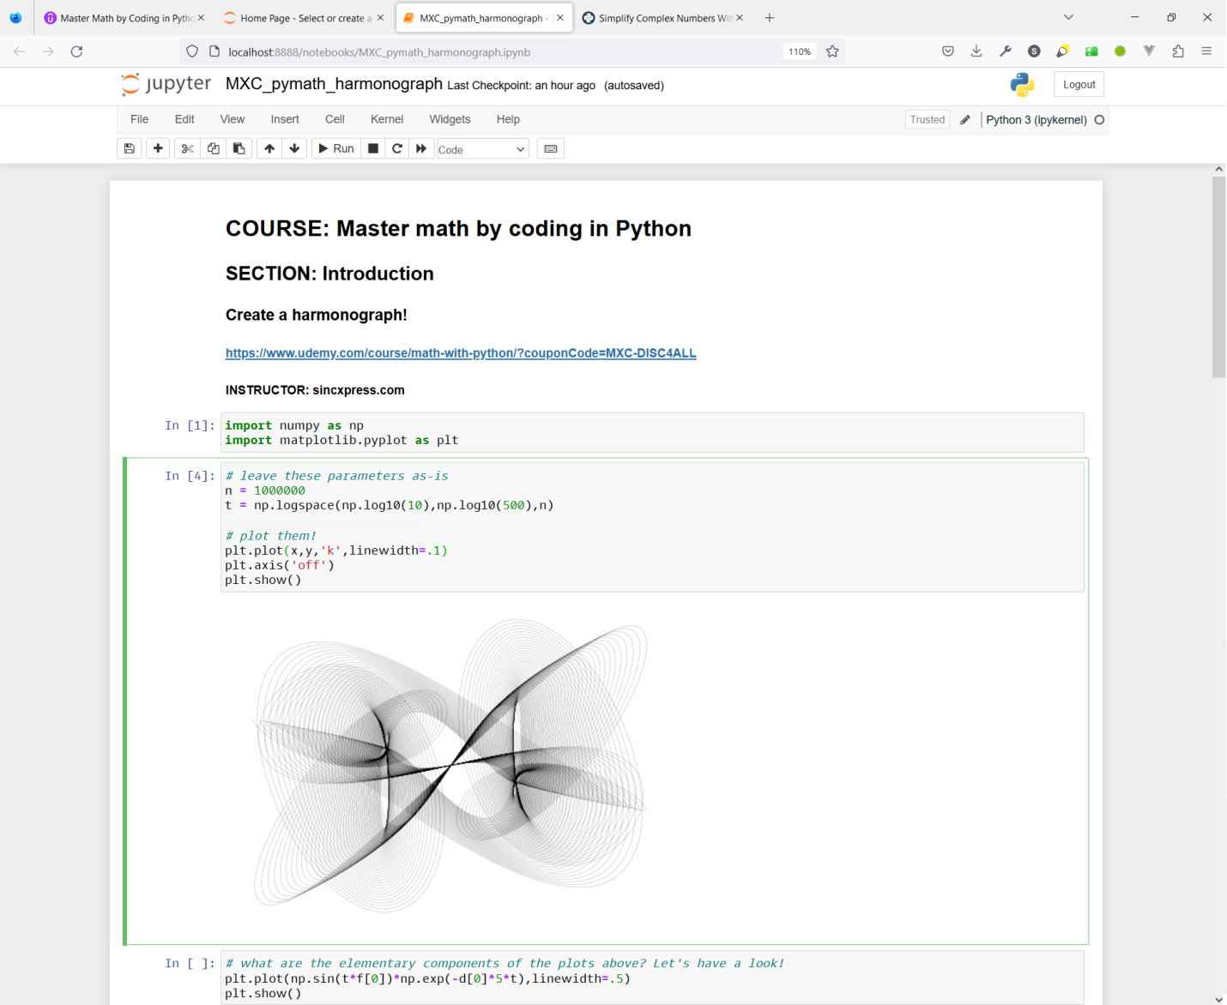

**Real Python**

I found the best Python resource for the way I learn is Real Python (Real Python, 2023). For Java, I was really helped by JavaTPoint and GeeksForGeeks, but their authors for Python are not at the same caliber as their authors for Java. Real Python has fantastic writers and fantastic articles (most available code is in Jupyter Notebook format), and I learned a lot from them.

**Conclusion**

I learned a lot while taking this course, primarily from finding unique ways to solve the problems. My favorite was the Complex class from week 6. I was able to truncate it to a point where it actually may have defeated the original intent of the assignment. I inherited complex and wrote a string override. See the code in Figure 2. By mulling over the assignments and finding unique ways like this to solve the problems, I learned a lot more than I would have plugging away at the modules.

**Figure 2**

*Module 6 Complex Class code.*

**class** Complex(complex):  
 **pass  
  
 def** __init__(self, z):  
 self.z = z  
  
 **def** __str__(self):  
 real = **'{0:.2f}'**.format(self.z.real)  
 imaginary = **'{0:.2f}'**.format(self.z.imag)  
 **if** self.z.imag >= 0:  
 **return** real + **'+'** + imaginary + **'i'  
 else**:  
 **return** real + **''** + imaginary + **'i'**

**References**

Anaconda, Inc. (2023). Anaconda | Anaconda Distribution. Anaconda. <https://www.anaconda.com/products/distribution>

Jupyter Team. (2023). Jupyter Project Documentation. Docs.jupyter.org. <https://docs.jupyter.org/en/latest/>

MatPloLlib development team. (2023). MatPlotLib: Python plotting — MatPlotLib documentation. Matplotlib.org. <https://matplotlib.org/stable/index.html>

NumPy. (2023). Overview — NumPy Manual. Numpy.org. <https://numpy.org/doc/stable/>

Real Python. (2023). Python Tutorials – Real Python. Realpython.com. <https://realpython.com/>