**Create MySQL Database**

Stephan Peters

Colorado State University Global

23WC-ITS410-2: Database Management

Jamia Mills

21 January 2024

## Create a MySQL Database

In this paper, I will use provided SQL scripts to create a database in MySQL and run some queries to test installation of the database. Full resolution images of the figures shown may be viewed with CSU Global Login via Google Drive here: <https://drive.google.com/drive/folders/1ifYw6jM80dM-c2Eg1JJB1yEIRZyxhxe3?usp=sharing>

## Part 1, Create the My Guitar Shop Database

This section shows successful installation of MySQL server and MySQL Workbench and installs the my_guitar_shop database from a provided SQL script.

### Running the Script

Figure 1 shows the database creation through running the script as a database administrator.

Figure 1

Running my_guitar_shop.sql in MySQL Workshop

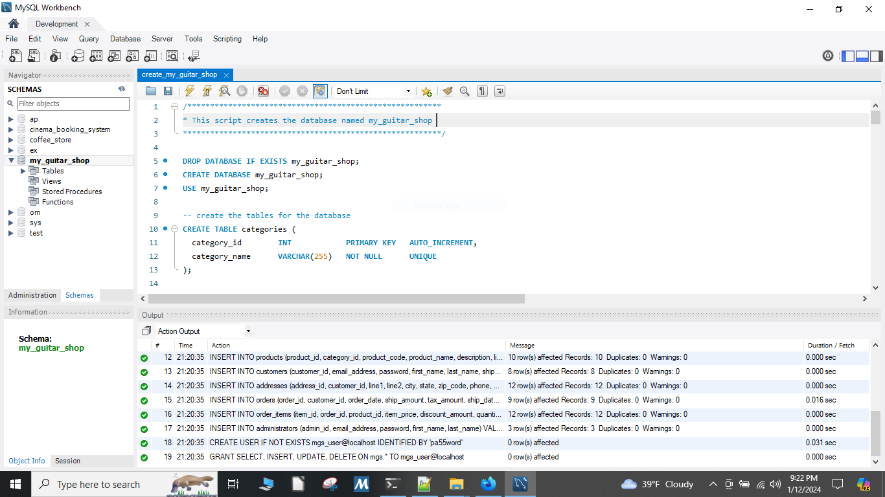

Running the script creates the initial database with the schema shown in Figure 2.

Figure 2

Initial Database Schema for my_guitar_shop

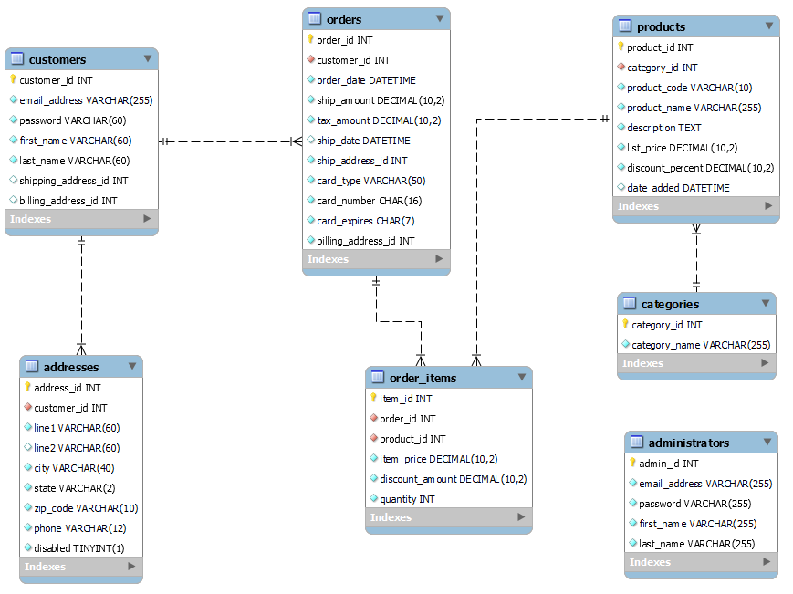

The database creation may be verified through a Command Line Interface (CLI) as shown in Figure 3.

Figure 3

Show Tables in the my_guitar_shop database using a CLI

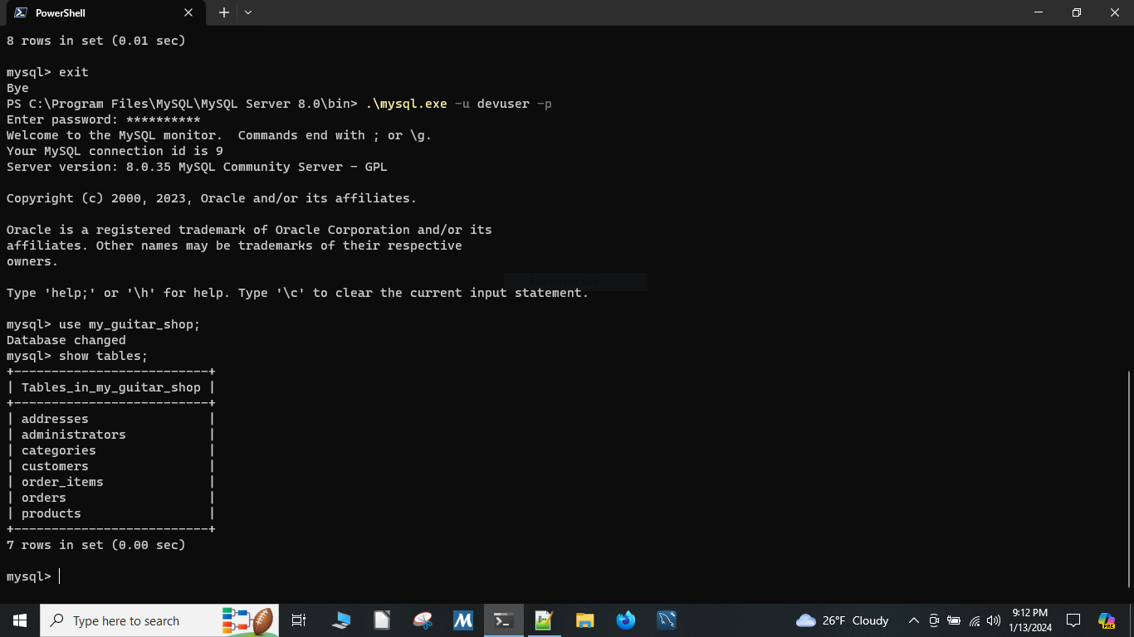

## Part 2, Running Select Statements Using the Database

This section shows execution of SELECT statements using the newly created database.

Figure 4

Running SELECT product_name FROM products;

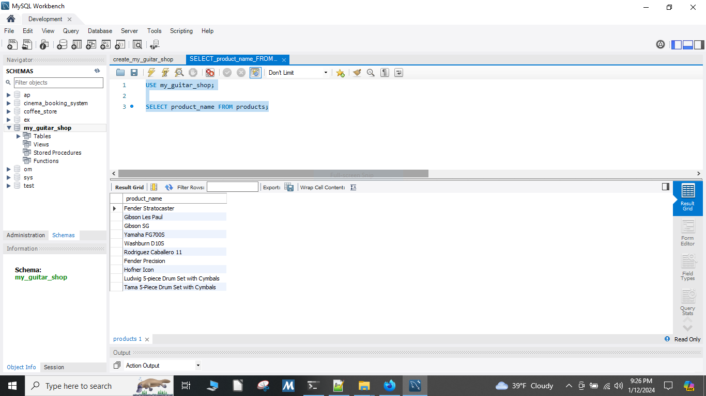

Figure 4b

Running SELECT product_nam FROM products;

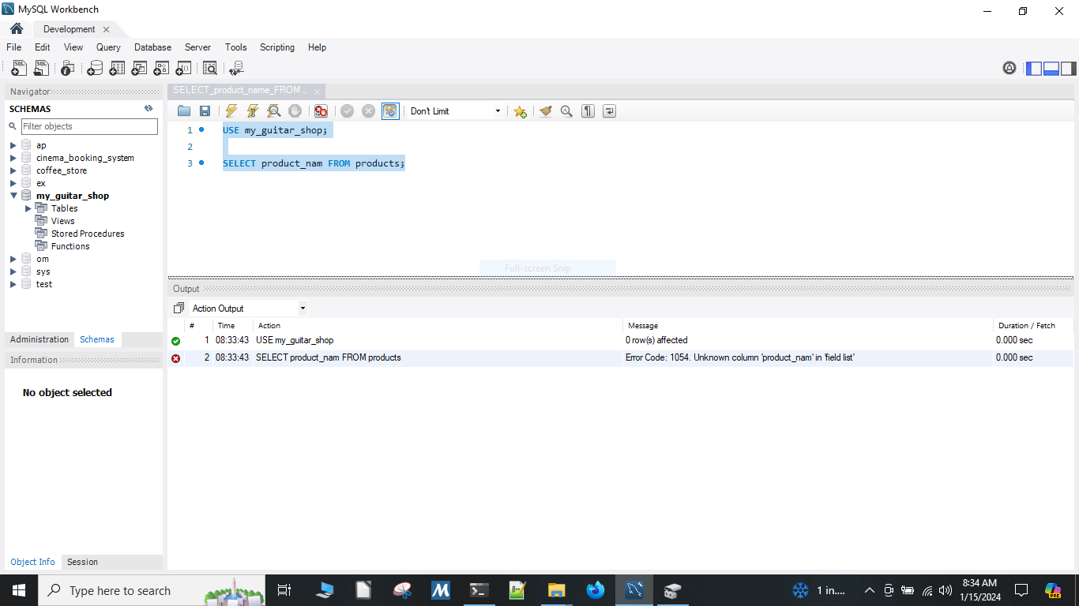

Figure 5

Running SELECT COUNT(*) AS number_of_products;

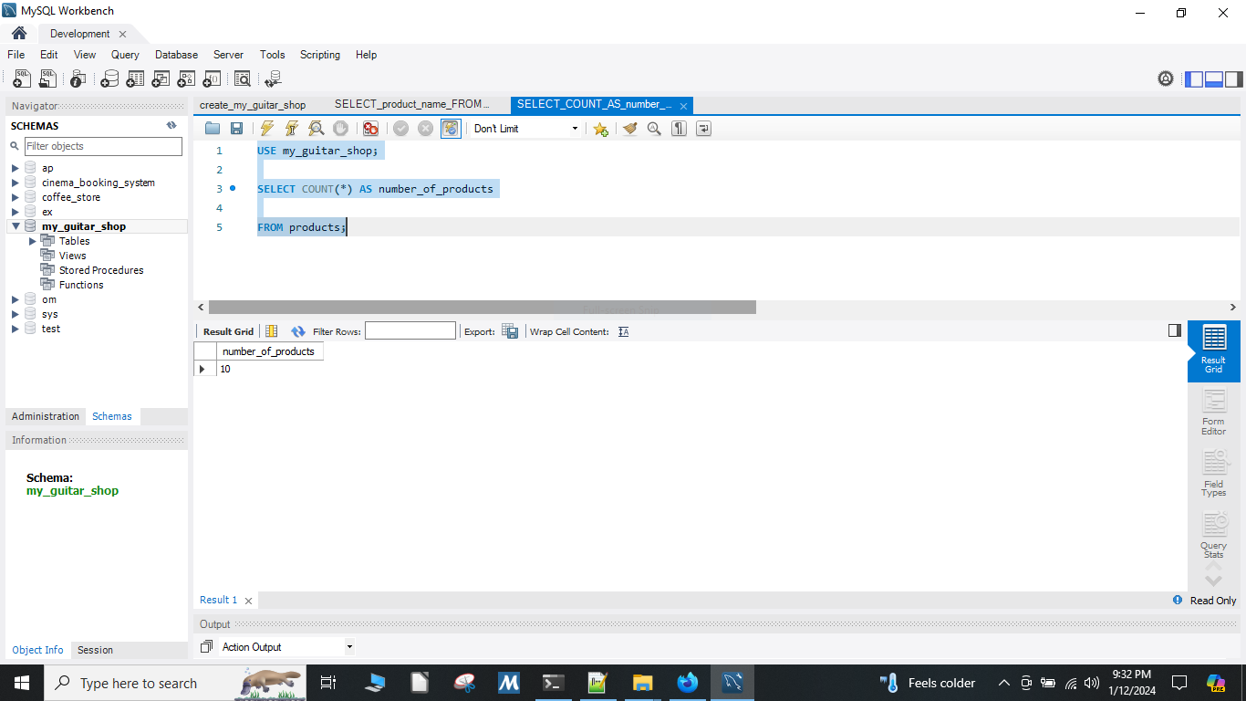

## Part 3, Using MySQL Workbench to Open and Run Scripts

This section shows execution provided scripts using the my_guitar_shop database.

Figure 6

Running product_details.sql

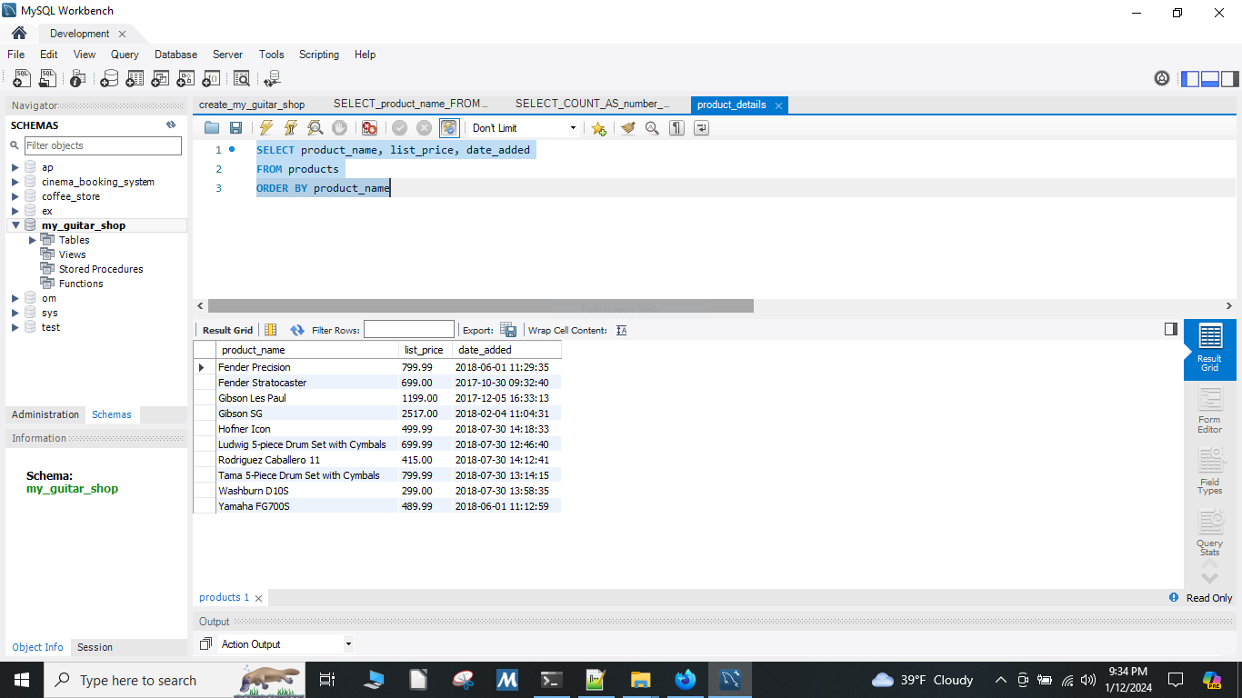

Figure 7

Running product_summary.sql

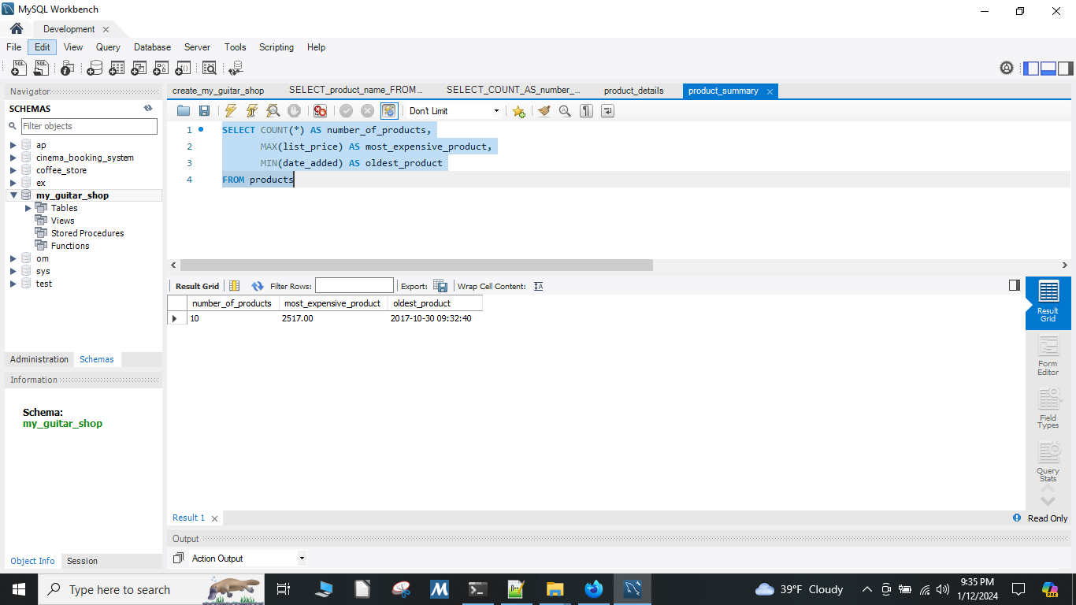

Figure 8

Running product_statements.sql, part 1

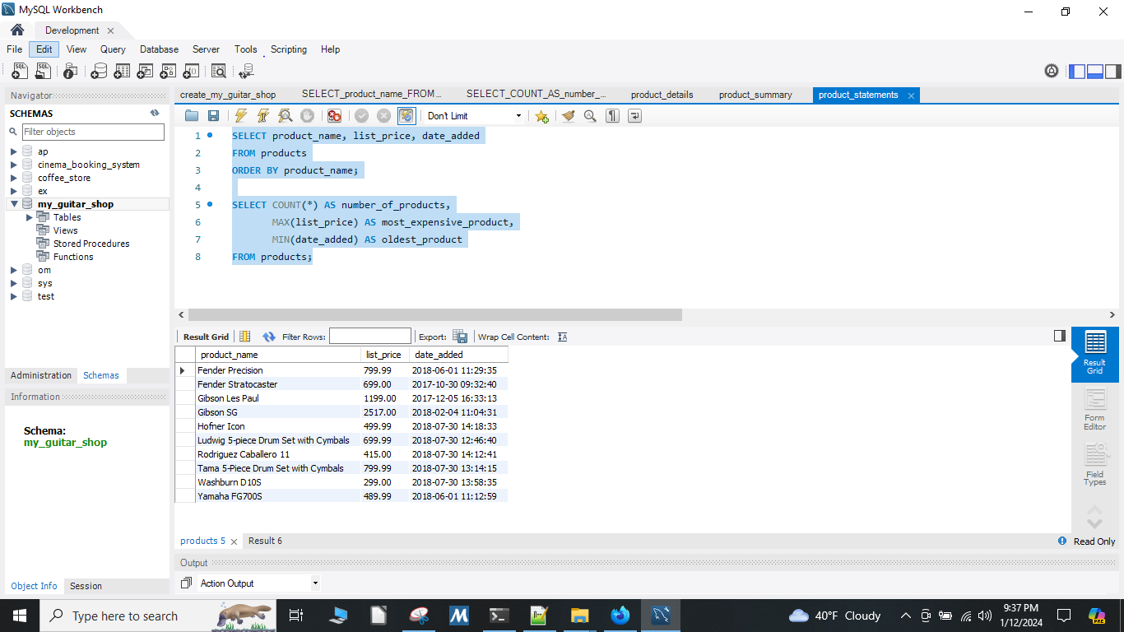

Figure 9

Running product_statements.sql, part 2

