**MySQL Select Statements**

Stephan Peters

Colorado State University Global

23WC-ITS410-2: Database Management

Jamia Mills

28 January 2024

## MySQL Select Statements

Full resolution images of the figures shown may be viewed with CSU Global Login via Google Drive here: <https://drive.google.com/drive/folders/1k6HthWbGkSZjdrcB3wbkr8gjb86Xt8et?usp=sharing>

## Select Columns from Products

This query returns product_code, product_name, list_price, and discount_percent from the products table in my_guitar_shop.

Figure 1

SELECT product_code, product_name, list_price, discount_percent FROM products;

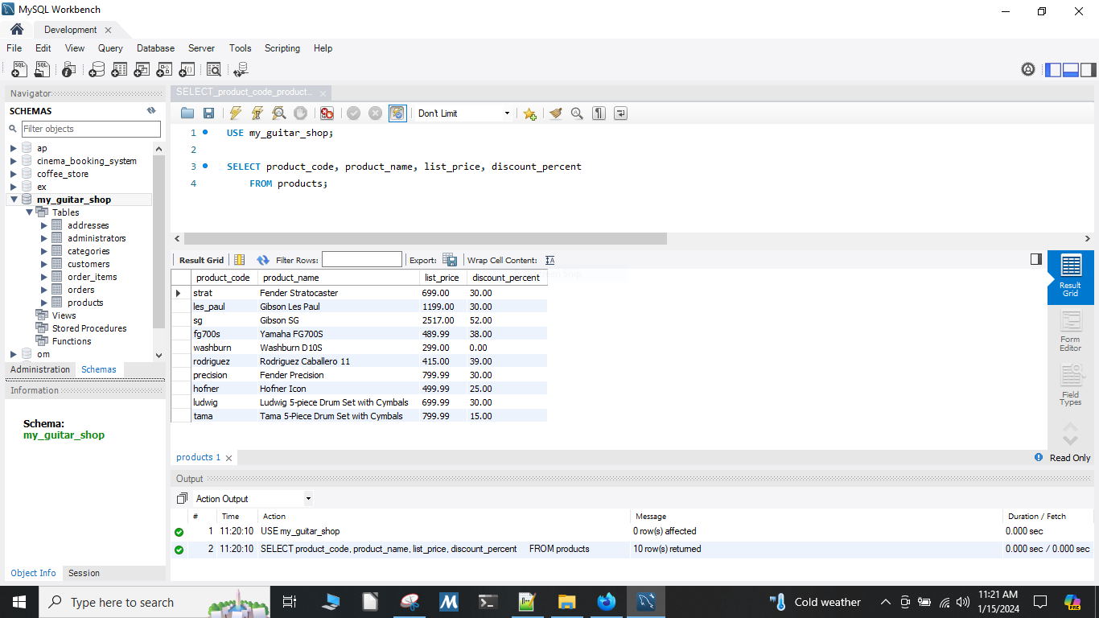

## Concatenation of Columns in a Table

This query returns full names for customers with last names starting with M or higher from the customers table in my_guitar_shop. I wrote two queries, one using BETWEEN and one using REGEXP that accomplish the same function.

Figure 2

SELECT concat(last_name, ", ", first_name) AS full_name FROM customers WHERE last_name REGEXP '^[M-Z]' ORDER BY last_name;

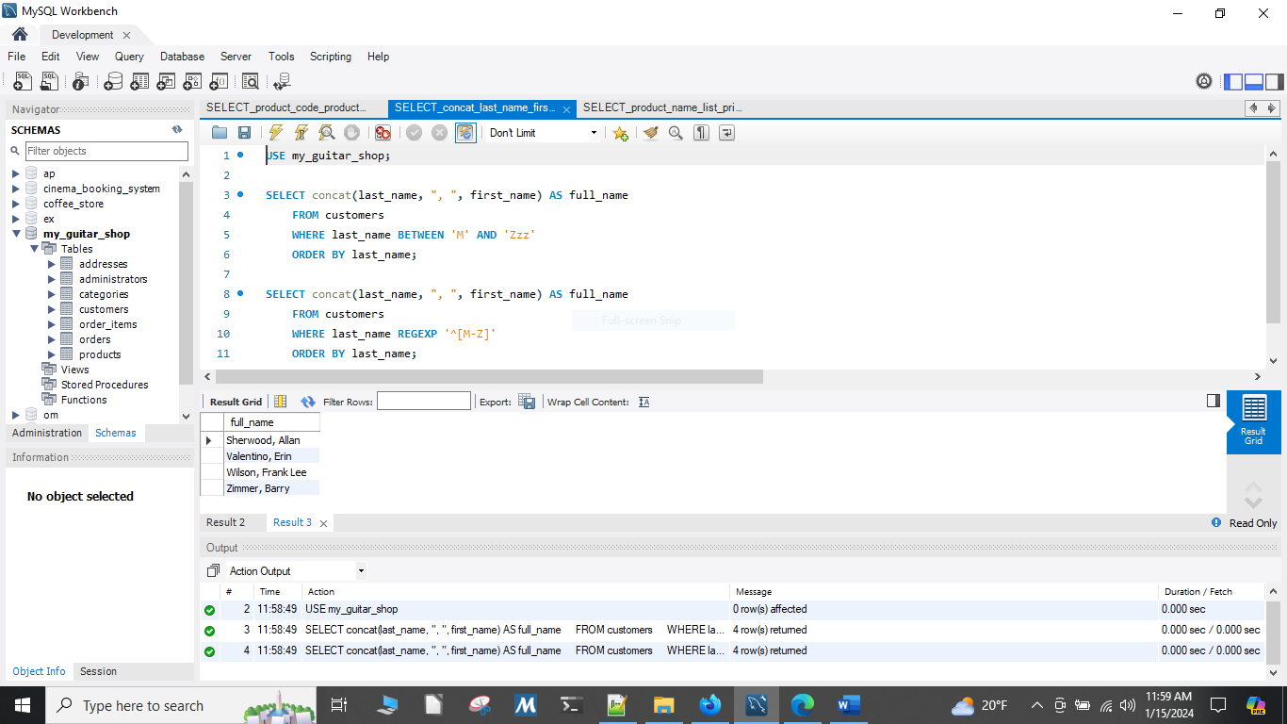

## Using Between and Sorting in Descending Order

This query returns product_name, list_price, and date_added from the products table in with prices over $500 but under $2000 from my_guitar_shop, sorted by newest first.

Figure 3

SELECT product_name, list_price, date_added FROM products WHERE list_price BETWEEN 500 AND 2000 ORDER BY date_added DESC;

