**MySQL Join Statements**

Stephan Peters

Colorado State University Global

23WC-ITS410-2: Database Management

Jamia Mills

4 February 2024

## MySQL Join Statements

Full resolution images of the figures shown may be viewed with CSU Global Login via Google Drive here: <https://drive.google.com/drive/folders/1kGarJlj9qYitDCd8MCFmfbIUfJrOqpx9?usp=sharing>

## Join Categories and Products

This query returns category_name, product_name and list_price from the categories and products table in my_guitar_shop, sorted by category_name then product_name.

Figure 1

SELECT c.category_name, p.product_name, p.list_price FROM products p JOIN categories c ON c.category_id = p.category_id ORDER BY c.category_name, p.product_name;

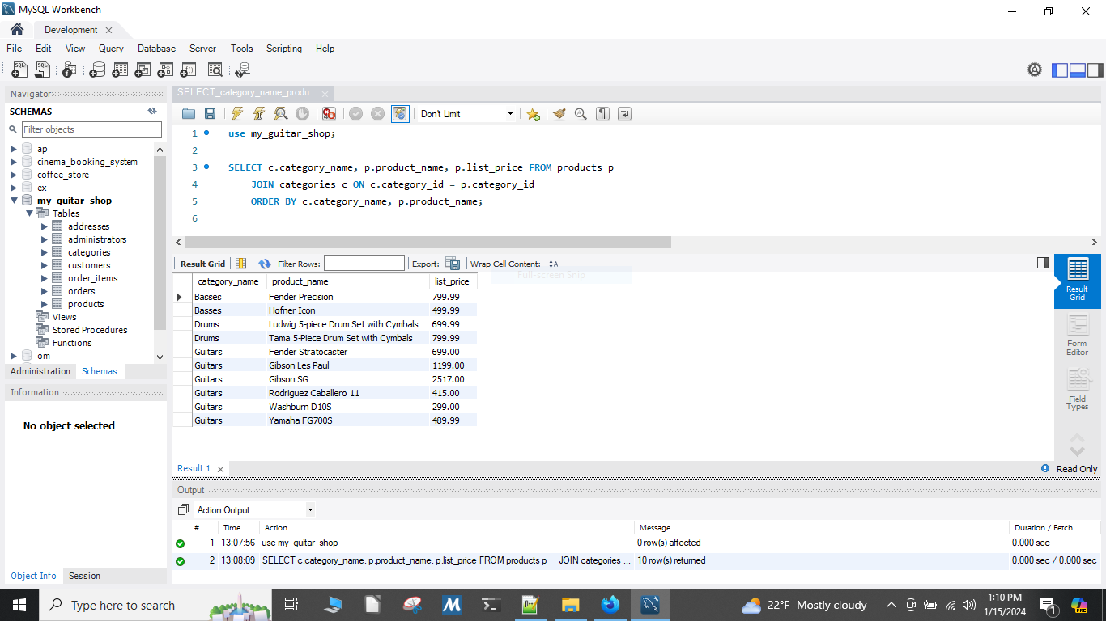

## Joining Tables to Retrieve Data

This query returns the customer’s name, shipping address and billing address (if different from shipping address) for a single customer email address.

Figure 2

SELECT c.first_name, c.last_name, a.line1, a.city, a.state, a.zip_code FROM addresses a JOIN customers c on a.customer_id = c.customer_id WHERE c.email_address = 'allan.sherwood@yahoo.com';

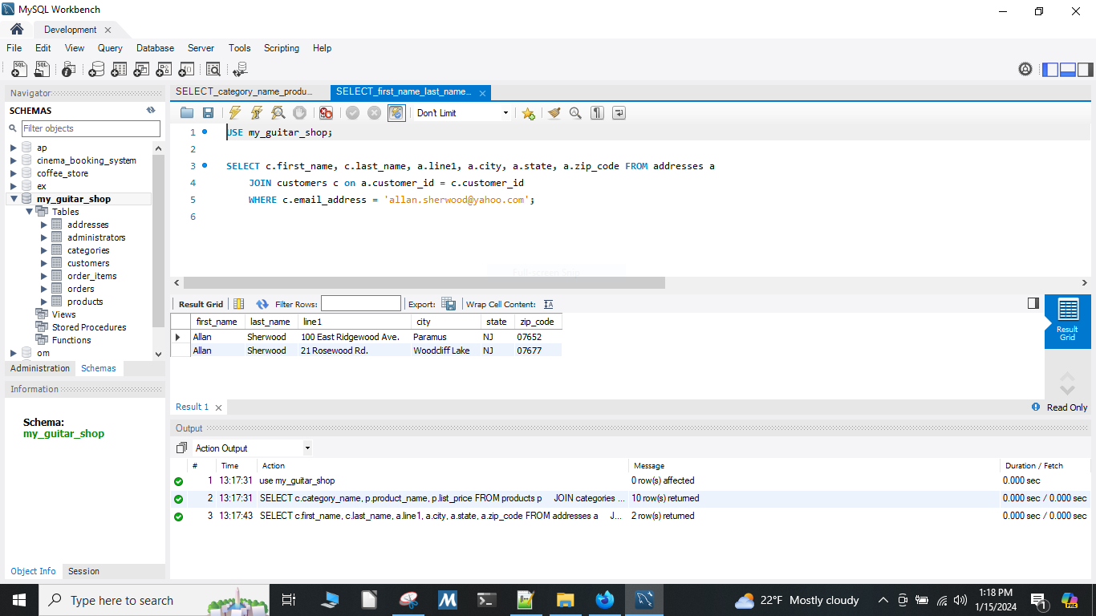

## Joining Tables to Retrieve Data from a Non-Normal Form Database

This query returns the customer’s name and shipping address but not the billing address from the customers and addresses tables. It uses a join to the orders table to force shipping address only.

Figure 3

SELECT c.first_name, c.last_name, a.line1, a.city, a.state, a.zip_code FROM addresses a JOIN customers c ON c.customer_id = a.customer_id INNER JOIN orders on orders.ship_address_id = a.address_id;

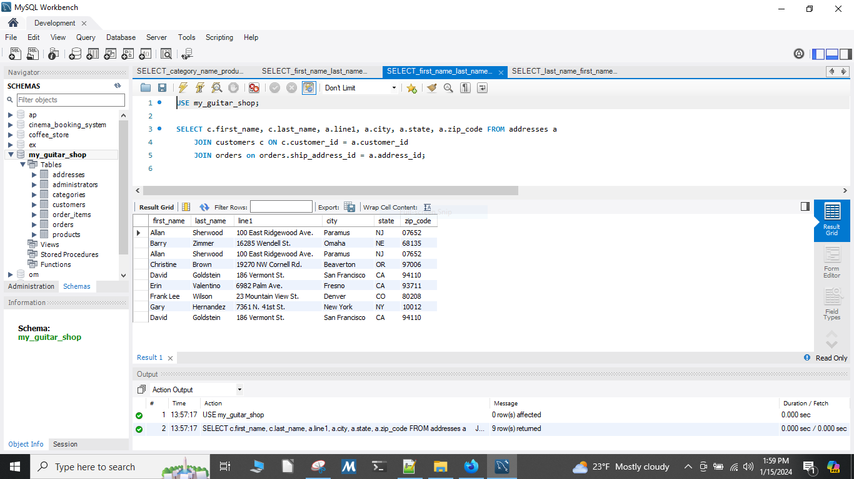

## Joining Multiple Tables

This query returns the customer’s last_name, first_name, the order’s order_date, the product’s product_name, and the order item’s item_price, discount_amount and quantity. It uses multiple joins to retrieve this information.

Figure 4

SELECT c.last_name, c.first_name, o.order_date, p.product_name, oi.item_price, oi.discount_amount, oi.quantity FROM order_items oi JOIN products p ON p.product_id = oi.product_id JOIN orders o ON o.order_id = oi.order_id JOIN customers c ON o.customer_id = c.customer_id ORDER BY c.last_name, o.order_date, p.product_name;

