**MySQL Data Manipulation Language**

Stephan Peters

Colorado State University Global

23WC-ITS410-2: Database Management

Jamia Mills

11 February 2024

## MySQL Data Manipulation Language

Full resolution images of the figures shown may be viewed with CSU Global Login via Google Drive here: <https://drive.google.com/drive/folders/1kV1LrPT9mpCNNs2Us3DRa4esOFhtMJaK?usp=sharing>

## Insert a Row into a Table

This query inserts a new category, Brass, into the categories table.

Figure 1

INSERT INTO categories (category_name) VALUES ('Brass');

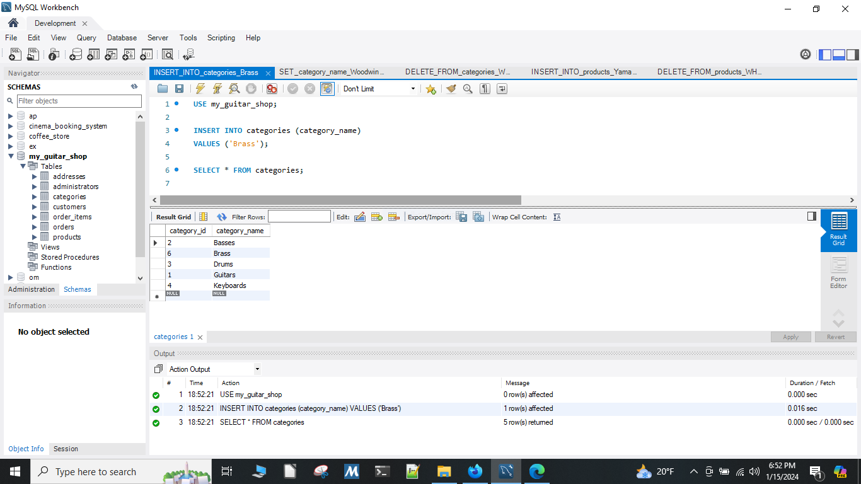

## Modify a Row in a Table

This query modifies the Brass category and changes it to Woodwinds.

Figure 2

UPDATE categories SET category_name = 'Woodwinds' WHERE category_name = 'Brass';

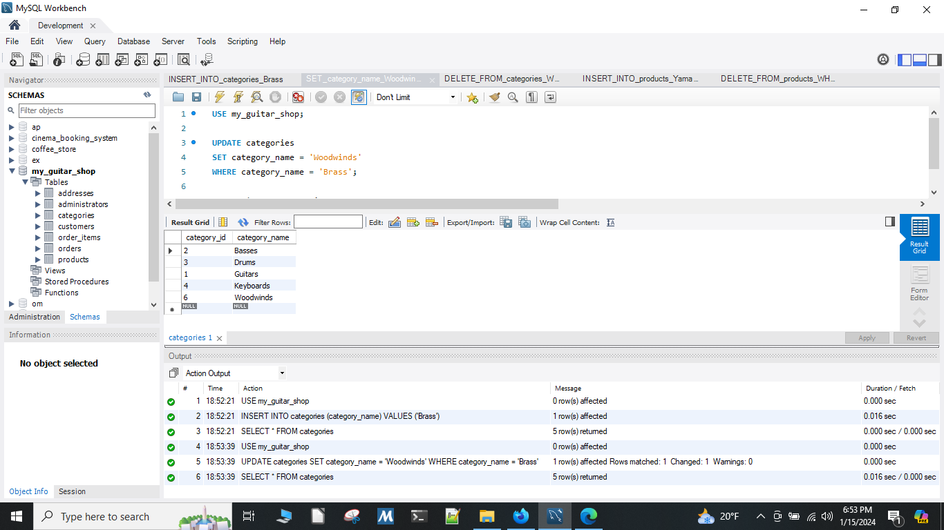

## Deleting an Entry from a Table

This query deletes the Woodwinds category from categories.

Figure 3

DELETE FROM categories WHERE category_name = 'Woodwinds';

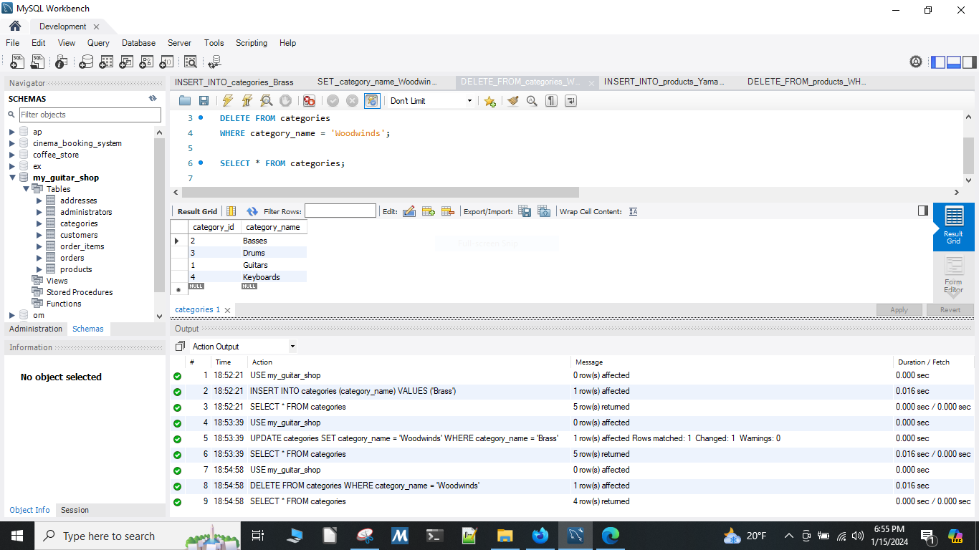

## Joining Multiple Tables

This query inserts a Yamaha DGX 640 88-Key Digital Piano into the products database. It was not necessary to include a value for discount_percent as this column defaults to 0.00. NOW() returns the current datetime.

Figure 4

INSERT INTO products (category_id, product_code, product_name, description, list_price, date_added) VALUES (4, 'dgx_640', 'Yamaha DGX 640 88-Key Digital Piano', 'Long description to come.', 799.99, NOW());

