**MySQL: Stored Functions and Procedures**

Stephan Peters

Colorado State University Global

23WC-ITS410-2: Database Management

Jamia Mills

25 February 2024

## MySQL: Stored Functions and Procedures

Full resolution images of the figures shown may be viewed on my public GitHub repository here: <https://github.com/speters33w/CSUGlobal_ITS410/blob/main/CriticalThinking6/Module_6_Critical_Thinking.md>, or with CSU Global Login via Google Drive here: <https://drive.google.com/drive/folders/1oN6HLD1ZJ5zVhVrkuce7vmJhUJzRRVUF?usp=sharing>

## Storing and Calling a Procedure

This writes a stored procedure named insert_category that adds a new row to the category table using a parameter for the category name. The next query (Script 1a / Figure 1a) calls the function and adds “Brass” as a category. The following (Script 1b / Figure 1b) calls the function and adds “Woodwinds” as a category. The function uses a SELECT statement to verify insertion of the new category while running.

Script 1a

|  |
| --- |
| USE my_guitar_shop;  DROP PROCEDURE IF EXISTS *insert_category*;  DELIMITER // CREATE PROCEDURE *insert_category*(param VARCHAR(255))  BEGIN  INSERT INTO categories(category_name)  VALUES(param);  SELECT category_name  FROM categories  ORDER BY category_id DESC;  END// DELIMITER ;  CALL *insert_category*('Brass');  SHOW PROCEDURE STATUS WHERE db = 'my_guitar_shop'; |

Figure 1a

CREATE PROCEDURE insert_category

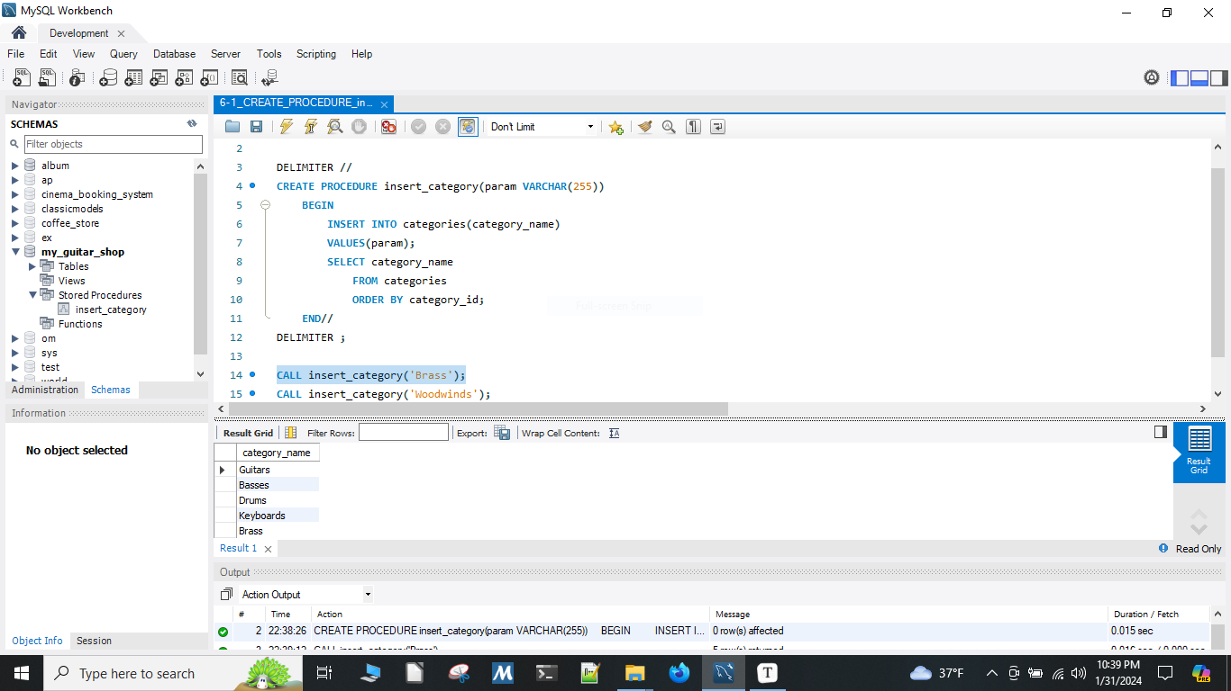

Script 1b

|  |
| --- |
| CALL *insert_category*('Woodwinds'); |

Figure 1b

CALL insert_category('Woodwinds');

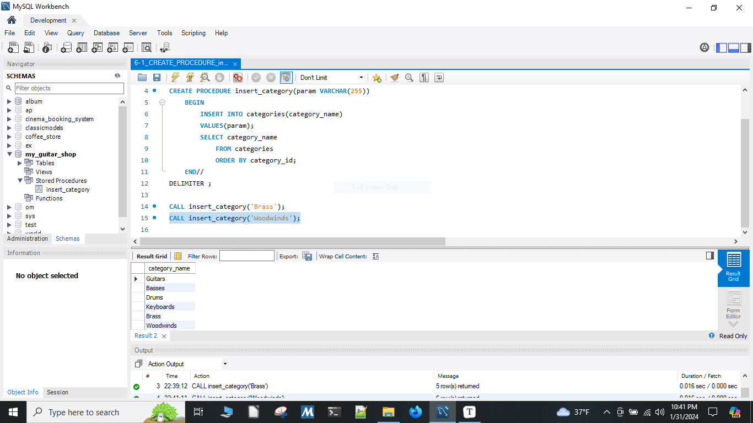

## Storing and Calling a Stored Function in MySQL

This function returns the actual price of an order item after the discount amount has been applied. The query returns the order item, the product name, the list price, the discount amount, and the discount price using the stored discount_price function ordered by order id.

Script 2

|  |
| --- |
| USE my_guitar_shop;  SELECT *\** FROM order_items;  DROP FUNCTION IF EXISTS *discount_price*;  DELIMITER // CREATE FUNCTION *discount_price*(order_item_id INT) RETURNS DECIMAL(10,2) DETERMINISTIC BEGIN  DECLARE actual_price DECIMAL(10,2);  SELECT (item_price - discount_amount) INTO actual_price  FROM order_items WHERE item_id = order_item_id;  RETURN actual_price; END// DELIMITER ;  SELECT o.item_id AS order_item_id, p.product_name, o.item_price,  o.discount_amount, *discount_price*(item_id) AS discount_price FROM order_items o JOIN products p USING (product_id) ORDER BY o.item_id;  SHOW FUNCTION STATUS WHERE db = 'my_guitar_shop'; |

Figure 2a

CREATE FUNCTION discount_price;

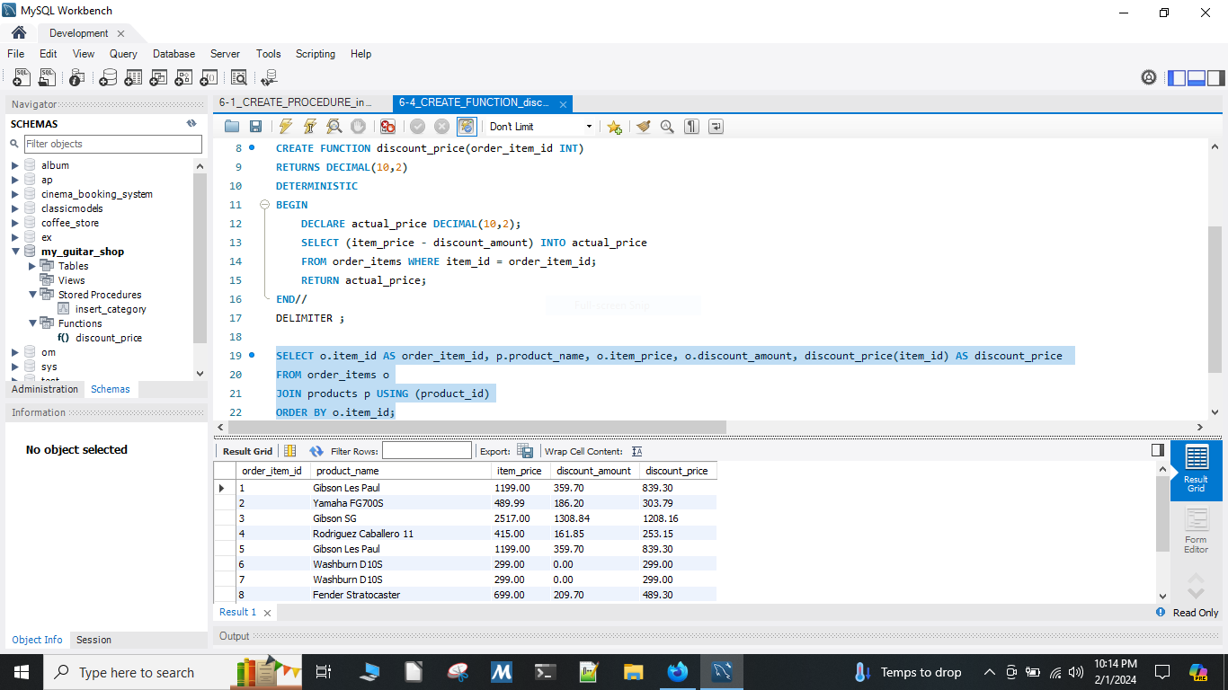

Figure 2b

Result of SELECT discount_price query.

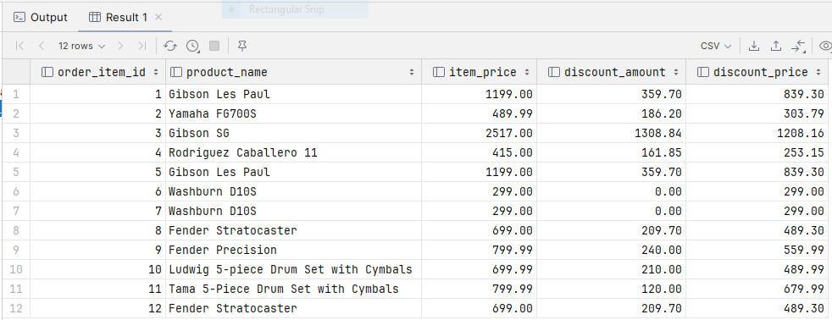

## Storing a Stored Function that uses another Stored Function

This function returns the total price of an order item after the discount amount has been applied multiplied by the quantity ordered. The query returns the order item, the product name, the list price, the discount amount, the discount price using the stored discount_price function, the quantity, and the item total using the stored item_total function ordered by order id. The function can be seen in action looking at order_id 5, where 2 Gibson Les Paul’s are ordered at the discount price of $839.30 each, for a total of $1678.60.

Script 3

|  |
| --- |
| USE my_guitar_shop;  SELECT *\** FROM order_items;  DROP FUNCTION IF EXISTS *item_total*;  DELIMITER // CREATE FUNCTION *item_total*(order_item_id INT) RETURNS DECIMAL(10,2) DETERMINISTIC BEGIN  DECLARE line_items_total DECIMAL(10,2);  SELECT (*discount_price*(order_item_id) * quantity) INTO line_items_total  FROM order_items WHERE item_id = order_item_id;  RETURN line_items_total; END// DELIMITER ;  SELECT o.item_id AS order_item_id, p.product_name, o.item_price,   o.discount_amount, *discount_price*(item_id) AS discount_price,   o.quantity, *item_total*(item_id) AS item_total FROM order_items o JOIN products p USING (product_id) ORDER BY o.item_id;  SHOW FUNCTION STATUS WHERE db = 'my_guitar_shop'; |

Figure 3

CREATE FUNCTION item_total;

