DECESION SUPPORT SYSTEMS

Home Work-0

Student Details:

Sandeep Petla (0999990986)

[Spetla9963@muleriders.saumag.edu](mailto:Spetla9963@muleriders.saumag.edu)

1. create a [Tableau account](https://tableau.com/) and **place a screenshot of your account** in your final homework document

Create a Tableau account with valid details from [here](https://www.tableau.com/), Log in with the same user credentials to launch respective tableau account

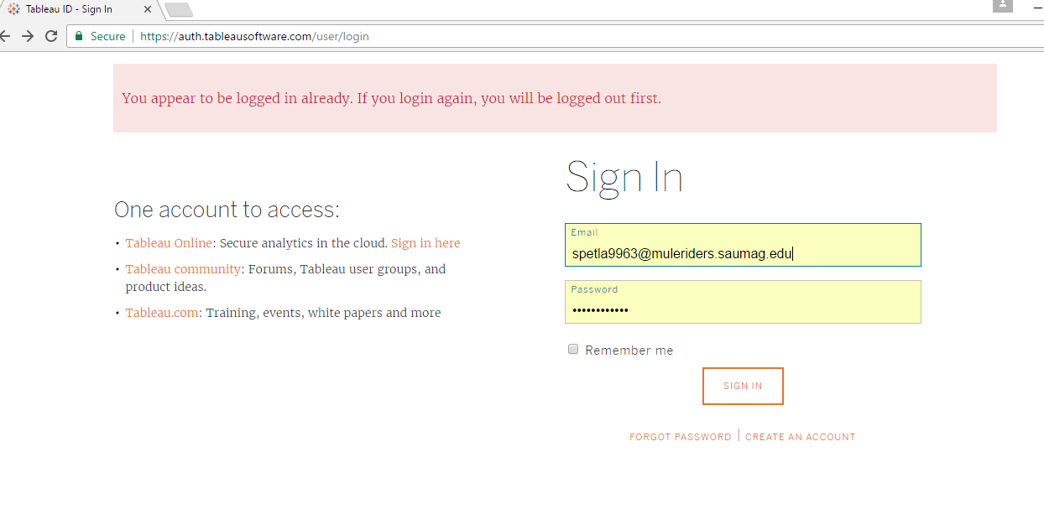

Tableau tool supports for analysists level trough tableau desktop, enterprise level for Tableau server and can work through online using Tableau cloud.

Tableau software created by Tableau. Tableau is a business intelligence tool that can connect to all data sources like Microsoft Excel, Web based data, corporate warehouse and transform data into visually appealing reports, charts and dashboards. This data can be shared to everyone and very easy to understand. This tool is extremely fast and easy to work on it.

Here I just made a try with Tableau online version:

* Created Online tableau website up on tapping on Tableau online option.

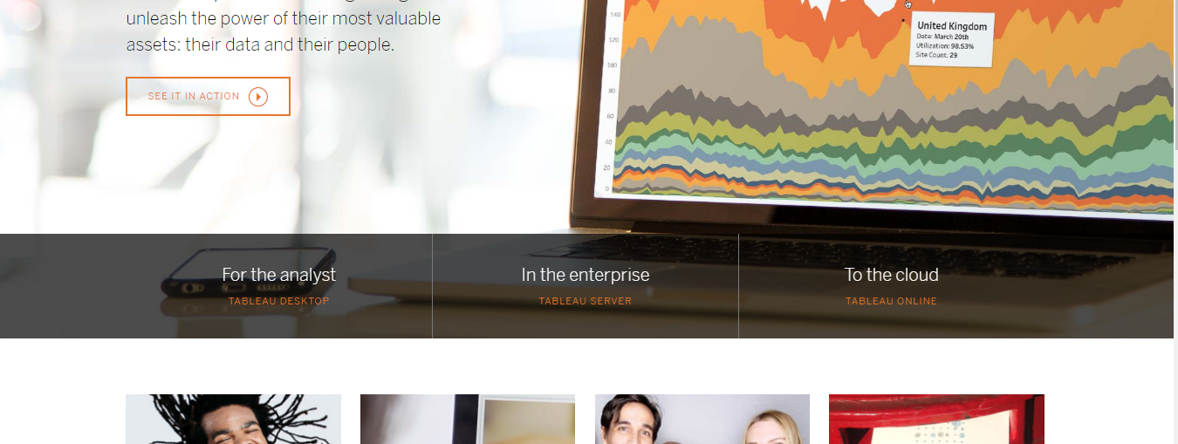

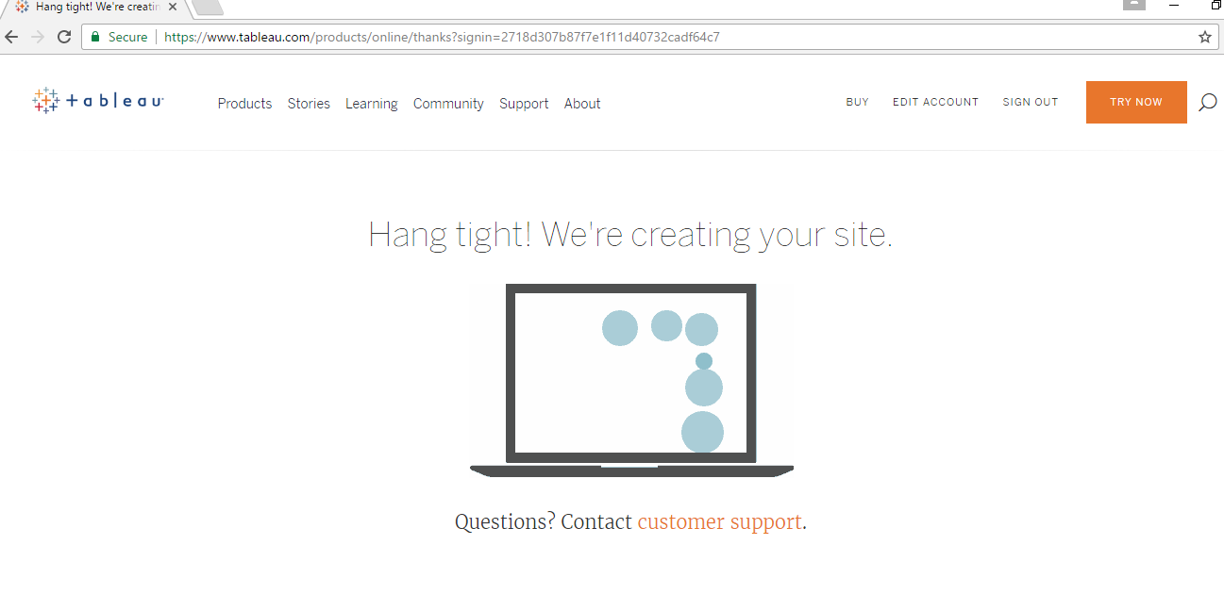

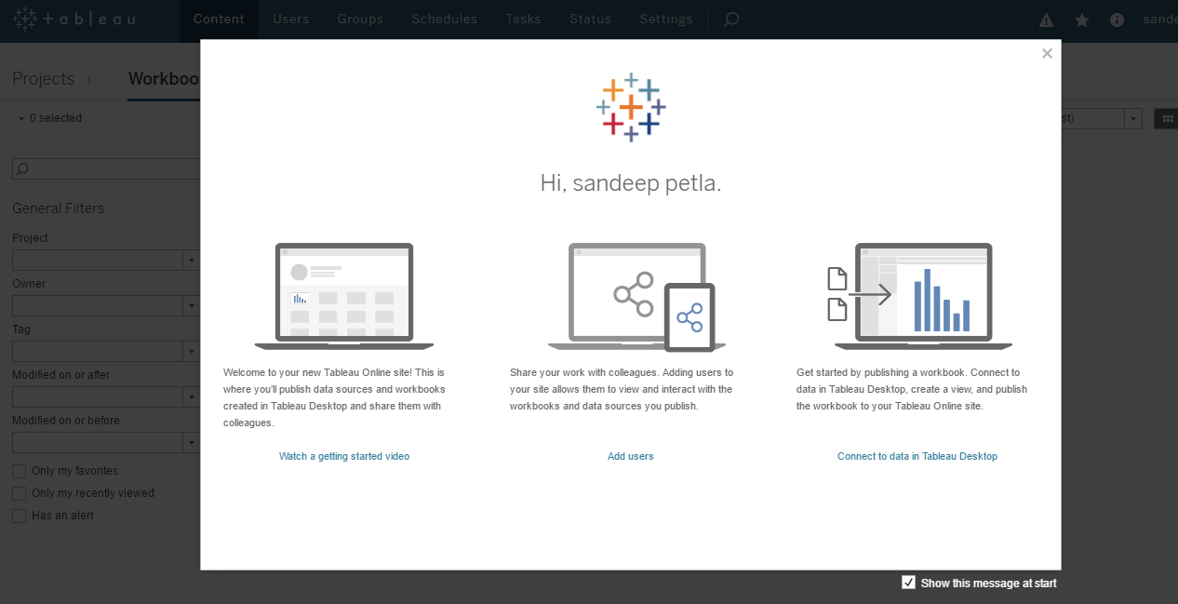

* Created a logo for my tableau website and Connected to super store data store and created another data store super store test1

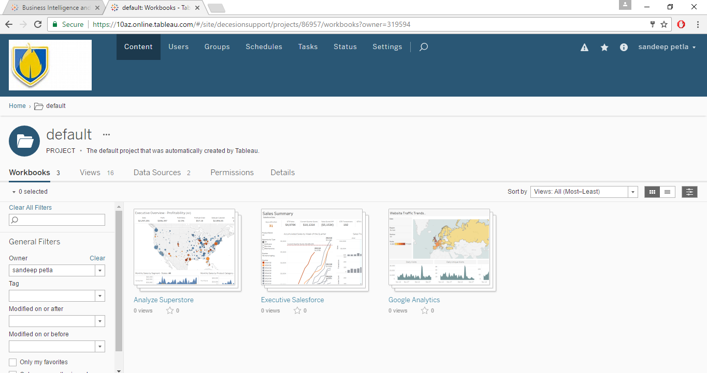

Tableau connects to various data sources and can analyze the date as below (I just snipped my work around with the Tableau tool)

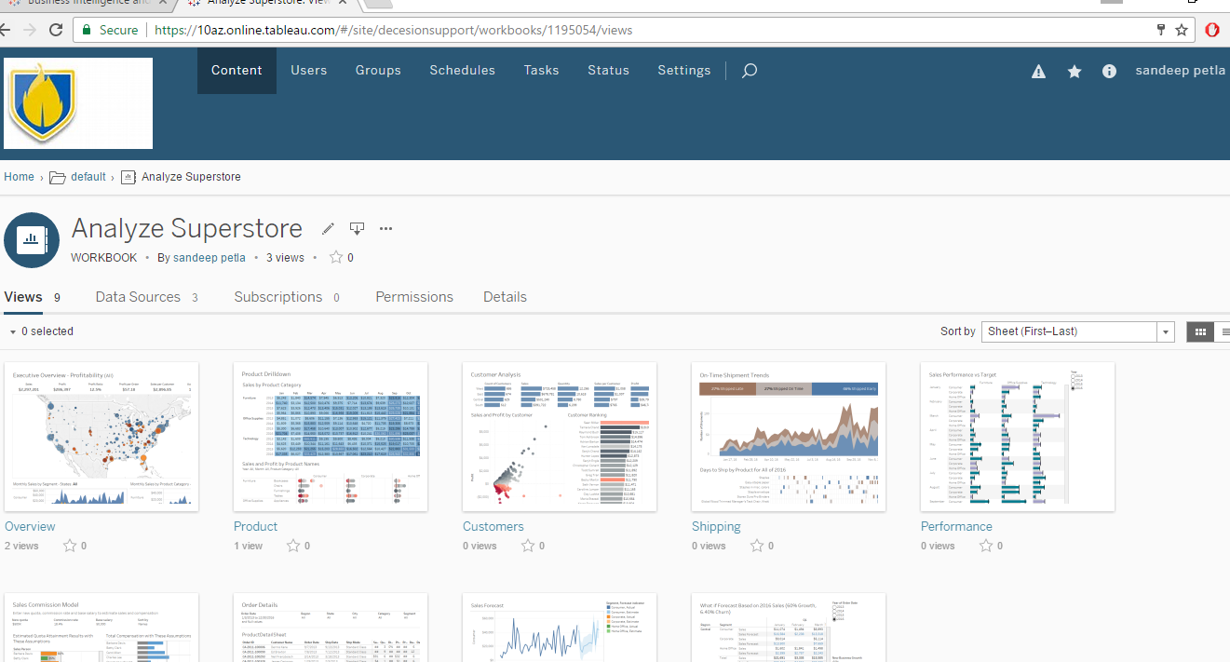

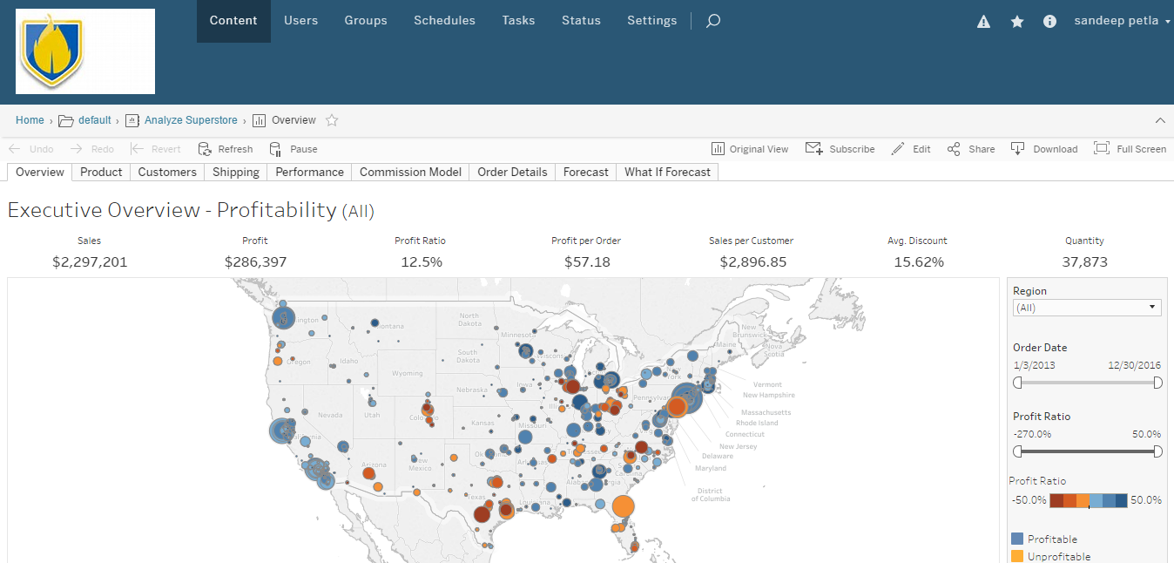

1. create a Github and place your github ID and a screenshot of your account in yourfinal homework document.

Open [github](https://github.com/) and create a new user.

Log in to the newly created account by sign in [here](https://github.com/login)

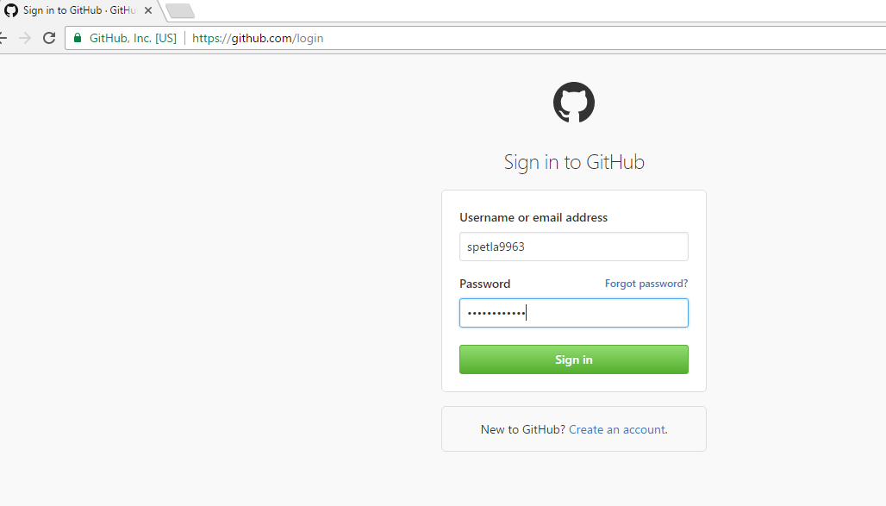

GitHub is a open source version conrol tool, this allows users to store piece of data or code and multiple users can access the same data at any tiime and can make necessary changes like data modificaton. All the data modified is stored in the repository and respectuive versions are created for further reference.

My Git hub repository:

<https://github.com/spetla9963/Decision-support-sysytems>

I have explored the below repository:

<https://github.com/majeshsalla/5303-Database-Majesh>

