Decision support systems

Sandeep petla

99999-0986

Homework 0:

* § create a [Tableau account](https://tableau.com/) and **place a screenshot of your account** in your final homework document.

Answer:

Email id: [spetla9963@muleriders.saumag.edu](mailto:spetla9963@muleriders.saumag.edu)

Screen shot:

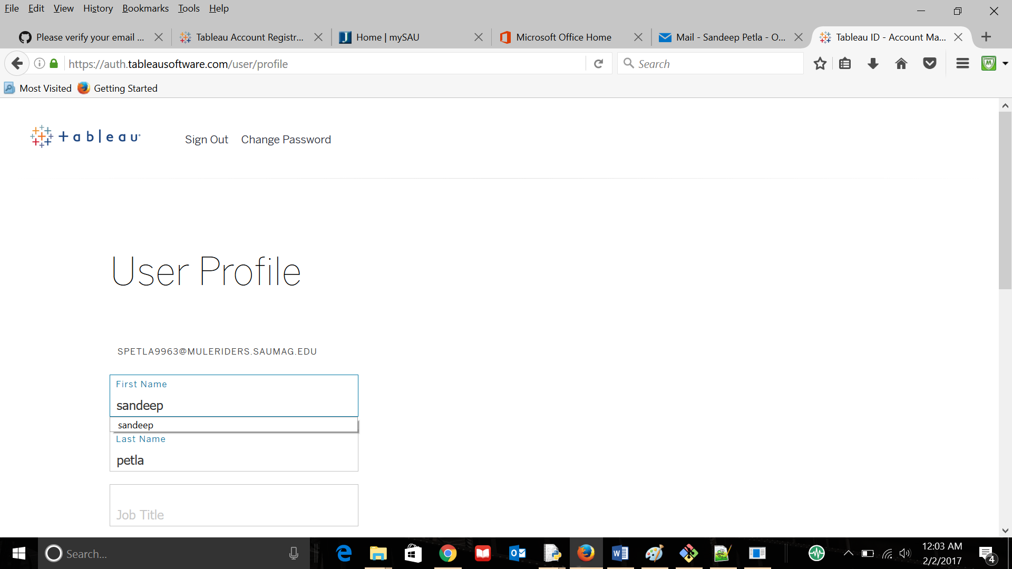

* § create a [Github](https://github.com/) and **place your github ID and a screenshot of your account** in your final homework document.

Answer:

Username: Maheswarareddymoyilla

Id: [spetla9963@muleriders.saumag.edu](mailto:spetla9963@muleriders.saumag.edu)

Screen shot:

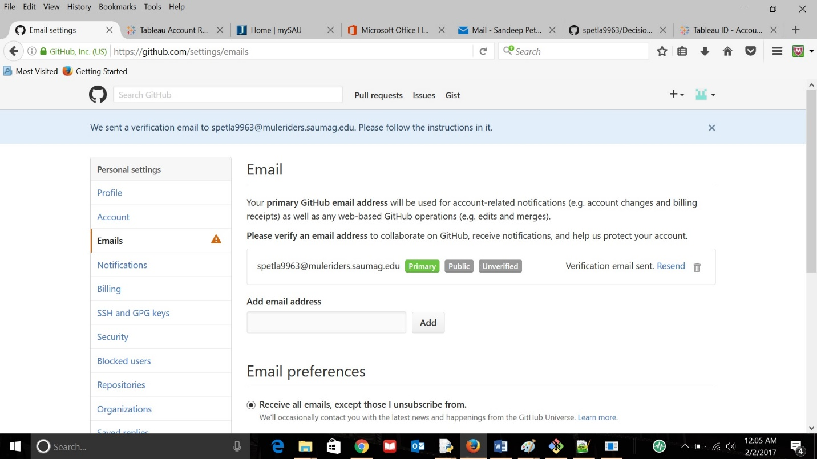

* § There is a lot to explore in Tableau. **Explore at least one Tableau report and summarize what you learned** from it. You will need only **supply 3-5 sentences in your summary**, but make sure there is enough detail so that someone who is not familiar with the area can learn something interesting.

Answer:

Tableau is used for data analytics, which deals with the data. More data from users are maintained and analytics are done on the data to give precise reports. Considering Education system reporting, a student reports, after studying about the interests, class and playing hours of a student, getting a report on it gives which course and what to do with the student can be understood by the teachers and school management.

* § Github is an amazing place with millions of repositories. **Find one of interest and explore it**. Please **provide a 3-5 sentence summary of what you found** in that Github repository. Also please provide the link to the repository. This part of the assignment will be much easier if you pick an active project (e.g. D3.js or something even a repository for a language that is active). While not a strict requirement, you are encouraged to find a repo having something to do with data.

Answer:

GitHub Repository Link:

https://github.com/spetla9963/Decision-support-sysytems.git

We uses GitHub to store the data or the code which need to be accessed from multiple points by multiple users. They can also update and push from the local machines.

Repository that I have explored is https://github.com/majeshsalla/5303-Database-Majesh. The repository is of about Database Management systems, mainly about Mongodb. How the database handle the data using the Mongodb and Nosql databes. They explained all the usefulness and effectiveness of Mongodb rather normal databases.