## Patterns

Write a program which receives a number and creates the following pattern. The number represents the largest count of stars on one row.

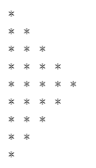

### Example

|  |  |
| --- | --- |
| **Input** | **Output** |
| 3 | *  **  ***  **  * |
| 5 | *  **  ***  ****  *****  ****  ***  **  * |