## Primary Diagonal

Write a program that finds the **sum of matrix primary diagonal**. On the **first line**, you will receive an integer **N** – the size of the square matrix. The next N **lines** holds the values for **every row** – N numbers, separated by a single space

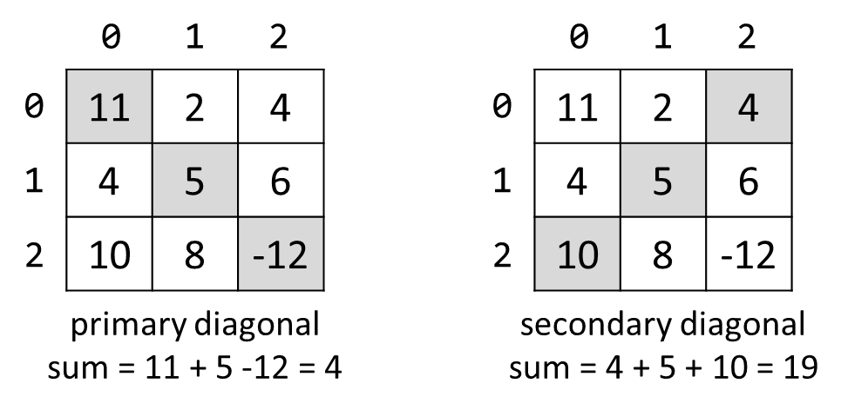

### Examples

|  |  |
| --- | --- |
| **Input** | **Output** |
| 3  11 2 4  4 5 6  10 8 -12 | 4 |
| 3  1 2 3  4 5 6  7 8 9 | 15 |