## Zoo

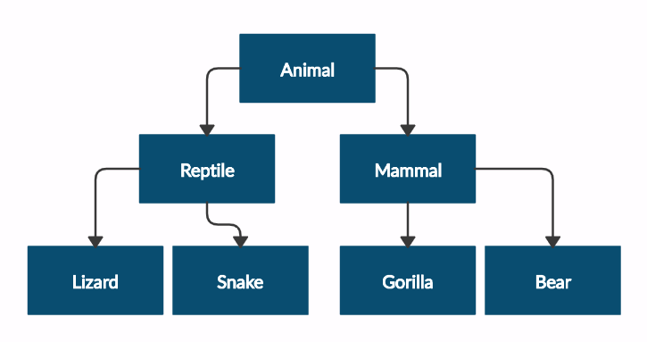Create a zoo which contains the following classes:

Submit in judge a **zip file** of the **project**, containing a separate file for each of the classes using the structure shown below:

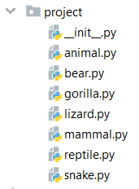

Follow the diagram and create all the classes. **Each** of them, except the **Animal** class, should **inherit** from **another** **class** as shown in the diagram. The **Animal** class should receive a name - string upon initialization.

Every class should have constructor, which accepts one parameter: **name**

|  |  |
| --- | --- |
| **Test Code** | **Output** |
| mammal = Mammal("Stella")  print(mammal.__class__.__bases__[0].__name__)  print(mammal.name)  lizard = Lizard("John")  print(lizard.__class__.__bases__[0].__name__)  print(lizard.name) | Animal  Stella  Reptile  John |