## Players and Monsters

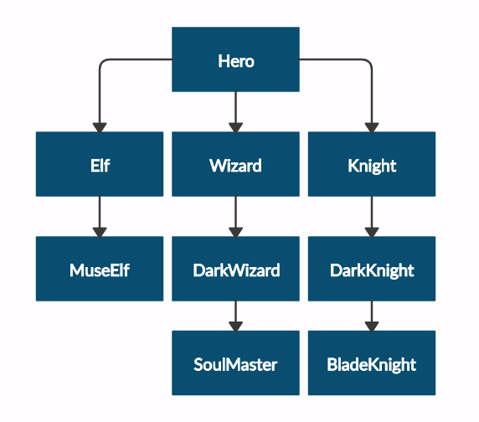Your task is to create the following game hierarchy:

Submit in judge a **zip file**, containing a separate file for each of the classes using the structure shown below:

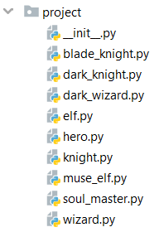

Create a class **Hero**. It should contain the following attributes:

* **username - string**
* **level - int**

Override the **__str__()** method of the base class so it returns: **"{name} of type {class_name} has level {level}"**

|  |  |
| --- | --- |
| **Test Code** | **Output** |
| hero = Hero("H", 4)  print(hero.username)  print(hero.level)  print(str(hero))  elf = Elf("E", 4)  print(str(elf))  print(elf.__class__.__bases__[0].__name__)  print(elf.username)  print(elf.level) | H  4  H of type Hero has level 4  E of type Elf has level 4  Hero  E  4 |