## Need for Speed

Create the following **hierarchy** with the following **classes**:

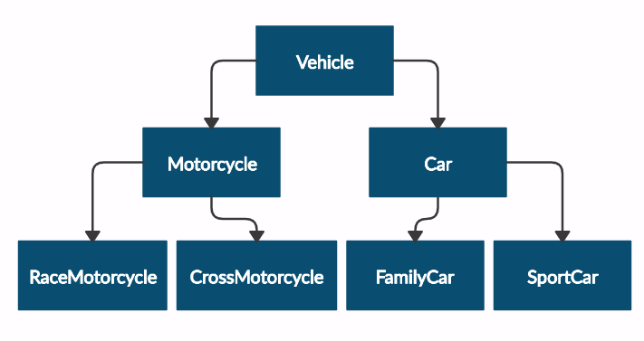

and submit in judge a **zip file**, containing a separate file for each of the classes using the structure shown below:

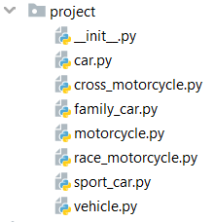

Create a base class Vehicle. It should contain the following attributes:

* **DEFAULT_FUEL_CONSUMPTION: float (constant)**
* **fuel_consumption: float – the given fuel consumption is per kilometer**
* **fuel: float – represent the fuel in the specific vehicle**
* **horse_power: int**

The class should recieve fuel and horse_power upon initialization and should **set** the **default fuel consumption** on the attribute fuel_consumption.

The class should have the following methods:

* **drive(kilometers)** -reduces the **fuel** based on the travelled kilometers and fuel consumption. Keep in mind that you can drive the vehicle only if you have enough fuel to finish the driving.

The default fuel consumption for **Vehicle** is 1.25.Some of the classes have **different** **default fuel consumption**:

* **SportCar - 10**
* **RaceMotorcycle - 8**
* **Car - 3**

|  |  |
| --- | --- |
| **Test Code** | **Output** |
| vehicle = Vehicle(50, 150)  print(Vehicle.DEFAULT_FUEL_CONSUMPTION)  print(vehicle.fuel)  print(vehicle.horse_power)  print(vehicle.fuel_consumption)  vehicle.drive(100)  print(vehicle.fuel)  family_car = FamilyCar(150, 150)  family_car.drive(50)  print(family_car.fuel)  family_car.drive(50)  print(family_car.fuel)  print(family_car.__class__.__bases__[0].__name__) | 1.25  50  150  1.25  50  0  0  Car |