## Restaurant

Create a **restaurant** with the following classes and hierarchy:

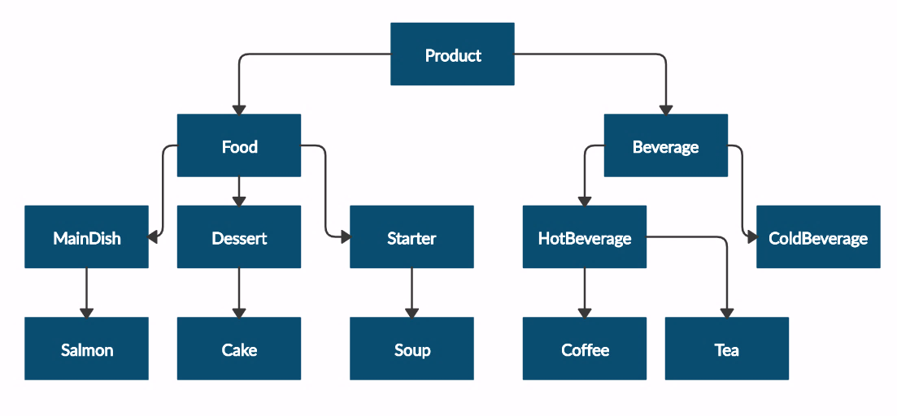

Submit in judge a **zip file**, containing a separate file for each of the classes using the structure shown below:

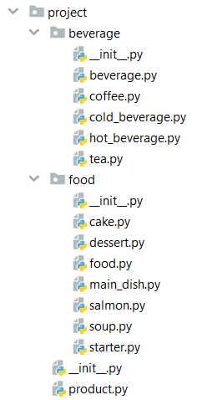

The **Product** class should have the following **private** **attributes** and subsequent **getters**:

* **name: string**
* **price: float**

**Beverage** and **Food** classes are **products**:

* The **Beverage** class should have an additional **private** **attribute –** **milliliters: float** and its subsequent **getter**
* The Food class should have an additional private **attribute – grams: float** and its subsequent **getter**

**HotBeverage** and **ColdBeverage** are **beverages.**

**Coffee** and **Tea** are **hot beverages:**

* The Coffee class should have an additional **private** **attribute – caffeine: float** and its subsequent **getter**. Itshould also have the following **class** **attributes** which should apply to all coffees made:
* **MILLILITERS = 50 (constant)**
* **PRICE = 3.50 (constant)**

Starter, MainDish and Dessert are **food**:

* The Dessert class should have an additional **private** **attribute - calories - float** and its subsequent **getter**

**Salmon** is a **main dish**. Also, it must have the following class attribute which should apply to all salmons:

* **GRAMS = 22 (constant)**

**Soup** is **starter**.

**Cake** is **dessert**. Also, it must have the following **class attributes** which should apply to all cakes made:

* **GRAMS = 250 (constant)**
* **CALORIES = 1000 (constant)**
* **PRICE = 5 (constant)**

|  |  |
| --- | --- |
| **Test Code** | **Output** |
| product = Product("coffee", 2.5)  print(product.__class__.__name__)  print(product.name)  print(product.price)  beverage = Beverage("coffee", 2.5, 50)  print(beverage.__class__.__name__)  print(beverage.__class__.__bases__[0].__name__)  print(beverage.name)  print(beverage.price)  print(beverage.milliliters)  soup = Soup("fish soup", 9.90, 230)  print(soup.__class__.__name__)  print(soup.__class__.__bases__[0].__name__)  print(soup.name)  print(soup.price)  print(soup.grams) | Product  coffee  2.5  Beverage  Product  coffee  2.5  50  Soup  Starter  fish soup  9.9  230 |