Even though subwoofers have a larger potential market, high quality and high-priced systems preferred by manufacturers because people aren’t willing to pay for mediocre-sounding systems – either very cheap for mediocre sound or premium for premium sound.

Describe why subwoofers are most in need of the solution to be presented from their physics.

Explain how nearly all loudspeakers are run without compensation and are therefore sound quality is tied directly to the quality of the system.

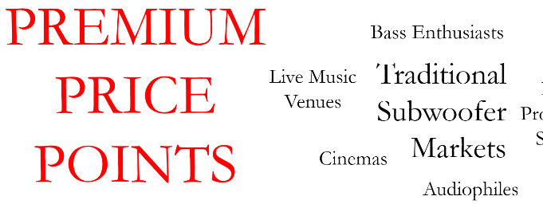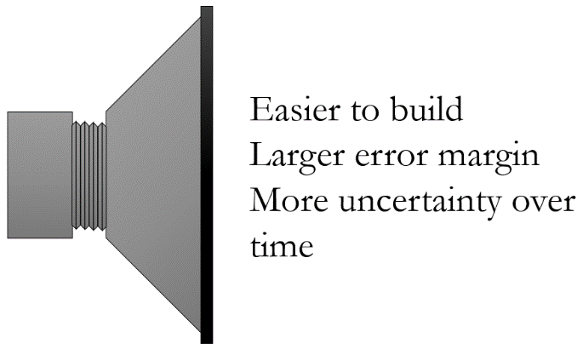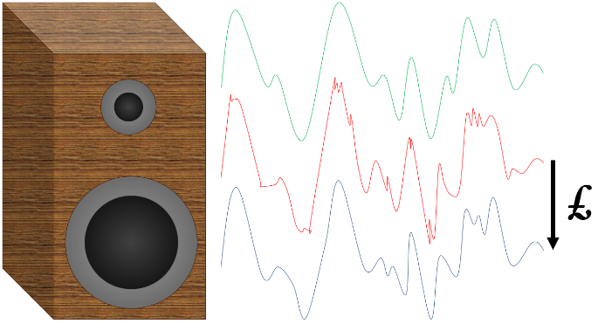

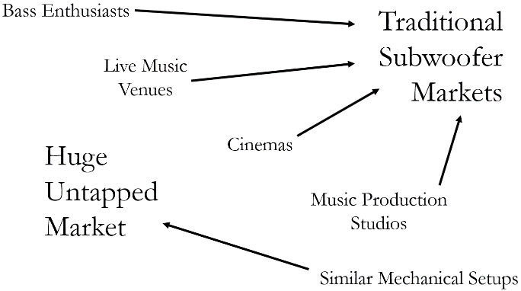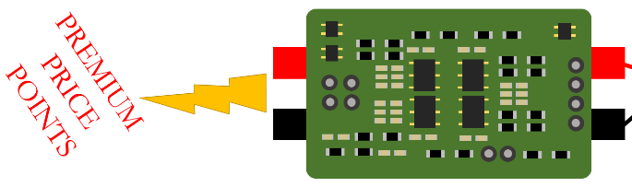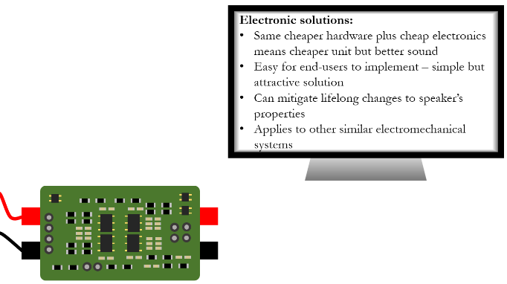

Restate the potential market for subwoofers, including the potential addition of similar mechanical setups. Mention the possibility of selling stand-alone controllers.

Hammer home the point that cheap electronics will help manufacturers deliver high-quality systems at lower price points.

Describe how cutting-edge research has allowed cheap electronics to extend and improve the response of a subwoofer. Highlight how the solution can be used for similar electromechanical systems.