*Scott Parker*

*spfrood@gmail.com | January 30, 2017*

*European Roulette with C++*

CSC-5-40107

**Table of Contents**

**Introduction 3**

**Gameplay and Rules 3**

**Development Summary 3**

**Concepts Used 5**

**Specifications 6**

**Flowchart 6**

**Variables 7**

**Datafiles 8**

**Pseudocode 9**

**Introduction**

This project will reproduce the core functionality of a European roulette game using C++ and make a playable version on the console. It will include most of the betting options, wheel spinning, and odds found in traditional roulette. Roulette is a gambling game based on spinning a wheel and betting on the results. The wheel is divided into 37 different sectors (or 38 for American roulette). The odds are paid as if there are only 35 different sectors which gives the house its advantage for single-number bets. For other bet types the house maintains an advantage by not including the 0 space in any of the win conditions or odds calculations on the other bets.

**Gameplay and Rules**

This program will model European roulette. European roulette is very similar to American roulette. The main difference is that European roulette only uses A single '0' rather than '0' and '00' which are included on American roulette tables. This means that even though the house still maintains a slight odds advantage, it is slightly less on European tables.

To play this roulette game there is no playfield. Instead the player is offered bets via a menu. In order to select a bet the player chooses that bet from a menu and then enters the amount of the bet. For bets that are not taken the default bet amount is $0. Entering a bet more than once on the same spin will overwrite the previous bet and not add to it.

Once the player indicates that they are finished entering bets the spin-phase will begin automatically. After the spin the game will calculate the win or loss amounts and keep track of internal record-keeping accordingly. For a win the odds amount will be paid for the value of the bet. On a loss the amount wagered will be deducted from the player’s bank. It is at this point that the player has the option to put the game on auto-play and select a number of games.

**Development Summary**

Project Size: 800+ Lines of Code

Global Constants: 11

Variables: 35+

Functions: 10

This project was coded over many hours on a very long weekend. The project includes the concepts went over during the first four weeks of the class (covered in the first 5 chapters of the Gaddis book). Specific examples of referenced concepts from various chapters can be found in the program at locations listed in the following table:

**Concepts Used**

**Specifications**

**Flowchart * Flowchart shows pre-code data**

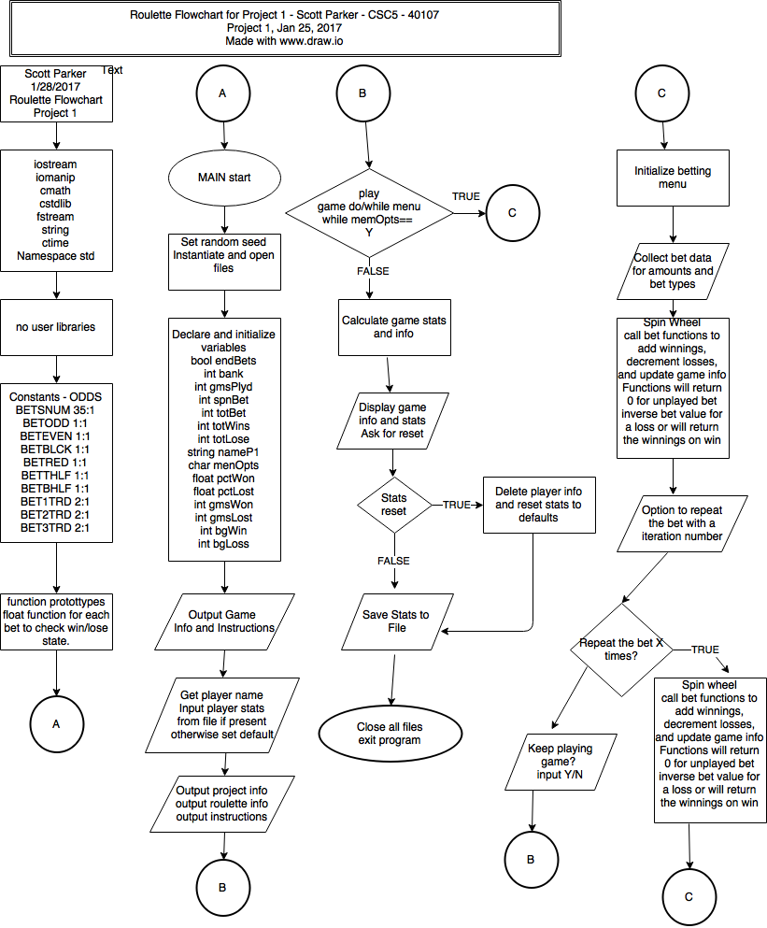

**Variables * taken from program**

float sNumWin(float, int, int); //returning value of single number win

float oddWin(float, int); //return value of win betting ODD

float evenWin(float, int); //return value of win betting EVEN

float blckWin(float, int); //return value of win betting BLACK

float redWin(float, int); //return value of win betting RED

float topHWin(float, int); //return value of win betting 1-18

float botHWin(float, int); //return value of win betting 19-36

float fstTWin(float, int); //return value of win betting 1-12

float sndTWin(float, int); //return value of win betting 13-24

float trdTWin(float, int); //return value of win betting 25-36

float bank=100.00, totBet=0.00, totWin=0.00, totLoss=0.00, hiWin=0.00,

mostBet=0.00, betSpin=0.00, winPcnt=0.00; //currency values

int gmsPlyd=0, spinVal=0, spinWin=0, betWin=0, gmsWon=0, gmsLost=0;

unsigned short gmsPush=0, resetBK=0, resetL=0, resetW=0, resetBT=0, switMen=0;

string playerN;

char menuOpt, yesNo;

bool playMor=true;

**Datafiles**

The program is capable of keeping track of player profiles and information so long as the players enter a unique name. The game attempts to read the players profile information from a datafile once the player inputs their name. The datafile is also saved with the player information just prior to the program exiting. The information in the datafile is read in sequence so the data must match up to the appropriate field. For example a datafile with the following contents will match up to the listed field and will have the matching output. The datafile ONLY contains the first column the field shows what is requested in the game.

101009 gmsPlyd

672 gmsWon

100317 gmsLost

19 gmsPush

2279 resetBK

2280 resetL

0 resetW

13751 resetBT

-921905 bank

3.01008e+06 totBet

308471 totWin

-444455 totLoss

6454 mostBet

175 hiWin

The above data results in the following statistical output in the game:

You have played 101009 games so far!

You have won money in 672 games so far!

You have lost money in 100317 games so far!

You neither won or loss in 20 games to date.

You have been saved from bankruptcy 2279 times so far.

This is your bank value reset counter

You have been saved from organ harvesting 2280 times so far.

This is your total losses reset counter

You have been saved from the IRS 0 times so far.

This is your total winnings reset counter

You have been saved from yourself 13751 times so far.

This is your total bet amount reset counter

Your bank currently has $-921905.00 in it.

Your total bets are $3010080.00 as of now.

Your winnings come to $308471.00 as of now.

Your total losses are $-444455.00 as of now.

$6454.00 is the most you have ever bet on a game.

Your biggest win was $175.00 on a single game.

Your win ratio is: 0.7%

**Pseudocode**

/*

* File: main.cpp

* Author: Scott Parker

* Created on January 28, 2017, 2:30 PM

* Purpose: Template to be used for all programming projects

*/

//System Libraries

//cin, cout, basic math, etc

//used to set random seed to spin roulette wheel

//used for the random number function to play roulette

//used to input/output player records

//Used for player name (in conjunction with fstream)

//used to format output to be like currency

//This program really doesn't use CMATH but it's here for

//the grade. SQRT and POW at end of program. Otherwise unused.

//standard namespaces

//Unsure if the following will work on WINDOWS machines. Test in class before

//submitting project. ** seems to work on windows 10 in class so leaving colors in

//For red text

//for green text

//for cyan text

//reset color to black

//User Libraries

//Global Constants

//Such as PI, Vc, -> Math/Science values

//as well as conversions from one system of measurements to another

const int ODDSNUM = 35; //Odds payout for betting single number

const int ODDODD = 1; //Odds payout for betting ODD numbers

const int ODDEVEN = 1; //Odds payout for betting EVEN numbers

const int ODDBLCK = 1; //Odds payout for betting BLACK numbers

const int ODDRED = 1; //Odds payout for betting RED

const int ODDTOPH = 1; //Odds payout for betting TOP HALF of field (1-18)

const int ODDBOTH = 1; //Odds payout for betting BOTTOM HALF of field (19-36)

const int ODDFSTT = 2; //Odds payout for betting FIRST THRID of field (1-12)

const int ODDSNDT = 2; //Odds payout for betting SECOND THIRD of field (13-24)

const int ODDTRDT = 2; //Odds payout for betting THIRD THIRD of field (25-36)

const int CONVBET = -1; //To convert a bet amount into negative number (loss)

//Function Prototypes (for returning the amounts of the bets)

//returning value of single number win

//return value of win betting ODD

//return value of win betting EVEN

//return value of win betting BLACK

//return value of win betting RED

//return value of win betting 1-18

//return value of win betting 19-36

//return value of win betting 1-12

//return value of win betting 13-24

//return value of win betting 25-36

//Executable code begins here! Always begins in Main

//Set random number seed

//Instantiate files - they are opened and used later

ifstream in;

ofstream out;

//Declare Variables

float betSNUM=0; //betting amount on single number

float betODD=0; //betting amount on ODD numbers

float betEVEN=0; //betting amount on EVEN numbers

float betBLCK=0; //betting amount on BLACK numbers

float betRED=0; //betting amount on RED

float betTHLF=0; //betting amount on TOP HALF of field (1-18)

float betBHLF=0; //betting amount on BOTTOM HALF of field (19-36)

float betFSTT=0; //betting amount on FIRST THRID of field (1-12)

float betSNDT=0; //betting amount on SECOND THIRD of field (13-24)

float betTRDT=0; //betting amount on THIRD THIRD of field (25-36)

int betNum=99; //set start value of betNum outside spin range

//These could technically all be unsigned shorts unless the player plays a

//LOT of roulette

int gmsPlyd=0, spinVal=0, spinWin=0, betWin=0, gmsWon=0, gmsLost=0;

unsigned short gmsPush=0, resetBK=0, resetL=0, resetW=0, resetBT=0, switMen=0;

string playerN; //player name used in saving stats and loading stats

char menuOpt, yesNo; //menu option choices that get reused

float bank=100.00, totBet=0.00, totWin=0.00, totLoss=0.00, hiWin=0.00,

mostBet=0.00, betSpin=0.00, winPcnt=0.00; //currency values

bool playMor=true; //boolean used in menu choices later on

//Input Values

//Displaying instructions for program

//Giving option to skip instructions and information

//Get player to enter name

//This will load a data file with the player's name

//if such exits. It will then populate the fields based

//on previous wins, losses, etc, unless they were reset

//Getting data from player file if available

//total games played

//number of games won

//number of games lost

//Games with no win or los

//Counter of bank value resets

//counter of loss amount resets

//counter of win amount resets

//counter of total money bet resets

//Amount of money player has

//Total amount player has bet

//Total amount player has won

//Total amount player has lost

//THe most the player has ever bet on a single spin

//The most a player has ever won on a single bet

//closing the data file

//displaying the players info if it existed previously

//Process by mapping inputs to outputs

//Drawing the roulette table in ASCII with colors if possible on machine

//This is the betting options. Displayed for player to choose bet type

//Switch menu to place the bets of each type

//betting THIRD THIRD of field (25-36)

//betting SECOND THIRD of field (13-24)

//betting FIRST THRID of field (1-12)

//betting BOTTOM HALF of field (19-36)

//betting TOP HALF of field (1-18)

//betting BLACK numbers

//betting RED

//betting EVEN numbers

//betting ODD numbers

//Info for betting a single number on the wheel

//getting the number to bet on

//making sure number in range of wheel

//Keep doing until number in valid range

//get amount to bet on single number

//Repeat? Bet again

//always reset variable to unused value after an input is done being used

//Spin the wheel

//random value from 0 to 36 for roulette wheel spin

//Editing player data and/or incrementing appropriate counters

//Find win or loss for single number bet

//Increment with every bet amount

//testing and setting highest win

//reset the win variable for this bet to zero.

//Find win or loss for ODD bet

//Increment with every bet amount

//testing and setting highest win

//reset the win variable for this bet to zero.

//Find win or loss for EVEN bet

//Increment with every bet amount

//testing and setting highest win

//reset the win variable for this bet to zero.

//Find win or loss for BLACK bet

//Increment with every bet amount

//testing and setting highest win

//reset the win variable for this bet to zero.

//Find win or loss for RED bet

//Increment with every bet amount

//testing and setting highest win

//reset the win variable for this bet to zero.

//Find win or loss for TOP HALF (1-18) bet

//Increment with every bet amount

//testing and setting highest win

//reset the win variable for this bet to zero.

//Find win or loss for BOTTOM HALF (19-36) bet

//Increment with every bet amount

//testing and setting highest win

//reset the win variable for this bet to zero.

//Find win or loss for FIRST THIRD (1-12) bet

//Increment with every bet amount

//testing and setting highest win

//reset the win variable for this bet to zero.

//Find win or loss for SECOND THIRD (13-24) bet

//Increment with every bet amount

//testing and setting highest win

//reset the win variable for this bet to zero.

//Find win or loss for SECOND THIRD (13-24) bet

//Increment with every bet amount

//testing and setting highest win

//reset the win variable for this bet to zero.

//settling variables to end this round of bets. Updating data for

//player profile info

//ternary operator test to update win for this spin

//Put the game on auto-play for a while for a user chosen number of games

//Editing player data. Needs to be edited every time wheel is spun to increment

// counters and update where needed if out of minimums or maximums

//random value from 0 to 36 for roulette wheel spin

//Find win or loss for single number bet

//Increment with every bet amount

//testing and setting highest win

//reset the win variable for this bet to zero.

//Find win or loss for ODD bet

//Increment with every bet amount

//testing and setting highest win

//reset the win variable for this bet to zero.

//Find win or loss for EVEN bet

//Increment with every bet amount

//testing and setting highest win

//reset the win variable for this bet to zero.

//Find win or loss for BLACK bet

//Increment with every bet amount

//testing and setting highest win

//reset the win variable for this bet to zero.

//Find win or loss for RED bet

//Increment with every bet amount

//testing and setting highest win

//reset the win variable for this bet to zero.

//Find win or loss for TOP HALF (1-18) bet

//Increment with every bet amount

//testing and setting highest win

//reset the win variable for this bet to zero.

//Find win or loss for BOTTOM HALF (19-36) bet

//Increment with every bet amount

//testing and setting highest win

//reset the win variable for this bet to zero.

//Find win or loss for FIRST THIRD (1-12) bet

//Increment with every bet amount

//testing and setting highest win

//reset the win variable for this bet to zero.

//Find win or loss for SECOND THIRD (13-24) bet

//Increment with every bet amount

//testing and setting highest win

//reset the win variable for this bet to zero.

//Find win or loss for SECOND THIRD (13-24) bet

//Increment with every bet amount

//testing and setting highest win

//reset the win variable for this bet to zero.

//settling variables to end this round of bets. Updating data for

//player profile info

//set highwin if applicable

//Reset spin to zero

//Reset bets to defaults

//Set number selector to out of bounds number

//Reset bet for ODD to zero

//Reset bet for EVEN to zero

//Reset bet for BLACK to zero

//reset bet for RED to zero

//Reset bet for TOP HALF (1-18) to zero

//Reset bet for BOTTOM HALF (19-36) to zero

//Reset bet for FIRST THIRD (1-12) to zero

//Reset bet for SECOND THIRD (13-24) to zero

//Reset bet for THIRD THIRD (25-36) to zero

//Outputting player info and statistics

//asking to reset the values in player data file to defaults

//Output values to file - save player profile

//Put in a Few things that require <cmath> since this program really doesn't need it

//Exit stage right! - This is the 'return 0' call

//DONT FORGET TO CLOSE FILES if they were not closed already

//********************* Pay for Single Number Bet ******************************

//Description: Determines single-number win and returns winnings value

//

//Inputs: amount bet, number chosen, winning number (spin results)

//

//Outputs: The amount of winnings for the individual bet or the amount lost

// if bet did not win (loss is only the amount bet

//****************************************************************************

//********************* Pay for ODD number bet ******************************

//Description: Determines ODD number win and returns winnings value

//

//Inputs: amount bet, winning number (spin results)

//

//Outputs: The amount of winnings for the odd number bet or the amount lost

// if bet did not win (loss is only the amount bet, wins can be a

// multiple of amount bet depending on the type of bet

//****************************************************************************

//********************* Pay for EVEN number bet ******************************

//Description: Determines EVEN number win and returns winnings value

//

//Inputs: amount bet, winning number (spin results)

//

//Outputs: The amount of winnings for the even number bet or the amount lost

// if bet did not win (loss is only the amount bet

//****************************************************************************

//345678901234567890123456789012345678901234567890123456789012345678901234567890

//********************* Pay for BLACK number bet ******************************

//Description: Determines BLACK number win and returns winnings value

//

//Inputs: amount bet, winning number (spin results)

//

//Outputs: The amount of winnings for the black number bet or the amount lost

// if bet did not win (loss is only the amount bet

//****************************************************************************

//********************* Pay for RED number bet ******************************

//Description: Determines RED number win and returns winnings value

//

//Inputs: amount bet, winning number (spin results)

//

//Outputs: The amount of winnings for the red number bet or the amount lost

// if bet did not win (loss is only the amount bet

//****************************************************************************

//********************* Pay for TOP HALF number bet ****************************

//Description: Determines Top Half (1-18) number win and returns winnings value

//

//Inputs: amount bet, winning number (spin results)

//

//Outputs: The amount of winnings for the top half (1-18) number bet or the

// amount lost if bet did not win (loss is only the amount bet, wins

// can be a multiple of amount bet depending on the type of bet

//****************************************************************************

//******************* Pay for BOTTOM HALF number bet **************************

//Description: Determines Bottom Half (19-36) number win and returns winnings

// value

//Inputs: amount bet, winning number (spin results)

//

//Outputs: The amount of winnings for the bottom half (19-36) number bet or the

// amount lost if bet did not win (loss is only the amount bet

//****************************************************************************

//******************* Pay for FIRST THIRD number bet **************************

//Description: Determines First Third (1-12) number win and returns winnings

// value

//Inputs: amount bet, winning number (spin results)

//

//Outputs: The amount of winnings for the First Third (1-12) number bet or the

// amount lost if bet did not win (loss is only the amount bet

//****************************************************************************

//******************* Pay for SECOND THIRD number bet **************************

//Description: Determines Second Third (13-24) number win and returns winnings

// value

//Inputs: amount bet, winning number (spin results)

//

//Outputs: The amount of winnings for the Second Third (13-24) number bet or the

// amount lost if bet did not win loss is only the amount bet

//****************************************************************************

//******************* Pay for THIRD THIRD number bet **************************

//Description: Determines Third Third (25-36) number win and returns winnings

// value

//Inputs: amount bet, winning number (spin results)

//

//Outputs: The amount of winnings for the Third Third (25-36) number bet or the

// amount lost if bet did not win loss is only the amount bet

//****************************************************************************