Scott Parker HTML Spring 2017 Assignment #2

**Part 1: Answer the 8 questions** below, covering hybrid video #2, by selecting the correct answer and **bolding and changing its text highlight color to yellow just like this text!** …

1. What HTML tag is used in the video to create links?…

a) <nav> b) <link> **c) <a>** d) <www> e) <http>

2. In the video, the links that go to Google and Dog Pile have been nested within….

a) <ul> b) <li> c) <dd> **d) <dt>**  e) <nav>

3. Links that are supposed to launch an email when clicked are created in HTML by placing what characters at the start of the “href” value?

a) email- b) email-to- c) mail: **d) mailto:** e) send:

4. How many actual working links are there in the “links.htm” page toward the start of the video (shown for the first time in the video around the 7th minute)?

**a) 0** b) 1 c) 2 d) 5 e) 10

5. How many actual working links are there in the “links.htm” page at the very end of the video?

a) 0 b) 5 c) 9 d) 12 **e) 15**

6. Which one of the following links would actually work to get to the web site ebay?

a) <a href=ebay.com>ebay</a>

b) <a href=”#ebay.com”>ebay</a>

c) <a href=”www.ebay.com”>ebay</a>

**d) <a href=”http://www.ebay.com”>ebay</a>**

e) <a href=”mailto:www.ebay.com”>ebay</a>

7. How many email links are there within the completed “links.htm” page (at the end of the video)?

a) 0 **b) 1** c) 2 d) 3 e) 5

8. Instead of placing the **id=”top”** in the <h1> tag, would the “top of page” links work properly if it was placed within the <body> tag? (try it and see)

**a) Yes** b) no

**Part 2: Your Favorite Links Web Page Screenshot**

[Paste your part 2 screenshot here. Use 2 screenshots if necessary to show the whole favorite links page. Then move to the next page below to paste your HTML code.]

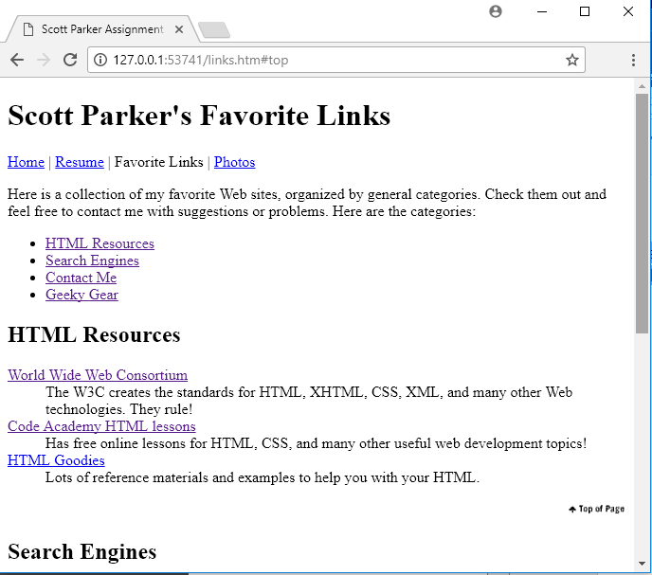

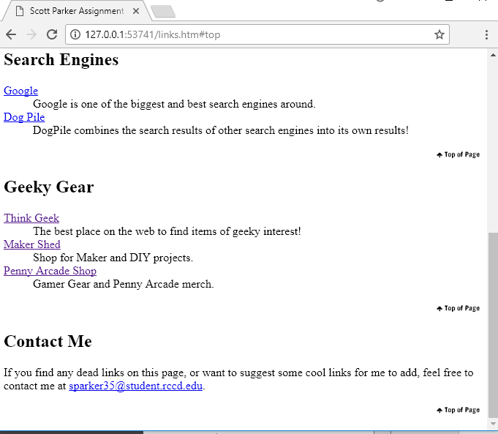

**Part 2: Your Favorite Links Web Page Code**

[Paste your Links page Code below – Be sure to paste ALL of the HTML code for the page. Use “Courier New” or another monospace font to make your code more readable. Bold the code too if that helps make it more readable. Then move on to the next page below for part 3.]

<!DOCTYPE html>

<html lang="en">

<head>

<meta charset="utf-8">

<title>Scott Parker Assignment 2 Part 2 Favorite Links</title>

</head>

<body>

<h1 id="top">Scott Parker's Favorite Links</h1>

<p><a href="home.htm">Home</a> | <a href="resume.htm">Resume</a> | Favorite Links | <a href="photos.htm">Photos</a></p>

<p>Here is a collection of my favorite Web sites, organized by general categories. Check them out and feel free to contact me with suggestions or problems. Here are the categories:

</p>

<ul>

<li><a href="#htmlresources">HTML Resources</a></li>

<li><a href="#searchengines">Search Engines</a></li>

<li><a href="#contact">Contact Me</a></li>

<li><a href="#geeklink">Geeky Gear</a></li>

</ul>

<h2 id="htmlresources">HTML Resources</h2>

<dl>

<dt><a href="http://www.w3.org">World Wide Web Consortium</a></dt>

<dd>The W3C creates the standards for HTML, XHTML, CSS, XML, and many other Web technologies. They rule!</dd>

<dt><a href="https://www.codecademy.com/learn/all">Code Academy HTML lessons</a></dt>

<dd>Has free online lessons for HTML, CSS, and many other useful web development topics!</dd>

<dt><a href="http://www.htmlgoodies.com">HTML Goodies</a></dt>

<dd>Lots of reference materials and examples to help you with your HTML.</dd>

</dl>

<p style="text-align: right">

<a href="#top"><img src="back2top.gif" style="border: none" title="top of page button" alt="top of page button" /></a>

</p>

<h2 id="searchengines">Search Engines</h2>

<dl>

<dt><a href="http://www.google.com ">Google</a></dt>

<dd>Google is one of the biggest and best search engines around.</dd>

<dt><a href="http://www.dogpile.com ">Dog Pile</a></dt>

<dd>DogPile combines the search results of other search engines into its own results!</dd>

</dl>

<p style="text-align: right">

<a href="#top"><img src="back2top.gif" style="border: none" title="top of page button" alt="top of page button" /></a>

</p>

<h2 id="geeklink">Geeky Gear</h2>

<dl>

<dt><a href="http://www.thinkgeek.com">Think Geek</a></dt>

<dd>The best place on the web to find items of geeky interest!</dd>

<dt><a href="https://www.makershed.com">Maker Shed</a></dt>

<dd>Shop for Maker and DIY projects.</dd>

<dt><a href="https://store.penny-arcade.com">Penny Arcade Shop</a></dt>

<dd>Gamer Gear and Penny Arcade merch.</dd>

</dl>

<p style="text-align: right">

<a href="#top"><img src="back2top.gif" style="border: none" title="top of page button" alt="top of page button" /></a>

</p>

<h2 id="contact">Contact Me</h2>

<p>If you find any dead links on this page, or want to suggest some cool links for me to add, feel free to contact me at <a href="mailto:sparker35@student.rccd.edu">sparker35@student.rccd.edu</a>.

</p>

<p style="text-align: right">

<a href="#top"><img src="back2top.gif" style="border: none" title="top of page button" alt="top of page button" /></a>

</p>

</body>

</html>

**Part 3: Your Rock Climbing Web Page Screenshot**

[Paste your part 3 screenshot here. Use 2 screenshots if necessary to show the whole rock climbing page. Then move to the next page below to paste your HTML code.]

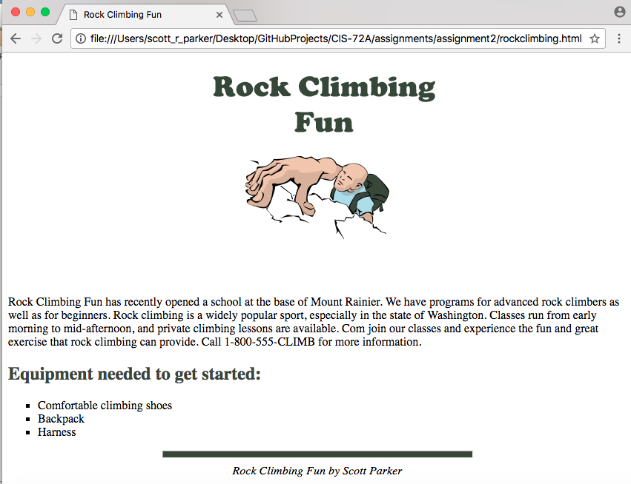

**Part 3: Your Rock Climbing Web Page Code**

[Paste your rock climbing page Code below – Be sure to paste ALL of the HTML code for the page. Use “Courier New” or another monospace font to make your code more readable. Bold the code too if that helps make it more readable. ]

<!DOCTYPE html>

<html lang="en">

<head>

<meta charset="utf-8" />

<title>Rock Climbing Fun</title>

</head>

<body>

<header style="text-align: center">

<img src="rockclimber.jpg" width="450" height="300" alt="Rock climber" title="top of page button" />

</header>

<section>

<article>

<p>Rock Climbing Fun has recently opened a school at the base of Mount Rainier. We have programs for advanced rock climbers as well as for beginners. Rock climbing is a widely popular sport, especially in the state of Washington. Classes run from early morning to mid-afternoon, and private climbing lessons are available. Com join our classes and experience the fun and great exercise that rock climbing can provide. Call 1-800-555-CLIMB for more information.</p>

<h2 style="color: #384738">Equipment needed to get started:</h2>

<ul style="list-style-type: square">

<li>Comfortable climbing shoes</li>

<li>Backpack</li>

<li>Harness</li>

</ul>

</article>

</section>

<hr style="height: 8px; background-color: #384738; width: 50%" />

<footer style="text-align: center; font-style: italic">

Rock Climbing Fun by Scott Parker

</footer>

</body>

</html>