**Assignment #2 RCC Spring 2017 CIS-72A HTML**

**HTML Links and an Intro to CSS**

**Due Friday May 5 @Noon**

**Late submissions are accepted with points deducted as indicated on syllabus**

**100 Points**

Note that this and future assignments will likely take longer to complete than the first assignment because you have more time (a full week) to complete them. So plan accordingly.

Before you begin this assignment, you should download the assignment’s starter file from Blackboard. This is the file you will be working on and eventually submitting into Blackboard. It is a Microsoft Word 2013 file, so you must have access to Word in order to edit that assignment file.

**Part 1: Hybrid Video #2 Questions & Answers**

For this part of the assignment, you are asked to watch and listen to an instructional video that covers HTML links. and then to answer some questions based on this video. The links to this hybrid video appear below (both standard and closed-captioned versions) as well as links to the data files (starting point for the video). The questions are in the other Blackboard download file for this assignment.

Below is the link to the standard Flash Hybrid Video #2 (50 min, 32 sec video):

<http://www.faculty.rcc.edu/mcleod/html/flash/xhtml_video_2_links.html>

If instead you want to view the closed-captioned version of this video, read how to do so by following the link below:

<http://www.faculty.rcc.edu/mcleod/html/handouts/about_closedcaptioned_videos.html>

To work along with the video and produce the same web site results, you need to obtain the video web site’s files because this video does not start from scratch like the first video did. Below is a link to the zip file containing the video web site’s files. Download it, unzip it (extract the files from it), and then you will be ready to start working with the video.

Link to the video’s data files (.zip file): [Data files for Video #2](http://www.faculty.rcc.edu/mcleod/html/videos/xhtml_video_2_links.zip)

But before you watch this video, you should download and read the questions in the assignment 2 starter file from Blackboard’s assignment 2 area. That way, as you watch and work with the video, you can be highlighting the correct answers or at least making notes. Also keep in mind that a later part of the assignment is going to be asking you to actually modify the same HTML page that is being modified in the video. So you might want to follow along with the video by actually doing what it does yourself. Up to you though. Maybe you just want to relax and get the answers to the questions the first time through and then do the HTML coding the 2nd time through. Either way, to complete part 1 of this assignment, highlight the correct answers to the questions as indicated in the starter Word file. Also don’t forget to save the file using your own name instead of the original “Your Name”.

**Part 2: Your Own Favorite Links Page**

For this part you must first complete the HTML coding that is given to you during the above video. That is your starting point for this part. Then do the following to this HTML code.

1. Replace all occurrences of “Joe Student” with your own full name wherever it occurs in the HTML code.

2. Next we are going to adjust some of the video’s tags to bring it up to HTML 5 standards. Begin by adding the “doctype” statement at the very beginning of the page (above the existing HTML tag). Then adjust the html tag itself to include the English language indicator (lang=”en”). Next add in the “meta” tag as indicated below. That should bring you up to speed with the HTML 5 recommendations shown below. Double check to make sure yours matches these tags.

Adjust the “title” area to include your own name and “Assignment 2 Part 2 Favorite Links”

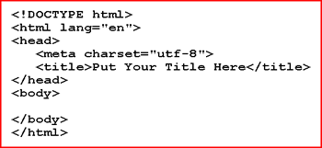

3. Ok, now that you have a valid HTML 5 based page, it is time to focus on the “body” portion of the page and customize this links page with some favorites of your own. Follow the guidelines given below for doing so. Follow them closely to maximize your points.

4. In the "Contact Me" section (if you did not already do so during the video), make sure that the email address that shows up as the visible (underlined) text in the browser as well as the actual email address that will be created when the link is clicked are both your own actual rcc student email address.

5. In the “HTML Resource s” section of the page, there is a link given to a site called “HTML Help”. This site has not been kept up to date so you are asked to replace this link and its description to a better HTML resource. If necessary, use a search engine to find a better resource first.

6. Next, you are asked to create a new link category section into this page that must include at least 2 new favorite links. Choose whatever category you like – examples of possible new link categories are “Shopping”, “Sports”, and “Games”, but pick something you are interested in and have at least 2 web sites that you are familiar with already within that category. Note that the links that you add to this page must be your own unique links -- not copied from anyone else's favorite links page.

To get full credit for this new category, it has to end up with all of the same features that the existing categories on the page have – an entry for the category name that links down to an “h2” heading for the category, at least 2 working favorite links formatted as a definition list, a working “back to top” image link at the bottom of the category, etc.

Note that this new category of links should be placed just above the existing “Contac t Me” section of the page. And therefore your new bulleted list category link(the one that scrolls the browser down to your new h2 category heading) should also be placed just above the existing “Contact Me” bulleted link so that the order of the category links matches the order of the categories themselves.)

7. Before you should consider this page to be complete, there are several details to double check.

* Be sure to test all of these links in the browser to make sure that they all function as expected
* Make sure that all of your code is correct – all tags are closed, lower case tags, etc.

8. When your page is complete, capture a screen shot of your page displaying in the browser so that the entire favorite links page is showing up (from the main page heading all the way down to your “Contact Me” section). Use 2 screenshots if you cannot capture it all with one. I need to see it all to give you full credit. To capture a screen shot in windows, you can use the “Snipping Tool” from the “Accessories Group” or the “PrintScreen” key.

9. Paste your screenshot(s) into your Word document in the indicated area.

10. With your favorite links page in your editor (such as Notepad), select and copy all of the HTML code (from the DOCTYPE all the way down to the closing “html” tag). Make sure to get it all. Then paste this code into your Word document starting on a new page (below your screenshot). Adjust the font of this code to “Courier New” or another monospace font and bold it if that helps to make it more readable.

**Part 3: Textbook Chapter 2 Rock Climbing Web Page**

1. For this part of the assignment, you are asked to read and follow along with the steps given in the textbook to create the "Rock Climbing Fun" Web page built up within chapter 2 on pages HTML 33-78. A screenshot of the completed page is shown below. Also pay attention to the additional notes below.

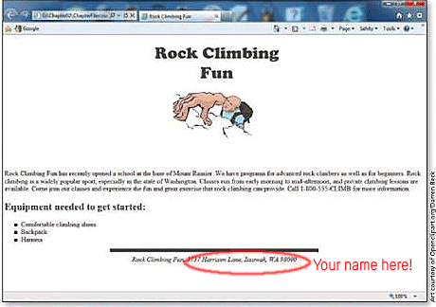

2. Change the given "html" tag (from the book's code) to include the **lang="en"** attribute as we did in part 2 of this assignment for the favorite links page.

3. Note that toward the end of this project, you will be asked to insert an image of a rock climber into the Web page you are building. (You can see from the screenshot above that this image ends up displaying toward the top of the page.) The file you need, "rockclimber.jpg", appears below along with a link to it.

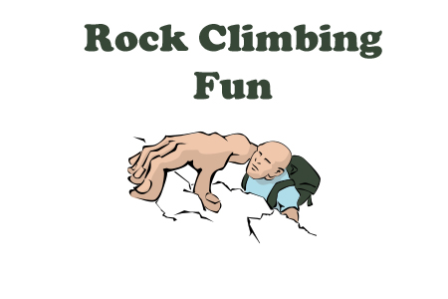

Below is the link to this image in case you need it. You should download a copy of this image to the same folder that contains your rock climbing web page.

<http://www.faculty.rcc.edu/mcleod/html/handouts/rockclimber.jpg>

4. As shown in the above screenshot, you need to modify the given copyright area. Replace the "address" portion of the copyright section at the bottom of the page (shown in red in the screenshot) with your own full name so that it reads "Rock Climbing Fun by Joe Student", where Joe Student is your name.

5. Make sure that all of your code is correct – all tags are closed, lower case tags, etc. Also make sure that you name does appear in the copyright area as indicated above.

6. When your page is complete and double checked for correctness, capture a screen shot of your rock climbing page displaying in the browser so that the entire page is showing up (much like it is in the sample screenshot above.) Use 2 screenshots if you cannot capture it all with one. I need to see it all to give you full credit.

7. Paste your screenshot(s) into your Word document in the indicated area.

8. With your rock climbing page in your editor (such as Notepad), select and copy all of the HTML code (from the DOCTYPE all the way down to the closing “html” tag). Make sure to get it all. Then paste this code into your Word document starting on a new page (below your last screenshot). Adjust the font of this code to “Courier New” or another monospace font and bold it if that helps to make it more readable.

9. Save your Word file, make sure your own name is part of the file’s name. After saving, exit Word, and then submit your Word file (the one containing the answers to the questions, the screen shots and the HTML code for all parts of this assignment. You should submit just this one Word file. Do not submit other files. Submit only once, when you are all done. Remember that lateness deductions will occur if it is after the deadline so get it in on time if you can.