Scott Parker CSS Fall 2017 Assignment #1

Follow these assignment instructions: <http://www.faculty.rcc.edu/mcleod/css/handouts/assignment1.html>

**Part 1:** HTML for CSS (5 Questions from Chapter 1, 15pts):   
**Bold and highlight in yellow the correct answers just like this text!**

1. What are the proper roles for HTML and CSS to play in the making of Web pages today?

a) HTML should provide the look of your Web site and CSS should provide the structure and meaning of the site's content.

b) HTML provides the display of the pages' images and layout, CSS provides the display of the text.

**c) HTML provides the structure for the site's content and CSS provides the formatting of the content.**

d) HTML played the role of writing Web page content in the past, but now it is the role of CSS.

2. In figure 1-3 on page 11, the banner (top) area was most likely created by using either a surrounding "div" tag or a surrounding "header" tag.

**True** or False

3. When deciding between using an "h2" tag or an "h3" tag for a heading, the decision should be based on...

a) how many other headings are above this one.

b) how many other headings are below this one.

**c) what role the heading plays relative to other text on the page**

d) how big you want this text to be displayed on the page

4. A "span" tag differs from a "div" tag in that... CSS can be used to format a "div" tag but not to format a "span" tag

a) A "span" tag is new in HTML5 whereas a "div" tag has been used in earlier versions of HTML

b) A "div" tag will create a visible border around itself in the browser but a "span" tag will not

c) "Div" tags can be used to surround blocks of page content but "span" tags cannot.

5. Where should a "doctype" statement be placed?

a) Anywhere within the HTML file.

**b) At the top of the HTML file.**

c) At the bottom of the HTML file.

d) Anywhere within the CSS file.

e) At the top of the CSS file.

**Part 2**: Five questions from "Chapter 2" & "CSS Essentials" video (15 Points)

**Bold and highlight in yellow the correct answers just like this text!**

1. A CSS style rule can have more than one declaration.

**a) True**

b) False

2. In the video, the "#333" is an example of a…

a) selector

**b) value**

c) property

d) declaration

3. Based on what is in the video, an "h3" would most likely play what role in a CSS rule?

**a) selector**

b) value

c) property

d) declaration

4. The W3C's Web site can be used for validating HTML code as well as for validating CSS code.   
(Note that this is not covered in the video but can be discovered online.)

**True**  or False

5. There are 3 ways to apply CSS to your Web site's pages: inline, internal, and external. Which is best for most web sites? (Note that this is not covered in the video, but the book discusses it and it is covered well here: <http://cssreset.com/css-styles-inline-vs-internal-vs-external>)

a) inline styles are best for most web sites

b) internal styles are best for most web sites

**c) external styles are best for most web sites**

**Part 3**: "HTML5 and CSS3 using Brackets" YouTube Video (40 points)

Right after completing your work from the video, capture a screen shot of your boards page and copy/paste your site's CSS code to show your evidence for completing part 3 below.

[1. Paste your "Boards" page screen Shot below]

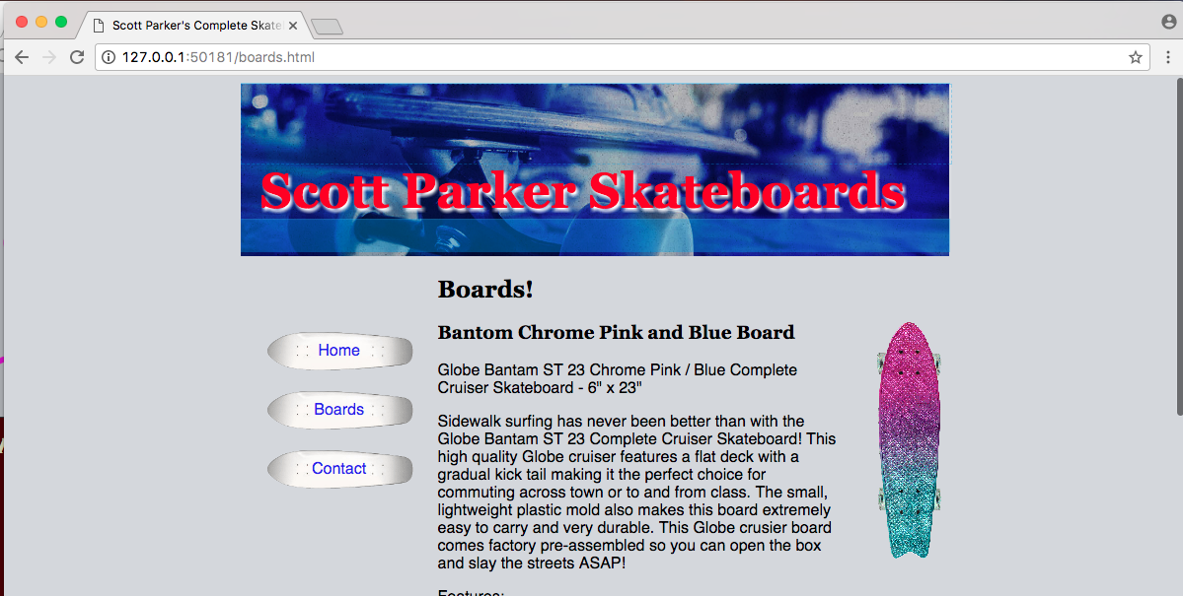

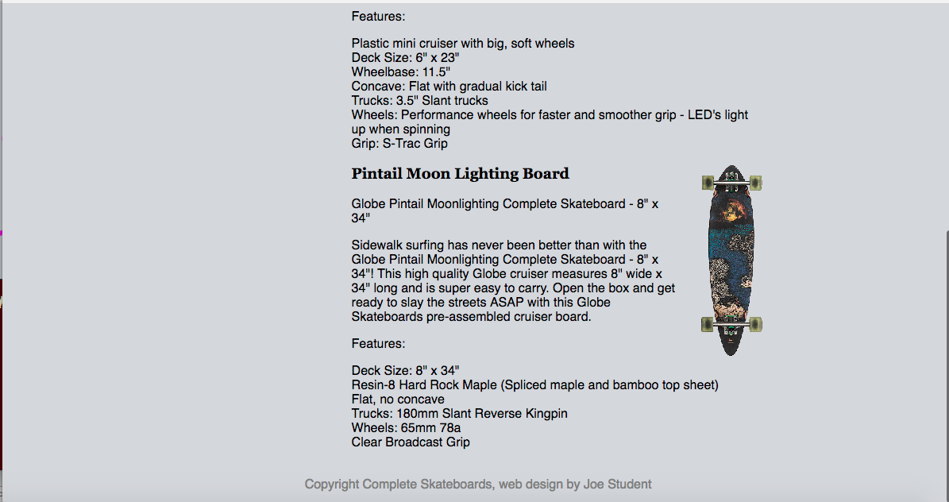

[2. Paste your "styles.css" file's CSS (not HTML) code below]

**body {**

**background-color: #D4D7DD;**

**margin-left: 20%;**

**margin-right: 20%;**

**font-family: sans-serif;**

**}**

**header {**

**height: 175px;**

**background-image: url(bg-banner.jpg);**

**background-repeat: no-repeat;**

**background-size: cover;**

**}**

**h1,**

**h2,**

**h3 {**

**font-family: Georgia, Times, serif;**

**}**

**h1 {**

**color: #F80708;**

**font-size: 50px;**

**text-shadow: 2px 3px 2px white;**

**padding-top: 80px;**

**text-indent: 20px;**

**margin-top: 1px;**

**}**

**nav {**

**width: 200px;**

**float: left;**

**margin-top: 50px;**

**}**

**#main {**

**padding-left: 200px;**

**}**

**nav a {**

**width: 200px;**

**height: 60px;**

**background: url(bg-links.gif) no-repeat center;**

**float: left;**

**background-size: 150px 45px;**

**text-align: center;**

**line-height: 60px;**

**text-decoration: none;**

**color: blue;**

**}**

**nav a:hover {**

**color: red;**

**}**

**ul {**

**list-style-image: url(skateboard-bullet.gif);**

**margin-left: 35px;**

**}**

**.productpic {**

**float: right;**

**margin-left: 30px;**

**}**

**footer {**

**text-align: center;**

**color: gray;**

**margin-top: 35px;**

**}**

**Part 4**: Going Beyond the Video --Make Some Further Changes (30 points)

After making all the changes indicated in part 4 of this assignment's instructions to your "Complete Boards" web site, paste in your "contact" page screen shot and "styles.css" CSS code as asked for in the indicated areas below.

[1. Paste your "Contact" page screen Shot below]

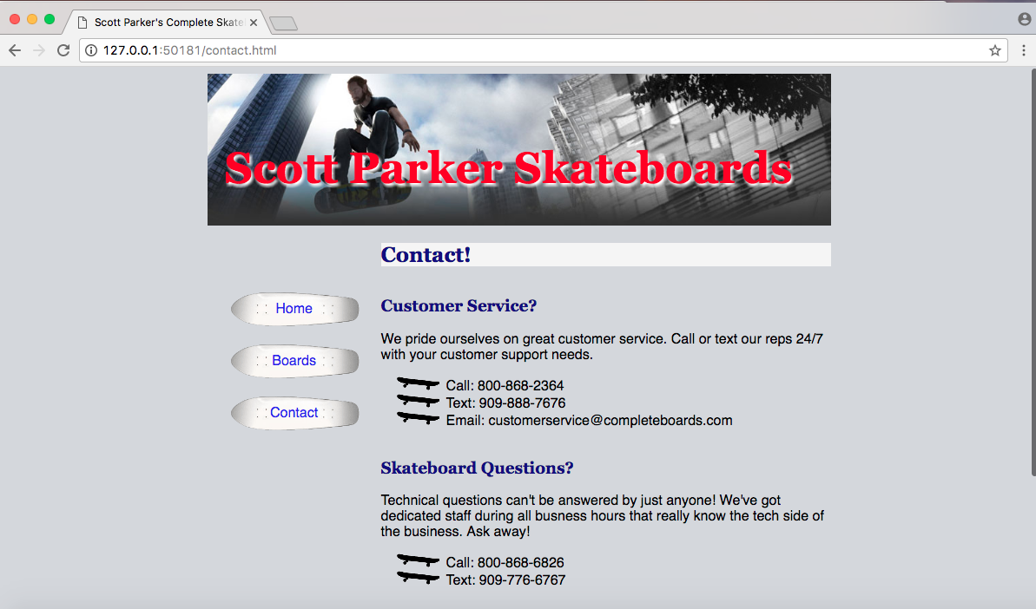

[2. Paste your "styles.css" file's CSS (not HTML) code here below]

**body {**

**background-color: #D4D7DD;**

**margin-left: 20%;**

**margin-right: 20%;**

**font-family: sans-serif;**

**}**

**header {**

**height: 175px;**

**background-image: url(bg-banner-2.jpg);**

**background-repeat: no-repeat;**

**background-size: cover;**

**}**

**h1,**

**h2,**

**h3 {**

**font-family: Georgia, Times, serif;**

**}**

**h1 {**

**color: #F80708;**

**font-size: 50px;**

**text-shadow: 2px 3px 2px white;**

**padding-top: 80px;**

**text-indent: 20px;**

**margin-top: 1px;**

**}**

**nav {**

**width: 200px;**

**float: left;**

**margin-top: 50px;**

**}**

**#main {**

**padding-left: 200px;**

**}**

**nav a {**

**width: 200px;**

**height: 60px;**

**background: url(bg-links.gif) no-repeat center;**

**float: left;**

**background-size: 150px 45px;**

**text-align: center;**

**line-height: 60px;**

**text-decoration: none;**

**color: blue;**

**}**

**nav a:hover {**

**color: red;**

**}**

**ul {**

**list-style-image: url(skateboard-bullet.gif);**

**margin-left: 35px;**

**}**

**.productpic {**

**float: right;**

**margin-left: 30px;**

**}**

**footer {**

**text-align: center;**

**color: gray;**

**margin-top: 35px;**

**}**

**/* Beyond the Video by Scott Parker */**

**h2 {**

**background-color: whitesmoke;**

**color: darkblue;**

**}**

**h3 {**

**margin-top: 35px;**

**color: darkblue;**

**}**