Scott Parker HTML Fall 2017 Assignment #5

Part 1: Answer the questions below, covering YouTube HTML5 form videos, by selecting the correct answer and **bolding and changing its text highlight color to yellow just like this text!** …

Note that the instructions file for this assignment has the links to the videos refered to within these questions.

1. In a "form" tag, which of the following makes the most sense as a value for the "action" attribute? -- See forms video #44: <https://www.youtube.com/watch?v=QsW0cjsBf6o>

a) forms.css **b) forms.html** c) forms.jpg d) forms.php e) forms.docx

2. In a text box, you can control the maximum number of characters allowed to be typed into that textbox by using what attribute?   
See forms video #45: <https://www.youtube.com/watch?v=AWqUHx0GcjA>

a) chars b) rows c) cols d) maxchars **e) maxlength**

3. In a select list, what html attribute can be used to indicate which option in the list should be initially chosen when the list first appears in the browser?  
See forms video #46: <https://www.youtube.com/watch?v=9iWBbkMNI90>

a) chosen one b) chosen **c) selected** d) checked e) picked

4. By default a check box will be unchecked intially in the browser, but there is an HTML attribute that can be used to make a check box to be checked initially.   
See forms video #47: <https://www.youtube.com/watch?v=pCa3-RdFWas>

**a) True** b) False

5. To control how many lines of text can be typed into an html "textarea" before vertical scrolling would be needed, what attribute should be used?   
See forms video #48: <https://www.youtube.com/watch?v=Kcn3QwFfaUM>

**a) rows** b) maxrows c) lines d) maxlines e) height

6. Where within a form does a "legend" appear?   
See forms video #50: <https://www.youtube.com/watch?v=LuJulyokmjE>

a) at the top of its form b) above its label c) below its label

**d) at the top of its fieldset** e) to the left of its form element

**Part 2 Screenshot: Your “Blue Wav Music” form page displaying in the browser.**

[Paste your part 2 “Blue Wav Music” form page screenshot (from the textbook chapter 6) here. Use 2 screenshots if necessary to show the entire page.]

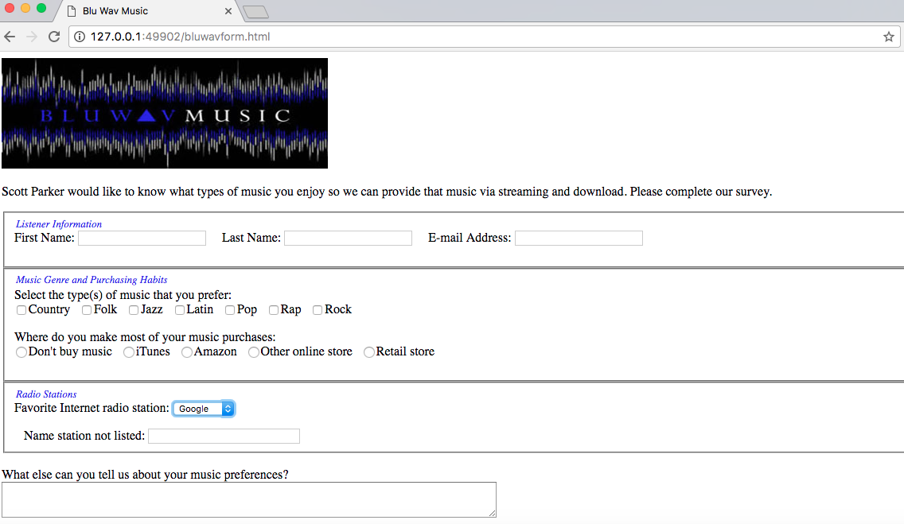

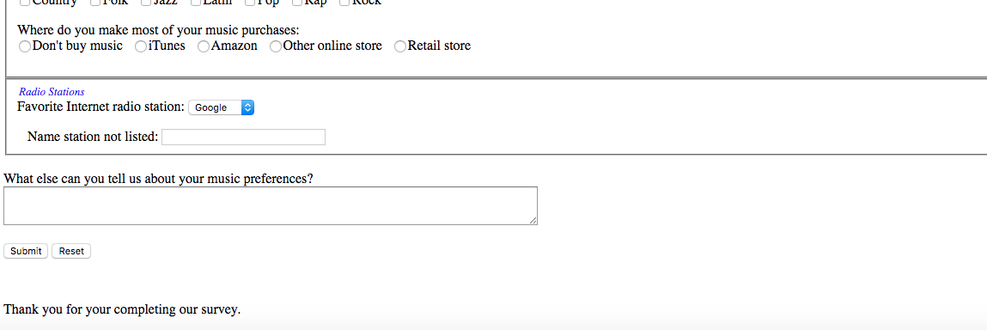

**Part 2 HTML Code: Your “Blue Wav Music” form page HTML Code:**

[Paste your “Blue Wav Music” page (“bluwavform.html”) HTML Code below – Be sure to paste ALL of the HTML code for the page – it is ok if it takes several pages. Use “Courier New” or another monospace font to make your code more readable. Bold the code too if that helps make it more readable. ]

**<!DOCTYPE HTML>**

**<html lang="en">**

**<head>**

**<meta charset="utf-8" />**

**<title>Blu Wav Music</title>**

**<style type="text/css">**

**<!-- legend {**

**float: left;**

**color: #0000fe;**

**font-style: italic;**

**font-size: small;**

**}**

**-->**

**</style>**

**</head>**

**<body>**

**<form method="post" action="mailto:bluwav@isp.com">**

**<header>**

**<img src="bluwavlogo.jpg" width="410" height="139" alt="Blu Wav logo" />**

**</header>**

**<p>Scott Parker would like to know what types of music you enjoy so we can provide that music via streaming and download. Please complete our survey. </p>**

**<fieldset>**

**<legend>Listener Information</legend>**

**<p>First Name: <input name="firstname" type="text" size="25" /> &nbsp; &nbsp; Last Name: <input name="lastname" type="text" size="25" /> &nbsp; &nbsp; E-mail Address: <input name="email" type="text" size="25" /></p>**

**</fieldset>**

**<fieldset>**

**<legend>Music Genre and Purchasing Habits</legend>**

**<br />Select the type(s) of music that you prefer:**

**<br /><input name="musictype" type="checkbox" value="country" />Country &nbsp;**

**<input name="musictype" type="checkbox" value="folk" />Folk &nbsp;**

**<input name="musictype" type="checkbox" value="jazz" />Jazz &nbsp;**

**<input name="musictype" type="checkbox" value="latin" />Latin &nbsp;**

**<input name="musictype" type="checkbox" value="pop" />Pop &nbsp;**

**<input name="musictype" type="checkbox" value="rap" />Rap &nbsp;**

**<input name="musictype" type="checkbox" value="rock" />Rock**

**<p>Where do you make most of your music purchases:**

**<br /><input name="purchases" type="radio" value="none" />Don't buy music &nbsp;**

**<input name="purchases" type="radio" value="iTunes" />iTunes &nbsp;**

**<input name="purchases" type="radio" value="amazon" />Amazon &nbsp;**

**<input name="purchases" type="radio" value="online" />Other online store &nbsp;**

**<input name="purchases" type="radio" value="retail" />Retail store &nbsp;**

**</p>**

**</fieldset>**

**<fieldset>**

**<legend>Radio Stations</legend>**

**<p>Favorite Internet radio station:**

**<select name="station">**

**<option>Google</option>**

**<option>Live 365</option>**

**<option>Pandora</option>**

**<option>Slacker</option>**

**<option>Spotify</option>**

**</select>**

**</p>**

**&nbsp; &nbsp;Name station not listed:**

**<input name="addstation" type="text" size="30" maxlength="30" />**

**</fieldset>**

**<br />What else can you tell us about your music preferences?**

**<br /><textarea name="other" rows="3" cols="100"></textarea>**

**<p><input type="submit" value="Submit" />**

**<input type="reset" value="Reset" /></p>**

**<br />**

**<p>Thank you for your completing our survey.</p>**

**</form>**

**</body>**

**</html>**