Scott Parker CSS Fall 2017 Assignment #2

Follow the assignment instructions: <http://www.faculty.rcc.edu/mcleod/css/handouts/assignment2.html>

**Part 1: Selection -- Resume Video Work (Hybrid Video #2, 20 Points)**

[1. Paste your styled "Resume" Page Screen Shot below]

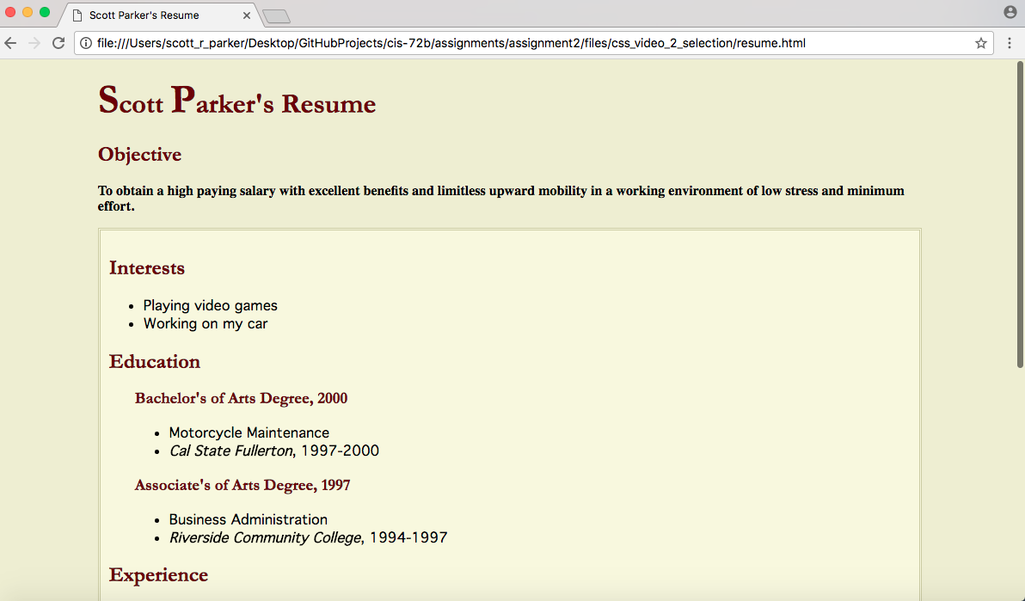

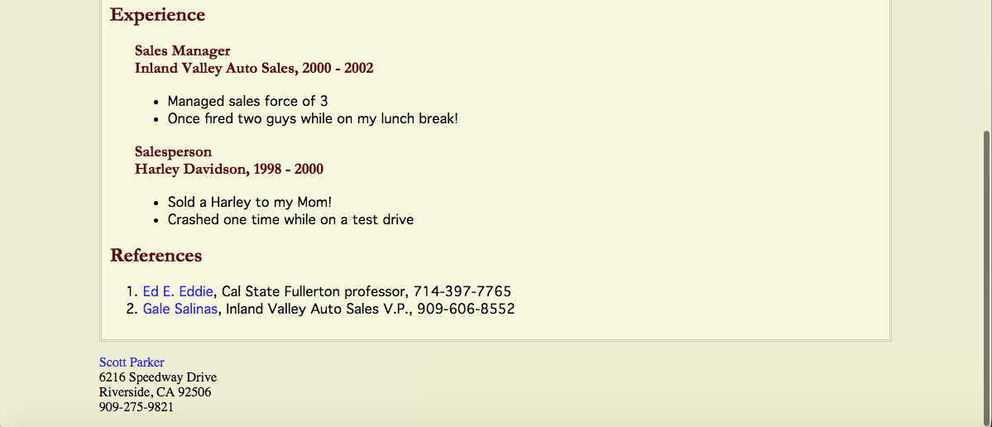

[2. Paste your "Resume" page's code (combo of HTML and CSS) below]

**<!DOCTYPE html PUBLIC "-//W3C//DTD XHTML 1.0 Strict//EN" "http://www.w3.org/TR/xhtml1/DTD/xhtml1-strict.dtd">**

**<html xmlns="http://www.w3.org/1999/xhtml" xml:lang="en" lang="en">**

**<head>**

**<title>Scott Parker's Resume</title>**

**<meta http-equiv="Content-Type" content="text/html; charset=iso-8859-1" />**

**<style type="text/css">**

**body {**

**margin-left: 10%;**

**margin-right: 10%;**

**background-color: #EEEECC;**

**color: black;**

**}**

**h1,**

**h2,**

**h3 {**

**font-family: Garamond, Georgia, serif;**

**color: #660000;**

**}**

**h1 span {**

**font-size: 150%;**

**}**

**p#objective {**

**font-weight: bold;**

**}**

**span.college {**

**font-style: italic;**

**font-weight: bold;**

**}**

**div#resumebody {**

**background-color: #F8F8D8;**

**border: double #CCCC99 3px;**

**padding: 10px;**

**font-family: Geneva, "Trebuchet MS", sans-serif;**

**}**

**div.details {**

**margin-left: 30px;**

**}**

**a:link {**

**color: blue;**

**text-decoration: none;**

**}**

**a:visited {**

**color: blue;**

**text-decoration: none;**

**}**

**a:hover {**

**color: blue;**

**text-decoration: underline;**

**}**

**a:active {**

**color: red;**

**text-decoration: underline;**

**}**

**</style>**

**</head>**

**<body>**

**<h1><span>S</span>cott <span>P</span>arker's Resume</h1>**

**<h2>Objective</h2>**

**<p id="objective">To obtain a high paying salary with excellent benefits and limitless upward mobility in a working environment of low stress and minimum effort.</p>**

**<div id="resumebody">**

**<h2>Interests</h2>**

**<ul>**

**<li>Playing video games</li>**

**<li>Working on my car</li>**

**</ul>**

**<h2>Education</h2>**

**<div class="details">**

**<h3>Bachelor's of Arts Degree, 2000</h3>**

**<ul>**

**<li>Motorcycle Maintenance</li>**

**<li><span class="college">Cal State Fullerton</span>, 1997-2000 </li>**

**</ul>**

**<h3>Associate's of Arts Degree, 1997</h3>**

**<ul>**

**<li>Business Administration</li>**

**<li><span class="college">Riverside Community College</span>, 1994-1997</li>**

**</ul>**

**</div>**

**<h2>Experience</h2>**

**<div class="details">**

**<h3>Sales Manager<br /> Inland Valley Auto Sales, 2000 - 2002</h3>**

**<ul>**

**<li>Managed sales force of 3</li>**

**<li>Once fired two guys while on my lunch break!</li>**

**</ul>**

**<h3>Salesperson<br /> Harley Davidson, 1998 - 2000</h3>**

**<ul>**

**<li>Sold a Harley to my Mom!</li>**

**<li>Crashed one time while on a test drive</li>**

**</ul>**

**</div>**

**<h2>References</h2>**

**<ol>**

**<li><a href="mailto:eddie@csuf.edu">Ed E. Eddie</a>, Cal State Fullerton professor, 714-397-7765</li>**

**<li><a href="mailto:gales@ivas.com">Gale Salinas</a>, Inland Valley Auto Sales V.P., 909-606-8552</li>**

**</ol>**

**</div>**

**<p><a href="mailto:sparker35@student.rccd.edu">Scott Parker</a><br /> 6216 Speedway Drive<br /> Riverside, CA 92506<br /> 909-275-9821**

**</p>**

**</body>**

**</html>**

**Part 2**: Selectors (Chapter 3 Tutorial, 20 Points)

[1. Paste your Chapter 3 Tutorial Page Screen Shot below]

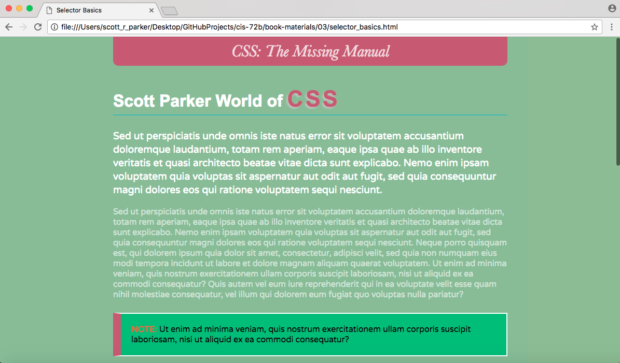

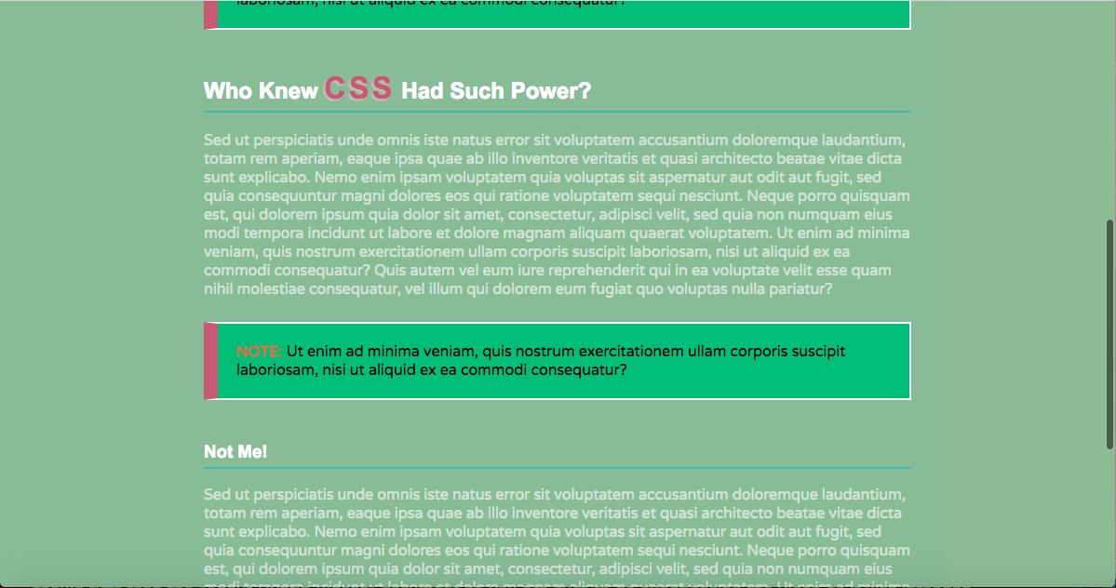

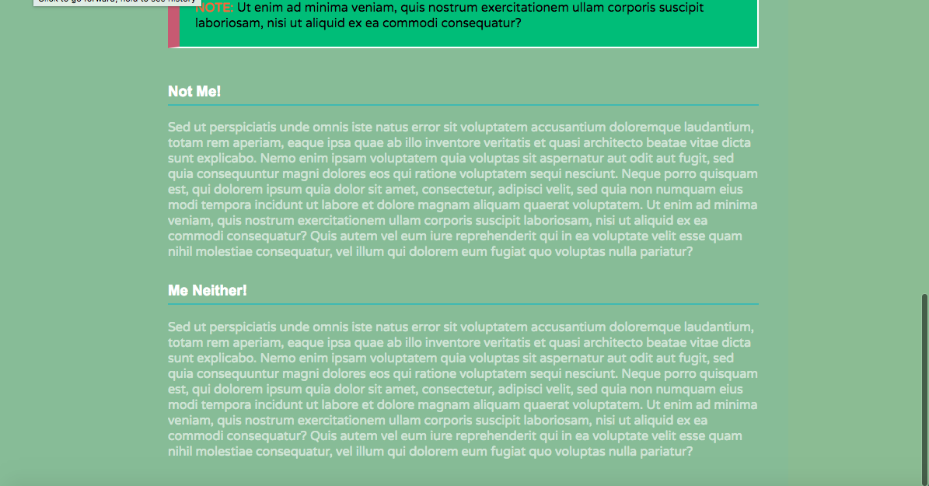

[2. Paste your Chapter 3 Tutorial Page's code (combo of HTML and CSS) below]

**<!doctype html>**

**<html>**

**<head>**

**<meta charset="UTF-8">**

**<title>Selector Basics</title>**

**<link href='http://fonts.googleapis.com/css?family=Varela+Round' rel='stylesheet'>**

**<style>**

**body {**

**background-color: darkseagreen;**

**padding: 0 20px 20px 20px;**

**margin: 0;**

**}**

**p {**

**color: rgba(255,255,255,.6);**

**font-size: 1em;**

**font-family: "Varela Round", Arial, Helvetica, sans-serif;**

**}**

**h1, h2, h3 {**

**color: rgb(255,255,255);**

**font-family: Arial, "Palatino Linotype", Times, serif;**

**border-bottom: 2px solid rgb(87,185,178);**

**padding-top: 10px;**

**padding-bottom: 5px;**

**}**

**h1 {**

**font-size: 2em;**

**}**

**h1 span, h2 span {**

**color: rgb(191, 91, 116);**

**font-size: 135%;**

**letter-spacing: .1em;**

**text-shadow: -.07em .07em .05em silver;**

**}**

**#logo {**

**font-family: Baskerville, Palatino, sans-serif;**

**font-size: 2em;**

**color: rgba(255,255,255,.8);**

**font-style: italic;**

**text-align: center;**

**margin-bottom: 30px;**

**background-color: rgb(191,91,116);**

**border-radius: 0 0 10px 10px;**

**padding: 10px;**

**}**

**.note {**

**color: black;**

**border: 2px solid white;**

**background-color: rgb(69,189,102);**

**margin-top: 25px;**

**margin-bottom: 35px;**

**padding: 20px;**

**border-left: 15px solid rgb(191,91,116);**

**}**

**.note strong {**

**color: #FC6512;**

**}**

**article {**

**max-width: 760px;**

**margin: 0 auto;**

**}**

**h1+p {**

**color: rgb(255,255,255);**

**font-size: 1.2em;**

**line-height: 140%;**

**}**

**</style>**

**</head>**

**<body>**

**<article>**

**<div id="logo">**

**CSS: The Missing Manual**

**</div>**

**<h1>Scott Parker World of <span>CSS</span></h1>**

**<p>Sed ut perspiciatis unde omnis iste natus error sit voluptatem accusantium doloremque laudantium, totam rem aperiam, eaque ipsa quae ab illo inventore veritatis et quasi architecto beatae vitae dicta sunt explicabo. Nemo enim ipsam voluptatem quia voluptas sit aspernatur aut odit aut fugit, sed quia consequuntur magni dolores eos qui ratione voluptatem sequi nesciunt. </p>**

**<p>Sed ut perspiciatis unde omnis iste natus error sit voluptatem accusantium doloremque laudantium, totam rem aperiam, eaque ipsa quae ab illo inventore veritatis et quasi architecto beatae vitae dicta sunt explicabo. Nemo enim ipsam voluptatem quia voluptas sit aspernatur aut odit aut fugit, sed quia consequuntur magni dolores eos qui ratione voluptatem sequi nesciunt. Neque porro quisquam est, qui dolorem ipsum quia dolor sit amet, consectetur, adipisci velit, sed quia non numquam eius modi tempora incidunt ut labore et dolore magnam aliquam quaerat voluptatem. Ut enim ad minima veniam, quis nostrum exercitationem ullam corporis suscipit laboriosam, nisi ut aliquid ex ea commodi consequatur? Quis autem vel eum iure reprehenderit qui in ea voluptate velit esse quam nihil molestiae consequatur, vel illum qui dolorem eum fugiat quo voluptas nulla pariatur?</p>**

**<p class="note"><strong>NOTE:</strong> Ut enim ad minima veniam, quis nostrum exercitationem ullam corporis suscipit laboriosam, nisi ut aliquid ex ea commodi consequatur? </p>**

**<h2>Who Knew <span>CSS</span> Had Such Power?</h2>**

**<p>Sed ut perspiciatis unde omnis iste natus error sit voluptatem accusantium doloremque laudantium, totam rem aperiam, eaque ipsa quae ab illo inventore veritatis et quasi architecto beatae vitae dicta sunt explicabo. Nemo enim ipsam voluptatem quia voluptas sit aspernatur aut odit aut fugit, sed quia consequuntur magni dolores eos qui ratione voluptatem sequi nesciunt. Neque porro quisquam est, qui dolorem ipsum quia dolor sit amet, consectetur, adipisci velit, sed quia non numquam eius modi tempora incidunt ut labore et dolore magnam aliquam quaerat voluptatem. Ut enim ad minima veniam, quis nostrum exercitationem ullam corporis suscipit laboriosam, nisi ut aliquid ex ea commodi consequatur? Quis autem vel eum iure reprehenderit qui in ea voluptate velit esse quam nihil molestiae consequatur, vel illum qui dolorem eum fugiat quo voluptas nulla pariatur?</p>**

**<p class="note"><strong>NOTE:</strong> Ut enim ad minima veniam, quis nostrum exercitationem ullam corporis suscipit laboriosam, nisi ut aliquid ex ea commodi consequatur? </p>**

**<h3>Not Me!</h3>**

**<p>Sed ut perspiciatis unde omnis iste natus error sit voluptatem accusantium doloremque laudantium, totam rem aperiam, eaque ipsa quae ab illo inventore veritatis et quasi architecto beatae vitae dicta sunt explicabo. Nemo enim ipsam voluptatem quia voluptas sit aspernatur aut odit aut fugit, sed quia consequuntur magni dolores eos qui ratione voluptatem sequi nesciunt. Neque porro quisquam est, qui dolorem ipsum quia dolor sit amet, consectetur, adipisci velit, sed quia non numquam eius modi tempora incidunt ut labore et dolore magnam aliquam quaerat voluptatem. Ut enim ad minima veniam, quis nostrum exercitationem ullam corporis suscipit laboriosam, nisi ut aliquid ex ea commodi consequatur? Quis autem vel eum iure reprehenderit qui in ea voluptate velit esse quam nihil molestiae consequatur, vel illum qui dolorem eum fugiat quo voluptas nulla pariatur?</p>**

**<h3>Me Neither!</h3>**

**<p>Sed ut perspiciatis unde omnis iste natus error sit voluptatem accusantium doloremque laudantium, totam rem aperiam, eaque ipsa quae ab illo inventore veritatis et quasi architecto beatae vitae dicta sunt explicabo. Nemo enim ipsam voluptatem quia voluptas sit aspernatur aut odit aut fugit, sed quia consequuntur magni dolores eos qui ratione voluptatem sequi nesciunt. Neque porro quisquam est, qui dolorem ipsum quia dolor sit amet, consectetur, adipisci velit, sed quia non numquam eius modi tempora incidunt ut labore et dolore magnam aliquam quaerat voluptatem. Ut enim ad minima veniam, quis nostrum exercitationem ullam corporis suscipit laboriosam, nisi ut aliquid ex ea commodi consequatur? Quis autem vel eum iure reprehenderit qui in ea voluptate velit esse quam nihil molestiae consequatur, vel illum qui dolorem eum fugiat quo voluptas nulla pariatur?</p>**

**</article>**

**</body>**

**</html>**

**Part 3**: Font & Text Properties -- “Daily Spin” Video Work (Hybrid Video #3, 20 Points)

[1. Paste your "Daily Spin" Page Screen Shot below]

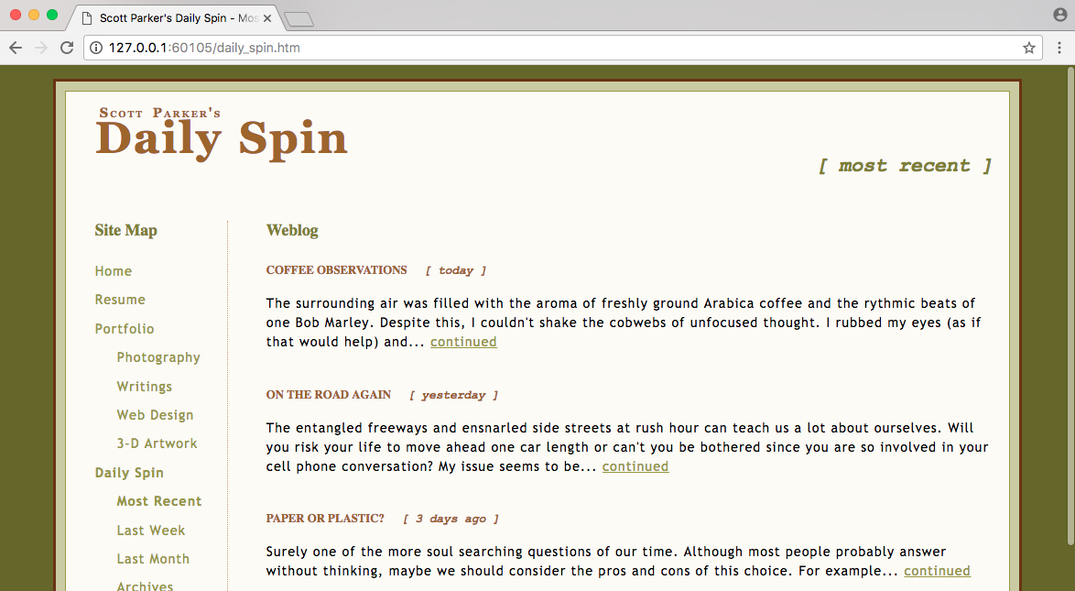

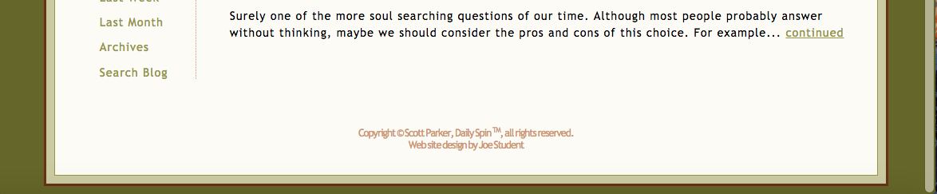

[2. Paste your "spin.css" style sheet file's code (just CSS) below]

**/* Styles for Daily Spin pages, by Joe Student */**

**body {**

**margin: 15px 5% 10px 5%;**

**background: #660;**

**color: black;**

**}**

**div#page {**

**background: #CCCC99;**

**padding: 10px;**

**border: solid #663300 3px;**

**}**

**table#main {**

**background: #FCFBF3;**

**border: solid 1px #999900;**

**}**

**h1 {**

**font-size: 300%;**

**font-family: Georgia, "Times New Roman", Times, serif;**

**}**

**h1 {**

**word-spacing: 4px;**

**letter-spacing: 2px;**

**color: #996600;**

**text-indent: 5px;**

**}**

**h1 span {**

**font-size: 30%;**

**font-variant: small-caps;**

**}**

**h2 {**

**text-align: right;**

**font-size: 135%;**

**color: olive;**

**}**

**h2,**

**h4 .date {**

**font-family: "Courier New", Courier, monospace;**

**text-transform: lowercase;**

**font-style: italic;**

**margin-left: 15px;**

**}**

**h1,**

**h2 {**

**margin-top: 0;**

**margin-bottom: 0;**

**line-height: .9;**

**}**

**h3 {**

**font-size: 110%;**

**color: olive;**

**margin-bottom: 1.5em;**

**}**

**h4 {**

**font-size: 80%;**

**color: #996600;**

**text-transform: uppercase;**

**}**

**p {**

**font-family: "Trebuchet MS", Verdana, Arial, sans-serif;**

**font-size: 90%;**

**line-height: 1.5;**

**letter-spacing: 1px;**

**}**

**#footer p {**

**letter-spacing: -1px;**

**word-spacing: -1px;**

**line-height: 1.25;**

**font-size: 80%;**

**color: #CC9966;**

**text-align: center;**

**}**

**#trademark {**

**vertical-align: super;**

**font-size: 60%;**

**}**

**a:link,**

**a:visited {**

**color: #999900;**

**}**

**a:hover,**

**a:active {**

**color: olive;**

**text-decoration: underline overline;**

**}**

**#links {**

**border-right: 1px #CC9966 dotted;**

**}**

**#links a:link,**

**#links a:visited {**

**text-decoration: none;**

**}**

**#links a:hover,**

**#links a:active {**

**text-decoration: underline;**

**}**

**#links .level2 {**

**margin-left: 1.5em;**

**}**

**#links,**

**h1 {**

**margin-left: 15px;**

**}**

**#links .thispage {**

**font-weight: bold;**

**color: #999900;**

**}**

**#links p {**

**line-height: 1.2;**

**}**

**#blogs {**

**margin-left: 10px;**

**}**

**#blogs p {**

**margin-bottom: 2.75em;**

**}**

**Part 4**: Formatting Text (Chapter 6 Tutorial, 20 Points)

[1. Paste yourChapter 6 Tutorial page Screen Shot below]

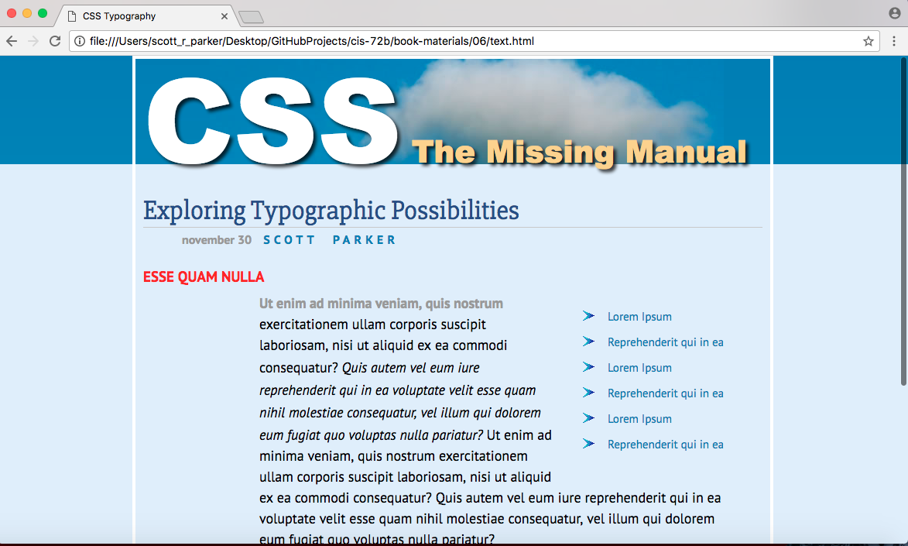

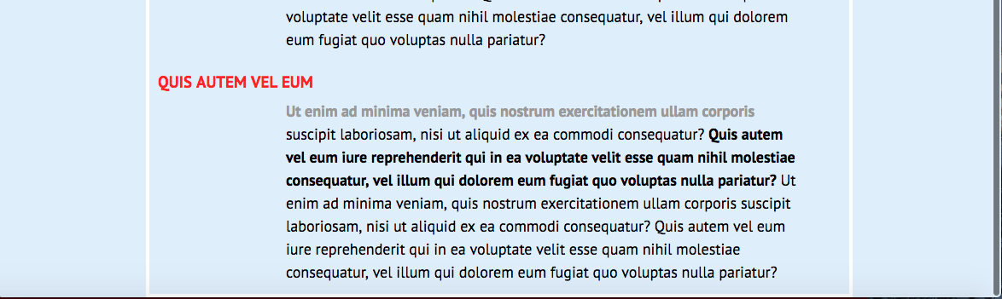

[2. Paste your Chapter 6 Tutorial page's code (combo of HTML and CSS) below]

**@font-face {**

**font-family: 'PTSans';**

**src: url('fonts/PTSansRegular.woff2') format('woff2'),**

**url('fonts/PTSansRegular.woff') format('woff');**

**font-weight: normal;**

**font-style: normal;**

**}**

**@font-face {**

**font-family: 'PTSans';**

**src: url('fonts/PTSansItalic.woff2') format('woff2'),**

**url('fonts/PTSansItalic.woff') format('woff');**

**font-weight: normal;**

**font-style: italic;**

**}**

**@font-face {**

**font-family: 'PTSans';**

**src: url('fonts/PTSansBold.woff2') format('woff2'),**

**url('fonts/PTSansBold.woff') format('woff');**

**font-weight: bold;**

**font-style: normal;**

**}**

**@font-face {**

**font-family: 'PTSans';**

**src: url('fonts/PTSansBoldItalic.woff2') format('woff2'),**

**url('fonts/PTSansBoldItalic.woff') format('woff');**

**font-weight: bold;**

**font-style: italic;**

**}**

**/* reset browser styles */**

**html,**

**body,**

**div,**

**span,**

**object,**

**iframe,**

**h1,**

**h2,**

**h3,**

**h4,**

**h5,**

**h6,**

**p,**

**blockquote,**

**pre,**

**a,**

**abbr,**

**acronym,**

**address,**

**big,**

**cite,**

**code,**

**del,**

**dfn,**

**em,**

**img,**

**ins,**

**kbd,**

**q,**

**s,**

**samp,**

**small,**

**strike,**

**strong,**

**sub,**

**sup,**

**tt,**

**var,**

**b,**

**u,**

**i,**

**center,**

**dl,**

**dt,**

**dd,**

**ol,**

**ul,**

**li,**

**fieldset,**

**form,**

**label,**

**legend,**

**table,**

**caption,**

**tbody,**

**tfoot,**

**thead,**

**tr,**

**th,**

**td,**

**article,**

**aside,**

**canvas,**

**details,**

**embed,**

**figure,**

**figcaption,**

**footer,**

**header,**

**hgroup,**

**menu,**

**nav,**

**output,**

**ruby,**

**section,**

**summary,**

**time,**

**mark,**

**audio,**

**video {**

**margin: 0;**

**padding: 0;**

**border: 0;**

**font-size: 100%;**

**vertical-align: baseline;**

**}**

**article,**

**aside,**

**details,**

**figcaption,**

**figure,**

**footer,**

**header,**

**hgroup,**

**menu,**

**nav,**

**section {**

**display: block;**

**}**

**body {**

**line-height: 1.2;**

**}**

**ol {**

**padding-left: 1.4em;**

**list-style: decimal;**

**}**

**ul {**

**padding-left: 1.4em;**

**list-style: square;**

**}**

**table {**

**border-collapse: collapse;**

**border-spacing: 0;**

**}**

**/* end reset browser styles */**

**html {**

**font-family: PTSans, Arial, sans-serif;**

**font-size: 62.5%;**

**background: rgb(225, 238, 253) url(../images/bg_body.png) repeat-x;**

**}**

**.main {**

**max-width: 800px;**

**margin: 0 auto;**

**padding: 0 10px;**

**border: 4px solid white;**

**background: transparent url(../images/bg_banner.jpg) no-repeat;**

**}**

**.main h1 {**

**color: rgb(249, 212, 120);**

**font-family: "Arial Black", Arial, Helvetica, sans-serif;**

**font-size: 4em;**

**text-shadow: 4px 4px 6px rgba(0, 0, 0, .75);**

**}**

**.main h1 strong {**

**font-size: 150px;**

**color: white;**

**line-height: 1;**

**}**

**.main h2 {**

**font: normal 3.5em "Slabo 27px", Garamond, Times, serif;**

**color: rgb(37, 76, 143);**

**border-bottom: 1px solid rgb(200, 200, 200);**

**margin-top: 25px;**

**}**

**.main h3 {**

**color: rgb(241, 47, 6);**

**font-size: 1.9em;**

**font-weight: bold;**

**text-transform: uppercase;**

**margin-top: 25px;**

**margin-bottom: 10px;**

**}**

**.main p {**

**font-size: 1.8em;**

**line-height: 1.5;**

**margin-left: 150px;**

**margin-right: 50px;**

**margin-bottom: 10px;**

**}**

**.main p::first-line {**

**font-weight: bold;**

**color: rgb(153, 153, 153);**

**}**

**.main ul {**

**margin: 50px 0 25px 50px;**

**width: 25%;**

**float: right;**

**list-style-image: url(blue-arrow-bullet.gif);**

**}**

**.main li {**

**color: rgb(32, 126, 191);**

**font-size: 1.5em;**

**margin-bottom: 7px;**

**line-height: 1.75em;**

**}**

**.main .byline {**

**font-size: 1.6em;**

**margin: 5px 0 25px 50px;**

**}**

**.main .byline strong {**

**color: rgb(32, 126, 191);**

**text-transform: uppercase;**

**margin-left: 11px;**

**letter-spacing: 5px;**

**word-spacing: 10px;**

**}**

**<!doctype html>**

**<html>**

**<head>**

**<meta charset="UTF-8">**

**<title>CSS Typography</title>**

**<link href="http://fonts.googleapis.com/css?family=Slabo+27px" rel="stylesheet">**

**<link href="css/styles.css" rel="stylesheet">**

**</head>**

**<body>**

**<div class="main">**

**<h1><strong>CSS</strong> The Missing Manual</h1>**

**<h2>Exploring Typographic Possibilities</h2>**

**<p class="byline">november 30 <strong>Scott Parker</strong></p>**

**<ul>**

**<li>Lorem Ipsum</li>**

**<li>Reprehenderit qui in ea</li>**

**<li>Lorem Ipsum</li>**

**<li>Reprehenderit qui in ea</li>**

**<li>Lorem Ipsum</li>**

**<li>Reprehenderit qui in ea</li>**

**</ul>**

**<h3>Esse quam nulla</h3>**

**<p>Ut enim ad minima veniam, quis nostrum exercitationem ullam corporis suscipit laboriosam, nisi ut aliquid ex ea commodi consequatur? <em>Quis autem vel eum iure reprehenderit qui in ea voluptate velit esse quam nihil molestiae consequatur, vel illum qui dolorem eum fugiat quo voluptas nulla pariatur?</em> Ut enim ad minima veniam, quis nostrum exercitationem ullam corporis suscipit laboriosam, nisi ut aliquid ex ea commodi consequatur? Quis autem vel eum iure reprehenderit qui in ea voluptate velit esse quam nihil molestiae consequatur, vel illum qui dolorem eum fugiat quo voluptas nulla pariatur?</p>**

**<h3>Quis autem vel eum</h3>**

**<p>Ut enim ad minima veniam, quis nostrum exercitationem ullam corporis suscipit laboriosam, nisi ut aliquid ex ea commodi consequatur? <strong>Quis autem vel eum iure reprehenderit qui in ea voluptate velit esse quam nihil molestiae consequatur, vel illum qui dolorem eum fugiat quo voluptas nulla pariatur? </strong>Ut enim ad minima veniam, quis nostrum exercitationem ullam corporis suscipit laboriosam, nisi ut aliquid ex ea commodi consequatur? Quis autem vel eum iure reprehenderit qui in ea voluptate velit esse quam nihil molestiae consequatur, vel illum qui dolorem eum fugiat quo voluptas nulla pariatur?</p>**

**</div>**

**</body>**

**</html>**

**Part 5 Theme Details (10-Points)**

Type in your answers and/or insert images where appropriate. Be as specific as possible. If you don't have an image to display, describe it as clearly as you can. Do not leave any of these blank or incomplete or you will lose points. See the assignment directions for examples.

1. Your full name:

Scott Parker

2. Your Hotel's name:

Horror Hotel (or Cthulu Hotel)

3. Explanation of theme:

Theme is dedicated to a hotel focusing on horror, drawing in particularly from the Cthulu mythos by HP Lovecraft

4. Hotel Image:

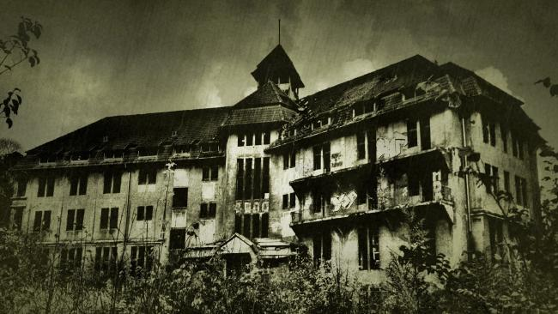

5. Color Scheme:

Gray and black with lots of over-exposure and faded images

6. Fonts:

<link href="https://fonts.googleapis.com/css?family=Exo+2|Vollkorn+SC" rel="stylesheet">

Vollkorn+SC and/or Exo+2 fonts… Similar other fonts are possible but it becomes a focus on readability vs. style

7. Bullet Images:

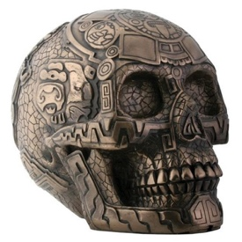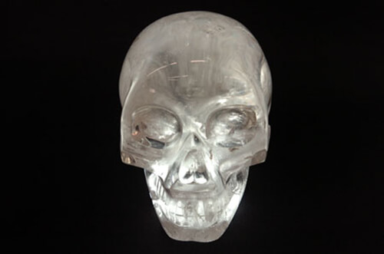

**Part 6: Test Your Knowledge Of Selectors (8 Questions, 10 Points):  
Bold and highlight in yellow the correct answers just like this text!**

1. If you want to create a style rule to format just the list items of bulleted lists (not of ordered lists), which selector would do the job?

a) ul .li

b) ul, li

**c) ul li**

d) li ul

e) li, ul

2. If you are writing a style rule to format a copyright paragraph differently from all other paragraphs on your page, which selector makes the most sense to use?

a) p

b) **.**copyright

c) p **.**copyright

d) #copyright

**e) p #copyright**

3. If you use the selector "nav+a", what would you be selecting?

a) The nav area plus all links after the nav

b) The nav area plus the first link after the nav

c) Just the first link inside the nav area

**d) Just the first link after the nav area only if it is the very next tag**

e) Just the first link after the nav area regardless of where it is

4. In a form with 3 text boxes, 4 radio buttons, 2 text areas (that can hold multiple lines of text), and one submit button, how many elements would be affected by the selector "input"?

a) 10

b) 9

c) 8

d) 7

**e) 3 but actually 4 elements**

5. In a form with 3 text boxes, 4 radio buttons, 2 text areas (that can hold multiple lines of text), and one submit button, how many elements would be affected by the selector below? input[type="text"] , input[type="button"]

a) 10

b) 7

c) 6

d) 5

**e) 3**

6. In a table with 5 rows, and 5 columns, which table cells would be affected by the selector "td:last-child"?

a) None of the cells would be affected

b) The 5 cells across the last row would be affected

**c) The 5 cells down the last column would be affected**

d) Just the last cell in the last column would be affected

e) All 25 cells would be affected

7. In a table with 5 rows, how many of those rows would be affected by the selector   
"tr:nth-child(3n+1)"?

a) 1 row would be affected

**b) 2 rows would be affected**

c) 3 rows would be affected

d) 4 rows would be affected

e) 5 rows would be affected

8. In a table with 5 rows and 5 columns, how many table cells would be affected by the descendant selector "tr:nth-child(odd) td:nth-child(even)"?

a) 25

b) 19

c) 15

**d) 6**

e) 0