Molecular properties and structural characterization of an alkaline extractable arabinoxylan from hull-less barley bran

Rui Guo ^{a, 1}, Zhongxiang Xu ^{a, 1}, Shengfang Wu ^{b}, Xujiao Li ª, Jinan Li ª, Hao Hu ª, Yan Wu ^{a, *}, Lianzhong Ai ^{c}

ª School of Agriculture and Biology, Shanghai Engineering Research Center of Food Safety, Shanghai Jiao Tong University, Shanghai 200240, China
^{b} State Key Laboratory of Food Science and Technology, Jiangnan University, Wuxi 214122, China
^{c} School of Medical Instrument and Food Engineering, University of Shanghai for Science and Technology, Shanghai 200093, China

¹ These authors contributed equally to this work and should be considered co-first authors.
* Corresponding author: Yan Wu
Tel.: +86-21-34205715
Fax: +86-21-34206918
E-mail address: wuy@sjtu.edu.cn

Highlights
- An alkali-extracted HBAX-25 from hull-less barley bran was characterized in detail.
- The molecular and spectral properties of HBAX-25 were revealed fundamentally.
- The structural basis of HBAX-25 was established and confirmed as an arabinoxylan.

ABSTRACT
An alkaline extractable arabinoxylan (HBAX-25) was fractionated from crude arabinoxylan (HBAX) obtained optimally in hull-less barley (Hordeum vulgare L. var. nudum Hook. f.) bran. Molecular properties and structural characterization of HBAX-25 were investigated thoroughly based on chemical composition of 8.31% (w/w) moisture and 87.57% (w/w) sugar with specifically few proteins (1.08%, w/w) and high arabinoxylans (82.46%, w/w). Data from monosaccharide composition indicated that HBAX-25 mainly consisted of arabinose (30.13 mol%) and xylose (51.55 mol%) with A/X ratio of 0.58, representative for arabinoxylans, which coincided with FT-IR results and was corroborated by methylation and NMR analyses, i.e., a relatively low-branched arabinoxylan composed of un-substituted (1,4-linked β-D-Xylp, 71.19%), mono-substituted (1,3,4-linked β-D-Xylp, 14.78%) and di-substituted (1,2,3,4-linked β-D-Xylp, 10.76%) xylose units as backbone via β-(1→4) linkages, with six possible branches or individuals included. Hence, a structural basis of HBAX-25 was established, which could have potential in food and other value-added applications capable of interpreting their physicochemical, functional and technological characteristics.

Keywords: Hordeum vulgare L. var. nudum Hook. f.; Hull-less barley bran; Arabinoxylan; Molecular properties; Methylation analysis; NMR analysis

1. Introduction
The hull-less barley (Hordeum vulgare L. var. nudum Hook. f.) is also known as highland barley, naked barley or Qingke in Mandarin, which is a special variety of barley (Hordeum vulgare L.) with the hulls easily detached from kernels during harvest. In China, it is mainly cultivated in Qinghai-Tibet Plateau (4200 ~ 4500 m above sea level) as a staple food crop (i.e., 97.7% and 64% of the total barley varieties and crop production, respectively, in Tibet) for edible purposes, such as brewing and feeding in addition to direct consumption (Gong, Jin, Wu & Zhang, 2012; Shen, Zhang, Cheng, Wang, Qian & Qi, 2016; Yangcheng, Gong, Zhang & Jane, 2016; Zhang et al., 2018; Zhu, Du & Xu, 2015). Recently, interest has been arisen continuously for applications of hull-less barley due to its high nutritional value and specific properties, e.g., the higher energy and expedited digestion provided were verified on ruminant animals compared to its hulled counterpart (Yang, Christensen, McKinnon, Beattie & Yu, 2013). Among those attributes, higher content of β-glucan than other cereals could be found nonnegligibly for some cultivars in the bran (6.15 ~ 7.58%) (Shen, Zhang, Cheng, Wang, Qian & Qi, 2016; Zheng, Li & Wang, 2011a), which is generally considered as an abundant by-product in the production of refined grains (Du, Zhu & Xu, 2014), and attracted more attention due to various health-promoting benefits (Tosh & Miller, 2016). Moreover, it has been claimed that food enriched with β-glucan could meet or outstrip the normal daily requirement of dietary fiber for human (Tiwari & Cummins, 2009; Zhu, Du & Xu, 2015). On the other hand, much higher content of arabinoxylan (AX, 14.21 ~ 21.06%) has been revealed in the bran of Tibetan hull-less barley, which also exerted a great effect on lowering plasma cholesterol, reducing glycemic index and improving mineral adsorption (e.g., Ca and Mg) (Gong, Jin, Wu & Zhang, 2012). Nevertheless, compared to β-glucan as an important source of water-soluble dietary fiber, there has been a scarcity of researches on arabinoxylan from the hull-less barley bran, which could serve as novel food ingredients or for non-food utilizations.
Generally, the arabinoxylan is composed of a linear backbone of 1,4-linked β-D-xylopyranosyl (1,4-β-D-Xylp) residues with a fundamental feature of terminal L-arabinofuranosyl (T-L-Araf) residues attached to substituted β-D-Xylp at O-2 and/or O-3 positions (Rumpagaporn, Reuhs, Kaur, Patterson, Keshavarzian & Hamaker, 2015). It should be noteworthy that apart from the uneven distribution of side residues along the backbone, the substitutional positions of β-D-Xylp main chain are inclined to vary. For example, 60 ~ 70% and 51 ~ 65% of β-D-Xylp units in the backbone are un-substituted for wheat and barley arabinoxylans, respectively, while mono-substituted β-D-Xylp residues at O-2 are rare in wheat contrast to a remarkable proportion (6 ~ 16%) in barley (Saulnier, Guillon, Sado & Rouau, 2007). In addition, the extent of intermolecular interactions amid arabinoxylans is affected by the presence of lateral L-Araf in the main chain, which is believed to hinder the inter-chain associations via hydrogen bonding and, thereafter, endow good water-extractability, solubility and enzymatic digestibility for arabinoxylans (Sárossy, Tenkanen, Pitkänen, Bjerre & Plackett, 2013). Thus, the fundamental knowledge about the structural feature of hull-less barley arabinoxylan is, from the practical aspect, vital for understanding its solution properties and rheological behaviors in various food matrices, such as yoghurt, ice cream, beverage, food made from dough, etc. Meanwhile, unravelling the composition and relative molecular weight of arabinoxylans is crucial to interpret the physicochemical and functional properties as well as technological performance of arabinoxylan in different systems (Bender et al., 2018; Koegelenberg & Chimphango, 2017; Sun, Cui, Gu & Zhang, 2011). It has been reported that the difference in the molecular structure of arabinoxylans was correlated with the bread-making quality (Skendi, Biliaderis, Izydorczyk, Zervou & Zoumpoulakis, 2011), starch retrogradation (Revanappa, Nandini & Salimath, 2015) and mechanical profiles of food packaging film (Anderson & Simsek, 2019).
Based on the previous optimization of alkaline extraction for crude arabinoxylan (Xu, Hu, Li & Wu, 2018), a further attempt has been conducted to elucidate the composition, molecular properties and fine structure of HBAX-25 (a fraction of crude arabinoxylan) from hull-less barley bran, which is regarded as a novel renewable resource. Meanwhile, those molecular information of HBAX-25 could be strongly associated with the molecular basis of eating quality and functionality in food applications as well as the development of value-added utilizations, e.g., in bread-making process to improve the rheological properties of dough and eating quality of bread.

2. Materials and methods

2.1. Sample preparation
The hull-less barley brans (originated from Yellow belly) were procured commercially from Guinan City (Qinghai, China) and were ground into a powder (40 mesh) by a high speed disintegrator (Model SF-2000, Chinese Traditional Medicine Machine Works, Shanghai, China) prior to this work. 95% (v/v) ethanol was added and stirred constantly at 25 ºC for 24 h in order to eliminate small molecules, oligosaccharides, volatile oil, etc. (Pavlovich-Abril, Rouzaud-Sández, Carvajal-Millán, Navarro, Robles-Sánchez & Barrón-Hoyos, 2016). The dry bran powder was then obtained under air drying at 60 ºC overnight, which was further de-starched in aqueous suspension (1:10, w/v) incubated at 95 ºC for 30 min using α-Amylase (EC 3.2.1.1 from Bacilus subtilis, Shanghai Yuan Ye Biotechnology Co., Ltd., Shanghai, China) (Aguedo, Fougnies, Dermience & Richel, 2014; Zhang et al., 2018). After that, the pretreated powder (de-fatted and de-starched) was rinsed twice with de-ionized water (Milli-Q, Millipore Co., New Bedford, MA, USA) and eventually dried at 60 ºC overnight.

2.2. Extraction and purification of HBAX
In brief, the crude arabinoxylan (HBAX) from pretreated bran powder was obtained under optimal conditions, i.e., an alkaline (0.375 M NaOH) extraction for 3 h at 55 ºC with a liquid-solid ratio of 25:1 mL/g, from which the highest yield of 14.31 ± 0.06% (w/w, based on bran mass) was resulted (Xu, Hu, Li & Wu, 2018). Afterwards, the slurry was centrifuged at 4000 rpm for 20 min (TD5A-WS Table type Low-speed Centrifuge, Hunan Xiangyi Laboratory Instrument Development Co., Ltd., Changsha, China) to separate un-extractable residues from the supernatant, which was later de-proteinized (pH 4.5 via 4 M HCl, 4 ºC overnight), concentrated (55 ºC, R206B Rotary Evaporator, Shanghai SENCO Technology Co., Ltd., Shanghai, China), dialyzed (MWCO 8 ~ 14 kDa, two days) and precipitated (three times of 95% (v/v) ethanol, 4 ºC overnight), respectively. Finally, the precipitates were collected centrifugally (4000 rpm, 30 min) and lyophilized (FreeZone® TriadTM Freeze Dry System, Model 7400030, Labconco Co., Kansas City, MI, USA) for two days to attain the HBAX.

2.3. Fractionation and separation of HBAX-25
The separation procedure to obtain different fractions of HBAX was partially illustrated in Fig. 1. Concisely, 2% (w/v) HBAX was firstly dissolved at 60 ºC to obtain homogeneous aqueous solution, and then seven fractions were isolated gradually by sequential ethanol precipitation up to a final concentration of 10%, 25%, 35%, 45%, 55%, 65% and 75% (v/v) at 4ºC overnight, which were denoted as HBAX-10, HBAX-25, HBAX-35, HBAX-45, HBAX-55, HBAX-65 and HBAX-75, accordingly. Among those collected via centrifugation (8000 rpm, 10 min), re-dissolution and lyophilization, the yield (w/w) for HBAX-25 was the highest (37.10 ± 0.04%) compared to those of HBAX-10 (6.23 ± 0.05%), HBAX-35 (4.78 ± 0.04%), HBAX-45 (6.67 ± 0.06%), HBAX-55 (18.26 ± 0.03%), HBAX-65 (17.25 ± 0.06%) and HBAX-75 (9.71 ± 0.05%). As a result, HBAX-25 was used for the subsequent experiments. According to the principle behind sequential ethanol precipitation, knowledge could be acquired that molecular weights from high to low ones were in such order: HBAX-10＞HBAX-25＞HBAX-35＞HBAX-45＞HBAX-55＞HBAX-65＞HBAX-75.
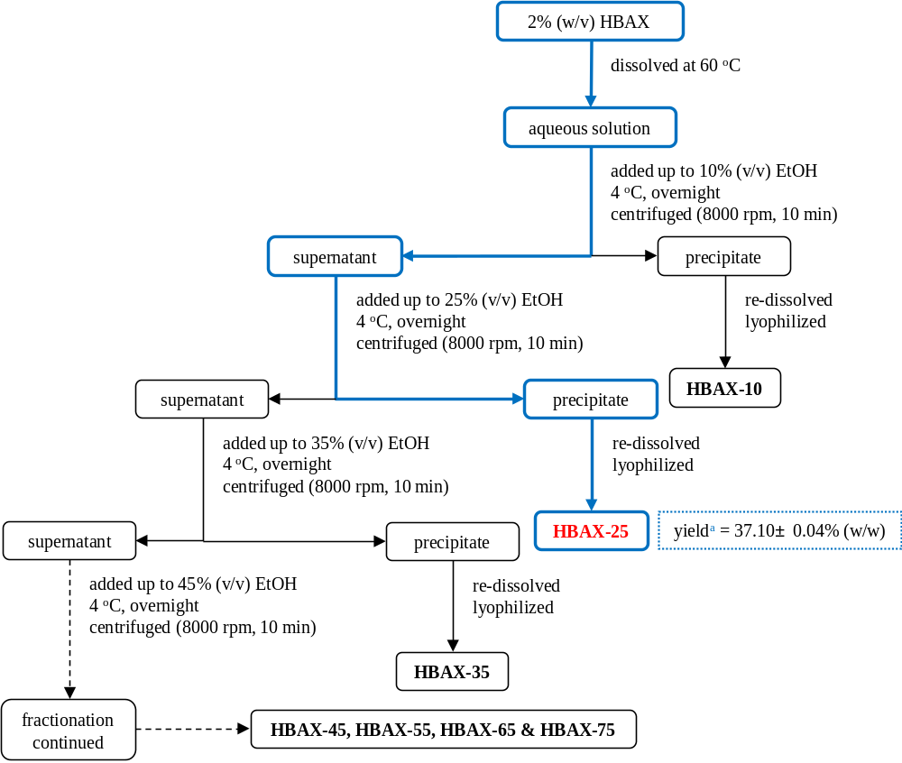

Fig. 1 The fractionation and separation procedure of different fractions from HBAX.

ª The yield of each fraction was based on HBAX mass.

2.4. Chemical composition of HBAX-25
The content of total sugar was obtained colorimetrically by phenol-sulfuric acid assay (Dubois, Gilles & Hamilton, 1956). Protein content was measured using Coomassie brilliant blue G-250 (Sangon Biotech (Shanghai) Co., Ltd., Shanghai, China) (Bradford, 1976). According to Guo, Cao, Wu & Wu (2016), the ash was determined via incineration in a muffle furnace at 550 ºC for 5h, the fat content was measured by the method of Soxhlet, and the determination of moisture was carried out by drying at 105 ºC until constant mass. In order to exhibit the proportion of arabinoxylan from total sugar content, the orcinol-hydrochloric acid method was applied (Delcour, Vanhamel & Geest, 1989). In addition, the percentage of β-glucan was determined using the Megazyme mixed-linkage β-glucan assay kit (AOAC method 995.16; Wicklow, Ireland) (McCleary & Mugford, 1997). Furthermore, the concentration of ferulic acid was quantified using a HPLC system (1260 Infinity, Agilent Technologies, Inc., Santa Clara, CA, USA), which was carried out on an XBridge C18 column (4.6 × 250 mm, 5 μm particle size; Waters Co., Auckland, New Zealand) at 30 ºC and detection wavelength of 320 nm. The mobile phase compositions and gradient elution program were showed in Table S1. The flow rate was kept at 1.0 mL/min, and 5 μL of standard and sample solutions was injected in each run.

2.5. Relative molecular weight determination of HBAX-25
The relative molecular weight profiles of HBAX-25 were determined by high-performance gel permeation chromatography (HPGPC; Agilent Technologies, Inc., Santa Clara, CA, USA) equipped with a refractive index detector. The mobile phase, which contained 0.1 M NaNO₃, was set to go through an Ultrahydrogel column (300 mm × 7.8 mm × 10 μm, Waters Co., Milford, MA, USA) at 35 ºC with a flow rate of 0.6 mL/min. Besides, 0.2% (w/v) HBAX-25 was pre-dissolved in mobile phase at 60 ºC and stayed overnight at 4 ºC for complete hydration, before it was filtered through a 0.45 μm membrane and injected onto HPGPC. In this work, dextrans of different molecular weights, i.e., 0.18, 2.70, 5.25, 9.75, 13.05, 36.80, 64.65, 135.35, 300.60 and 2,000 kDa, respectively, were employed as standard (Cyran, 2010; Feng, Dou, Alaxi, Niu & Yu, 2017).

2.6. UV-vis and FT-IR spectroscopy of HBAX-25
0.05% (w/v) aqueous solution of HBAX-25 was prepared and its UV spectrum (190 ~ 400 nm) at 25 ºC was obtained through a TU-1810PC UV-Vis Spectrophotometer (Beijing PERSEE General Instrument Co., Ltd., Beijing, China) using a quartz cuvette with 1 cm optical path. In addition, the FT-IR spectrum (4000 ~ 400 cm⁻¹) was scanned 128 times each at a resolution of 4 cm⁻¹ and recorded on a Nicolet 6700 FT-IR spectrometer (Thermo Fisher Scientific, Waltham, MA, USA) with an ATR accessory.

2.7. Monosaccharide composition of HBAX-25
The analysis of monosaccharide composition was conducted via gas chromatography (GC), which was elucidated graphically in Fig. 2 including hydrolysis and derivatization of HBAX-25 prior to being injected into a GC-2010 Plus Gas Chromatograph (GC-2010 plus, Shimadzu Co., Kyoto, Japan). Noteworthily, 0.1% (w/v) HBAX-25 was prepared and stored at 4 ºC overnight before used. During GC analysis, a DB-5 capillary column (30 m × 0.25 mm × 0.25 µm, Agilent Technologies, Inc., Santa Clara, CA, USA) combined with a helium carrier (1 mL/min) was applied to separate HBAX-25 derivatives. The column temperature was programmed as below: holding at 100 ºC for 5 min, rising to 190 ºC at 20 ºC/min and then to 260 ºC at 3 ºC/min before to 300 ºC at 10 ºC/min, eventually holding at 300 ºC for 10 min. The molar ratios (mol%) of different monosaccharides in HBAX-25 were calibrated and calculated by a series of standard solutions (50 μg/mL) of L-rhamnose (Rha), D-glucose (Glc), D-xylose (Xyl), D-mannose (Man), L-arabinose (Ara) and D-galactose (Gal).
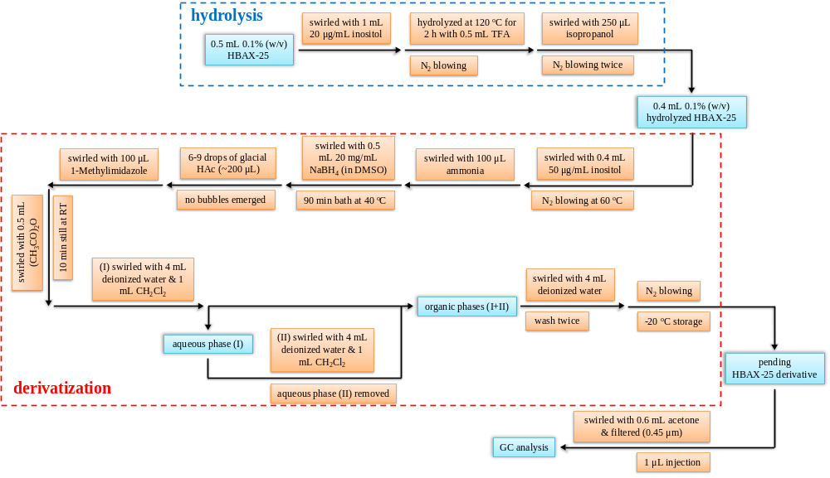

Fig. 2 The diagram of monosaccharide analysis of HBAX-25 via GC method.

2.8. Methylation and GC-MS analyses of HBAX-25
The patterns of monosaccharide linkages for HBAX-25 were preliminarily determined by methylation analysis (as shown in Fig. 3), which was performed in the light of Guo et al. (2016). Briefly, the sample was pre-methylated, hydrolyzed, reduced and acetylated in sequence to collect partially methylated alditol acetates (PMAAs), and then the PMAAs were loaded into a GCMS-QP2010 Ultra system (Shimadzu Co., Kyoto, Japan), which was equipped with a DB-5 capillary column (30 m × 0.25 mm × 0.25 µm) and a helium carrier (1 mL/min), for gas chromatography-mass spectroscopy (GC-MS) analysis. Moreover, the column temperature was set as: holding at 100 ºC for 2 min, 100 ~ 190 ºC at 15 ºC/min, 190 ~ 250 ºC at 5 ºC/min, 250 ~ 280 ºC at 10 ºC/min and holding at 280 ºC for 5 min, sequentially.
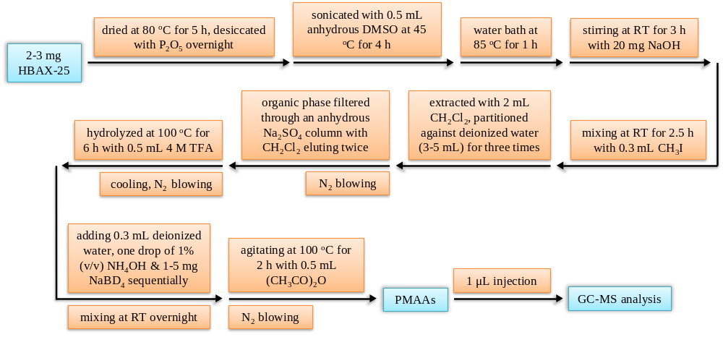

Fig. 3 The procedure of methylation analysis of HBAX-25.

2.9. NMR analysis of HBAX-25
The NMR analysis procedure was carried out as before (Guo et al., 2016) with minor modifications. 40 mg HBAX-25 dissolved in 0.5 mL 99.9% (v/v) D₂O (Cambridge Isotope Laboratories, Inc., Cambridge, MA, USA) was swirled for 3 h at 60 ºC before being fully hydrated at 4 ºC overnight. Afterwards, lyophilization treatment was consecutively performed for two days via FreeZone® TriadTM Freeze Dry System. For the substitution of -OH with -OD in HBAX-25 occurring entirely, those procedures were repeated thrice. Before the 1D- and 2D-NMR experiments, which were conducted on a Bruker Avance III 600 MHz NMR spectrometer (Bruker Co., Karlsruhe, Baden-Württemberg, Germany) at 25 ºC, the pretreated HBAX-25 was completely dissolved in 0.5 mL D₂O at 60 ºC for 3 h, using trimethylsilyl propionate (TSP) as an internal standard (-0.017 and -1.8 ppm for ¹H and ¹³C, respectively) (Cheng & Neiss, 2012). In this work, 2D-NMR data were obtained from ¹H-¹H correlation spectroscopy (COSY), ¹H-¹H total correlation spectroscopy (TOCSY), ¹H-¹³C heteronuclear single quantum coherence spectroscopy (HSQC) and ¹H-¹³C heteronuclear multiple bond correlation spectroscopy (HMBC), of which the chemical shifts (δ) were expressed in ppm.

3. Results and discussion

3.1. Chemical composition and relative molecular weight
The major chemical compositions of HBAX-25 were determined and analyzed in Table 1, compared with purified HBAX extracted under an optimal alkaline condition and bran powder from Hordeum vulgare L. var. nudum Hook. f. It was unveiled that the main components in hull-less barley bran were 51.74 ± 0.19% (w/w) sugar and 24.35 ± 0.51% (w/w) protein, while more satisfactory results were obtained for HBAX with a relatively high yield of 14.31 ± 0.06% (w/w), i.e., 72.64 ± 0.37% (w/w) sugar and 3.34 ± 0.20% (w/w) protein. Similarly, comparatively high contents of total sugar in crude arabinoxylans were also reported in DWR-162 (78.1%, w/w) and MACS-2496 (76.0%, w/w) varieties of Triticum aestivum L. (Revanappa, Nandini & Salimath, 2015). Moreover, this was, in particular, manifested via comparing the proportions of arabinoxylan between bran powder (31.65 ± 0.21%, w/w) and HBAX (65.78 ± 0.15%, w/w), which indicated a superior amount of arabinoxylans was more than doubled in HBAX after a series of alkaline extraction and purification procedures as aforementioned when compared to other crude arabinoxylans, such as from Hordeum Vulgare (50 ~ 63%, w/w, multiple extractions) (Höije, Gröndahl, Tømmeraas & Gatenholm, 2005), Triticum aestivum L. (44.3 ~ 49.3%, w/w, alkaline extraction) (Koegelenberg & Chimphango, 2017) and Triticum durum L. (39.53%, w/w, water extraction) (Pavlovich-Abril, Rouzaud-Sández, Carvajal-Millán, Navarro, Robles-Sánchez & Barrón-Hoyos, 2016). It could be implied that the composition and yield of polysaccharides were impacted by different extraction methods as well as culture environments and genotypes of plant-derived samples (Qian, Cui, Wu & Goff, 2012). Besides, Bender et al. (2018) demonstrated that the total contents of arabinoxylan from rye differed significantly (P ＜ 0.05) between water (38.57 ± 0.09%, w/w) and calcium hydroxide (63.82 ± 2.24%, w/w) extractions. Therefore, in order to release the major percentage of arabinoxylans in cereal grains, which are cross-linked (e.g., through di-ferulic acid bridges and covalent ester linkages) in an insoluble structure network, stricter treatments such as alkaline solutions could be required (Zhang, Smith & Li, 2014). On the other hand, since the highest yield (37.10 ± 0.04%, w/w) was obtained for HBAX-25, it was adopted and found to possess more proportions of sugar (87.57 ± 0.53%, w/w), esp. arabinoxylan (82.46 ± 0.24%, w/w), and less protein (1.08 ± 0.13%, w/w) than HBAX, which suggested its availability and feasibility as a potential alternative for application in different fields. For instance, Anderson and Simsek (2019) concluded that higher content of arabinoxylan (＞ 58.1% in cases investigated) was crucial for creating films as it eliminated some (though not all) of the variation in mechanical properties due to impurities, such as strength and flexibility.

Table 1 Chemical and monosaccharide compositions of powder, HBAX and HBAX-25 from hull-less barley bran.
 | Moisture  (%, w/w) | Ash  (%, w/w) | Protein  (%, w/w) | Fat  (%, w/w) | Sugar  (%, w/w) | Ferulic acid ^{c}  (%, w/w) | Arabinoxylan ^{d}  (%, w/w) | β-glucan  (%, w/w) | Monosaccharide compositions (mol%) |  |  |  |  | A/X
 |  |  |  |  |  |  |  |  | Xyl | Ara | Gal | Glc | Man | A/X
Powder | 14.29 ± 0.12 ª | 7.19 ± 0.23 | 24.35 ± 0.51 | 2.43 ± 0.14 | 51.74 ± 0.19 | 0.060 ± 0.009 | 31.65 ± 0.21 | 0.76 ± 0.07 | - | - | - | - | - | -
HBAX | 7.56 ± 0.29 | - ^{b} | 3.34 ± 0.20 | - | 72.64 ± 0.37 | 0.018 ± 0.003 | 65.78 ± 0.15 | 4.60 ± 0.08 | 45.92 | 36.99 | 9.21 | 3.52 | 4.36 | 0.81
HBAX-25 | 8.31 ± 0.14 | - | 1.08 ± 0.13 | - | 87.57± 0.53 | 0.029 ± 0.002 | 82.46 ± 0.24 | 4.56 ± 0.05 | 51.55 | 30.13 | 10.33 | 5.09 | 2.90 | 0.58
ª Expressed as mean ± standard deviation (n = 3).
^{b} Not measured.
^{c} Based on arabinoxylan mass (mean ± standard deviation, n = 3).
^{d} Measured using orcinol-hydrochloric acid method.

The weight-average relative molecular weight ($\overline{M_{w}}$), number-average relative molecular weight ($\overline{M_{n}}$) and distribution of HBAX-25 were obtained by means of HPGPC method. The molecular parameters were resulted in 298.36 kDa and 45.25 kDa for $\overline{M_{w}}$ and $\overline{M_{n}}$, respectively, while the polydispersity index (PDI, $\overline{M_{w}}$/$\overline{M_{n}}$) was in a high value of 6.59, indicating some degree of heterogeneity for alkali-extracted HBAX-25. This was also encountered previously by Dervilly, Leclercq, Zimmermann, Roue, Thibault and Saulnier (2002), which is probably due to the facts as below: i) as glycosidic linkages in the backbone of HBAX-25 were resistant to alkaline treatment used in this work, the acidic environment formed after de-proteinization process (pH 4.5 overnight) could promote the hydrolysis of glycosidic linkages in HBAX-25, thus leading to a relatively high polydispersity in a narrow range (10 ~ 15%, v/v) of stepwise precipitation using ethanol (Bastos, Coelho & Coimbra, 2018); ii) different levels of molecular aggregation of HBAX-25 might occur via the formation of intermolecular hydrogen bonds, thereby exhibiting comparatively high PDI when chromatographed by HPGPC (Izydorczyk, 2014). Besides, Hromádková, Paulsen, Polovka, Košťálová and Ebringerová (2013) also revealed that the formation of aggregates by carbohydrate-protein associations or cross-links through the ferulic acid substituents could be possibly accountable for high relative molecular weight of arabinoxylan, which should contain higher proportion of protein or ferulic acid compared to ours in this work.

3.2. UV-vis and FT-IR analyses
As shown in Fig. 4A, relatively strong peaks of absorption occurring around 192 nm were observed for both HBAX and its fraction HBAX-25, indicative of the presence of polysaccharides as major components (Guo, Cao, Wu & Wu, 2016). Regarding the absorptions peaked at 280 nm, which indicated the proteinaceous existence, it is obvious that only marginal amount of protein was detected spectroscopically for HBAX, which was consistent with the results from Table 1. Meanwhile, no nucleic acid existed in HBAX and HBAX-25 due to the absence of absorbance at 260 nm (Guo, Cao, Wu & Wu, 2016). Therefore, it could be reasonably deduced that the purification of HBAX was relatively adequate in this work.
The FT-IR spectra of HBAX and HBAX-25 were depicted in Fig. 4B based on the typical spectral patterns and absorption modes identified previously (Cui, Phillips, Blackwell & Nikiforuk, 2007; Guo, Cao, Wu & Wu, 2016; Hromádková, Paulsen, Polovka, Košťálová & Ebringerová, 2013; Kačuráková, Capek, Sasinková, Wellner & Ebringerová, 2000; Pavlovich-Abril, Rouzaud-Sández, Carvajal-Millán, Navarro, Robles-Sánchez & Barrón-Hoyos, 2016; Sárossy, Tenkanen, Pitkänen, Bjerre & Plackett, 2013). In general, two relatively extensive absorptions, i.e. 3430.74 cm⁻¹ and 3434.91 cm⁻¹, were distinguished for HBAX and HBAX-25, respectively, which were attributed to the vibration of O-H stretching (3600 ~ 2500 cm⁻¹) indicating inter-/intra-hydrogen bonding interactions in polysaccharide networks, where C-H stretching modes of asymmetric CH₂- groups (2940 ~ 2920 cm⁻¹) were peaked at 2927.41 cm⁻¹ (HBAX) and 2919.42 cm⁻¹ (HBAX-25). Additionally, the stretching absorptions at 1646.91 cm⁻¹ and 1630.96 cm⁻¹, corresponding to asymmetric COO- (1700 ~ 1600 cm⁻¹), as well as 1398.14 cm⁻¹ and 1400.54 cm⁻¹, assigned to symmetric COO- (1400 ~ 1300 cm⁻¹), were reportedly responsible for the presence of uronic acid in HBAX and HBAX-25 (Guo, Cao, Wu & Wu, 2016). However, the result was not in line with the analysis of monosaccharide compositions (Table 1). On the one hand, it should be noteworthy that the phenolic compounds and proteins could have specific absorption bands in the region of 1700 ~ 1500 cm⁻¹ (Sárossy, Tenkanen, Pitkänen, Bjerre & Plackett, 2013). On the other hand, the intensity of amide I (1658 ~ 1650 cm⁻¹) and amide II (1548 ~ 1530 cm⁻¹) bands should be seen clearly in the FT-IR spectra (Fig. 4B) to hint the adequate existence of protein (Hromádková, Paulsen, Polovka, Košťálová & Ebringerová, 2013; Pavlovich-Abril, Rouzaud-Sández, Carvajal-Millán, Navarro, Robles-Sánchez & Barrón-Hoyos, 2016; Sárossy, Tenkanen, Pitkänen, Bjerre & Plackett, 2013). Consequently, a small amount of protein, as well as ferulic acid mainly bound to the side chains of arabinoxylan, was more likely to consist in HBAX and HBAX-25. Furthermore, it is broadly recognized that the vibration modes between 1200 and 800 cm⁻¹ are considered as the “finger-print” zone of polysaccharides, which contain multiple contributions of coupled C-O-C, C-C-O and C-OH vibrations. Amid the zone, the absorption bands (1200 ~ 1000 cm⁻¹), where vibrations of ring overlapped with lateral groups (C-OH) and glycosidic linkages (C-O-C) occur, are particularly useful for structural identification. As exhibited in Fig. 4B, one comparatively intense peak (1039.44 cm⁻¹ and 1007.94 cm⁻¹), indicative of C-OH bendings, with a shoulder (993.16 cm⁻¹ and 980.65 cm⁻¹) was found for HBAX and HBAX-25, respectively, which is typical for arabinoxylan-type polysaccharides (Hromádková, Paulsen, Polovka, Košťálová & Ebringerová, 2013; Sárossy, Tenkanen, Pitkänen, Bjerre & Plackett, 2013). Moreover, the characteristic “anomeric region” for β-linkage of pyranose (ca. 898 cm⁻¹) and α-linkage of furanose (ca. 858 cm⁻¹) was recognized for HBAX (892.88 and 863.95 cm⁻¹) and HBAX-25 (891.76 and 861.22 cm⁻¹) (Kačuráková, Capek, Sasinková, Wellner & Ebringerová, 2000).
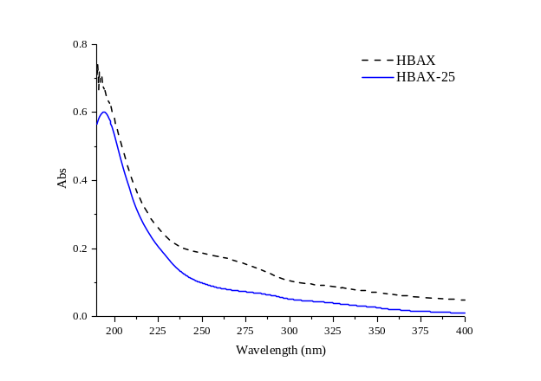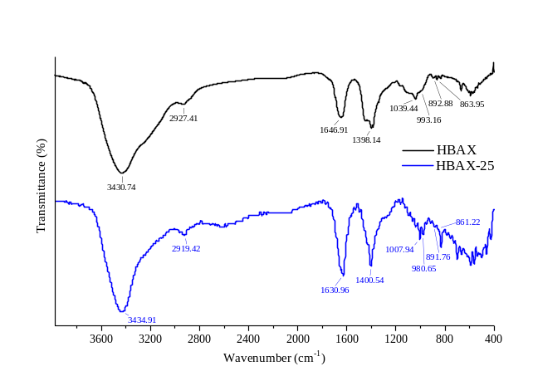
(A) (B)

Fig. 4 The UV-vis (A) and FT-IR (B) spectra of HBAX and HBAX-25 from hull-less barley bran.

3.3. Monosaccharide composition analysis
With the application of GC, the monosaccharide compositions and molar ratios of Ara to Xyl (A/X), which are described as an average measure of the branching degree of arabinoxylan (Bastos, Coelho & Coimbra, 2018), were compared and analyzed for HBAX and its fraction HBAX-25 (Table 1). Evidently, there were mainly five different monosaccharides found in HBAX and HBAX-25, while the smallest amounts of constituents were confirmed, separately, as Glc (3.52 mol%) and Man (2.90 mol%), which also signified that the enzymatic starch removal employed in this work was relatively effective. Furthermore, among those monosaccharides, it is apparent that Xyl and Ara were the dominant neutral elements, of which the total contents were added up to 82.91 mol% and 81.68 mol% for HBAX and HBAX-25, respectively, with A/X molar ratios of 0.81 and 0.58 correspondingly, probably representative for arabinoxylans within the general range of A/X ratio (0.4 ~ 1.2) in bran (Bastos, Coelho & Coimbra, 2018). It was possible that the different A/X ratios were resulted from distinguishing arabinose sources (e.g., arabinogalactan) and processes of extraction and isolation (e.g., alkaline extraction and isolation via sequential ethanol precipitation). In addition, the A/X molar ratio of HBAX-25 (0.58) was comparable to those of bran arabinoxylans from Secale cereal (0.57) (Sárossy, Tenkanen, Pitkänen, Bjerre & Plackett, 2013), hull-less barley (Zangqing cultivar, 0.55) (Zheng, Li & Wang, 2011b), and wheat (0.6) (Koegelenberg & Chimphango, 2017), while similar results to A/X molar ratio of HBAX (0.81) were also unveiled from Triticum aestivum (0.85 ~ 0.88) (Hromádková, Paulsen, Polovka, Košťálová & Ebringerová, 2013) and wheat (0.83) (Aguedo, Fougnies, Dermience & Richel, 2014). According to Koegelenberg and Chimphango (2017), the A/X ratio is directly related to the solubility of extracts, and a decrease of Ara substitution is likely to result in inferior aqueous solubility. As compared to HBAX, the solubility of HBAX-25 with lower A/X molar ratio in water could be restricted to some extent, which is likely to be attributable to several factors, such as the aggregation of un-substituted regions stabilized by hydrogen bonds (Courtin & Delcour, 2002), intra-/inter-molecular crosslinks and interactions induced by the existence of free/bound ferulic acids. Hence, it is speculated that polysaccharides from the hull-less barley bran might be considered as arabinoxylans, of which the A/X ratio was likely to exert impact on the functionality of HBAX-25 as well as the physicochemical and technological properties of products, e.g., in bread-making process (Koegelenberg & Chimphango, 2017).

3.4. Methylation analysis of HBAX-25
In terms of the comprehensive analysis of monosaccharide composition (Table 1) and NMR elucidation (referred to section 3.5), the results of methylation analysis for HBAX-25 after comparisons with standard mass spectra of PMAAs (Carpita & Shea, 1989) were compiled in Table 2, where eight sugar derivatives were mainly observed, i.e., 2,3,4-O-Me₃-Xyl (1.84 mol%), 2,3-O-Me₂-Xyl (40.16 mol%), 2-O-Me-Xyl (8.34 mol%), pentaacetate-Xyl (6.07 mol%), 2,3,5-O-Me₃-Ara (31.80 mol%), 2,5-O-Me₂-Ara (3.16 mol%), 2,4,6-O-Me₃-Gal (3.76 mol%) and 2,3,6-O-Me₃-Gal (4.87 mol%), which were determined as T-D-Xylp, 1,4-linked D-Xylp, 1,3,4-linked D-Xylp, 1,2,3,4-linked D-Xylp, T-L-Araf, 1,3-linked L-Araf, 1,3-linked D-Galp and 1,4-linked D-Galp, respectively. In contrast to a medium-branched wheat arabinoxylan (Hromádková, Paulsen, Polovka, Košťálová & Ebringerová, 2013), it is unmasked that the preliminary structure of HBAX-25 was proposed as a relatively low-branched arabinoxylan with 1,4-linked backbone consisting of un-substituted (71.19%), mono-substituted (O-3, 14.78%) and di-substituted (O-2,3, 10.76%) D-Xylp residues, where T-D-Xylp might be underestimated due to susceptibility to acidic damage during methylation analysis (Ding, Qian, Goff, Wang & Cui, 2018), while the largest amount of T-L-Araf (31.80 mol%) was possibly appended directly to D-Xylp backbone or other sugar segments. Similarly, the T-D-Xylp was also presumed to be either at the non-reducing end of D-Xylp backbone, as a single side chain attached to O-3 position of D-Xylp backbone, or linked at O-2/-3 sites of L-Araf units in branches (Rumpagaporn, Reuhs, Kaur, Patterson, Keshavarzian & Hamaker, 2015). According to Yadav, Kale, Hicks and Hanah (2017), less branched structure of arabinoxylan may be associated with lower water holding capacity and viscosity of suspension, which should be demonstrated and improved in further research.
As for the comparison of A/X ratios based on different analyses (Table S2), however, it should be noted that more accurate degree of substitution for arabinoxylan (the “real” A/X ratio) could be derived from the proportion of ramified positions in D-Xylp backbone, which was the lowest (0.36) indicating that the HBAX-25 was slightly contaminated with other arabino-polysaccharides, e.g., arabinogalactan as per the methylation analysis (Table 2), similar to that obtained from Triticum aestivum (Hromádková, Paulsen, Polovka, Košťálová & Ebringerová, 2013). Besides, it is possible that a slightly greater value (0.62) of A/X ratio, which was uncovered from the GC of PMAAs (Table S2), was induced by under-methylation, incomplete hydrolysis and selective losses of volatile components related to D-Xylp in HBAX-25 during solvent evaporation (Blakeney, Harris, Henry & Stone, 1983; Harris, Henry, Blakeney & Stone, 1984). Furthermore, the degree of branching (DB) for HBAX-25 was also calculated to be 0.48 denoting its branched structure, which is substantiated by the arabinoxylan from Linum usitatissiumum L. (Ding, Qian, Goff, Wang & Cui, 2018).

Table 2 Major linkage patterns of monosaccharide residues in HBAX-25 via methylation analysis.
Retention times  (min) | PMAAs | Fragments ª  (diagnostic ions, m/z) | Linkage patterns | Molar ratios ^{b}  (mol%)
8.12 | 1,4-di-O-acetyl-(1-deuterio)-2,3,5-tri-O-methyl arabitol | 45, 101, 102, 118, 129, 145, 161, 162, 205 | T-L-Araf | 31.80
8.47 | 1,5-di-O-acetyl-(1-deuterio)-2,3,4-tri-O-methyl xylitol | 101, 102, 117, 118, 161, 162 | T-D-Xylp | 1.84
8.98 | 1,3,4-tri-O-acetyl-(1-deuterio)-2,5-di-O-methyl arabitol | 113, 118, 173, 233 | 1,3-linked L-Araf | 3.16
9.37 | 1,4,5-tri-O-acetyl-(1-deuterio)-2,3-di-O-methyl xylitol | 87, 102, 118, 129, 162, 173, 189, 233 | 1,4-linked D-Xylp | 40.16
10.20 | 1,3,4,5-tetra-O-acetyl-(1-deuterio)-2-O-methyl xylitol | 118, 201, 261 | 1,3,4-linked D-Xylp | 8.34
10.70 | 1,3,5-tri-O-acetyl-(1-deuterio)-2,4,6-tri-O-methyl galactitol | 45, 101, 118, 129, 161, 174, 217, 234, 277 | 1,3-linked D-Galp | 3.76
10.80 | 1,4,5-tri-O-acetyl-(1-deuterio)-2,3,6-tri-O-methyl galactitol | 45, 102, 113, 118, 162, 173, 233, 277 | 1,4-linked D-Galp | 4.87
10.99 | 1,2,3,4,5-penta-O-acetyl-(1-deuterio) xylitol | 73, 74, 145, 146, 217, 218, 289, 290 | 1,2,3,4-linked D-Xylp | 6.07
ª Determined from mass spectra of PMAAs in Fig. S2.
^{b} Obtained from the ratio of main peak areas.

3.5. NMR analysis of HBAX-25
As aforementioned, HBAX-25 was initially considered as a low-branched arabinoxylan possibly contaminated with a few arabinogalactans. Thus, 1D- and 2D-NMR information were recorded for further identification and confirmation of its fine structure based on the resonance assignment of proton/carbon signals in HBAX-25. As shown in Table 3, the chemical shifts of proton/carbon signals for HBAX-25 were obtained from ¹H (600.13 MHz) and ¹³C (150.92 MHz) spectra, respectively, and compared with the NMR data of other arabinoxylans. Specifically, the proton/carbon signals of T-L-Araf could be classified as A^{T} (3mX), A^{T} (3dX) and A^{T} (2dX) in terms of their appendences to O-3-mono-substituted or O-2,3-di-substituted D-Xylp residues, of which the proton signals in anomeric region (Fig. 5A) were explicitly assigned as 5.28, 5.23 and 5.19 ppm, separately, indicating the nature of α-configuration for T-L-Araf (5.6 ~ 5.0 ppm) (Hoffman, Kamerling & Vliegenthart, 1992). With regard to other assignments in ¹H spectra (Fig. 5A & 5B), however, it was difficult to identify them clearly due to overlapping of diverse structural signals, and 2D-NMR spectra of ¹H-¹H COSY (Fig. S1A & S1B) were too ambiguous to be distinguished alone. Hence, the recognition of multiple signals was initiated in ¹³C spectra (Fig. 5C & 5D), where assignments were readily to be revealed, and then determined correspondingly with the aid of cross-peaks in ¹H-¹³C HSQC spectra (Fig. 5E & 5F). It was clearly resulted (Table 3) that signal at 5.28 ppm was responsible for the identification of 3-α-L-Araf (A³) anomeric proton, while signals at 4.48, 4.46, 4.49, 4.64, 4.46 and 4.60 ppm were interpretable to the β-anomerization of T-D-Xylp (X^{T}), 1,4-D-Xylp (X⁴), 1,3,4-D-Xylp (X³⁴), 1,2,3,4-D-Xylp (X²³⁴), 1,3-D-Galp (G³) and 1,4-D-Galp (G⁴), respectively (Toole, Barron, Le Gall, Colquhoun, Shewry & Mills, 2009). Similarly, the anomeric assignments in ¹³C spectra (Fig. 5C & 5D) were performed, which were ascribed to A^{T} (3mX, 108.03 ppm), A^{T} (3dX, 108.07 ppm), A^{T} (2dX, 108.67 ppm), A³ (108.67 ppm), X^{T} (101.66 ppm), X⁴ (101.60 ppm), X³⁴ (101.79 ppm), X²³⁴ (99.80 ppm), G³ (102.53 ppm) and G⁴ (102.63 ppm), accordingly. As for the A/X ratios of HBAX-25, which is a crucial parameter interrelated with the molecular flexibility, solubility, rheological behavior as well as synergistic interaction of macromolecules, could be also acquired approximately as 0.31 and 0.33 (Table S2) from the relative peak areas in ¹H and ¹³C anomeric regions, separately, which were close to that proposed as the proportion of ramified sites in β-D-Xylp backbone, consolidating the assumption that HBAX-25 was probably contaminated with slight arabinogalactans. Moreover, due to the impact on chain conformation of arabinoxylan, the distribution of α-L-Araf substituents along its β-D-Xylp backbone could be of more interest than the degree of substitution (Skendi, Biliaderis, Izydorczyk, Zervou & Zoumpoulakis, 2011).

Table 3 ¹H and ¹³C NMR chemical shifts for HBAX-25 compared with other arabinoxylans.
Residue linkages | Origins | Temperatures  (ºC) | Concentrations  (mg/mL) | Resonance frequencies  (MHz) | Chemical shifts (δ, ppm)
 |  |  |  |  | H1/C1 | H2/C2 | H3/C3 | H4/C4 | H5, H5’/C5 | H6, H6’/C6
α-L-Araf
T-α-L-Araf (3mX) | A ª | 25 | 80 | 600 | 5.28/108.03 | 4.17/80.91 | 3.94/77.49 | 4.31/84.35 | 3.79, 3.76/61.19 | —
T-α-L-Araf (3mX) | B ^{b} | 85 | 7.14-8.57 | 600 | 5.36/108.2 | 4.14/81.5 | 3.9/77.8 | 4.22/85.3 | 3.77, 3.72/62.0 | —
T-α-L-Araf (3mX) | C ^{c} | 65 | 40 | 400 | 5.40/108.16 | 4.20/81.40 | 3.92/77.81 | 4.20/85.29 | 3.77, 3.75/62.01 | —
T-α-L-Araf (3dX) | A |  |  |  | 5.23/108.07 | 4.17/80.94 | 3.96/77.55 | 4.31/84.24 | 3.79, 3.76/61.05 | —
T-α-L-Araf (3dX) | B |  |  |  | 5.26/108.5 | 4.14/81.7 | 3.92/77.9 | 4.23/84.9 | 3.77, 3.72/62.0 | —
T-α-L-Araf (3dX) | C |  |  |  | 5.29/108.53 | 4.20/81.67 | 3.92/78.00 | 4.20/85.29 | 3.77, 3.75/61.88 | —
T-α-L-Araf (2dX) | A |  |  |  | 5.19/108.67 | 4.16/81.15 | 3.97/77.14 | 4.12/84.23 | 3.79, 3.76/60.89 | —
T-α-L-Araf (2dX) | B |  |  |  | 5.19/109.0 | 4.12/82.1 | 3.95/77.5 | 4.1/84.8 | 3.77, 3.72/62.0 | —
T-α-L-Araf (2dX) | C |  |  |  | 5.22/109.16 | 4.16/82.01 | 3.95/77.10 | 4.12/84.79 | 3.77, 3.75/61.88 | —
1,3-α-L-Araf | A |  |  |  | 5.28/108.67 | 4.16/80.94 | 3.97/84.43 | 4.12/84.35 | 3.67, 3.69/60.89 | —
1,3-α-L-Araf | D ^{d} | 70 | 20 | 500 | 5.16/108.7 | 4.08/80.9 | 3.82/85.2 | 4.19/83.6 | 3.61, 3.67/62.0 | —
1,3-α-L-Araf | E ^{e} | 20 | 60 | 600 | 5.29/108.28 | 4.39/79.44 | 3.97/82.52 | 4.20/84.97 | 3.52, 3.70/61.09 | —
β-D-Xylp
1,4-β-D-Xylp | A |  |  |  | 4.46/101.60 | 3.30/72.64 | 3.56/73.60 | 3.79/75.55 | 4.11, 3.38/62.92 | —
1,4-β-D-Xylp | B |  |  |  | 4.45/101.7 | 3.3/73.3 | 3.55/74.3 | 3.77/77.0 | 4.08, 3.37/63.4 | —
1,4-β-D-Xylp | C |  |  |  | 4.50/102.20 | 3.34/73.27 | 3.58/74.30 | 3.78/76.99 | 4.11, 3.34/63.57 | —
1,3,4-β-D-Xylp | A |  |  |  | 4.49/101.79 | 3.43/72.71 | 3.77/76.32 | 3.87/73.60 | 4.11, 3.38/62.92 | —
1,3,4-β-D-Xylp | B |  |  |  | 4.49/101.9 | 3.45/73.7 | 3.72/77.8 | 3.84/74.3 | 4.08, 3.37/63.4 | —
1,3,4-β-D-Xylp | C |  |  |  | 4.52/101.79 | 3.45/73.54 | 3.75/78.02 | 3.82/74.31 | 4.11, 3.34/63.56 | —
1,2,3,4-β-D-Xylp | A |  |  |  | 4.64/99.80 | 3.56/78.54 | 3.81/76.27 | 3.89/73.68 | 4.11, 3.38/62.92 | —
1,2,3,4-β-D-Xylp | B |  |  |  | 4.64/100.6 | 3.58/78.6 | 3.83/77.7 | 3.83/74.3 | 4.08, 3.37/63.4 | —
1,2,3,4-β-D-Xylp | C |  |  |  | 4.65/100.52 | 3.59/78.81 | 3.84/77.40 | 3.84/74.31 | 4.11, 3.34/63.13 | —
T-β-D-Xylp | A |  |  |  | 4.48/101.66 | 3.31/73.60 | 3.43/76.37 | 3.63/69.36 | 3.98, 3.33/65.16 | —
T-β-D-Xylp | C |  |  |  | 4.57/103.12 | 3.37/73.51 | 3.45/76.24 | 3.62/69.80 | 3.99, 3.32/65.82 | —
T-β-D-Xylp | D |  |  |  | 4.43/104.0 | 3.19/73.8 | 3.29/76.5 | 3.48/70.1 | 3.83, 3.14/65.9 | —
β-D-Galp
1,3-β-D-Galp | A |  |  |  | 4.46/102.53 | 3.51/71.81 | 3.64/82.91 | 4.02/69.41 | 3.97/73.99 | 3.91, 3.66/60.67
1,3-β-D-Galp | F ^{f} | 27 | — ^{i} | 500 | 4.44/104.5 | 3.52/71.7 | 3.63/84.0 | 3.99/69.0 | 3.97/74.0 | 3.91, 3.68/61.5
1,4-β-D-Galp | A |  |  |  | 4.60/102.63 | 3.67/72.78 | 3.69/75.44 | 4.16/78.33 | 3.76/74.77 | 3.83, 3.80/62.49
1,4-β-D-Galp | G ^{g} | 30 | — | 600 | 4.62/106.1 | 3.68/73.6 | 3.76/75.1 | 4.16/79.4 | 3.70/76.2 | 3.82, 3.79/62.6
1,4-β-D-Galp | H ^{h} | 70 | 20 | 400 | 4.60/105.2 | 3.67/72.8 | 3.68/75.4 | 4.14/78.4 | 3.75/74.2 | 3.81, 3.78/61.7
ª referred to the bran of Hordeum vulgare L. var. nudum Hook. f. (HBAX-25) in this work.
^{b} referred to the seed of Triticum aestivum L. (Dodoni cultivar) (Skendi, Biliaderis, Izydorczyk, Zervou & Zoumpoulakis, 2011).
^{c} referred to the Chinese black-grained wheat bran (Sun, Cui, Gu & Zhang, 2011).
^{d} referred to the seed mucilage of Linum usitatissiumum L. (Ding, Qian, Goff, Wang & Cui, 2018).
^{e} referred to the seed of Plantago asiatica L. (Yin, Lin, Nie, Cui & Xie, 2012).
^{f} referred to the corm of Amorphophallus campanulatus (Das et al., 2009).
^{g} referred to the phloem fibers of Linum usitatissimum L. (Mikshina, Gurjanov, Mukhitova, Petrova, Shashkov & Gorshkova, 2012).
^{h} referring to the fruit pulp of Sicana odorifera (Kienteka, Corrêa-Ferreira & de Oliveira Petkowicz, 2018).
^{i} not mentioned or detected.

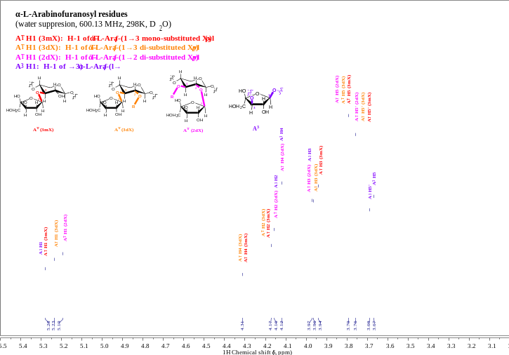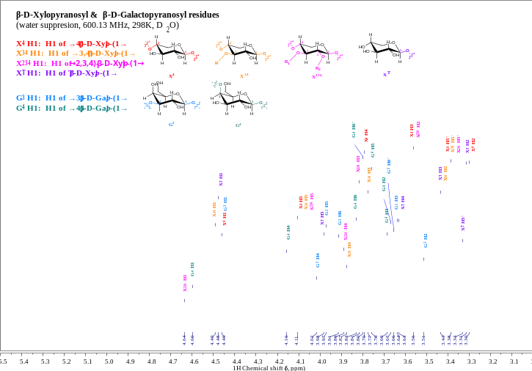
(A) (B)
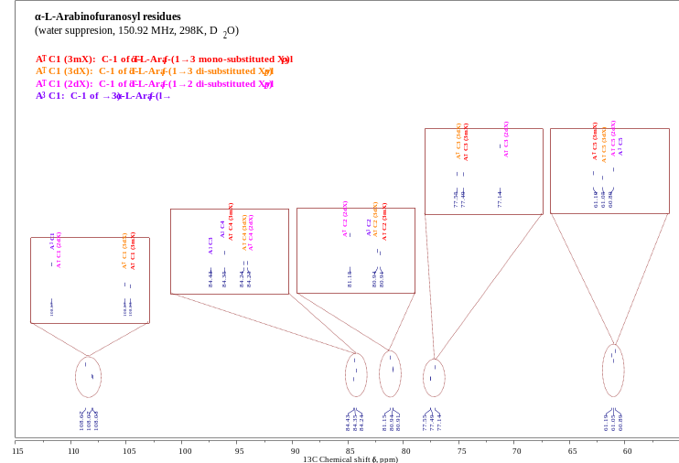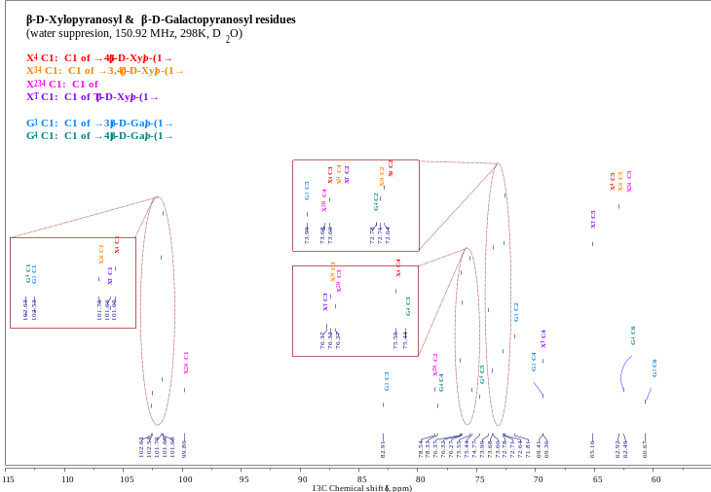
(C) (D)
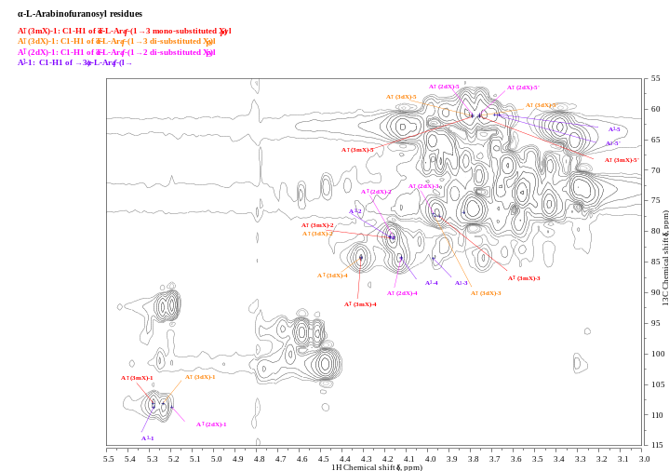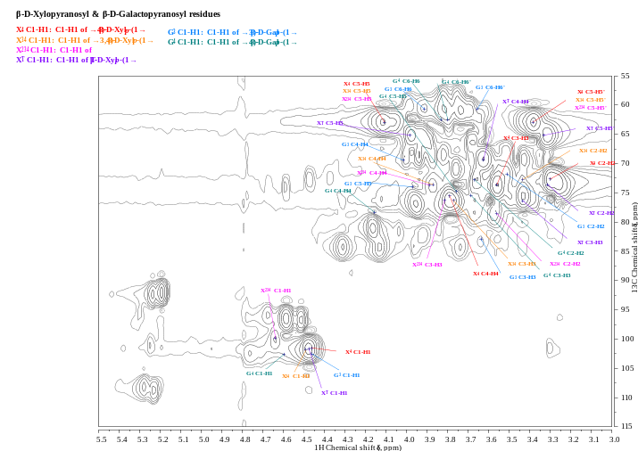
(E) (F)
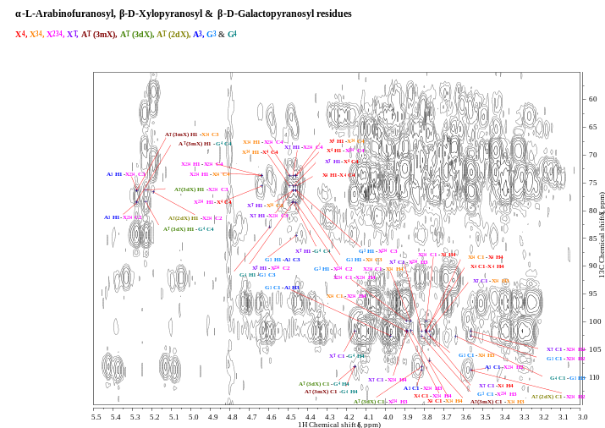

Fig. 5 ¹H (A & B), ¹³C (C & D), HSQC (E & F) and HMBC (G) spectra of HBAX-25 from hull-less barley bran.
(G)

In order to determine glycosidic linkages existing variously in HBAX-25, the ¹H-¹³C HMBC spectrum (Fig. 5G) was applied, where significant proton/carbon connectivities between two sugar residues were mapped in pair and listed in Table 4. For instance, the correlation signals (X⁴ H1-X⁴ C4 vs. X⁴ C1-X⁴ H4, X⁴ H1-X³⁴ C4 vs. X⁴ C1-X³⁴ H4, X⁴ H1-X²³⁴ C4 vs. X⁴ C1-X²³⁴ H4) between β-D-Xylp residues implied that the O-1 of 1,4-β-D-Xylp was connected to the O-4 of 1,4-β-D-Xylp, 1,3,4-β-D-Xylp or 1,2,3,4-β-D-Xylp via (1→4) linkages. Among those, it should be noteworthy that the intersections of A^{T} (3mX/3dX) H1-G⁴ C4 vs. A^{T} (3mX/3dX) C1-G⁴ H4 and G⁴ H1-G³ C3 vs. G⁴ C1-G³ H3 were detected, which could be expressed briefly as A^{T}-G⁴-G³- indicating the presence of arabinogalactans as individuals (contaminants) or branched groups. Additionally, similar intersecting signals were also unveiled to advocate the existence of X^{T}-G⁴-G³-, A^{T}-G⁴-G³-A³- and X^{T}-G⁴-G³-A³-. Therefore, the fine structure of HBAX-25 (Fig. 6) was probably proposed as a relatively low-branched arabinoxylan consisting of un-substituted (71.19%), mono-substituted (O-3, 14.78%) and di-substituted (O-2,3, 10.76%) β-D-Xylp as the main chain via (1→4) linkages, where possible branches or individuals involved A^{T}, X^{T}, A^{T}-G⁴-G³-, A^{T}-G⁴-G³-A³-, X^{T}-G⁴-G³- and X^{T}-G⁴-G³-A³-.

Table 4 The chemical shift pairs for significant anomeric proton/carbon connectivities in HMBC spectrum of HBAX-25.
Residue linkages | Symbols | Atoms | Chemical shift pairs (δ, ppm) for significant connectivities |  | Atoms | Symbols | Residue linkages
Residue linkages | Symbols | Atoms | δ_{H}/δ_{C} | δ_{C}/δ_{H} | Atoms | Symbols | Residue linkages
1,4-β-D-Xylp | X⁴ | X⁴-1 | 4.46/75.55 | 101.60/3.79 | X⁴-4 | X⁴ | 1,4-β-D-Xylp
1,4-β-D-Xylp | X⁴ | X⁴-1 | 4.46/73.60 | 101.60/3.87 | X³⁴-4 | X³⁴ | 1,3,4-β-D-Xylp
1,4-β-D-Xylp | X⁴ | X⁴-1 | 4.46/73.68 | 101.60/3.89 | X²³⁴-4 | X²³⁴ | 1,2,3,4-β-D-Xylp
T-β-D-Xylp | X^{T} | X^{T}-1 | 4.48/75.55 | 101.66/3.79 | X⁴-4 | X⁴ | 1,4-β-D-Xylp
T-β-D-Xylp | X^{T} | X^{T}-1 | 4.48/76.32 | 101.66/3.77 | X³⁴-3 | X³⁴ | 1,3,4-β-D-Xylp
T-β-D-Xylp | X^{T} | X^{T}-1 | 4.48/73.68 | 101.66/3.89 | X²³⁴-4 | X²³⁴ | 1,2,3,4-β-D-Xylp
T-β-D-Xylp | X^{T} | X^{T}-1 | 4.48/78.54 | 101.66/3.56 | X²³⁴-2 | X²³⁴ | 1,2,3,4-β-D-Xylp
T-β-D-Xylp | X^{T} | X^{T}-1 | 4.48/76.27 | 101.66/3.81 | X²³⁴-3 | X²³⁴ | 1,2,3,4-β-D-Xylp
T-β-D-Xylp | X^{T} | X^{T}-1 | 4.48/78.33 | 101.66/4.16 | G⁴-4 | G⁴ | 1,4-β-D-Galp
1,3,4-β-D-Xylp | X³⁴ | X³⁴-1 | 4.49/75.55 | 101.79/3.79 | X⁴-4 | X⁴ | 1,4-β-D-Xylp
1,3,4-β-D-Xylp | X³⁴ | X³⁴-1 | 4.49/73.68 | 101.79/3.89 | X²³⁴-4 | X²³⁴ | 1,2,3,4-β-D-Xylp
1,2,3,4-β-D-Xylp | X²³⁴ | X²³⁴-1 | 4.64/75.55 | 99.80/3.79 | X⁴-4 | X⁴ | 1,4-β-D-Xylp
1,2,3,4-β-D-Xylp | X²³⁴ | X²³⁴-1 | 4.64/73.60 | 99.80/3.87 | X³⁴-4 | X³⁴ | 1,3,4-β-D-Xylp
1,2,3,4-β-D-Xylp | X²³⁴ | X²³⁴-1 | 4.64/73.68 | 99.80/3.89 | X²³⁴-4 | X²³⁴ | 1,2,3,4-β-D-Xylp
T-α-L-Araf (3mX) | A^{T} (3mX) | A^{T} (3mX)-1 | 5.28/76.32 | 108.03/3.77 | X³⁴-3 | X³⁴ | 1,3,4-β-D-Xylp
T-α-L-Araf (3dX) | A^{T} (3dX) | A^{T} (3dX)-1 | 5.23/76.27 | 108.07/3.81 | X²³⁴-3 | X²³⁴ | 1,2,3,4-β-D-Xylp
T-α-L-Araf (2dX) | A^{T} (2dX) | A^{T} (2dX)-1 | 5.19/78.54 | 108.67/3.56 | X²³⁴-2 | X²³⁴ | 1,2,3,4-β-D-Xylp
T-α-L-Araf (3mX) | A^{T} (3mX) | A^{T} (3mX)-1 | 5.28/78.33 | 108.03/4.16 | G⁴-4 | G⁴ | 1,4-β-D-Galp
T-α-L-Araf (3dX) | A^{T} (3dX) | A^{T} (3dX)-1 | 5.23/78.33 | 108.07/4.16 | G⁴-4 | G⁴ | 1,4-β-D-Galp
1,3-α-L-Araf | A³ | A³-1 | 5.28/76.27 | 108.67/3.81 | X²³⁴-3 | X²³⁴ | 1,2,3,4-β-D-Xylp
1,3-α-L-Araf | A³ | A³-1 | 5.28/78.54 | 108.67/3.56 | X²³⁴-2 | X²³⁴ | 1,2,3,4-β-D-Xylp
1,4-β-D-Galp | G⁴ | G⁴-1 | 4.60/82.91 | 102.63/3.64 | G³-3 | G³ | 1,3-β-D-Galp
1,3-β-D-Galp | G³ | G³-1 | 4.46/76.32 | 102.53/3.77 | X³⁴-3 | X³⁴ | 1,3,4-β-D-Xylp
1,3-β-D-Galp | G³ | G³-1 | 4.46/76.27 | 102.53/3.81 | X²³⁴-3 | X²³⁴ | 1,2,3,4-β-D-Xylp
1,3-β-D-Galp | G³ | G³-1 | 4.46/78.54 | 102.53/3.56 | X²³⁴-2 | X²³⁴ | 1,2,3,4-β-D-Xylp
1,3-β-D-Galp | G³ | G³-1 | 4.46/84.43 | 102.53/3.97 | A³-3 | A³ | 1,3-α-L-Araf

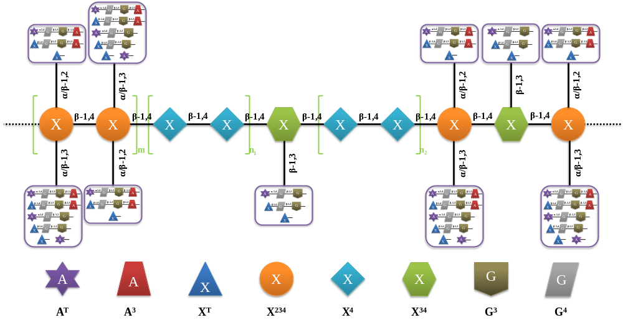

Fig. 6 The fine structure of HBAX-25: A^{T}, A³, X^{T}, X²³⁴, X⁴, X³⁴, G³ and G⁴ refer to T-α-L-Araf, 1,3-α-L-Araf, T-β-D-Xylp, 1,2,3,4-β-D-Xylp, 1,4-β-D-Xylp, 1,3,4-β-D-Xylp, 1,3-β-D-Galp and 1,4-β-D-Galp, respectively. Besides, the purple rectangular frames indicate the sites where different branches or individuals including A^{T}, X^{T}, A^{T}-G⁴-G³-, A^{T}-G⁴-G³-A³-, X^{T}-G⁴-G³- and X^{T}-G⁴-G³-A³- could be attached to the backbone.

4. Conclusions
In this work, an alkali-extracted arabinoxylan fraction (HBAX-25) was obtained from hull-less barley (Hordeum vulgare L. var. nudum Hook. f.) bran, and its structural elucidation was manifested as a relatively low-ramified arabinoxylan composed of un-substituted (1,4-linked β-D-Xylp, 71.19%), mono-substituted (1,3,4-linked β-D-Xylp, 14.78%) and di-substituted (1,2,3,4-linked β-D-Xylp, 10.76%) xylose units as backbone through β-(1→4) glycosidic linkages, where six possible branches or individuals abbreviated as A^{T}, X^{T}, A^{T}-G⁴-G³-, A^{T}-G⁴-G³-A³-, X^{T}-G⁴-G³- and X^{T}-G⁴-G³-A³- were deduced. In addition, the relatively higher PDI (6.59) as the ratio of $\overline{M_{w}}$ (298.36 kDa) to $\overline{M_{n}}$ (45.25 kDa) was observed possibly owing to the molecular aggregations of HBAX-25 at different levels via intermolecular hydrogen bonding, which could be discussed in further researches focusing on its solution properties and conformational behaviors in different aqueous systems.

Acknowledgements
This study was supported financially by the National Key Research and Development Program of China (Grant No. 2017YFD0400205) and Shanghai Committee of Science and Technology, China (Grant No. 16DZ2281400).

References
Aguedo, M., Fougnies, C., Dermience, M., & Richel, A. (2014). Extraction by three processes of arabinoxylans from wheat bran and characterization of the fractions obtained. Carbohydrate Polymers, 105, 317-324.
Anderson, C., & Simsek, S. (2019). Mechanical profiles and topographical properties of films made from alkaline extracted arabinoxylans from wheat bran, maize bran, or dried distillers grain. Food Hydrocolloids, 86, 78-86.
Bastos, R., Coelho, E., & Coimbra, M. A. (2018). Arabinoxylans from cereal by-products: insights into structural features, recovery, and applications. In C. M. Galanakis (Ed.). Sustainable Recovery and Reutilization of Cereal Processing By-Products (pp. 227-251). Cambridge, MA: Woodhead Publishing
Bender, D., Nemeth, R., Cavazzi, G., Turoczi, F., Schall, E., D'Amico, S., Török, K., Lucisano, M., Tömösközi, S., & Schoenlechner, R. (2018). Characterization of rheological properties of rye arabinoxylans in buckwheat model systems. Food Hydrocolloids, 80, 33-41.
Blakeney, A. B., Harris, P. J., Henry, R. J., & Stone, B. A. (1983). A simple and rapid preparation of alditol acetates for monosaccharide analysis. Carbohydrate Research, 113(2), 291–299.
Bradford, M. M. (1976). A rapid and sensitive method for the quantitation of microgram quantities of protein utilizing the principle of protein-dye binding. Analytical Biochemistry, 72(1-2), 248-254.
Carpita, N. C., & Shea, E. M. (1989). Linkage structure of carbohydrates by gas chromatography–mass spectrometry (GC–MS) of partially methylated alditolacetates. In C. J. Biermann & G. D. McGinnis (Eds.). Analysis of Carbohydrates by GLC and MS (pp. 157–216). Boca Raton, FL: CRC Press.
Cheng, H. N., & Neiss, T. G. (2012). Solution NMR spectroscopy of food polysaccharides. Polymer Reviews, 52(2), 81-114.
Courtin, C. M., & Delcour, J. A. (2002). Arabinoxylans and endoxylanases in wheat flour bread-making. Journal of Cereal Science, 35(3), 225-243.
Cui, S. W., Phillips, G. O., Blackwell, B., & Nikiforuk, J. (2007). Characterisation and properties of Acacia senegal (L.) Willd. var. senegal with enhanced properties (Acacia (sen) SUPERGUM™): Part 4. Spectroscopic characterisation of Acacia senegal var. senegal and Acacia (sen) SUPERGUM™ arabic. Food Hydrocolloids, 21(3), 347-352.
Cyran, M. R. (2010). Structural characterization of feruloylated arabinoxylans and xylans released from water-unextractable cell walls of rye outer layers upon treatment with lichenase and cellulase. Carbohydrate Research, 345(7), 899-907.
Das, D., Mondal, S., Roy, S. K., Maiti, D., Bhunia, B., Maiti, T. K., & Islam, S. S. (2009). Isolation and characterization of a heteropolysaccharide from the corm of Amorphophallus campanulatus. Carbohydrate Research, 344(18), 2581-2585.
Delcour, J. A., Vanhamel, S., & Geest, C. D. E. (1989). Physico-chemical and functional properties of rye nonstarch polysaccharides. I. Colorimetric analysis of pentosans and their relative monosaccharide compositions in fractionated (milled) rye products. Cereal Chemistry, 66(2), 107-111.
Dervilly, G., Leclercq, C., Zimmermann, D., Roue, C., Thibault, J. F., & Saulnier, L. (2002). Isolation and characterization of high molar mass water-soluble arabinoxylans from barley and barley malt. Carbohydrate Polymers, 47(2), 143-149.
Ding, H. H., Qian, K., Goff, H. D., Wang, Q., & Cui, S. W. (2018). Structural and conformational characterization of arabinoxylans from flaxseed mucilage. Food Chemistry, 254, 266-271.
Du, B., Zhu, F., & Xu, B. (2014). β-Glucan extraction from bran of hull-less barley by accelerated solvent extraction combined with response surface methodology. Journal of Cereal Science, 59(1), 95-100.
Dubois, M., Gilles, K., & Hamilton, J. (1956). Colorimetric method for determination of sugars and related substances. Analytical Chemistry, 28(3), 350-356.
Feng, Z., Dou, W., Alaxi, S., Niu, Y., & Yu, L. L. (2017). Modified soluble dietary fiber from black bean coats with its rheological and bile acid binding properties. Food Hydrocolloids, 62, 94-101.
Gong, L., Jin, C., Wu, X., & Zhang, Y. (2012). Determination of arabinoxylans in Tibetan Hull-less barley bran. Procedia Engineering, 37, 218-222.
Guo, R., Ai, L., Cao, N., Ma, J., Wu, Y., Wu, J., & Sun, X. (2016). Physicochemical properties and structural characterization of a galactomannan from Sophora alopecuroides L. seeds. Carbohydrate Polymers, 140, 451-460.
Guo, R., Cao, N., Wu, Y., & Wu, J. (2016). Optimized extraction and molecular characterization of polysaccharides from Sophora alopecuroides L. seeds. International Journal of Biological Macromolecules, 82, 231-242.
Harris, P. J., Henry, R. J., Blakeney, A. B., & Stone, B. A. (1984). An improved procedure for the methylation analysis of oligosaccharides and polysaccharides. Carbohydrate Research, 127(1), 59–73.
Hoffman, R. A., Kamerling, J. P., & Vliegenthart, J. F. G. (1992). Structural features of a water-soluble arabinoxylan from the endosperm of wheat. Carbohydrate Research, 226(2), 303-311.
Höije, A., Gröndahl, M., Tømmeraas, K., & Gatenholm, P. (2005). Isolation and characterization of physicochemical and material properties of arabinoxylans from barley husks. Carbohydrate Polymers, 61(3), 266-275.
Hromádková, Z., Paulsen, B. S., Polovka, M., Košťálová, Z., & Ebringerová, A. (2013). Structural features of two heteroxylan polysaccharide fractions from wheat bran with anti-complementary and antioxidant activities. Carbohydrate Polymers, 93(1), 22-30.
Izydorczyk, M. S. (2014). Barley Arabinoxylans: Molecular, Physicochemical, and Functional Properties. In P. R. Shewry & S. E. Ullrich (Eds.). Barley: Chemistry and Technology (2nd Edition) (pp. 97-122). St. Paul, MN: AACC International, Inc.
Kačuráková, M., Capek, P., Sasinková, V., Wellner, N., & Ebringerová, A. (2000). FT-IR study of plant cell wall model compounds: pectic polysaccharides and hemicelluloses. Carbohydrate Polymers, 43(2), 195-203.
Kienteka, S. S., Corrêa-Ferreira, M. L., & de Oliveira Petkowicz, C. L. (2018). Characterization of cell wall polysaccharides from Sicana odorifera fruit and structural analysis of a galactan-rich fraction pectins as side chains. Carbohydrate Polymers, 197, 395-402.
Koegelenberg, D., & Chimphango, A. F. A. (2017). Effects of wheat-bran arabinoxylan as partial flour replacer on bread properties. Food Chemistry, 221, 1606-1613.
McCleary, B.V., & Mugford, D. C. (1997). Determination of β-glucan in barley and oats by streamlined enzymatic method: Summary of collaborative study. Journal of AOAC International, 80(3), 580-583.
Mikshina, P. V., Gurjanov, O. P., Mukhitova, F. K., Petrova, A. A., Shashkov, A. S., & Gorshkova, T. A. (2012). Structural details of pectic galactan from the secondary cell walls of flax (Linum usitatissimum L.) phloem fibres. Carbohydrate Polymers, 87(1), 853-861.
Pavlovich-Abril, A., Rouzaud-Sández, O., Carvajal-Millán, E., Navarro, R. E., Robles-Sánchez, R. M., & Barrón-Hoyos, J. M. (2016). Molecular characterization of water extractable arabinoxylans isolated from wheat fine bran and their effect on dough viscosity. LWT - Food Science and Technology, 74, 484-492.
Qian, K. Y., Cui, S. W., Wu, Y., & Goff, H. D. (2012). Flaxseed gum from flaxseed hulls: Extraction, fractionation, and characterization. Food Hydrocolloids, 28(2), 275-283.
Revanappa, S. B., Nandini, C. D., & Salimath, P. V. (2015). Structural variations of arabinoxylans extracted from different wheat (Triticum aestivum) cultivars in relation to chapati-quality. Food Hydrocolloids, 43, 736-742.
Rumpagaporn, P., Reuhs, B. L., Kaur, A., Patterson, J. A., Keshavarzian, A., & Hamaker, B. R. (2015). Structural features of soluble cereal arabinoxylan fibers associated with a slow rate of in vitro fermentation by human fecal microbiota. Carbohydrate Polymers, 130, 191-197.
Sárossy, Z., Tenkanen, M., Pitkänen, L., Bjerre, A.-B., & Plackett, D. (2013). Extraction and chemical characterization of rye arabinoxylan and the effect of β-glucan on the mechanical and barrier properties of cast arabinoxylan films. Food Hydrocolloids, 30(1), 206-216.
Saulnier, L., Guillon, F., Sado, P. E., & Rouau, X. (2007). Plant Cell Wall Polysaccharides in Storage Organs: Xylans (Food Applications). In J. P. Kamerling, G. J. Boons, Y. C. Lee, A. Suzuki, N. Taniguchi & A. G. J. Voragen (Eds.). Comprehensive Glycoscience: From Chemistry to Systems Biology (Vol. 2: Analysis of Glycans; Polysaccharide Functional Properties, pp. 653–689). Oxford: Elsevier Science.
Shen, Y., Zhang, H., Cheng, L., Wang, L., Qian, H., & Qi, X. (2016). In vitro and in vivo antioxidant activity of polyphenols extracted from black highland barley. Food Chemistry, 194, 1003-1012.
Skendi, A., Biliaderis, C. G., Izydorczyk, M. S., Zervou, M., & Zoumpoulakis, P. (2011). Structural variation and rheological properties of water-extractable arabinoxylans from six Greek wheat cultivars. Food Chemistry, 126(2), 526-536.
Sun, Y., Cui, S. W., Gu, X., & Zhang, J. (2011). Isolation and structural characterization of water unextractable arabinoxylans from Chinese black-grained wheat bran. Carbohydrate Polymers, 85(3), 615-621.
Tiwari, U., & Cummins, E. (2009). Factors influencing β-glucan levels and molecular weight in cereal-based products. Cereal Chemistry, 86(3), 290-301.
Toole, G. A., Barron, C., Le Gall, G., Colquhoun, I. J., Shewry, P. R., & Mills, E. N. C. (2009). Remodelling of arabinoxylan in wheat (Triticum aestivum) endosperm cell walls during grain filling. Planta, 229(3), 667-680.
Tosh, S. M., & Miller, S. S. (2016). Health Effects of β-Glucans Found in Cereals. In C. Wrigley, H. Corke, K. Seetharaman & J. Faubion (Eds.). Encyclopedia of Food Grains, 2nd Edition (Vol. 2: Nutrition and Food Grains, pp. 236-240). Waltham, MA: Academic Press.
Wu, Y., Guo, R., Cao, N., Sun, X., Sui, Z., & Guo, Q. (2018). A systematical rheological study of polysaccharide from Sophora alopecuroides L. seeds. Carbohydrate Polymers, 180, 63-71.
Xu, Z., Hu, H., Li, J., & Wu, Y. (2018). Optimization of extraction process and structural analysis of arabinoxylans from hull-less barley bran. Food Science, 39(8), 191-197.
Yadav, M. P., Kale, M. S., Hicks, K. B., & Hanah, K. (2017). Isolation, characterization and the functional properties of cellulosic arabinoxylan fiber isolated from agricultural processing by-products, agricultural residues and energy crops. Food Hydrocolloids, 63, 545-551.
Yang, L., Christensen, D. A., McKinnon, J. J., Beattie, A. D., & Yu, P. (2013). Effect of altered carbohydrate traits in hulless barley (Hordeum vulgare L.) on nutrient profiles and availability and nitrogen to energy synchronization. Journal of Cereal Science, 58(1), 182-190.
Yangcheng, H., Gong, L., Zhang, Y., & Jane, J. L. (2016). Pysicochemical properties of Tibetan hull-less barley starch. Carbohydrate Polymers, 137, 525-531.
Yin, J.-Y., Lin, H.-X., Nie, S.-P., Cui, S. W., & Xie, M.-Y. (2012). Methylation and 2D NMR analysis of arabinoxylan from the seeds of Plantago asiatica L. Carbohydrate Polymers, 88(4), 1395-1401.
Zhang, H., Zhang, N., Xiong, Z., Wang, G., Xia, Y., Lai, P., & Ai, L. (2018). Structural characterization and rheological properties of β-D-glucan from hull-less barley (Hordeum vulgare L. var. nudum Hook. f.). Phytochemistry, 155, 155-163.
Zhang, Z., Smith, C., & Li, W. (2014). Extraction and modification technology of arabinoxylans from cereal by-products: A critical review. Food Research International, 65, 423-436.
Zheng, X., Li, L., & Wang, Q. (2011a). Distribution and molecular characterization of β-glucans from hull-less barley bran, shorts and flour. International Journal of Molecular Sciences, 12(3), 1563-1574.
Zheng, X., Li, L., & Wang, X. (2011b). Molecular characterization of arabinoxylans from hull-less barley milling fractions. Molecules, 16(4), 2743-2753.
Zhu, F., Du, B., & Xu, B. (2015). Superfine grinding improves functional properties and antioxidant capacities of bran dietary fibre from Qingke (hull-less barley) grown in Qinghai-Tibet Plateau, China. Journal of Cereal Science, 65, 43-47.

Figure captions

Fig. 1 The fractionation and separation procedure of different fractions from HBAX. ª The yield of each fraction was based on HBAX mass.

Fig. 2 The diagram of monosaccharide analysis of HBAX-25 via GC method.

Fig. 3 The procedure of methylation analysis of HBAX-25.

Fig. 4 The UV-vis (A) and FT-IR (B) spectra of HBAX and HBAX-25 from hull-less barley bran.

Fig. 5 ¹H (A & B), ¹³C (C & D), HSQC (E & F) and HMBC (G) spectra of HBAX-25 from hull-less barley bran.

Fig. 6 The fine structure of HBAX-25: A^{T}, A³, X^{T}, X²³⁴, X⁴, X³⁴, G³ and G⁴ refer to T-α-L-Araf, 1,3-α-L-Araf, T-β-D-Xylp, 1,2,3,4-β-D-Xylp, 1,4-β-D-Xylp, 1,3,4-β-D-Xylp, 1,3-β-D-Galp and 1,4-β-D-Galp, respectively. Besides, the purple rectangular frames indicate the sites where different branches or individuals including A^{T}, X^{T}, A^{T}-G⁴-G³-, A^{T}-G⁴-G³-A³-, X^{T}-G⁴-G³- and X^{T}-G⁴-G³-A³- could be attached to the backbone.

Table captions

Table 1 Chemical and monosaccharide compositions of powder, HBAX and HBAX-25 from hull-less barley bran.

Table 2 Major linkage patterns of monosaccharide residues in HBAX-25 via methylation analysis.

Table 3 ¹H and ¹³C NMR chemical shifts for HBAX-25 compared with other arabinoxylans.

Table 4 The chemical shift pairs for significant anomeric proton/carbon connectivities in HMBC spectrum of HBAX-25.

