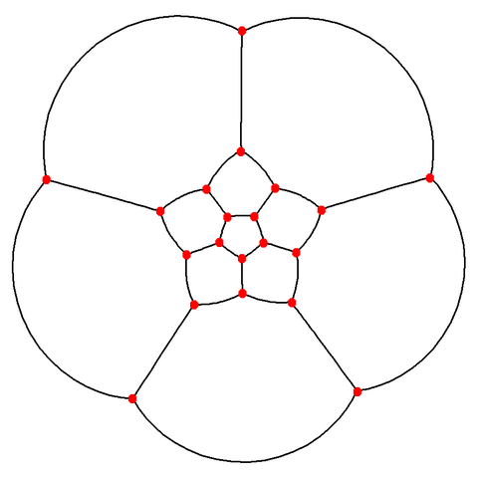

The 3 Tests are connected.
An unperson is someone whose existence is erased from history. Ex. You become an unperson if Big Brother erases all mention of you from the books.
Letters to Numbers.

Big Brother is Watching You.

V = 22.
P = 16.
F = 6.


I = 9.

