Coherent Communications in Self-Organizing Networks with Distributed Beamforming

Yi Shi and Yalin E. Sagduyu

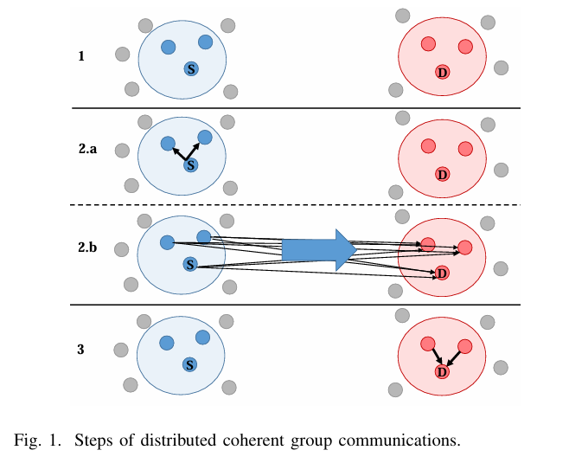

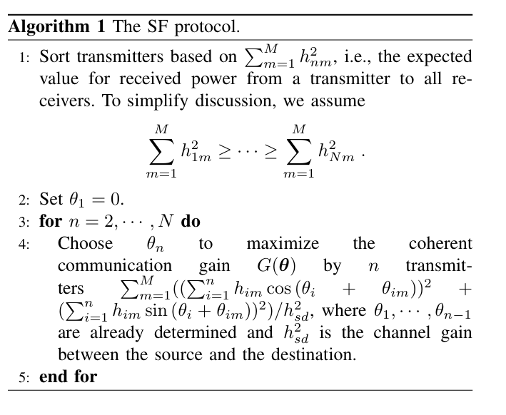

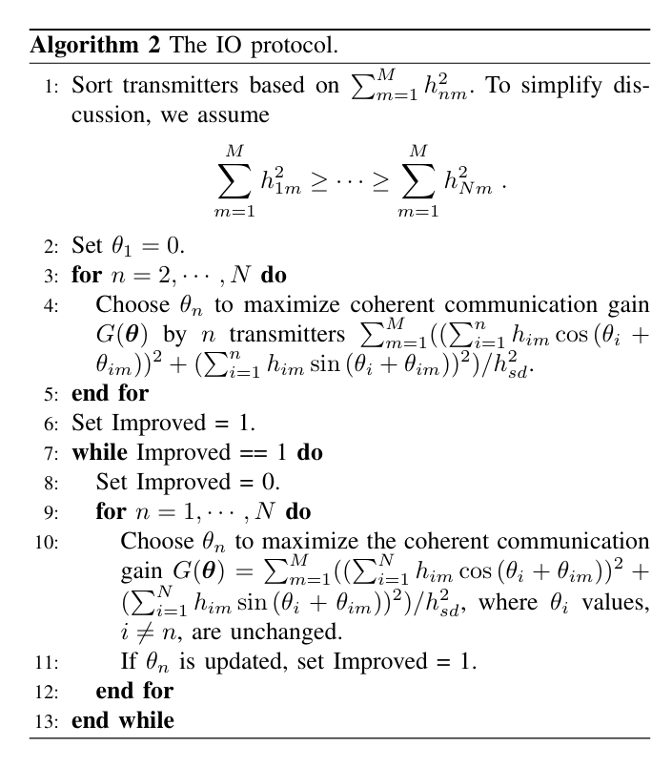

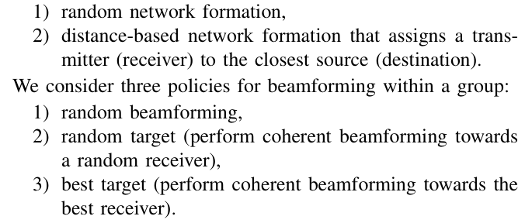

|  |  |  |  |  |
| --- | --- | --- | --- | --- |
| 文章类型 | 标题 | 场景 | 技术点 | 投稿 |
| 综述 | [1] (2009) | / | / | IEEE Communications Magazine |
| [2] (2017) | Wireless Sensor Networks | / | CST |
| [3] (2022) | Satellite Com | Architectures and Synchronization | IEEE Acess |
|  |  |  |  |
|  |  |  |  |
| 理论+仿真 | [4] (2005) | Wireless Ad Hoc Sensor Networks | 规律研究（间距较小） | TSP |
| [5](2007) | Wireless Networks | 理论分析：功率和同步 | TWC |
| [6](2023) | UAV | 建模+理论分析 | MDPI Drones |
| [7](2024) | Satellite Com | 功率增强 | TVT |
|  | [8](2024) | Self-Organizing Networks | 多发多收 | / |
|  |  |  |  |  |
|  |  |  |  |  |
| 实物 | **[12(2006)** | **/** | **1bit feedback** | **Proceedings of the 44th Allerton conference on communication, control and computation** |
| [9] (2019) | UAV | Synchronization +基于信道估计的BF | MASS |
| [10] (2021) | Wireless Network | Synchronization | MobiCom |
| [13](2021) | Energy Transfer | WIFI-friendly | TN |
| [11] (2022) | Mu-Massive MIMO | Secure + blind BF | 专利：  US11271620B1 |
| [14](2023) | UAV | Destination-Feedback Free | TMC |
| [15](2023) | UAV | Determine the pre-BF SNR, the length of the preambles, and the number of BF radios | TWC |

IEEE TRANSACTIONS ON SIGNAL PROCESSING(TSP)

IEEE TRANSACTIONS ON VEHICULAR TECHNOLOGY(TVT)

IEEE Internatonal Conference on Mobile Adhoc and Sensor Systems (MASS)

IEEE COMMUNICATIONS SURVEYS & TUTORIALS(CST)

IEEE TRANSACTIONS ON WIRELESS COMMUNICATIONS(TWC)

IEEE/ACM TRANSACTIONS ON NETWORKING (TN)

IEEE TRANSACTIONS ON MOBILE COMPUTING(TMC)

1. Distributed Transmit Beamforming: Challenges and Recent Progress
2. Distributed and Collaborative Beamforming in Wireless Sensor Networks: Classifications, Trends, and Research Directions
3. Architectures and Synchronization Techniques for Distributed Satellite Systems: A Survey
4. Collaborative Beamforming for Distributed Wireless Ad Hoc Sensor Networks
5. On the Feasibility of Distributed Beamforming in Wireless Networks
6. Distributed Antenna in Drone Swarms: A Feasibility Study
7. Enhancement of Direct LEO Satellite-to-Smartphone Communications by Distributed Beamforming
8. Coherent Communications in Self-Organizing Networks with Distributed Beamforming
9. AirBeam: Experimental Demonstration of Distributed Beamforming by a Swarm of UAVs
10. RFClock: Timing, Phase and Frequency Synchronization for Distributed Wireless Networks
11. Method for secure communication in mu-massive MIMO system via blind distributed beamforming
12. Mudumbai R, Wild B, Madhow U, et al. Distributed beamforming using 1 bit feedback: from concept to realization[C]//Proceedings of the 44th Allerton conference on communication, control and computation. 2006, 8: 1020-1027.
13. WiFED Mobile: WiFi Friendly Energy Delivery With Mobile Distributed Beamforming
14. Destination-Feedback Free Distributed Transmit Beamforming Using Guided Directionality
15. Distributed Transmit Beamforming: Design and Demonstration From the Lab to UAVs