
Your IP address: 192.168.25.
Your netmask: 255.255.255.0

Commands for the Simplicity of Networking workshop
ethtool eth0
Settings for eth0:
Supported ports: [ TP ]
Supported link modes: 10baseT/Half 10baseT/Full
100baseT/Half 100baseT/Full
1000baseT/Full
Supported pause frame use: No
Supports auto-negotiation: Yes
Advertised link modes: Not reported
Advertised pause frame use: No
Advertised auto-negotiation: Yes
Speed: 100Mb/s
Duplex: Full
Port: Twisted Pair
PHYAD: 0
Transceiver: internal
Auto-negotiation: on
MDI-X: Unknown
Supports Wake-on: pg
Wake-on: g
Current message level: 0x0000003f (63)
drv probe link timer ifdown ifup
Link detected: yes
ifconfig eth0
eth0 Link encap:Ethernet HWaddr 00:25:22:d8:dc:9f
inet addr:192.168.12.143 Bcast:192.168.12.255 Mask:255.255.255.0
inet6 addr: fe80::225:22ff:fed8:dc9f/64 Scope:Link
inet6 addr: 2001:980:5c11:1:225:22ff:fed8:dc9f/64 Scope:Global
inet6 addr: 2001:980:5c11:1:29fb:c94b:b666:d196/64 Scope:Global
UP BROADCAST RUNNING MULTICAST MTU:1500 Metric:1
RX packets:106359 errors:0 dropped:0 overruns:0 frame:0
TX packets:63029 errors:0 dropped:0 overruns:0 carrier:1
collisions:0 txqueuelen:1000
RX bytes:136757942 (136.7 MB) TX bytes:6650865 (6.6 MB)
ifconfig eth0 up
tcpdump -i eth0 -ntev
-i interface
-n no name resolving (DNS)
-t no timestamp
-e show link-level header (layer 2)
-v extra output (verbose)
ifconfig eth0 10.11.12.100 netmask 255.255.255.0 up
ping -c 1 192.168.25.250
arp -an
ping -c 1 8.8.8.8
route -n
route add -net 8.8.8.8 netmask 255.255.255.255 gateway 192.168.25.254
traceroute -n 8.8.8.8
ping -c 1 192.168.26.1
ping -c 1 192.168.26.2
route add -net 192.168.26.0 netmask 255.255.255.0 gateway 192.168.25.1
nc -lnp 2000
nc <ip.add.re.ss> 2000
nano /etc/resolv.conf
search ws.z25.lan
nameserver 192.168.25.254
dig z25.org NS
dig z25.org MX
dig www.z25.org A
dig _xmpp-server._tcp.z25.org SRV
ping -c 1 fsf.org
route add -net 0.0.0.0 netmask 0.0.0.0 gateway 192.168.25.254
ifconfig lo:1 172.16.1.1 netmask 255.255.255.255 up
echo 1 > /proc/sys/net/ipv4/ip_forward
route add -net 172.16.1.1 netmask 255.255.255.255 gateway 192.168.25.x
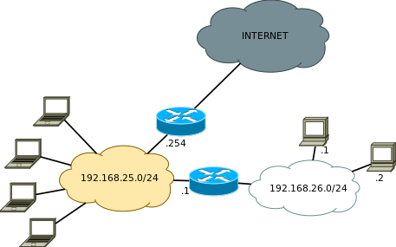

arnaud@z25.org, twitter.com/sphaero, github.com/sphaero

More workshops: http://mws.z25.org

