ORDER No.
Report Date: 9 April 2026. Rev.0

Report No: TAS-K1-SS-RWB-O/L-S_s

Rev | By | Date | Description | Chk’d
A | RM | 2026-04-09 | For Approval | TAS

Title:
Sibanye Stillwater – Kloof 1# Sub Shaft

Report on:
Site Visual Inspection of Conveyance – Rock Winder Bridle Overlay South

Client: Sibanye Stillwater

Contact Person: Kannetjie Van Eck

Author: Rendani Maphalaphathwa

Distribution List: Kannetjie Van Eck
Morne Erasmus

Rafal Szejwallo

Executive Summary

The Rock Winder Bridle No. K1-SS-RWB-O/L-S_s was found to be in a safe operating condition.

Findings of the inspection are compiled in Table 1 attached to this Report.

RW 1-07 Bridle was found to be in a safe operating condition.

Findings of the inspection are compiled in Table 1 attached to this Report.

.

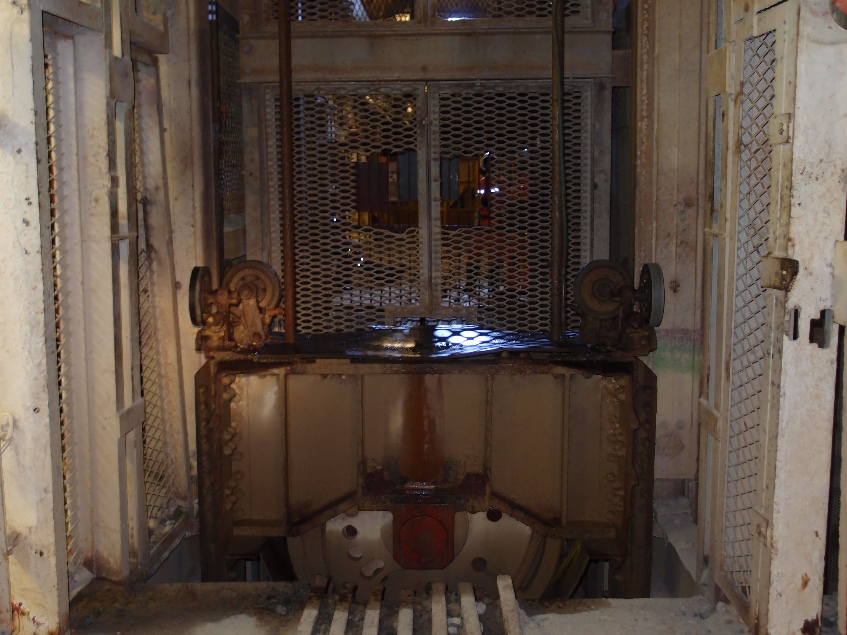
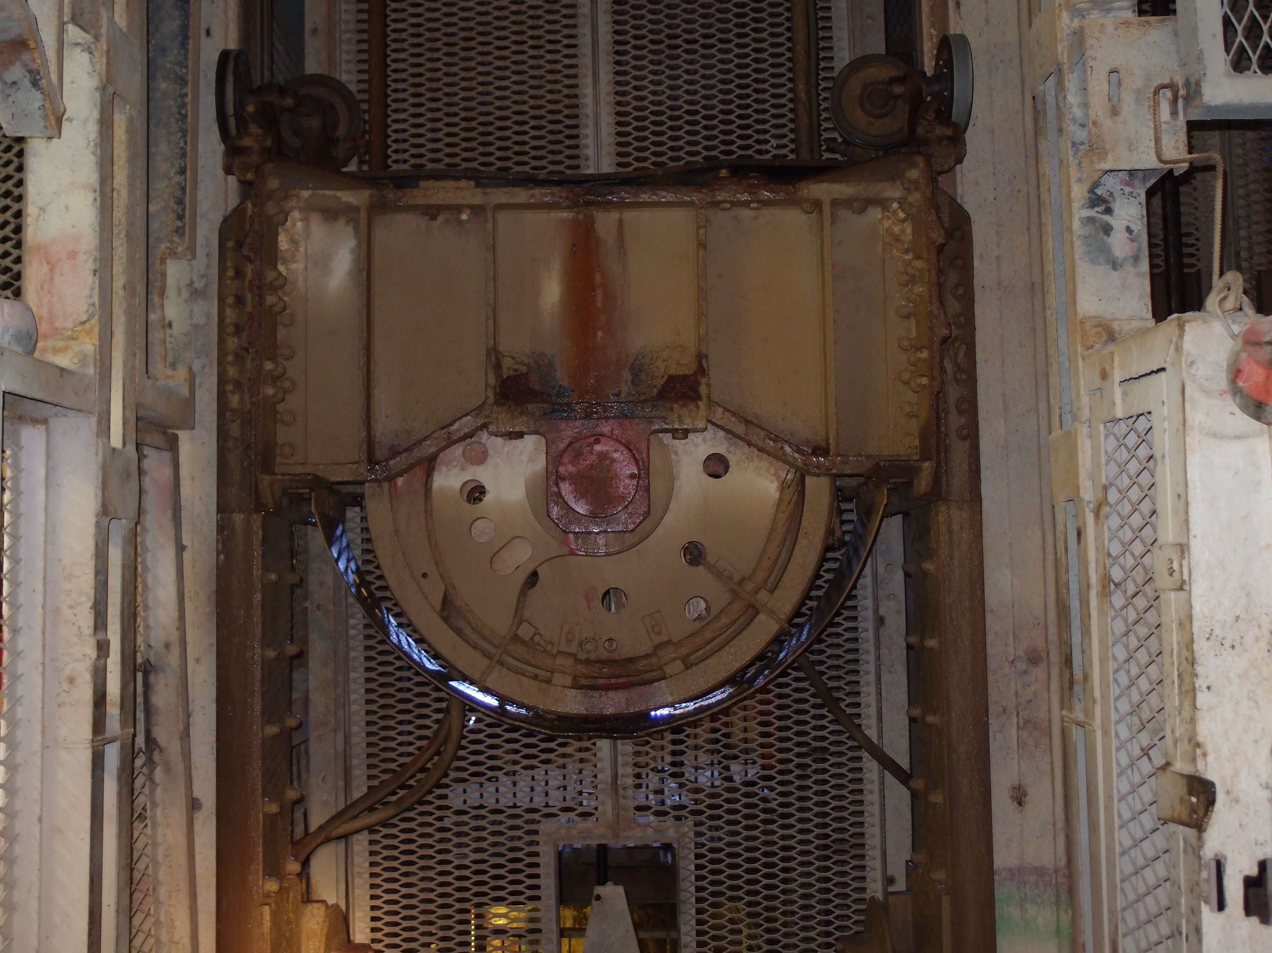

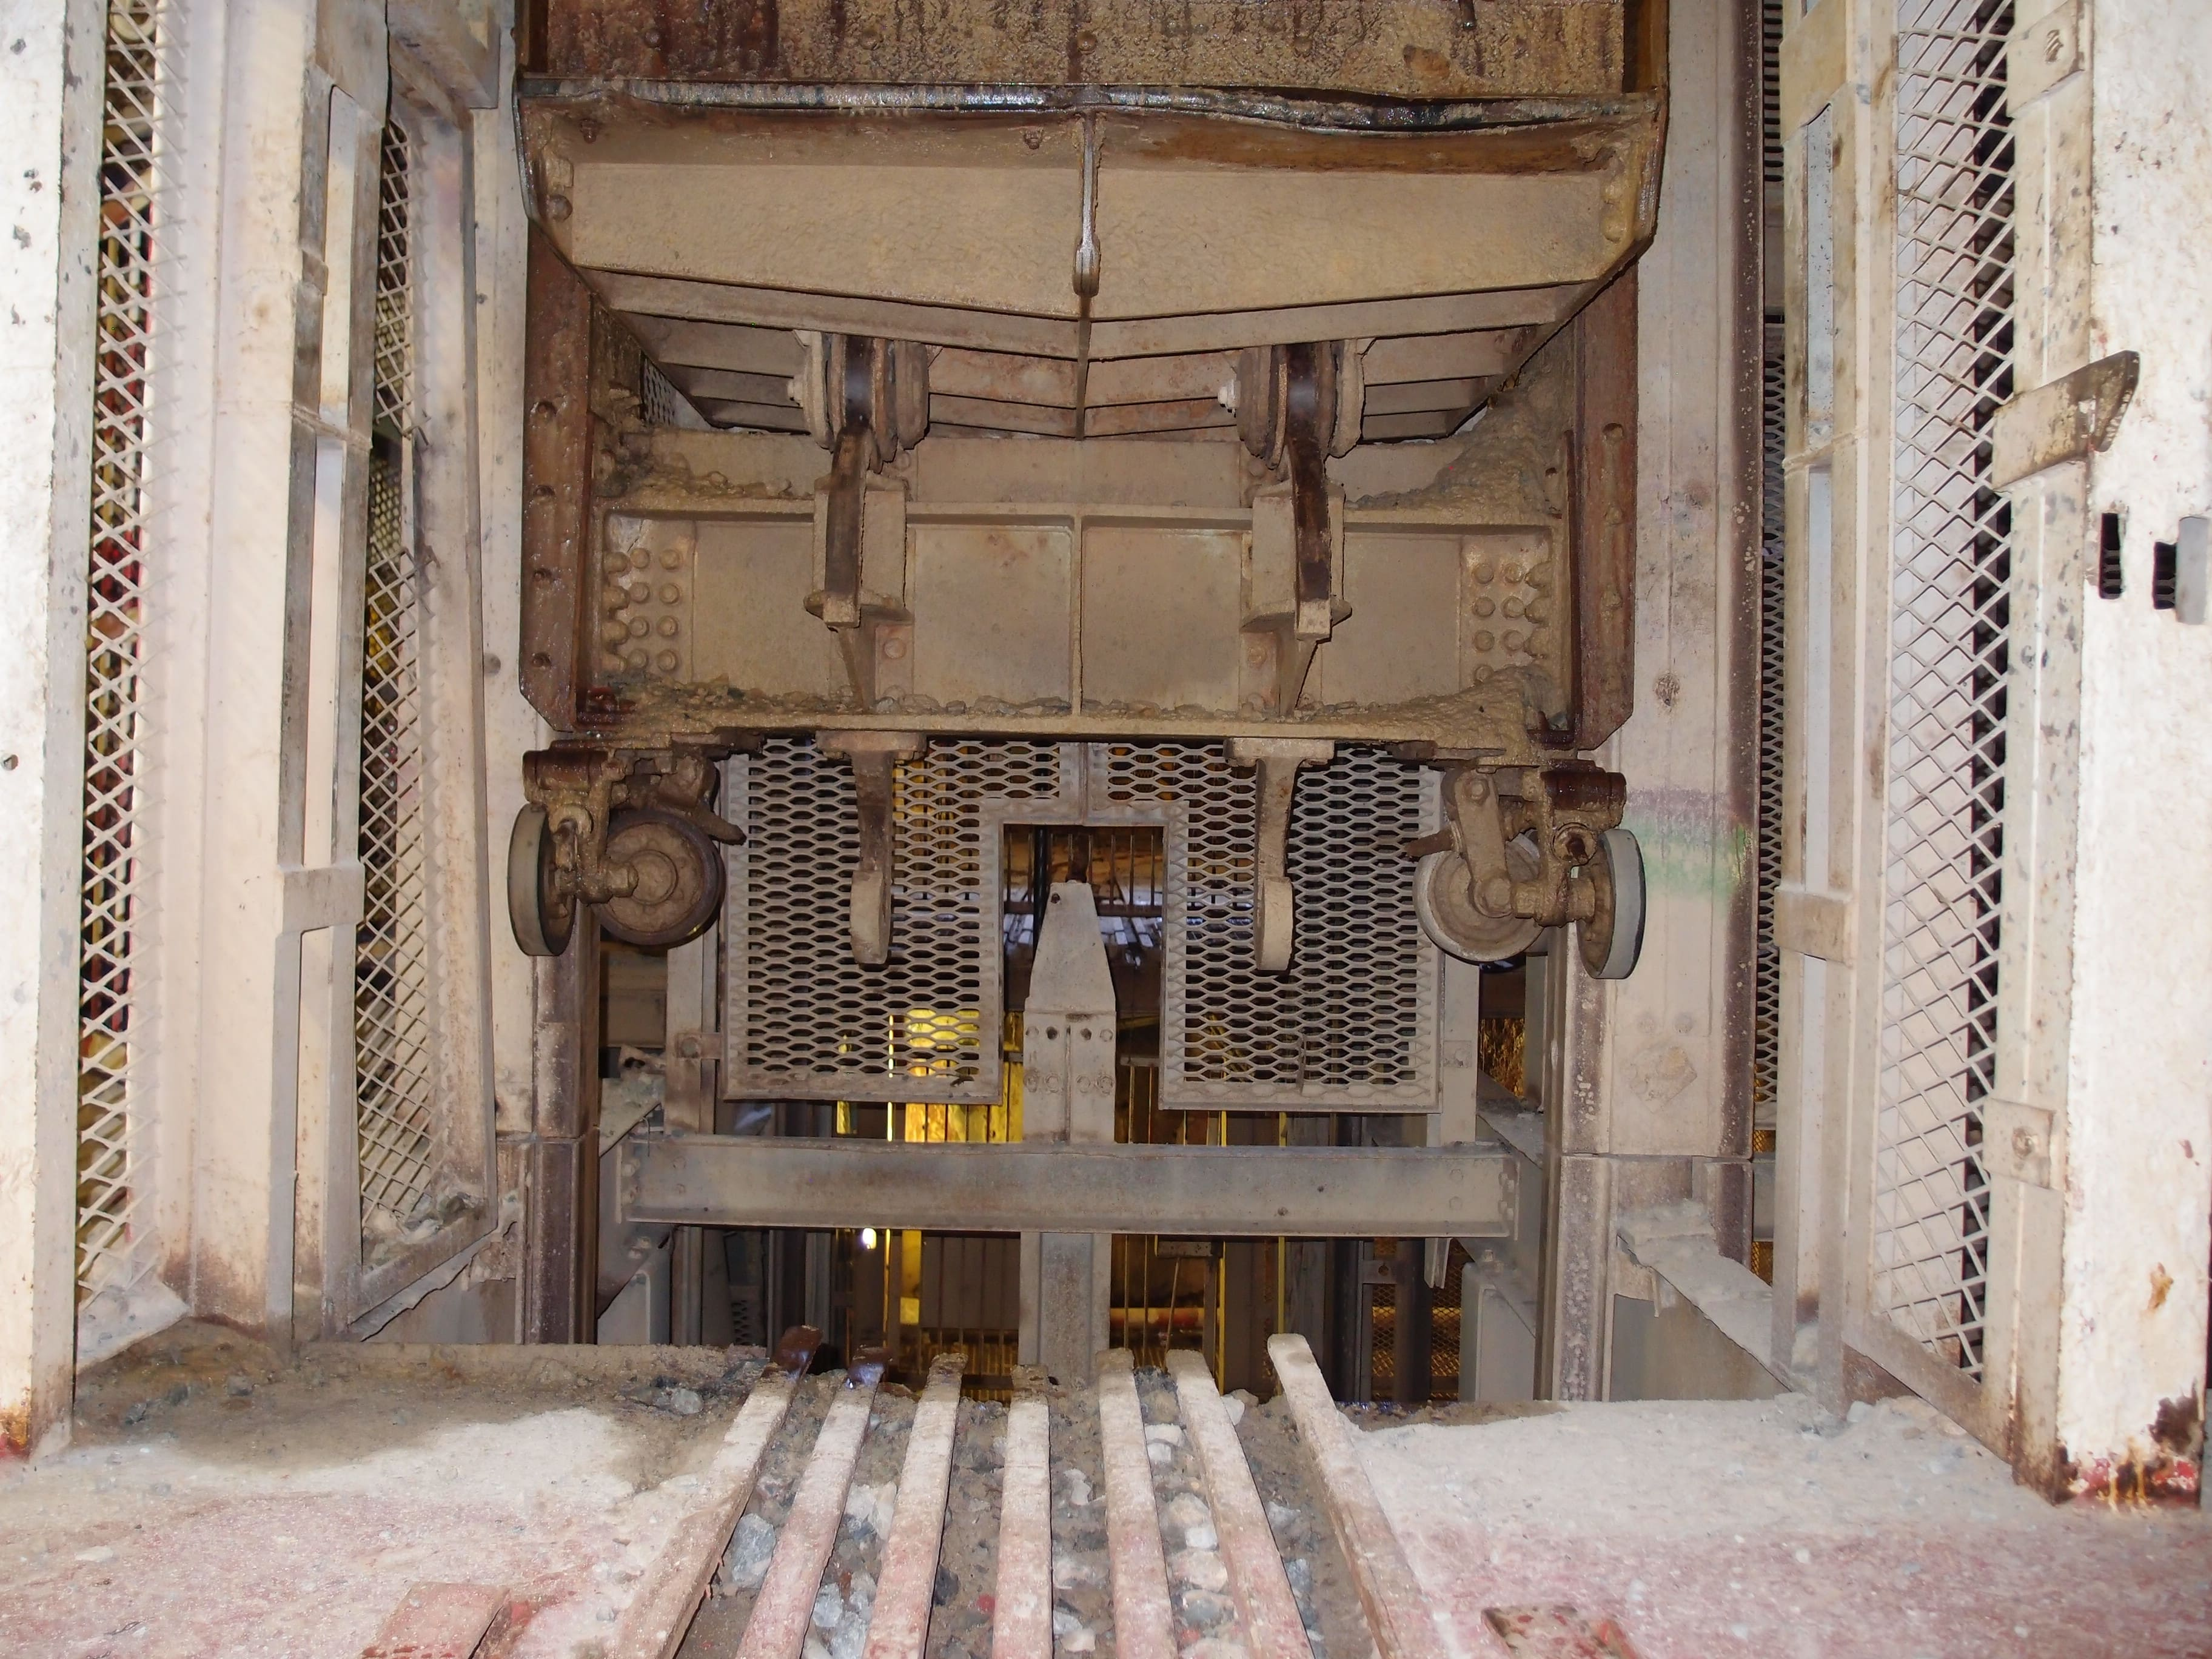
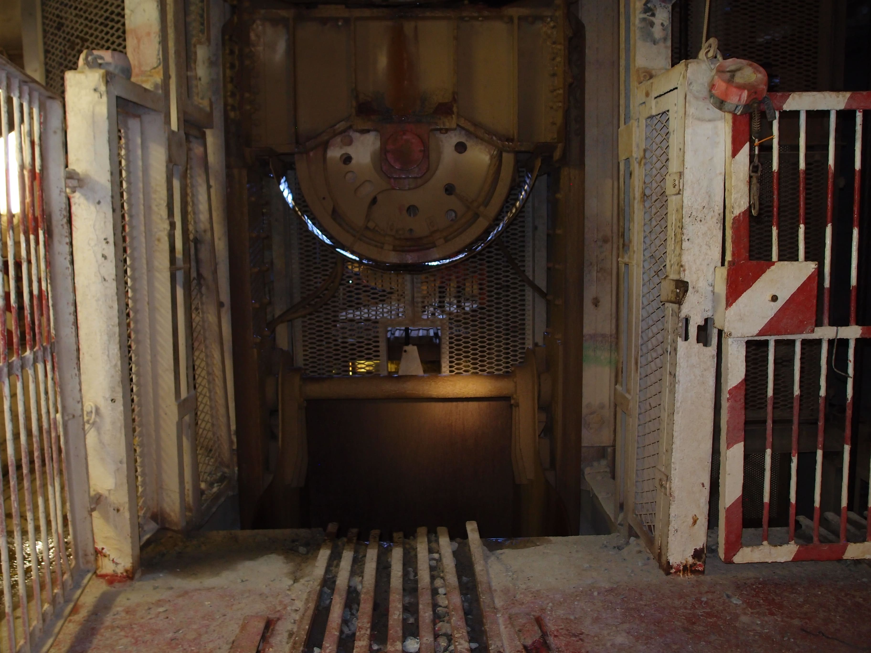
Pic 3. Top Dolly Wheels
Pic 2. Stringers & Pivot Bar
Pic 4. Bottom Transom
Pic 1. Top Transom

Introduction

Sibanye Stillwater appointed Technical Auditing Services to perform a visual inspection of the RWB (Pic 1 to 4).

The inspection took place on 2026/04/02 and was performed according to Sibanye-Stillwater guideline
GLV-058. (Rev:00)

The Rock Winder Bridle was not cleaned before inspection.
No specialised equipment or test have been performed during inspection.

Inspection results

The inspection results are compiled in the appendix A of this report.

Summary

There was no mechanical damage to the above-mentioned Rock Winder Bridle. No Visible structural compromise, some deterioration to the integrity or function of the Rock Winder Bridle and can be safely used within design parameters.

Recommendations

The Rock Winder Bridle indicated above was in good condition and can be kept in service.

COMPONENT | REMARKS
Top transom | No visual issues recorded
Dolly Wheels | No visual issues recorded
Bottom transom | No visual issues recorded
Jack catch lugs | No visual issues recorded
Stringers | No visual issues recorded
Slipper plates | To be advised.
Guide rollers | No visual issues recorded
Slinging hooks | No visual issues recorded
Compliance with drawings | Not Available.
General comments | Refer to page 2 for recommendations.

Appendix A: Rock Winder Bridle K1-SS-RWB-O/L-S_s major visual inspection results

Company | Technical Auditing Services Pty Ltd
Mine | Kloof 1#
Shaft | Main Shaft
Department | Maintenance
Conveyance | Rock Winder Bridle Overlay South
Serial Number | K1-SS-RWB-O/L-S_s
Year constructed &  Date of Installation | To be advised  To be advised
NDT Date | 03/12/2025
Total service age of conveyance | To be advised
Deceleration test trace | N/A
General shaft environment | Extreme |  |  | Aggressive |  |  | Benign
Inspection results
Structural component |  | Deterioration, defects, etc.
 |  | Corrosion | Wear |  | Cracking | Connect-  ion |  | Mech. damage
Top transom |  | 2 | 3 |  | 3 | 3 |  | 3
Dolly wheels |  | 3 | 3 |  | 3 | 3 |  | 3
Bottom transom |  | 2 | 2 |  | 2 | 2 |  | 2
Jack catch lugs |  | 2 | 2 |  | 2 | 2 |  | 2
Stringers |  | 2 | 2 |  | 2 | 2 |  | 2
Slipper plates |  | TBA | TBA |  | TBA | TBA |  | TBA
Guide rollers |  | 3 | 3 |  | 3 | 3 |  | 3
Slinging hooks |  | 2 | 2 |  | 2 | 2 |  | 2
Compliance with drawings |  | N/A | N/A |  | N/A | N/A |  | N/A

Kloof 1# Sub Shaft

