project3_report

UML :

|  |
| --- |
| MinWindow |
| +birdie[4]:Bird*  +pigs[3]:Pig*  +obs[3]:obstacle*  +pigx[3]:float  +pigy[3]:float  +count:int  +birdnum:int  +shotmode:int  +countv:int  +firstScore:int  +i:int  +pignum:int  +obsnum:int  +countresult:int  +judgeobs[3]:int  +judgepig[3]:int  +result: QGraphicsPixmapItem *  -scene : QGraphicsScene *  -world : b2World *  -itemList : QList<QameItem *>  -timer :　QTimer  -birdtimer :　QTimer  -pigtimer :　QTimer |
| +<<explicit>>MainWindow(parent:QWidget *=0): void  +~Maindow()  +showEvent(QShowEvent *):void  +eventFilter(QObject *,event:QEvent):bool  +closeEvent(QCloseEvent *):void  +<<signals>>quitGame():void  -<<slots>>tick():void  -<<slots>>QUITSLOT():void  -<<slots>>tick():void  -<<slots>>judgebirdv():void  -<<slots>>judgepigpos():void  -<<slots>>judgeobsv():void  -<<slots>>judgeresult():void |

↓

|  |
| --- |
| GameItem |
| +g_body:b2Body*  +g_pixmap:QGraphicsPixmapItem  #g_size:QsizeF  #g_world:b2World*  +g_worldsize:static QsizeF  +g_windowsize:static QsizeF |
| +QameItem(world:b2World *)  +~GameItem()  +setGlobalSize(worldsize:QsizeF,windowsize:QsizeF):static void  +<<slots>>paint():void |

|  |
| --- |
| Land |
|  |
| +Land(x:float,y:float,w:float,h:float,pixmap:QPixmap,world:b2World*,scene:QGraphicsScene*) |

|  |
| --- |
| obstacle |
| +bodydef:b2BodyDef  + bodyshape:b2CircleShape |
| +obsatcle(x:float,y:float,w:float,h:float,timer:QTimer*,pixmap:QPixmap,world:b2World*,scene:QGraphicsScene*)  +setLinearVelocity(velocity:b2Vec2):void |

|  |
| --- |
| pig |
| +bodydef:b2BodyDef |
| +Pig(x:float,y:float,radius:float,timer:QTimer*,pixmap:QPixmap,world:b2World*,scene:QGraphicsScene*)  +setLinearVelocity(velocity:b2Vec2):void |

|  |
| --- |
| Bird |
| +bodydef:b2BodyDef  + bodyshape:b2CircleShape  +fixturedef:b2FixtureDef |
| +Bird(x:float,y:float,radius:float,timer:QTimer*,pixmap:QPixmap,world:b2World*,scene:QGraphicsScene*)  +setLinearVelocity(velocity:b2Vec2):void  +*ability():*void |

|  |
| --- |
| birdgreen |
| +r1:int |
| +birdgreen(x:float,y:float,radius:float,timer:QTimer*,pixmap:QPixmap,world:b2World*,scene:QGraphicsScene*)  +*ability():*void |

|  |
| --- |
| birdpink |
|  |
| +birdpink(x:float,y:float,radius:float,timer:QTimer*,pixmap:QPixmap,world:b2World*,scene:QGraphicsScene*)  +*ability():*void |

|  |
| --- |
| birdyellow |
| -countaccel:int |
| +birdyellow(x:float,y:float,radius:float,timer:QTimer*,pixmap:QPixmap,world:b2World*,scene:QGraphicsScene*)  +*ability():*void |

How to play :

1. This is the beginning view.

There are three obstacles and three pigs, and you get your first red bird at first.

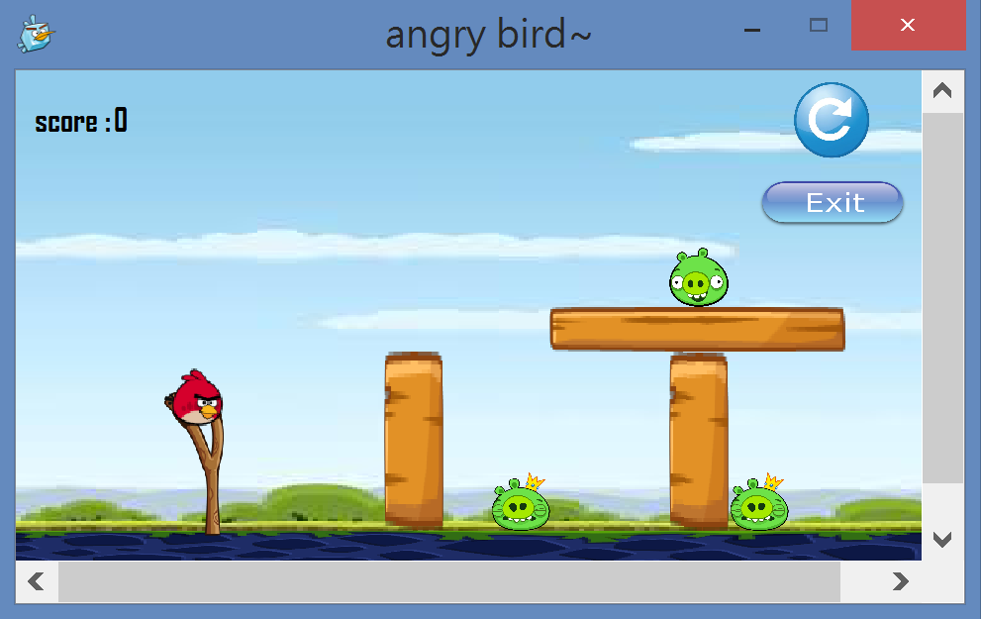

You can catch the bird with your mouse so you can choose the place to shoot the bird.

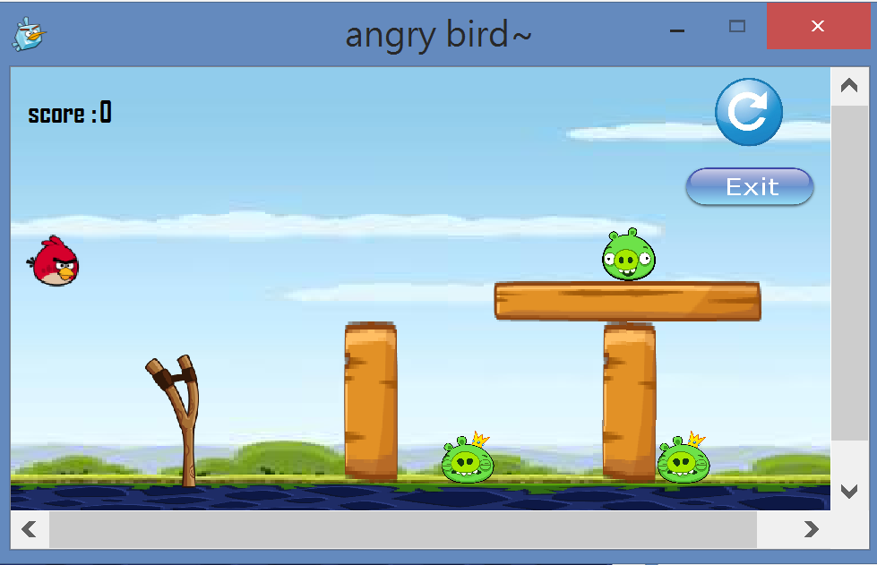

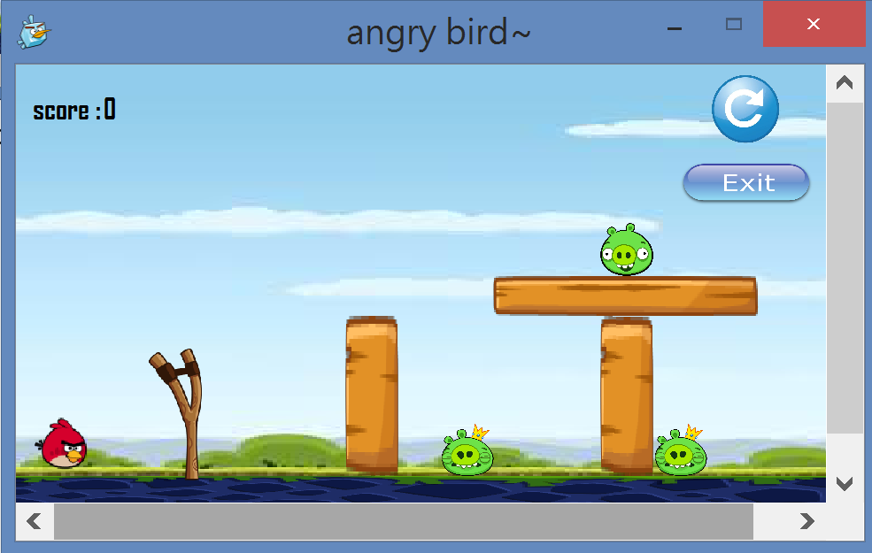

Then you can attack!! By release the mouse.

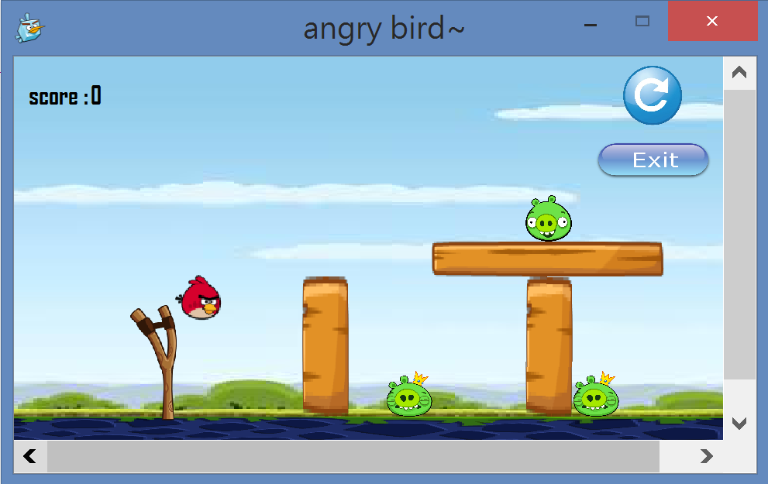

And the bird may hit the obstacles or the pigs. When the obstacle or pig disappear, you can get the point. The pig is 1000 points. The obstacle is 500 points.

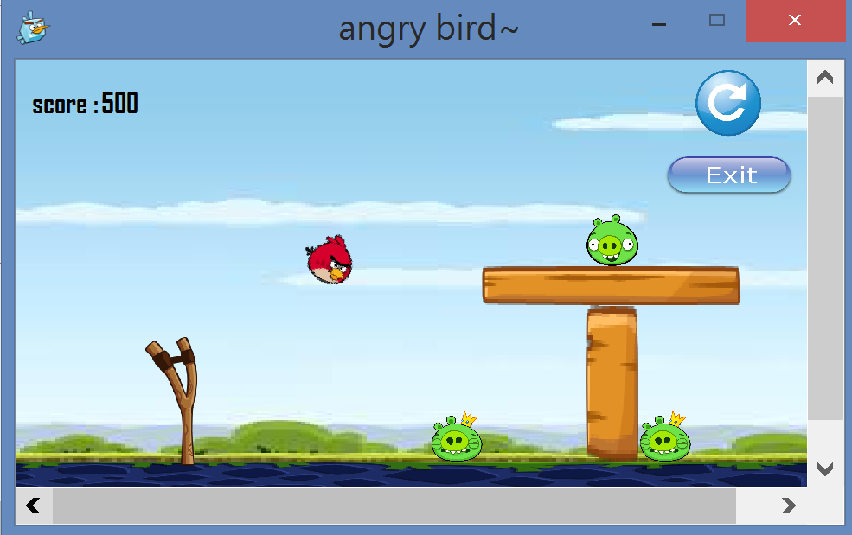

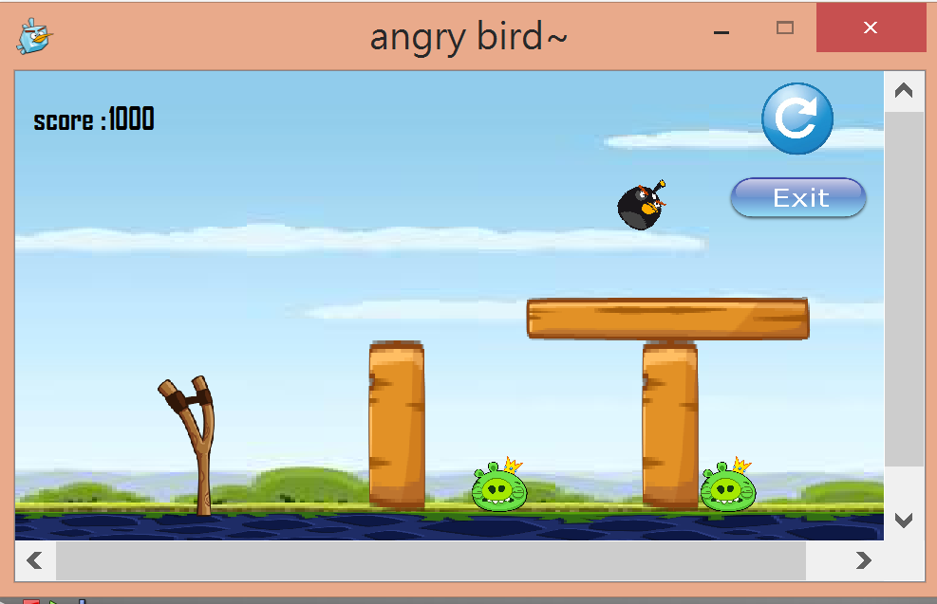

If you get more than 1000 points, you win.

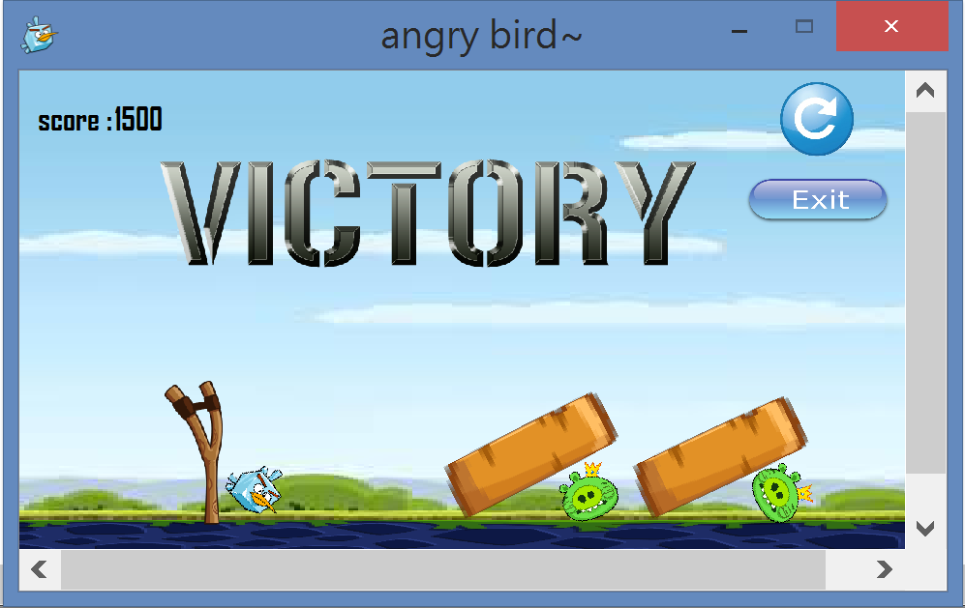

If your score is less than 1000, you lose.

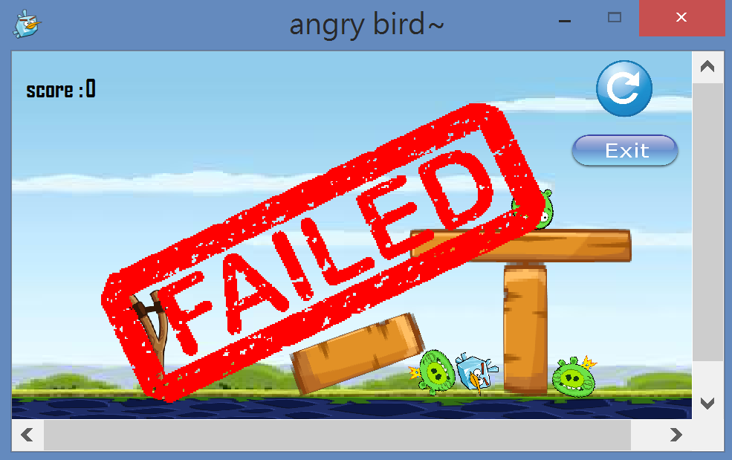

If you press the restart button, the game will restart.

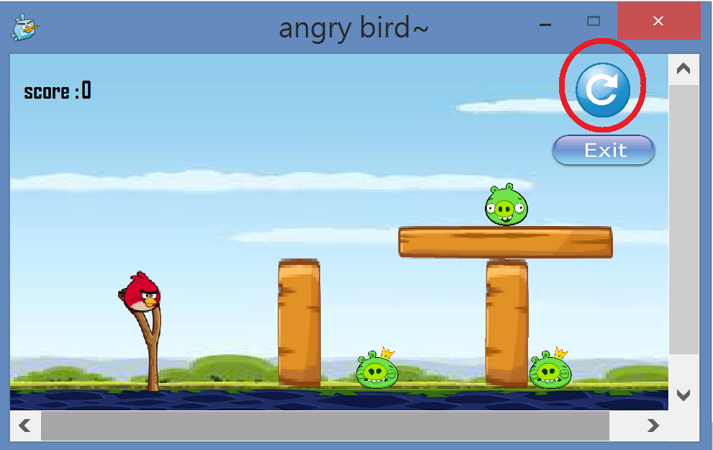

And if you press the exit button, you can leave the game.

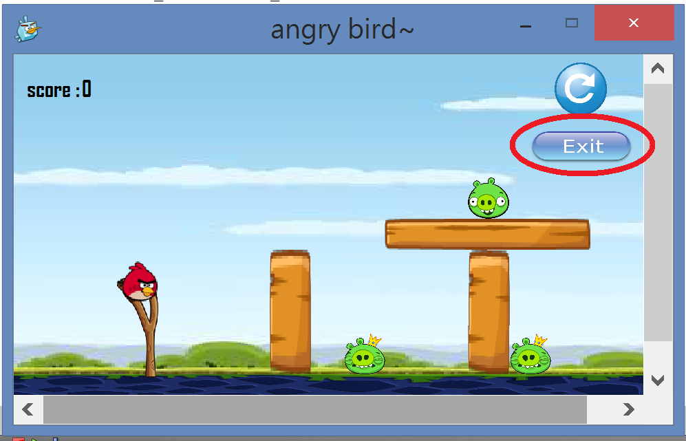

The birds :

 normal bird.

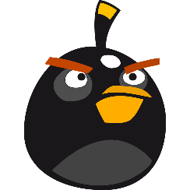 black bird : it will accelerate when you press for one time.

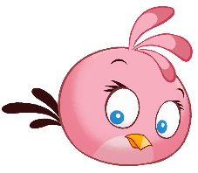pink bird : it will change to 張哲 head when you press.

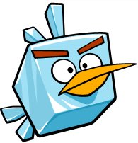ice bird : it will turn big when you press.