Problem Framing Document

TechFix AI Customer Support Resolution Agent

1. Project Overview
The TechFix AI Customer Support Resolution Agent is an intelligent customer support assistant designed to assist customers with common technical issues, warranty queries, return policies, shipping information, and frequently asked questions related to TechFix Electronics products.
The system combines Retrieval-Augmented Generation (RAG), conversation memory, safety guardrails, and support ticket generation to provide accurate and context-aware responses. The solution is implemented using Python, LangChain, Ollama (Mistral), and FAISS.

2. Problem Statement
Customer support teams frequently handle repetitive queries regarding warranty policies, troubleshooting procedures, shipping timelines, return policies, and product information. Manually responding to these requests increases response time and operational workload.
The objective of this project is to develop an AI-powered customer support agent capable of retrieving relevant information from an organizational knowledge base while maintaining conversation context, ensuring safe interactions, and assisting users by generating support ticket drafts for technical issues.

3. Business Scenario
TechFix Electronics provides electronic products including laptops, smartphones, smartwatches, and wireless earbuds.
Customers often contact support for:
- Warranty information
- Product troubleshooting
- Return and refund policies
- Shipping information
- Business hours
- Technical issues
- Escalation support
The proposed AI agent automates these common interactions while allowing complex issues to be escalated to human support.

4. Target Users
The intended users of the system include:
- Existing TechFix customers
- New customers seeking product information
- Customer support executives
- Technical support teams

5. Project Objectives
The objectives of the project are:
- Develop a conversational AI customer support assistant.
- Retrieve accurate answers from a structured knowledge base.
- Maintain context across multiple user interactions.
- Generate support ticket drafts for technical issues.
- Prevent unsafe or unauthorized requests.
- Record customer feedback for future improvements.
- Log conversations for monitoring and evaluation.

6. Functional Requirements
The AI agent shall:
- Answer customer questions using Retrieval-Augmented Generation (RAG).
- Retrieve relevant information from the TechFix knowledge base.
- Maintain short-term conversation memory.
- Generate structured support ticket drafts.
- Reject unsafe or unauthorized requests.
- Record customer feedback.
- Log user interactions.

7. Non-Functional Requirements
The system should:
- Execute locally using Ollama.
- Generate responses with low latency.
- Provide accurate and context-aware answers.
- Maintain modular and maintainable code.
- Operate without requiring external cloud APIs.
- Be easy to extend with additional tools or knowledge sources.

8. System Components
The implemented system consists of the following components:
- Baseline Rule-Based Agent
- Ollama (Mistral) Large Language Model
- FAISS Vector Database
- Ollama Embedding Model (nomic-embed-text)
- Knowledge Base
- Conversation Memory
- Support Ticket Generator
- Safety Guardrails
- Feedback Manager
- Chat Logger
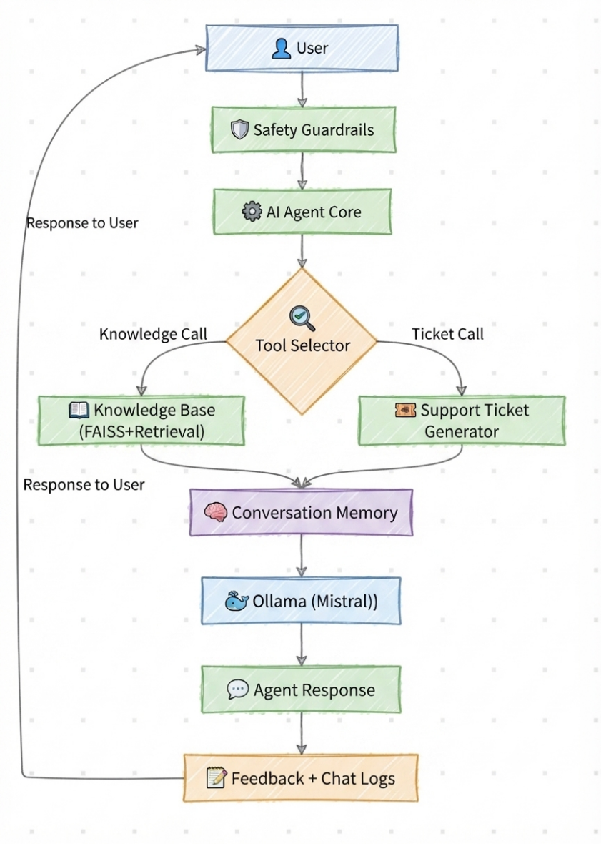

ARCHITECTURE DIAGRAM
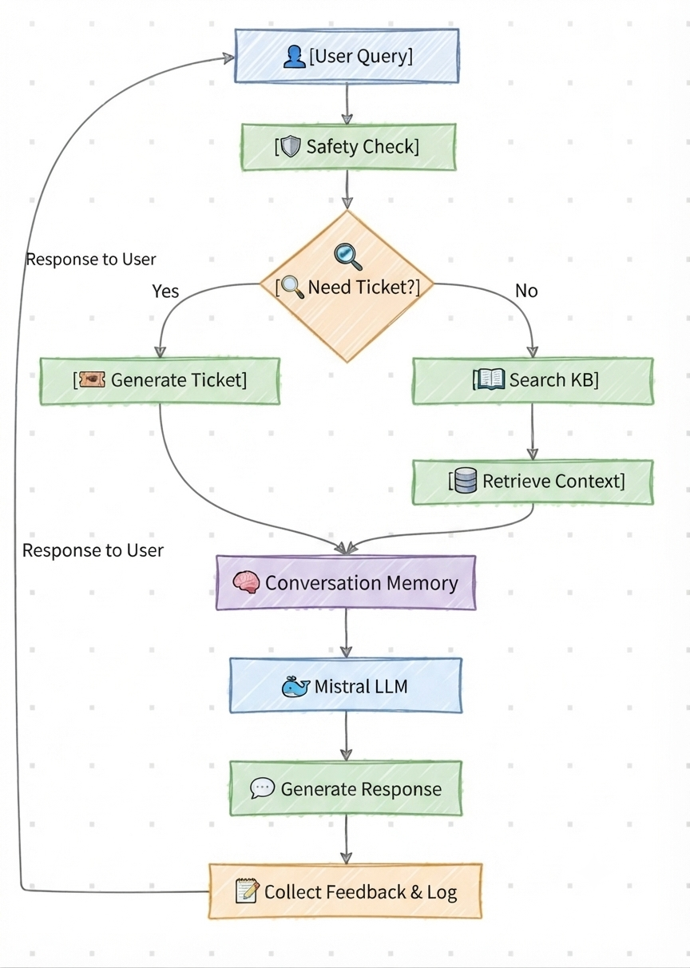
WORKFLOW

9. Success Criteria
The project is considered successful if the AI agent can:
- Correctly retrieve answers from the knowledge base.
- Maintain conversation context.
- Generate support ticket drafts.
- Refuse unsafe requests.
- Record customer feedback.
- Produce meaningful responses using the LLM.
- Successfully demonstrate Retrieval-Augmented Generation.

10. Scope

Included
- Customer support automation
- Warranty assistance
- Troubleshooting support
- Return policy assistance
- Shipping information
- Support ticket generation
- Conversation memory
- Feedback collection

Excluded
- Real customer database
- Live order tracking
- Payment processing
- Account management
- Authentication
- External API integrations

11. Risks and Limitations
The current implementation has the following limitations:
- Uses a small local knowledge base.
- Support ticket generation creates draft tickets only.
- Feedback is stored locally and does not retrain the model.
- Conversation memory is limited to the current session.
- The system depends on the quality of the knowledge base documents.

12. Conclusion
The proposed TechFix AI Customer Support Resolution Agent provides an efficient solution for automating common customer support interactions using Retrieval-Augmented Generation. By integrating a local language model, semantic search, conversation memory, support ticket generation, and safety mechanisms, the system demonstrates the practical application of modern AI agent technologies in a customer support environment.
13. References
- LangChain Documentation
- Ollama Documentation
- FAISS Documentation
- Python Documentation

