Prompt Comparison Report

TechFix AI Customer Support Resolution Agent

1. Objective
Prompt engineering is an essential part of AI agent development. The objective of this exercise was to improve the quality, accuracy, and safety of the generated responses by iteratively refining the system prompt.
Three versions of the prompt were evaluated during development.

2. Prompt Version 1 – Basic Prompt
You are a customer support assistant.
Answer the user's questions.

Observation
This prompt generated responses using the language model's general knowledge. While responses were fluent, they were not grounded in the TechFix knowledge base and could include fabricated information.

Advantages
- Simple implementation
- Natural responses

Limitations
- Hallucinated company policies
- No restriction on external knowledge
- No safety instructions
- No escalation behavior

3. Prompt Version 2 – Knowledge-Based Prompt
You are TechFix AI Customer Support Assistant.

Answer using the provided context.

If the answer is not available,
state that the information is unavailable.

Observation
The addition of retrieval context significantly improved factual accuracy. Responses became grounded in the knowledge base and reduced hallucinations.

Advantages
- Improved retrieval accuracy
- Better consistency
- Reduced fabricated information

Limitations
- No conversation awareness
- No explicit safety instructions
- Limited guidance for unsupported requests

4. Prompt Version 3 – Final Prompt
You are TechFix AI Customer Support Assistant.

Answer customer support questions.

Use ONLY the provided knowledge base.

Never invent company policies.

If information is unavailable,
reply that it is not available in the TechFix knowledge base.

Never expose customer information.

Escalate sensitive issues to authorized support representatives.

Maintain a professional and concise tone.

Observation
The final prompt produced the most reliable responses by combining retrieval constraints with safety instructions and professional response guidelines.

Advantages
- Grounded responses
- Reduced hallucinations
- Improved safety
- Consistent professional tone
- Better handling of unknown questions

5. Prompt Comparison Table
Feature | Version 1 | Version 2 | Version 3
Natural Responses | ✓ | ✓ | ✓
Knowledge Grounding | ✗ | ✓ | ✓
Hallucination Reduction | ✗ | Partial | ✓
Safety Instructions | ✗ | ✗ | ✓
Escalation Support | ✗ | ✗ | ✓
Professional Tone | Partial | ✓ | ✓

6. Sample Comparison

User Question
How long is the laptop warranty?

Version 1
General answer based on model knowledge.

Version 2
Answer retrieved from the TechFix warranty document.

Version 3
Answer retrieved from the TechFix warranty document while following safety and response constraints.
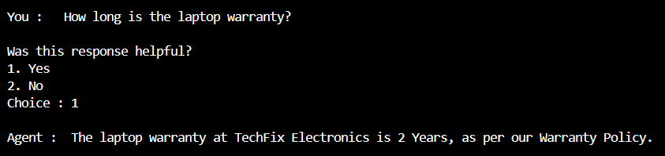

7. Conclusion
The final prompt was selected because it produced the most accurate, context-aware, and safe responses. By combining Retrieval-Augmented Generation with explicit behavioral instructions, the AI agent consistently generated responses aligned with the TechFix knowledge base while avoiding unsupported claims and unsafe disclosures.

