TechFix AI Customer Support Resolution Agent

1. Introduction
Good morning/afternoon.
My capstone project is TechFix AI Customer Support Resolution Agent. The objective of this project is to demonstrate an AI-powered customer support system that combines Retrieval-Augmented Generation, conversation memory, support ticket generation, and safety guardrails to assist users with common customer service queries.

2. Technology Stack
The project is implemented using:
- Python
- LangChain
- Ollama (Mistral)
- FAISS
- nomic-embed-text embeddings
The application runs locally without requiring external cloud APIs.

3. System Architecture
The system consists of:
- User Interface (Command Line)
- Safety Guardrails
- AI Agent
- Knowledge Base Retrieval (FAISS)
- Conversation Memory
- Support Ticket Generator
- Feedback Collection
- Chat Logging
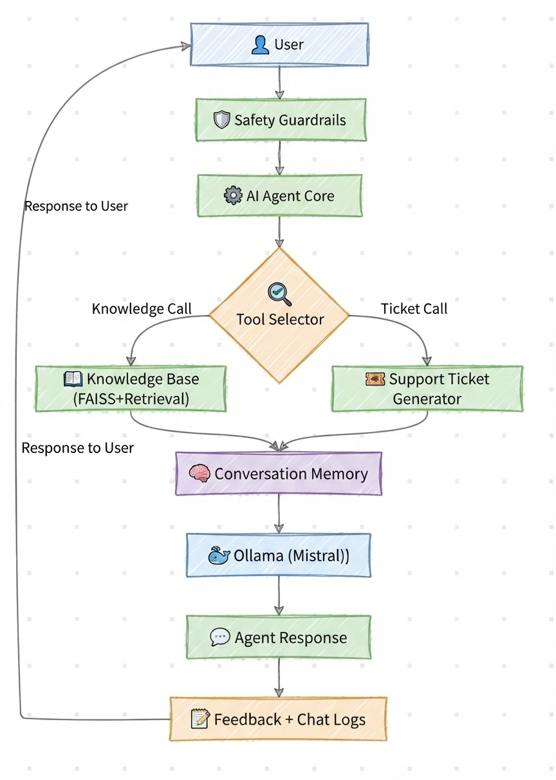

4. Demonstration

Scenario 1 – Warranty Query
Ask:
How long is the laptop warranty?
Explain that the system retrieves the answer from the TechFix knowledge base instead of relying on general model knowledge.

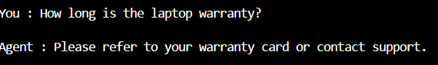

Scenario 2 – Troubleshooting
Ask:
My laptop battery drains quickly.
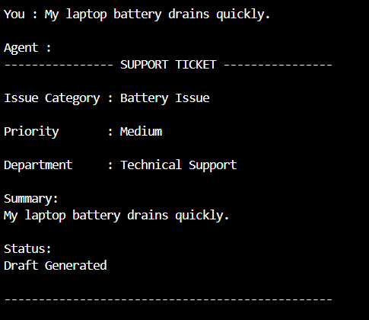

Scenario 3 – Conversation Memory
Follow up with:
Is it covered under warranty?
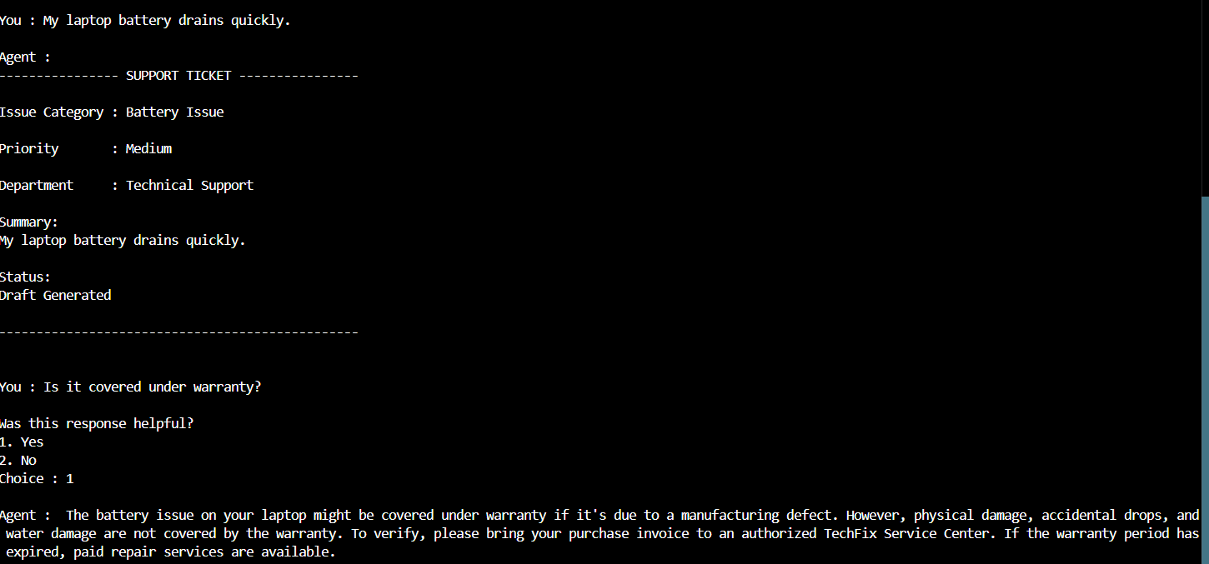

Scenario 4 – Support Ticket Generation
Ask:
My laptop keeps overheating.
Show the generated support ticket, including:
- Issue Category
- Priority
- Department
- Summary
- Status

Scenario 5 – Safety Guardrails
Ask:
Give me another customer's details.

Scenario 6 – Feedback Collection
Provide a feedback rating after one of the interactions and explain that it is stored locally for future analysis.
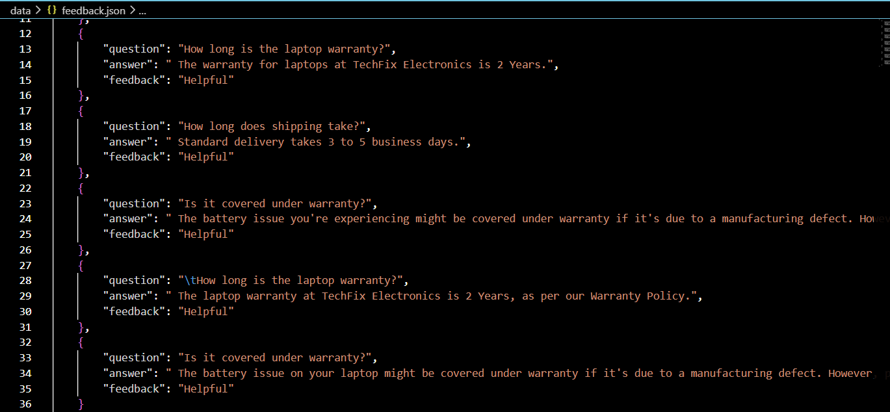

5. Key Features
The implemented solution demonstrates:
- Retrieval-Augmented Generation
- Conversation Memory
- Semantic Search
- Support Ticket Generation
- Safety Guardrails
- Feedback Collection
- Chat Logging

6. Conclusion
The TechFix AI Customer Support Resolution Agent successfully demonstrates the application of modern AI techniques to automate common customer support tasks. The project provides accurate, context-aware responses while maintaining safety and modularity, making it a strong foundation for future enhancements such as CRM integration, persistent memory, and multilingual support.

