National Institute of Technology Raipur
Department of Computer Science and Engineering
AI-DRIVEN PORTFOLIO OPTIMIZATION &
RISK MANAGEMENT ASSISTANT
Major / Minor Project Documentation
Submitted by
Lakshita Chandrakar (23115053)
Pratyu Dahariya (23115074)
Bachelor of Technology
Computer Science and Engineering
2026

Abstract
This project presents the design and implementation plan for an AI-driven financial assistant that studies market data, incorporates an individual investor's risk profile, allocates capital across a portfolio of stocks, validates the allocation against explicit risk constraints, and generates actionable Buy, Sell, or Rebalance recommendations along with natural-language explanations. The system integrates classical portfolio optimization theory (Markowitz / Black-Litterman) with reinforcement learning (Proximal Policy Optimization via the FinRL framework) and large-language-model-based financial signal extraction (Retrieval-Augmented Generation combined with FinGPT), coordinated through a central orchestrating agent. A dedicated, rule-based Risk Checker module sits between the optimization engine and the final recommendation, ensuring that no allocation is presented to the user without first being validated against position, concentration, and volatility limits appropriate to their risk tier. The primary objective is to improve risk-adjusted portfolio performance and reduce the likelihood of over-concentrated or excessively volatile recommendations, evaluated through walk-forward backtesting against standard benchmarks.

Table of Contents
1. Introduction
2. Problem Statement
3. Objectives
4. Literature Survey / Related Work
5. System Architecture
6. Module Description
7. Technology Stack
8. Evaluation Methodology
9. Implementation Roadmap
10. Expected Outcomes
11. Limitations and Future Scope
12. References

1. Introduction
Retail investors face a persistent gap between two extremes: generic robo-advisor heuristics that ignore real-time market and news context, and manual research that does not scale and is prone to behavioral bias. Advances in reinforcement learning and large language models now make it feasible to build a system that personalizes investment decisions to an individual's risk profile while incorporating both quantitative market signals and qualitative, textual financial information. This project explores that intersection, combining a learned decision-making core with a deterministic risk-validation layer so that the system's recommendations remain both adaptive and safe.

2. Problem Statement
There is a need for a portfolio assistant that can:
- Personalize asset allocation to an individual investor's risk tolerance, investment horizon, and available capital.
- Incorporate both quantitative market data and qualitative/textual financial information (news, filings, earnings commentary) into its decisions.
- Explicitly validate whether a proposed allocation is too risky before it is acted upon, rather than trusting a learned model's output unconditionally.
- Explain the reasoning behind each recommendation in plain language, rather than presenting numbers alone.

3. Objectives
- Build a portfolio allocation engine that outputs asset weights conditioned on a user's risk profile and the current market state.
- Integrate qualitative financial signals derived via RAG and FinGPT into the allocation decision.
- Implement an independent, rule-based risk-checking layer capable of clipping or rejecting allocations that violate defined risk constraints.
- Generate discrete Buy / Sell / Rebalance actions and human-readable explanations for each recommendation.
- Benchmark the system's risk-adjusted performance against standard baselines (Markowitz optimization, buy-and-hold, market index) using walk-forward backtesting.

4. Literature Survey / Related Work
Modern Portfolio Theory (Markowitz, 1952) established the mean-variance framework that remains the standard baseline for portfolio optimization, later extended by the Black-Litterman model (1992) to incorporate investor views. More recently, reinforcement learning has been applied to automated trading and allocation; the FinRL library (AI4Finance Foundation) provides a standardized environment and pre-built agents (including PPO) for financial decision-making tasks. In parallel, domain-specific large language models such as FinGPT have demonstrated the ability to extract sentiment and event signals from financial news and filings, enabling qualitative information to be incorporated into otherwise purely quantitative pipelines. This project draws on all three lines of work: classical optimization as a robust baseline, FinRL-based PPO as a learned enhancement, and FinGPT-driven RAG for qualitative signal extraction.

5. System Architecture
The system is organized as a pipeline coordinated by a central Financial Agent, which gathers the user's profile and current holdings, retrieves market data and qualitative financial signals, produces a unified state representation, and passes this to the optimization layer. Candidate portfolio weights from the optimizer are always passed through a Risk Checker before any recommendation is finalized. The complete architecture is shown below.
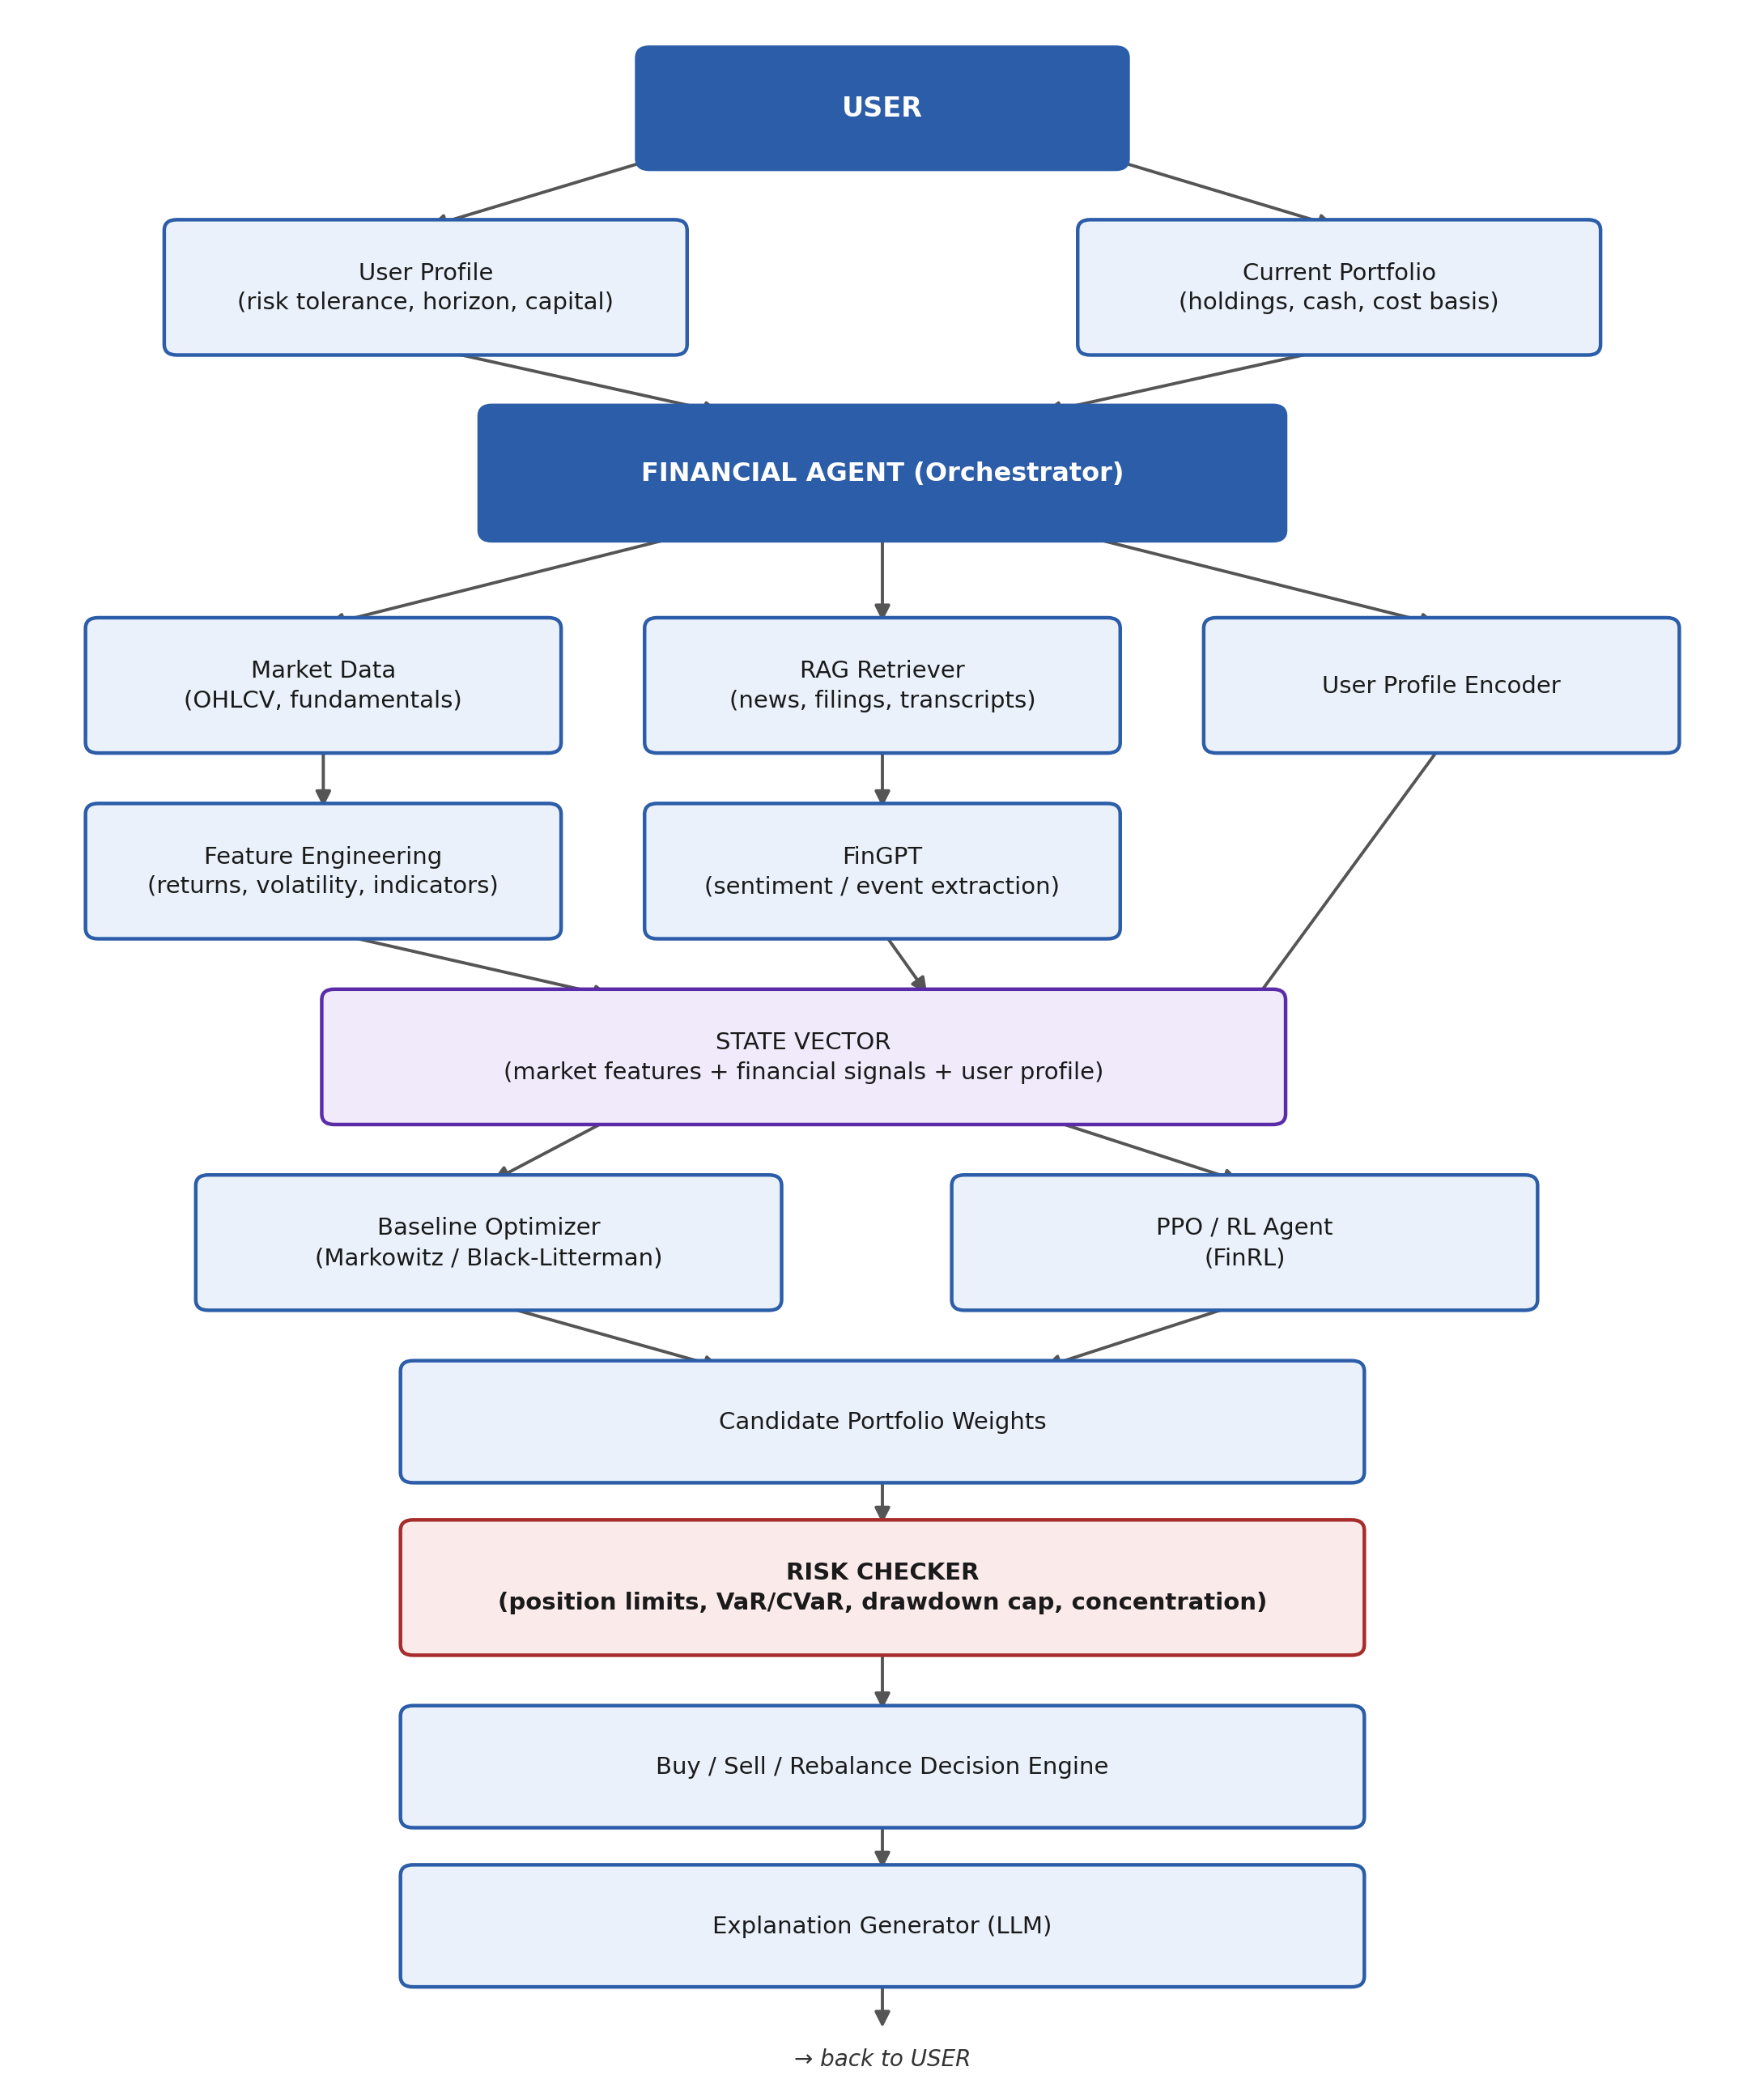
Figure 1: End-to-end system architecture.

6. Module Description

6.1 User Profile Module
Captures the investor's risk tolerance, investment horizon, available capital, and any hard constraints. This is encoded into a numeric profile vector consumed by downstream modules.

6.2 Market Data & Feature Engineering
Sources include yfinance, Alpha Vantage, and NSE/BSE APIs for OHLCV price data, along with fundamental ratios (P/E, EPS growth, debt-to-equity) where available. Derived features include rolling returns, volatility, RSI, MACD, moving averages, volume trends, and beta relative to a benchmark index.

6.3 RAG + FinGPT Signal Layer
A retrieval-augmented generation pipeline indexes recent news articles, earnings call transcripts, and filings for stocks in the investment universe. FinGPT is used to produce a per-stock sentiment score and event flags (e.g., earnings beat/miss, guidance changes), forming a financial signal vector that is versioned and logged for auditability.

6.4 Portfolio Optimization Engine
Implemented in two tiers. The baseline tier uses mean-variance (Markowitz) or Black-Litterman optimization over the feature and signal vectors, providing a fast, deterministic, and explainable allocation. The advanced tier trains a PPO agent via FinRL, with state defined as market features, financial signals, user profile, and current holdings; action defined as target portfolio weights; and reward defined as a risk-adjusted return measure (e.g., differential Sharpe ratio) rather than raw return.

6.5 Risk Checker
A deterministic, non-learned validation gate applied to every candidate allocation, enforcing:
- Maximum weight per individual stock, scaled by the user's risk tier.
- Maximum sector or industry concentration.
- Portfolio-level volatility or VaR/CVaR ceiling.
- Maximum acceptable drawdown, estimated via historical simulation.
- Correlation checks against the investor's existing holdings.
Allocations that breach a rule are either clipped and re-normalized, or returned to the optimizer with an additional constraint.

6.6 Decision Engine (Buy / Sell / Rebalance)
Compares the approved target weights against current holdings and produces discrete trade actions, accounting for transaction costs and minimum trade thresholds to avoid excessive rebalancing on small drifts.

6.7 Explanation Generator
Converts the numeric decision — target weights, risk metrics, and the signals that drove the change — into a plain-language explanation citing the specific factors that most influenced the recommendation.

7. Technology Stack
Layer | Tools / Frameworks
Market data | yfinance, Alpha Vantage, NSEpy
RAG | FAISS / Chroma, sentence-transformer embeddings
Financial LLM | FinGPT (sentiment / forecasting variant)
RL framework | FinRL (built on Stable-Baselines3 PPO)
Baseline optimization | PyPortfolioOpt (Markowitz / Black-Litterman)
Risk metrics | empyrical, quantstats
Backend orchestration | Python, FastAPI
Frontend / demo | Streamlit
Explanation LLM | Instruction-tuned LLM via API

8. Evaluation Methodology
Portfolio optimization is evaluated using risk-adjusted performance metrics rather than classification-style accuracy:
- Sharpe ratio and Sortino ratio (return per unit of risk).
- Maximum drawdown.
- Cumulative return versus benchmark (market index, buy-and-hold, and the Markowitz baseline).
- Portfolio turnover, to verify the RL agent is not over-trading.
- Risk Checker trigger rate, as a proxy for how well-behaved the learned policy is.
Backtesting follows a walk-forward protocol with rolling, chronologically ordered train/test windows and realistic transaction cost and slippage assumptions. Performance is reported separately per risk tier (low / medium / high) to verify that the system meaningfully personalizes its recommendations rather than converging to a single allocation regardless of investor profile.

9. Implementation Roadmap
Phase | Deliverable
1 | User profile module, market data pipeline, and feature engineering.
2 | Baseline Markowitz / Black-Litterman optimizer with a preliminary risk checker.
3 | RAG pipeline and FinGPT signal extraction, integrated into optimizer inputs.
4 | Full Risk Checker with configurable rule sets per risk tier.
5 | PPO / FinRL agent, trained and benchmarked against the Phase 2 baseline.
6 | Decision engine (Buy / Sell / Rebalance) and explanation generator.
7 | Backtesting framework and walk-forward evaluation.
8 | Streamlit demo interface, documentation, and final presentation.

10. Expected Outcomes
- A working prototype capable of generating personalized, risk-validated portfolio recommendations.
- Demonstrated improvement in risk-adjusted returns over the Markowitz baseline in backtesting.
- An auditable risk-validation layer that measurably reduces over-concentrated or excessively volatile allocations.
- Human-readable explanations accompanying every recommendation, supporting transparency and user trust.

11. Limitations and Future Scope
Reinforcement learning policies are trained on historical data and are not guaranteed to generalize to unseen market regimes such as structural breaks or black-swan events; this is treated as an explicit, stated limitation rather than a hidden assumption. The quality of FinGPT-derived sentiment signals depends on the freshness and coverage of the underlying RAG corpus, which may be sparser for smaller-cap stocks. The current design is scoped to long-only equity positions; extending it to options, derivatives, or short positions would require a substantially more complex risk model. Future work includes a multi-agent setup with sector-specialized agents, continual learning as new market data arrives, and incorporation of macroeconomic indicators such as interest rates and inflation as additional state features.

12. References
1. Markowitz, H. (1952). Portfolio Selection. The Journal of Finance.
2. Black, F., & Litterman, R. (1992). Global Portfolio Optimization. Financial Analysts Journal.
3. AI4Finance Foundation. FinRL: A Deep Reinforcement Learning Library for Automated Stock Trading.
4. AI4Finance Foundation. FinGPT: Open-Source Financial Large Language Models.

