Used in the game sometime:

Humanoid Dressed:
HD07_Hunter
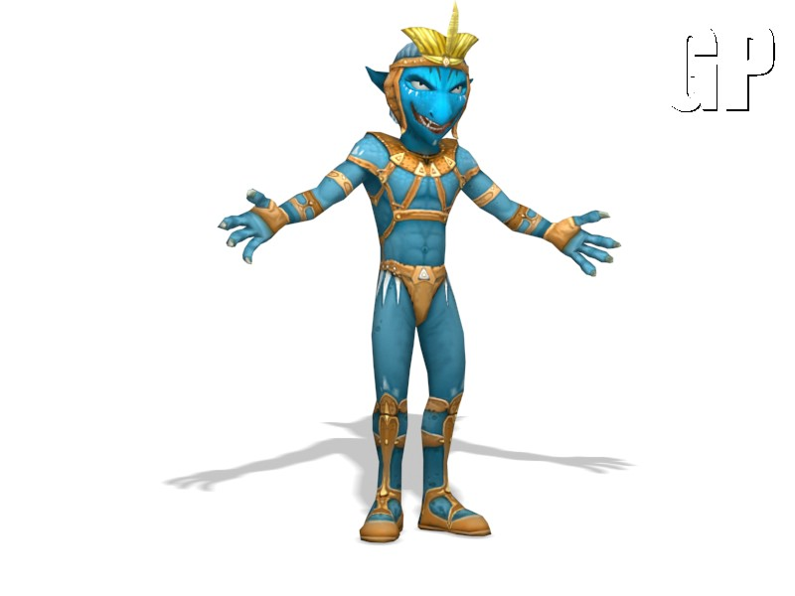
HD34_Aby_Fat_Cake
HD37_V02_Aby_Upper_Class

Flying
FL01_2headed_chickenbat or FL01_headed_chickenbat
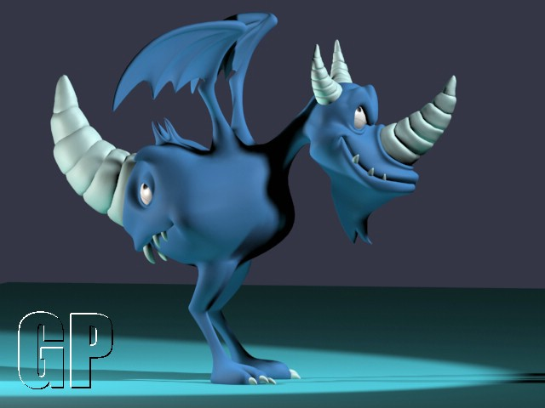

Insects
IN08_Tacked_Spider
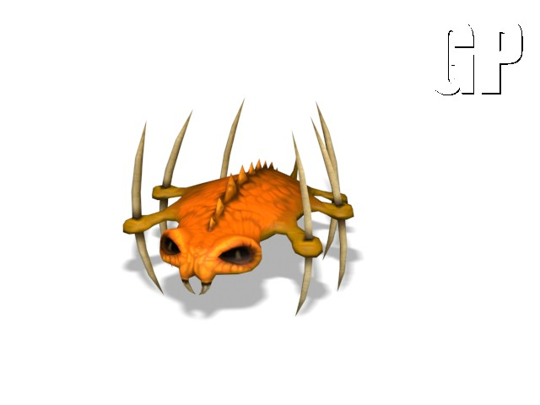

Animal Biped -> Mammal
BM04_alien_verminhorn
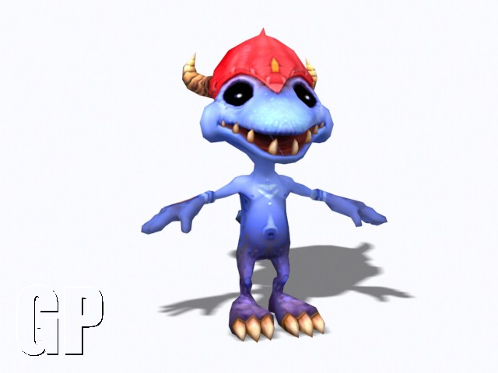

Animal Biped -> Reptile
BR03_Lizard_Mount
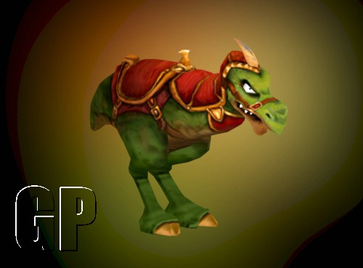

Animal Quadruped -> Undead
QU03_Skeletal_Worm
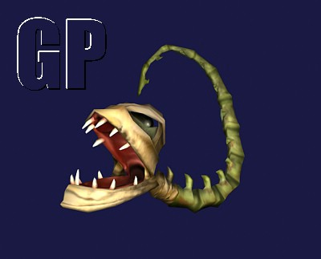
QU07_Dead_Arm
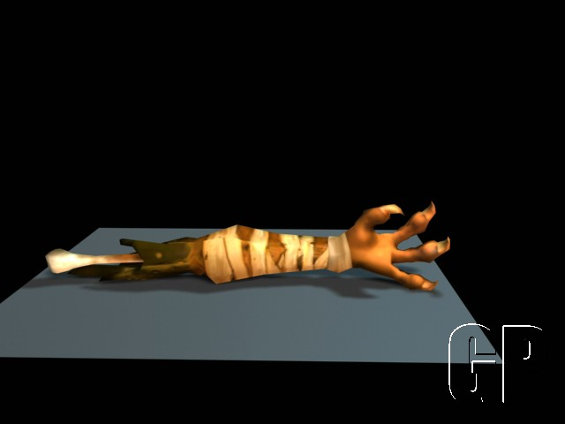

They have never been used in the game

Humans:
HU01_old_Man
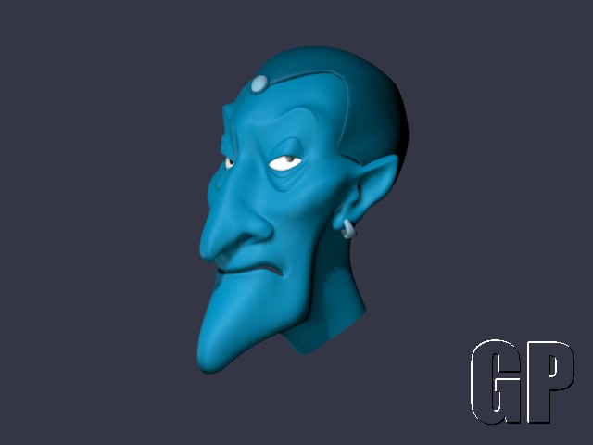
HU14_pharaoh
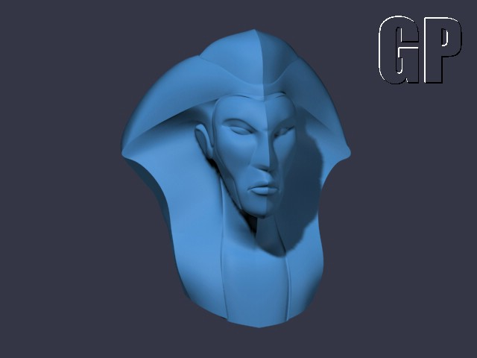

Humanoid Dressed:
HD04_Fox_Anubis
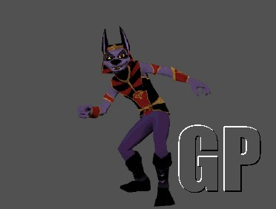
HD08_suave_Dog
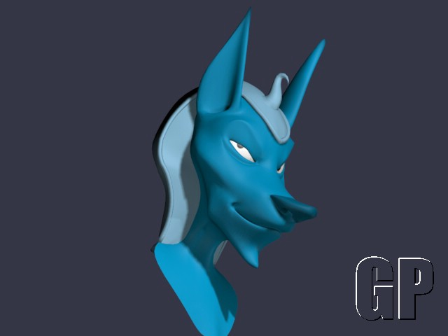
HD11_pretty_reptileman
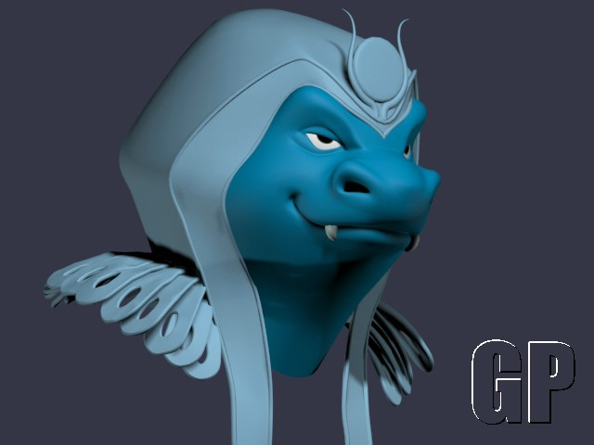

Animal Biped -> Mammal
BM08_grinning_burble
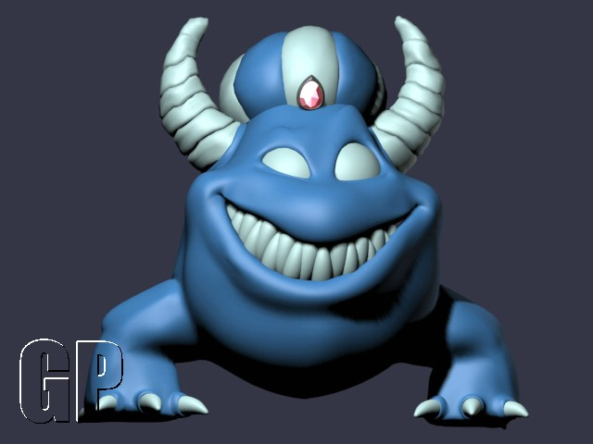
BM11_half_camel

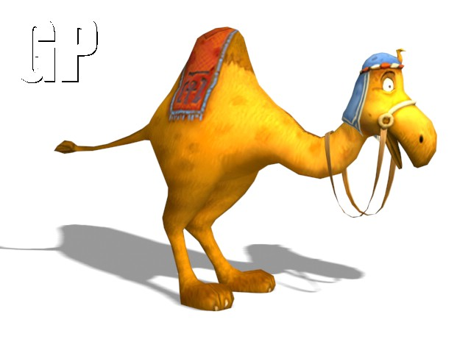

Animal Biped -> Reptile
BR01_big_lizard
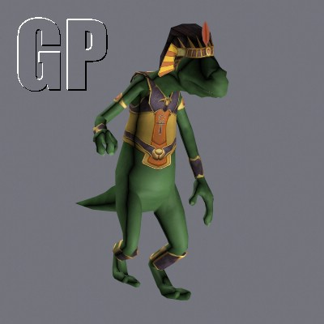

BR02_BR02_small_lizard
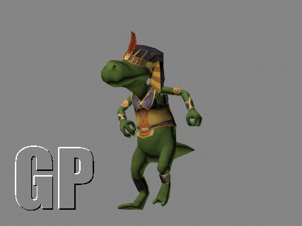

Plants
PL03_tweezers_tree
