
Server Operating System
®
A White Paper from the Desktop and Business Systems Division
Microsoft® Active Directory Service Interfaces: ADSI
Open Interfaces for Managing and Using Directory Services
© 1998 Microsoft Corporation. All rights reserved.
The information contained in this document represents the current view of Microsoft Corporation on the issues discussed as of the date of publication. Because Microsoft must respond to changing market conditions, it should not be interpreted to be a commitment on the part of Microsoft, and Microsoft cannot guarantee the accuracy of any information presented after the date of publication.
This White Paper is for informational purposes only. MICROSOFT MAKES NO WARRANTIES, EXPRESS OR IMPLIED, IN THIS DOCUMENT.
Microsoft, the BackOffice logo, Visual Basic, Windows and Windows NT are either registered trademarks or trademarks of Microsoft Corporation in the United States and/or other countries.
Other product or company names mentioned herein may be the trademarks of their respective owners.
Microsoft Corporation • One Microsoft Way • Redmond, WA 98052-6399 • USA
0398


This paper details the vision of Microsoft for integrating multiple directory services through a well defined, open set of interfaces: Microsoft® Active Directory Service Interfaces. The availability of a standard, open directory service administration and programming model for Windows®-based platforms will encourage the inclusion of directory services in a wide range of commercial and customer-developed applications.
Abstract

Introduction 1
CONTENTS
Why are Active Directory Service Interfaces Important? 1
What You Should Already Know 1
Directory Services Today 2
Active directory Service Interfaces 4
What are Active Directory Service Interfaces? 4
Who Will Use Active Directory Service Interfaces? 4
Benefits of Active Directory Service Interfaces 5
Active Directory Service Interfaces Architecture 6
Object Model 6
Active Directory Service Interfaces Objects 6
Active Directory Service Interfaces Provider 6
Active Directory Service Interfaces Schema Management 6
Schema Management Active Directory Service Interfaces Objects 7
Schema container object 7
Class container object 8
Active Directory Service Interfaces Caching 8
Active Directory Service Interfaces Names 8
Active Directory Service Interfaces Navigation 9
Active Directory Service Interfaces Searching 10
Active Directory Service Interfaces Security 11
Active Directory Service Interfaces Extension 12
Active Directory Service Interfaces Standard Objects 13
Directory Objects 13
Standard Container Objects 13
Standard Leaf Objects 13
Active Directory service Interfaces Programming Model 14
Component Object Model 14
OLE Automation Interface (IDispatch) 15
Using Active Directory Service Interfaces 16
Using Active Directory Service Interfaces for Administration Creating a List of Users. 16
Adding Users to Groups 16
Starting and Stoppin Services 16
Using Active Directory service Interfaces for Schema Management 18
Conclusion 19
For More Information 19

Why are Active Directory Service Interfaces Important?

Introduction
One of the challenges of working within a large, distributed computing environment is identifying and locating resources such as users, groups, print queues, and documents. A directory service is part of a distributed computing environment that provides a way to locate and identify the users and resources available in the system. A directory service is like a phone directory. Given a name for a person or a resource, it provides the information necessary to access that person or resource. You do not have to use specific binding information to access a resource on the network.
Most enterprises already have many different directories in place. For example, network operating systems, electronic mail systems, and “groupware” products all have their own directories. Many issues arise when a single enterprise deploys multiple directories. These issues include usability, data consistency, development cost, and support cost, among others.
Active Directory Service Interfaces addresses these issues by providing a single, consistent, open set of interfaces for managing and using multiple directories.

What You Should Already Know
This document assumes readers have a working knowledge of OLE, the Component Object Model, and directory services. Example code appears in the Microsoft Visual Basic® development system.
It is common to find a variety of directories—many playing an administrative role—that are deployed within a single organization. These include network resource directories, such as and LDAP-based directory, Active Directory, Banyan StreetTalk, Microsoft Windows NT® operating system Directory Service, and Novell Directory Services, as well as application specific directories, such as, Lotus Notes, cc:Mail, or Microsoft Mail. Although a single directory for an entire organization is desirable, no product available today can fill this very large requirement.

Directory Services Today
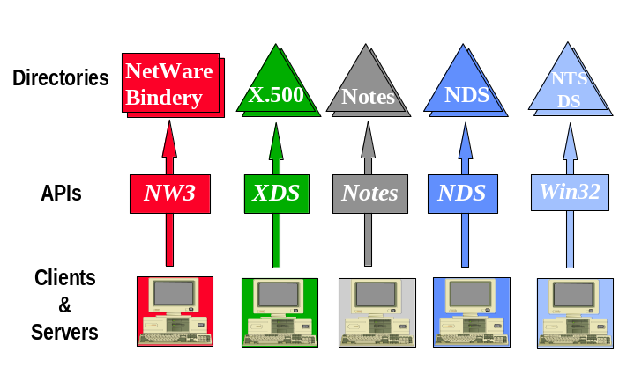
Figure 1 - The directory challenge
Multiple directories in the organization pose complex challenges to users, administrators, and developers. These problems have limited wide-directory deployment. End users face multiple logons and a variety of interfaces to information across multiple directories. Administrators face the complexity of managing multiple directories. End users and administrators want application developers to use an existing administrative directory, but developers face a dilemma—which one should they use? Each directory offers unique application interfaces. Developers must choose a specific directory implementation, or support multiple versions of their application. As a result, developers seldom use existing directory services.
Microsoft has a strategy for helping to solve these customer problems noted above—the Active Directory Service Interfaces (ADSI). ADSI is a set of COM programming interfaces that will make it easy for customers and Independent Software Vendors (ISVs) to build applications that register with, access, and manage multiple directory services with a single set of well-defined interfaces.
One of the most familiar open programming API is Open Data Base Connectivity (ODBC). ODBC provides open interfaces for relational databases, thus allowing developers to write applications and tools that will work with any database that supports ODBC. Because of the thriving ODBC development community, every major relational database now supports ODBC. ADSI is “ODBC for directory services.”
- ADSI gives developers access to multiple directory service providers via an open set of interfaces. Applications written to ADSI will work with any directory service that offers an ADSI provider. ADSI addresses the problems outlined above.
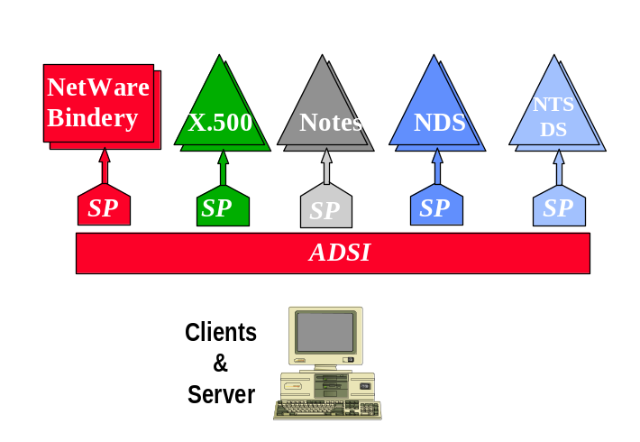
Figure 2 - The open solution
The remainder of this document presents the concepts, features, benefits, and architecture of Active Directory Service Interfaces, and provides examples of Active Directory Service Interfaces usage.

What are Active Directory Service Interfaces?

Active directory
Service Interfaces
Active Directory Service Interfaces abstracts the capabilities of directory services from different network providers to present a single set of directory service interfaces for managing network resources. The standard Active Directory Service Interfaces objects are those found within multiple namespaces. The typical namespaces for Active Directory Service Interfaces are directory services for various network operating systems. Administrators and developers can use Active Directory Service Interfaces services to enumerate and manage the resources in a directory service, no matter which network environment contains the resource.
Active Directory Service Interfaces makes it easier to perform common administrative tasks, such as adding new users, managing printers, and locating resources throughout the distributed computing environment.
Active Directory Service Interfaces makes it easy for developers to “directory enable” their applications. Administrators and developers deal with a single set of directory service interfaces—regardless of the installed directory services.
Active Directory Service Interfaces are one component of the Windows® Open Services Architecture (WOSA) Open Directory Service Interfaces (ODSI).

Who Will Use Active Directory Service Interfaces?
Network Administrators will use Active Directory Service Interfaces to automate common administrative tasks, such as adding users and groups, managing printers, and setting permissions on network resources.
Independent Software Vendors (ISVs) and end user developers will use Active Directory Service Interfaces to “directory enable” their products and applications. Services can publish themselves in a directory, clients can use the directory to find the services, and both can use the directory to find and manipulate other objects of interest. Because Active Directory Service Interfaces are independent of the underlying directory service(s), the directory enabled products and applications will operate successfully in multiple network and directory environments.

Benefits of Active Directory Service Interfaces
Feature | Benefit
Open | Any directory provider can implement an Active Directory Service Interfaces provider; users gain freedom of choice in directory services without sacrificing manageability.
DS Independent | Administrative applications are not tightly bound to a given vendor’s directory service. The same application can work on multiple directories. Development time and support costs are reduced.
Java Support | Active Directory Service Interfaces objects provide easy access to directory services for Java applets and programs through Java COM.
Security | ADSI both support Authentication and Authorization programming model
Simple Programming Model | Administrative and other directory-enabled applications can be developed with no need to understand vendor-specific directory APIs.
OLE Automation Server | Any OLE Automation Controller (for example, Visual Basic, Perl, Rexx, C/C++ and others) can be used to develop directory service applications. Administrators and developers can use the tools they already know. Productivity is enhanced—development time and support costs are reduced.
Functionally Rich | ISVs and sophisticated end users can develop serious applications using the same Active Directory Service Interfaces models that are used for simple scripted administrative applications.
Extensible | Directory providers, ISVs, and end users can extend Active Directory Service Interfaces with new objects and functions to add value or meet unique needs.

Object Model

Active Directory
Service Interfaces
Architecture
The Active Directory Service Interfaces object model consists of Active Directory Service Interfaces objects and dependent objects. Clients manipulate objects with interfaces. Active Directory Service Interfaces providers implement the Active Directory Service Interfaces objects and their interfaces.

Active Directory Service Interfaces Objects
Active Directory Service Interfaces objects are COM objects that represent persistent objects in an underlying directory service. An Active Directory Service Interfaces object is manipulated using one or more COM interfaces.
Active Directory Service Interfaces objects are divided into two groups: directory service leaf objects, and directory service container objects. A container object can contain other Active Directory Service Interfaces objects. A leaf object cannot contain Active Directory Service Interfaces objects.

The division of a given object type into a host and one or more dependent objects implements a logical grouping of properties and methods. This division does not necessarily reflect the structure of the underlying directory. The host and dependent object relationship should not be confused with the container and contents relationship—the former is a characteristic of Active Directory Service Interfaces, the latter a characteristic of the underlying directory.

Active Directory Service Interfaces Provider

An Active Directory Service Interfaces provider contains the implementation of Active Directory Service Interfaces objects and dependent objects for a particular namespace. Figure 3 below demonstrates that clients are concerned only with getting and using interfaces on an object, and not with the details of where and how the software of an object is implemented.

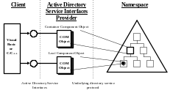
Figure 3 - Provider architecture

Active Directory Service Interfaces Schema Management
Active Directory Service Interfaces provides predefined objects so that directory service manipulation can be uniform across namespaces. However, an Active Directory Service Interfaces object in any given directory might have more functionality than that specified by Active Directory Service Interfaces. A directory might also contain objects that are not defined at all by Active Directory Service Interfaces. In addition, there are extensible directory services that allow their base schema to be modified and their objects to be arbitrarily extended by administrators and independent software vendors.
Object extensions are handled by the Schema Management Active Directory Service Interfaces objects. These objects are used to:
- Browse the definitions of objects.
- Extend the definitions of objects.

Schema Management Active Directory Service Interfaces Objects
The schema management objects can be used to browse and modify the schema of a namespace. These objects are:
- Schema container object, which contains a given schema.
- Class container object, which defines an object class.
- Property object, which describes a property.
- Syntax object, which describes a syntax that can be used in a property definition.
These objects are different from directory service objects like the User component, in that their properties are not subdivided into functional sets.

Schema container object
The schema container object is used to attach a set of object definitions to a part of a directory tree. Typically, each instance of a directory will have its own schema. Active Directory Service Interfaces represents this by placing a schema container as a child of the directory root.
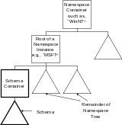
Figure 4 - The Schema container
Figure 4 shows the typical layout. However, Active Directory Service Interfaces does not limit schema containers to this level of the tree. A complex directory might allow multiple schemas to exist in a directory instance. In that case, schema containers might be found in other parts of a tree. As shown in Figure 5, there can only be one schema container in any given Active Directory Service Interfaces container.
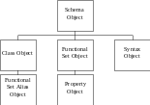
Figure 5 - Schema hierarchy
The schema container itself is a tree that contains class, functional set, property, and syntax definitions. New classes and functional sets can be created in the container to expand the schema.
Functional sets are defined separately from classes so that they can be used in multiple class definitions.

Class container object
The class container object is used to define a class of objects that can be created in the directory. New classes can be derived from existing classes using the Active Directory Service Interfaces model.
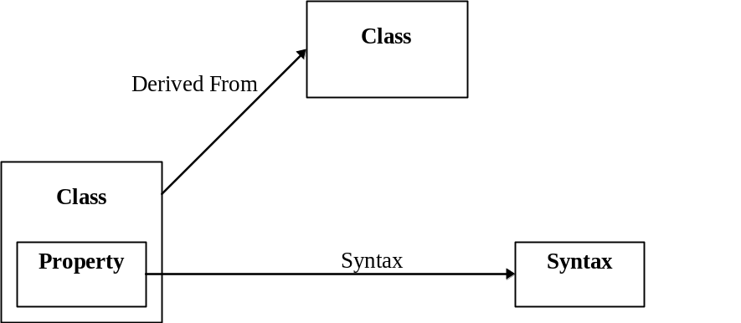
Figure 6 - Creating a class
Figure 6 illustrates how a class container object relates to other class objects, property objects, and syntax objects to create a definition of a class. A class object points to property objects, which point to the syntax the property supports.

Active Directory Service Interfaces Caching
All Active Directory Service Interfaces objects provide two methods—GetInfo and SetInfo—to provide simple caching for properties. Operations that involve getting and setting properties occur in the cache.
A caller can obtain a property value from an Active Directory Service Interfaces object at any time after obtaining the object. The caller need not call GetInfo first. If the property in question has not been previously retrieved, the provider is responsible for retrieving and caching it to satisfy the request. Subsequent requests will be satisfied from the cached value.
GetInfo is called to explicitly refresh the object’s cached properties from the underlying directory. By calling GetInfo, the caller ensures that the property values are current as of the time of the GetInfo call. If the GetInfo method is executed after changes are made to the local object’s cache but before the SetInfo method is executed, the changes are discarded. GetInfo allows the client to provide hints about which properties it uses, so that the provider can optimize network access.
SetInfo is called to write an object back to the underlying directory. No changes are made to an object’s properties within the directory until the SetInfo method is called.

Active Directory Service Interfaces Names
Objects that reside within a given namespace, are identified by a unique name. For example, files stored on a PC disk drive reside in the file system namespace. The unique name of a file is based on where it is stored in the file system namespace, for example:
C:\public\documents\adsi\adsi_spec_v3.doc
Directory service namespaces also identify the objects they contain by unique names, which are usually based on the location in the directory where the object can be found. For example, in a Active Directory, a given object might have a name like this:
CN=JSmith, OU=Sales, DC=ArcadiaBay, DC=Com
Different directory services use different forms for naming the objects they contain. This makes dealing with different namespaces challenging, especially for developers, considering all of the different environments on which the code might be running.
A goal of Active Directory Service Interfaces is to minimize the code’s knowledge of an object’s path so that programs can be namespace-portable.
Active Directory Service Interfaces defines a naming convention that can uniquely identify an Active Directory Service Interfaces object in a heterogeneous environment. These names are called ADsPath strings. AdsPath consists of provider’s moniker (for example LDAP:, WinNT:)and provider’s specific path. Example of ADsPath strings are:

WinNT://REDMOND/jsmith, user see previous comment re: “WinNT”
Identifies jsmith user in Redmond Domain
WinNT://REDMOND/comp1, computer
Identifies comp1 in Redmond Domain
WinNT://REDMOND/comp1/alice
Identifies alice as local user on comp1 computer.
LDAP://OU=Sales, DC=ArcadiaBay, DC=COM
Identifies an organizational unit in Arcadia Domain
LDAP://exch01/O=Microsoft
Identifies exchange object on exchange server

Active Directory Service Interfaces Navigation
Active Directory Service Interfaces provides easy navigation models via
IADsContainer. Using this interface, a caller can also filter types of object.
Example – Show all objects in a given organizational unit
Set ou = GetObject(“LDAP://host1/OU=Sales, DC=ArcadiayBay,DC=COM”)
For each obj in ou
Debug.Print obj.Name
Next
Example: List all users in ArcadiaBay domain
Set dom = GetObject(“WinNT://ArcadiaBay”)
dom.Filter = Array(“user”)
For each usr in dom
Debug.Print usr.Name
Next

Active Directory Service Interfaces Searching
Searching is one of most frequently used tasks in most directories. In ADSI, searching can be performed either using OLE DB interfaces or directly using Active Directory Service Interfaces directly. For better control, these interfaces allow a caller to specify search page size, sort, size limit, search level, search scope and other options.
Since ADSI is also an OLE DB provider, with Distributed Query technology shipped with Microsoft SQL Server™, one can join one result set from ADSI and other result set from other OLE DB provider. For example, one can join a sales data in SQL Server with user and contact information found in Active Directory.
Example: Querying Active Directory using ADO

Dim con As New Connection, rs As New Recordset
Dim Com As New Command

'Open a Connection object
con.Provider = "ADsDSOObject"
con.Open "Active Directory Provider"

‘Create a command object on this connection
Set Com.ActiveConnection = con

Com.CommandText = "select name from 'LDAP://DC=ArcadiayBay,DC=COM' where objectClass='*' ORDER BY NAME"

'-----------------------------------------
'Set the preferences for Search
'--------------------------------------
Com.Properties("Page Size") = 1000
Com.Properties("Timeout") = 30 'seconds
Com.Properties("searchscope") = ADS_SCOPE_SUBTREE
'--------------------------------------------
'Execute the query
'--------------------------------------------
Set rs = Com.Execute

'--------------------------------------
' Navigate the record set
'----------------------------------------
While Not rs.EOF
Debug.Print rs.Fields(“Name”).Value
rs.MoveNext
Wend

Active Directory Service Interfaces Security
Active Directory Service Interfaces provides both authentication and authorization client access. If it is used to communicate to Active Directory, a user may be authentication using Kerberos or NTLM depending on the environment. ADSI also provides a developer to manipulate Security Descriptor.
Example: Logon as JSmith

Dim dso As IADsOpenDSObject
Dim domain As IADsDomain
Set dso = GetObject("WinNT:")
Set domain = dso.OpenDSObject("WinNT://ArcadiaBay", "JSmith", "secret", ADS_SECURE_AUTHENTICATION)

Example – Adding ACE permission to an object

Dim Ace1 as new IADsAccessControlEntry
Dim Ace2 As new IADsAccessControlEntry
Dim Dacl as new IADsAccessControlList
' Add the ACEs to the Disretionary ACL
Dacl.AclRevision = 4 ‘DS ACL Revision
' Set up the first ACE
Ace1.AccessMask = -1 'Full Permission (Allowed)
Ace1.AceType = ADS_ACETYPE_ACCESS_ALLOWED
Ace1.AceFlags = ADS_ACEFLAG_INHERIT_ACE
Ace1.Trustee = "ACTIVED\Administrator"
' Add the ACEs to the Disretionary ACL
Dacl.AddAce Ace1
Dacl.AddAce Ace2

Active Directory Service Interfaces Extension
ISVs or corporate developers will be able to extend the object semantic by adding interfaces to the existing ADSI interfaces. ADSI combines COM Aggregation model and directory technology to bring a powerful extension model. A backup and restore vendor, for example, may extend computer object with vendor specific methods or properties. By having these methods available, a scriptwriter or administrator can write a script to back up all computer to a given organizational he or she delegates.
Code Example – Backup all computers in Sales organizational unit.
Set ou = GetObject(“LDAP://OU=Sales, DC=ArcadiaBay, DC=COM”)
Ou.Filter = Array(“computer”)
For each comp in ou
comp.BackUpNow() ‘ this is extension method
Next

Directory Objects

Active Directory
Service Interfaces Standard Objects
Active Directory Service Interfaces defines two kinds of objects. Clients use Schema Management Objects to browse and extend the schema. Directory Objects represent the objects in the underlying namespaces managed by the Active Directory Service Interfaces providers. Schema Management Objects are discussed above, in “Active Directory Service Interfaces Schema Management.”
Active Directory Service Interfaces defines a set of standard container and leaf objects that represent the most common objects found in network directories. Using the schema extension model, provider writers and application developers can add additional objects as needed.

Standard Container Objects
- Namespaces
- Country
- Locality
- Organization
- Organizational Unit
- Domain
- Computer

Standard Leaf Objects
- User
- Group
- Alias
- Service
- Print Queue
- Print Device
- Print Job
- File Service
- File Share
- Session
- Resource

Component Object Model

Active Directory
service Interfaces
Programming Model
Active Directory Service Interfaces objects are Component Object Model (COM) objects. Active Directory Service Interfaces programming is COM programming. In its most basic form, programmers interact with COM objects by calling one of the standard OLE procedures to obtain a pointer to an object’s IUnknown interface. They then call QueryInterface to obtain a pointer to the specific interface of interest.
Active Directory Service Interfaces can all be called using this standard COM model by using traditional compiled languages such as, Microsoft C and Microsoft C/C++. Active Directory Service Interfaces provides a “helper” function, ADsGetObject, to simplify the process of obtaining the desired interface pointer from a given Active Directory Service Interfaces object.
Example 1: Creating a User (C/C++)
IADsContainer *pContainer;
IADs *pNewObject;
IADs *pNewObject;
IADsUser *pUser;

//
// Bind to the known container.
//
ADsGetObject(TEXT"WinNT://MSFT",
IID_IADsContainer,
(void**)&pContainer);

//
// Create the new Active Directory Service Interfaces User object.
//
pContainer->Create(TEXT"User",
TEXT"Jane",
&pNewObject);

//
// Get the IADsUser interface from the user object.
//
pNewObject->QueryInterface(IID_IADsUser, &pUser);

//
// Set Jane’s password.
//
pUser->SetPassword(TEXT"Argus");

//
// Complete the operation to create the object.
//
pUser->SetInfo();

//
// Cleanup.
//
pContainer->Release();
pNewObject->Release();
pUser->Release();

OLE Automation Interface (IDispatch)
Active Directory Service Interfaces objects are also OLE Automation Servers. All Active Directory Service Interfaces can be invoked via the IDispatch interface.
The IDispatch interface is defined by OLE. It is the OLE Automation interface for controllers that do not use COM interfaces directly. Accessing an object through IDispatch is called name-bound or late-bound access, since the connection between the client and the OLE object (server) occurs at run time, and not when the client program is linked.
OLE Automation controllers like Visual Basic hide the inner workings of OLE, and calls all of the necessary methods in IDispatch on behalf of the programmer. Programmers can concern themselves with the logic of their application, and not the low-level details of OLE.
Example 2: Creating a User Object (Visual Basic)
Dim Container as IADsContainer
Dim NewUser as IADsUser

‘ Bind to the known container.
Set Container = GetObject("WinNT://MSFT")

‘ Create the new Active Directory Service Interfaces User.
Set NewUser = Container.Create("User", "Jane")

‘ Set Jane’s password.
NewUser.AccountRestrictions.SetPassword("Argus")

‘ Complete the operation to create the object in the directory.
NewUser.SetInfo

Using Active Directory Service Interfaces for
Administration
Creating a List of Users.

Using Active
Directory Service
Interfaces
Building lists of users and their properties is a common need. In this example, a Visual Basic script extracts all of the users in the “WinNT” namespace in ABX Compute Corporation’s Manufacturing division. Here each user’s name and known telephone numbers (as they appear in the directory) are passed to a “PrintUser” routine.
Example 3: Creating a list of users
dim MyUserContainer as IADsContainer
dim MyUser as IADsUser

set MyUserContainer as GetObject(“WinNT://ABX”)

for each MyUser in MyUserContainer
PrintUser MyUser.Name, MyUser.TelephoneNumber
next MyUser

Adding Users to Groups
Adding users to groups for security purposes is a common and time-consuming activity for system administrators. In this example, the users from the preceding example are added to the Manufacturing Users group in the ABX organization, if they do not already belong.
Example 4: Adding users to groups
dim MyUserContainer as IADsContainer
dim MyUser as IADsUser
dim MyGroup as IADsGroup
dim Filter as Variant

Filter = Array(“user”);

set MyUserContainer = GetOBject(“WinNT://ABX”)
MyContainer.Filter = Filter ‘ filter out all objects except users
set MyGroup = GetObject(“WinNT://ABX/Manufacturing_Users”)

for each MyUser in MyUserContainer
if not MyGroup.IsMember(MyUser) then
MyGroup.Add(MyUser)
end if
next MyUser

Starting and Stoppin Services
In this scenario, John Smith is given the responsibility to manage services in the company. He wants to write a small script that will stop all DHCP services.
Example 5: Start/Stop Services
Set dom = GetObject(“WinNT://ABX”)
Dom.Filter = Array(“Computer”)
For each comp in dom
comp.Filter = Array(“Service”)
For each svc in comp
If ( svc.Name = Browser ) then
svc.Stop
End if
Next
Next

With Windows 2000 Active Directory, a caller can also enumerate published services for a given organizational unit, search for all published services in a given enterprise and more.
A useful feature of schema-based directory services is the ability of administrators to add properties to objects. For example, administrators at the “ABX” organization might want to create an “ABXuser” based on the standard Active Directory Service Interfaces user object, which contains additional properties useful at ABX.

Using Active
Directory service
Interfaces for Schema Management
Assume that ABX wants to add a Card Key number to the user object, and call the new object type “ABXuser.” Active Directory Service Interfaces makes this simple. First, a new class is created in the schema container, and is marked as derived from the desired base class. New properties are added to the new Class. The Visual Basic code to perform this extension appears below.
Example 7: Extending the Schema
' get the Schema Path
set ds = getobject("LDAP://RootDSE") ' and from that that the schema container
set sch = getobject("LDAP://"&ds.get("schemaNamingContext"))

' create the new attribute object
set newatt = sch.create("attributeSchema","cn=CardKey")
' set the desired values
newatt.put "attributeId","1.2.840.113556.1.4.7000.16"
newatt.put "oMSyntax",20
newatt.put "attributeSyntax","2.5.5.4"
newatt.put "isSingleValued",True
' write it back to the DS
newatt.setinfo

'create a new class
set newcls = sch.create("classSchema","cn=ABXUser") ' set the desired values
newcls.put "cn","myClass"
newcls.put "governsId","1.2.840.113556.1.5.7000.12"
newcls.put "objectClassCategory",1 ' 1 = Structural Class
newcls.put "subClassOf","user"
newcls.put "possSuperiors","organizationalUnit"
newcls.setinfo

' add the new attibute (CardKey) to this class
' Values for ::PutEx are defined in one of the IADS.H include file, found in the
newcls.putex ADS_PROPERTY_APPEND,"mayContain", Array("1.2.840.113556.1.4.7000.16") ‘It’s Card Key’s OID

' write it back to the DS
newcls.setinfo

Most organizations have multiple directories in place. The presence of multiple directories within an organization poses complex challenges to users, administrators, and developers.

Conclusion
Active Directory Service Interfaces addresses these challenges by providing a single, consistent, open set of interfaces for managing and using multiple directories.
Active Directory Service Interfaces and the associated components are an effective tool for simplifying the directory usage and management issues facing users and developers.

For More Information
For the latest information on Active Directory Service Interfaces, check out our World Wide Web site at http://www.microsoft.com/adsi or the Windows NT Server Forum on the Microsoft Network (GO WORD: MSNTS).
You can send your feedback to adsi@microsoft.com

The division may coincidentally reflect the actual structure of the underlying directory; the point here is that the host/dependent object relationship is an artifact of the Active Directory Service Interfaces, not of any particular directory.

