Experiment 1: Case Study
Problem Statement: Choose a real-world case study such as an KL ERP System, create user stories, select an appropriate software development process model, identify a suitable programming language, and propose an implementation and evaluation strategy.
Real-World case study an online shopping platform
1. Functional Requirements
Faculty
• Login securely
• View assigned courses
• Record student attendance
• Update attendance records
• Upload course materials
• Create assignments
• Enter internal and examination marks
• View student performance
• Send announcements to students
• View teaching timetable
• Generate class performance reports
Administrator
• Login securely
• Manage student records
• Manage faculty records
• Manage course information
• Assign faculty to courses
• Create academic timetables
• Manage examination schedules
• Generate institutional reports
• Manage user accounts and permissions
• Monitor fee payment records
• Backup and restore system data
2. User Stories
User ID | User Story | Priority
US-01 | As a faculty member, I want to log in securely so that I can access the ERP system safely. | High 8
US-02 | As a faculty member, I want to view my assigned courses so that I can manage my teaching schedule. | High 6
US-03 | As a faculty member, I want to record student attendance so that attendance records remain accurate. | High
US-04 | As a faculty member, I want to upload lecture notes and course materials so that students can access learning resources.. | High
US-05 | As a faculty member, I want to enter internal and examination marks so that students can view their academic performance. | Medium2
US-06 |  | High
  As a faculty member, I want to send announcements to students so that they receive important academic updates.
US-07 | As a faculty member, I want to create assignments so that students can complete coursework online. | High
US-08 | As an administrator, I want to manage student records so that student information remains accurate and up to date. | Medium
US-09 | As an administrator, I want to assign faculty members to courses so that teaching responsibilities are organized properly. | High
US-10 | As an administrator, I want to generate academic and administrative reports so that management can monitor institutional performance. | High
US-11 | As an administrator, I want to manage user accounts and permissions so that only authorized users can access the system. | Medium
US-12 |  | Medium
  As an administrator, I want to manage examination schedules so that exams are conducted without conflicts.
3. Selected Software Development Process Model
Agile Scrum
Reason for Selection
• Requirements change frequently in educational institutions.
• Continuous feedback from faculty and administrators.
• Incremental delivery of ERP modules.
• Faster development and testing.
• Easy maintenance and bug fixing.
• Suitable for large-scale academic management systems.
Sprint Plan
Sprint | Features
Sprint 1 | User Authentication & Login
Sprint 2 | Faculty Dashboard & Course Management
Sprint 3 | Attendance Management
Sprint 4 | Examination & Marks Management
Sprint 5 | Student & Faculty Record Management
Sprint 6 | Reports & Notifications
Sprint 7 | Testing & Deployment

4. Programming Language Selection
Backend
- Java (Spring Boot)
Reasons
- Secure
- Scalable
- Enterprise-level applications
- REST API support
- Excellent database connectivity
Frontend
- HTML5
- CSS3
- JavaScript
- React.js

Database
- MySQL
Other Technologies
- REST API
- JWT Authentication
- Stripe/Razorpay Payment Gateway
- Git
- Docker
- AWS Cloud

5. System Architecture

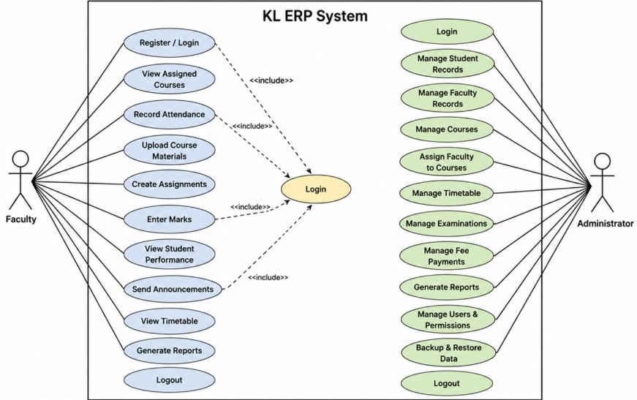

6. Implementation Strategy
Phase 1 – Requirement Analysis
• Gather requirements from faculty and administrators.
• Prepare the Software Requirement Specification (SRS).
• Develop use case diagrams.
• Identify system modules.
Phase 2 – System Design
- Design database schema.
- Design user interface wireframes
- Create UML diagrams.
- Develop overall system architecture.

Phase 3 – Development
- Implement secure login and authentication.
- Develop Faculty Dashboard.
- Develop Attendance Management Module.
- Develop Examination & Marks Module.
- Develop Student & Faculty Management Module
- Develop Reports and Notification Module.
Phase 4 – Testing
Unit Testing
- Login
- Attendance
- Marks Entry
- Student Record Management
Integration Testing
- Attendance + Reports
- Faculty + Examination Module
- User Authentication + Database
System Testing
- Complete ERP functionality
User Acceptance Testing (UAT)
- Verify all academic and administrative requirements.

Phase 5 – Deployment
- Docker Container
- AWS EC2
- MySQL Database
- Nginx Web Server

7. Evaluation Strategy
Evaluation Parameter | Method
Functional Accuracy | Requirement verification
Performance | Load testing using JMeter
Security | Authentication and penetration testing
Reliability | Continuous monitoring
Usability | User feedback survey
Scalability | Concurrent user testing
Maintainability | Code review and documentation

10. Expected Outcomes
- Secure online shopping platform.
- Fast product search.
- Reliable order management.
- Accurate inventory updates.
- Secure online payments.
- Improved customer satisfaction.
- Scalable architecture for future enhancements.

