Name: Kunchala Naga Chaitanya Sphoorthy
Roll Number:2420030510
Experiment 1: Case Study
Problem Statement: Choose a real-world case study such as an Online Food Delivery System, create user stories, select an appropriate software development process model, identify a suitable programming language, and propose an implementation and evaluation strategy.
Real-World case study: an online food delivery system
1. Functional Requirements
Customer
- Register and login securely
- Browse nearby restaurants
- Search food items by name or cuisine
- View restaurant menus and item details
- Add items to cart
- Place food orders
- Make secure online payments
- Track order status in real time
- View order history
- Rate and review restaurants
- Apply discount coupons
- Cancel an order
Restaurant Partner
- Login securely
- Manage menu items and pricing
- Update item availability
- Accept or reject incoming orders
- Update order preparation status
- View order history
- Manage restaurant profile and timings
- View sales reports
Delivery Agent
- Login securely
- View assigned delivery orders
- Update delivery status
- Navigate to pickup and delivery locations
- Mark order as delivered
- View earnings and delivery history
Administrator
- Login securely
- Manage customer accounts
- Manage restaurant partner accounts
- Manage delivery agent accounts
- Monitor orders across the platform
- Manage payment settlements
- Generate sales and performance reports
- Manage promotional offers and coupons
- Handle customer complaints and support tickets
- Backup and restore system data
2. User Stories
User Story ID | User Story | Priority
US-01 | As a customer, I want to register and log in securely so that I can access the food delivery app safely. | High
US-02 | As a customer, I want to browse nearby restaurants so that I can choose where to order food from. | High
US-03 | As a customer, I want to search for specific food items or cuisines so that I can quickly find what I want to eat. | High
US-04 | As a customer, I want to add items to my cart and place an order so that I can get food delivered to my location. | High
US-05 | As a customer, I want to make secure online payments so that I can complete my order conveniently. | High
US-06 | As a customer, I want to track my order in real time so that I know when my food will arrive. | High
US-07 | As a customer, I want to rate and review restaurants so that I can share my experience with others. | Medium
US-08 | As a restaurant partner, I want to manage my menu and item availability so that customers see accurate information. | High
US-09 | As a restaurant partner, I want to accept or reject incoming orders so that I can manage my kitchen workload. | High
US-10 | As a delivery agent, I want to view assigned deliveries and update their status so that customers stay informed. | High
US-11 | As an administrator, I want to manage restaurant and delivery agent accounts so that only verified partners use the platform. | Medium
US-12 | As an administrator, I want to generate sales and performance reports so that management can monitor platform performance. | Medium
3. Selected Software Development Process Model
Agile Scrum
Reason for Selection
- Requirements change frequently based on customer and market feedback.
- Continuous feedback from customers, restaurant partners, and delivery agents.
- Incremental delivery of platform modules.
- Faster development and testing cycles.
- Easy maintenance and bug fixing.
- Suitable for large-scale, high-traffic consumer applications.

Sprint Plan
Sprint | Features
Sprint 1 | User Authentication & Registration
Sprint 2 | Restaurant Listing & Menu Management
Sprint 3 | Cart & Order Placement
Sprint 4 | Payment Gateway Integration
Sprint 5 | Order Tracking & Delivery Management
Sprint 6 | Ratings, Reviews & Notifications
Sprint 7 | Testing & Deployment

4. Programming Language Selection
Backend
- Java (Spring Boot)
Reasons
- Secure
- Scalable
- Enterprise-level applications
- REST API support
- Excellent database connectivity
Frontend
- HTML5
- CSS3
- JavaScript
- React.js
Database
- MySQL
Other Technologies
- REST API
- JWT Authentication
- Stripe/Razorpay Payment Gateway
- Google Maps API for live order tracking
- Firebase Cloud Messaging for push notifications
- Git
- Docker
- AWS Cloud

5. System Architecture
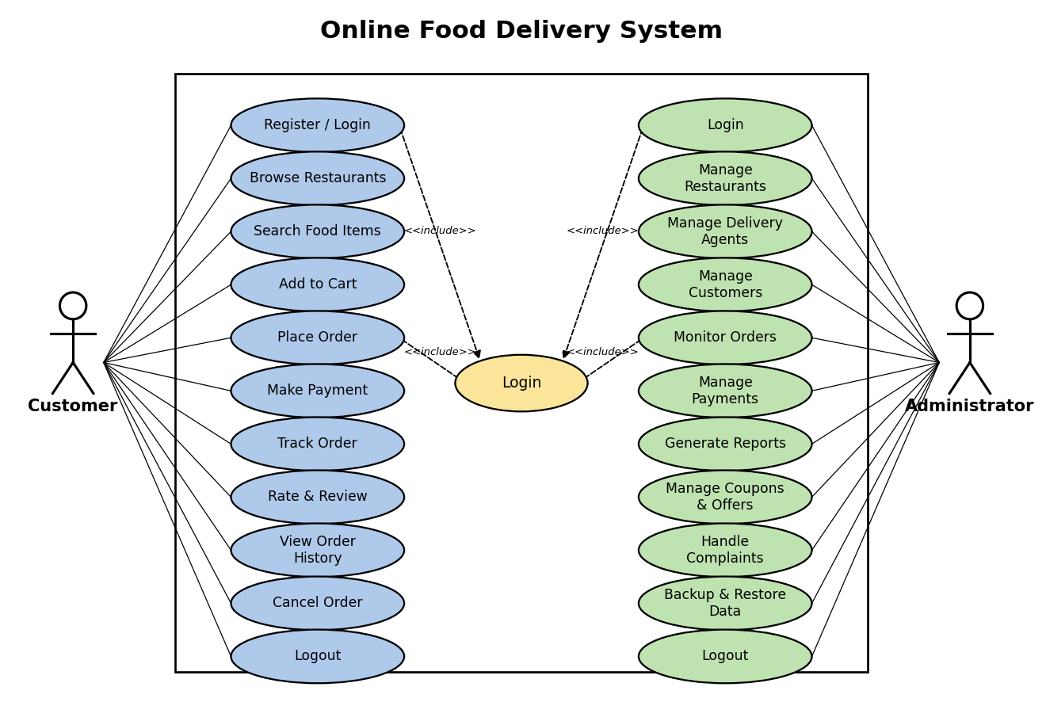
6. Implementation Strategy
Phase 1 -- Requirement Analysis
- Gather requirements from customers, restaurant partners, and delivery agents.
- Prepare the Software Requirement Specification (SRS).
- Develop use case diagrams.
- Identify system modules.
Phase 2 -- System Design
- Design database schema.
- Design user interface wireframes.
- Create UML diagrams.
- Develop overall system architecture.
Phase 3 -- Development
- Implement secure login and authentication.
- Develop Customer App / Restaurant Browsing Module.
- Develop Cart and Order Placement Module.
- Develop Payment Gateway Integration.
- Develop Delivery Tracking Module.
- Develop Ratings, Reviews and Notification Module.
Phase 4 -- Testing
Unit Testing
- Login
- Cart and Checkout
- Payment Processing
- Order Tracking
Integration Testing
- Order + Payment
- Restaurant + Order Management
- Delivery Agent + Notification System
System Testing
- Complete platform functionality
User Acceptance Testing (UAT)
- Verify all customer, restaurant, and delivery workflow requirements.
Phase 5 -- Deployment
- Docker Container
- AWS EC2
- MySQL Database
- Nginx Web Server
7. Evaluation Strategy
Evaluation Parameter | Method
Functional Accuracy | Requirement verification
Performance | Load testing using JMeter
Security | Authentication and penetration testing
Reliability | Continuous monitoring
Usability | User feedback survey
Scalability | Concurrent user / order-load testing
Maintainability | Code review and documentation
8. Expected Outcomes
- Secure and user-friendly online food ordering platform.
- Fast restaurant and food search.
- Reliable order placement and management.
- Real-time delivery tracking.
- Secure online payments.
- Improved customer satisfaction.
- Scalable architecture to handle high order volumes.

