- GPIO
- I2C DISPLAY
- PONG
- NETWORK

- GPIO
references:
https://elinux.org/RPi_GPIO_Code_Samples
https://www.pieter-jan.com/node/15

according to raspberry pi 4 bcm2711 data sheet:

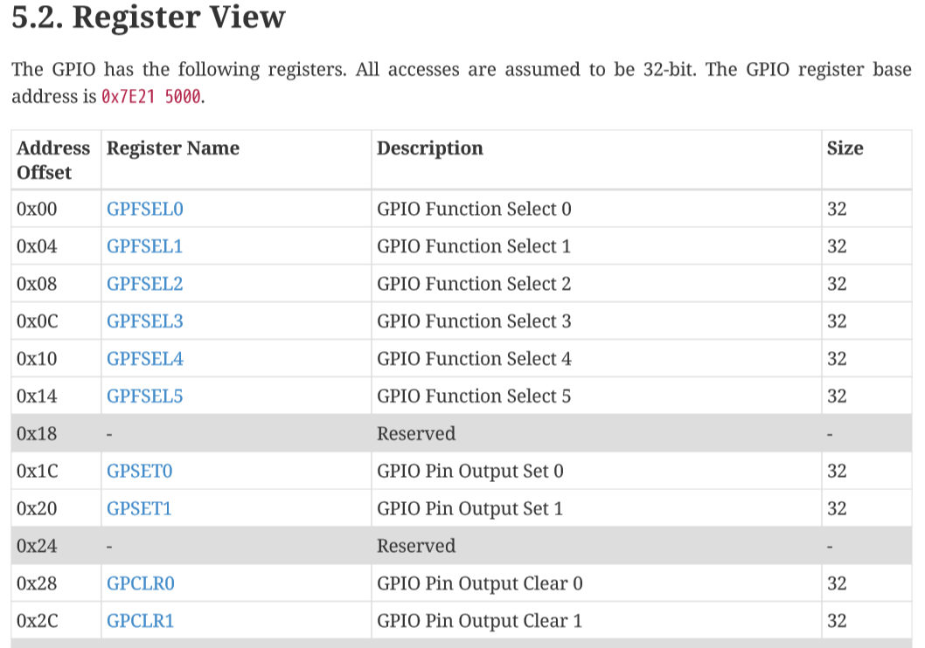
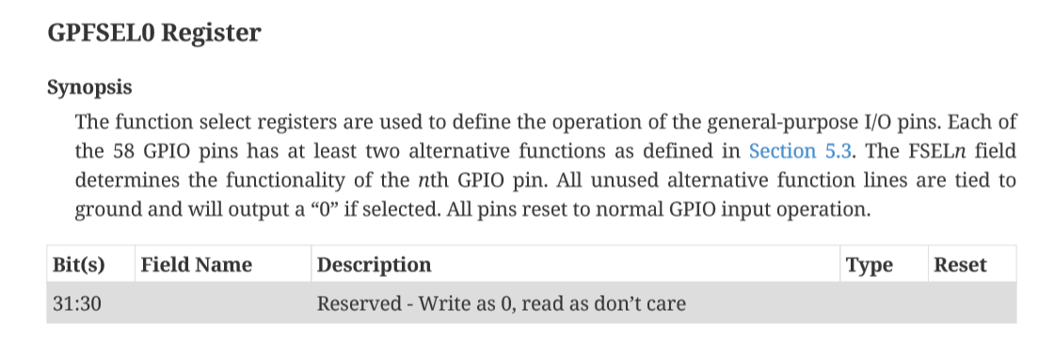
to set gpio pin as input/output: GPFSEL

-> to set gpio9 as output we need to set bit 27-29th of GPFSEL0 to 000
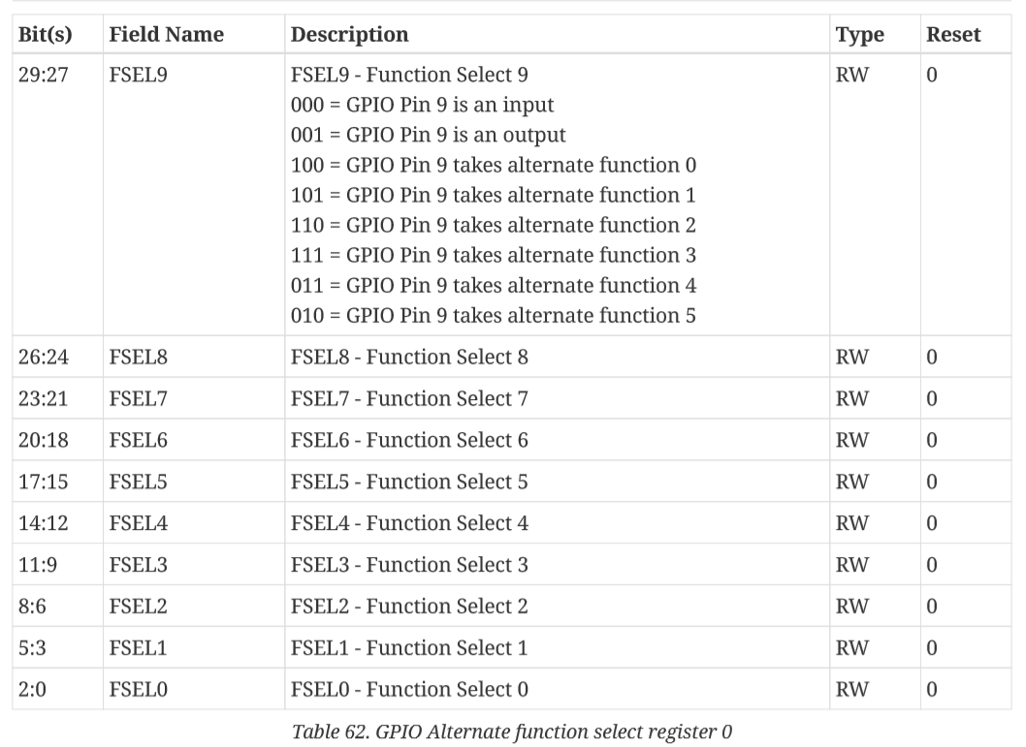
GPFSEL0 &= ~(0b111 << 27);
to set gpio9 as output bit 29 - 27th to 001
GPFSEL0 |= 0b1 << 27;

to set output on gpio pin: GPSET
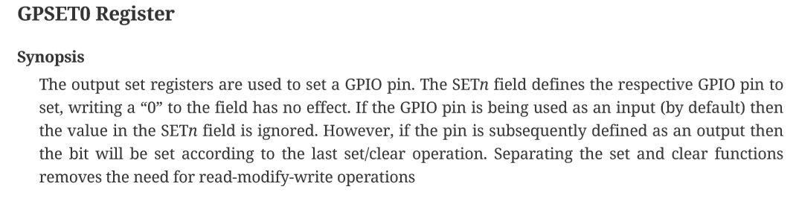

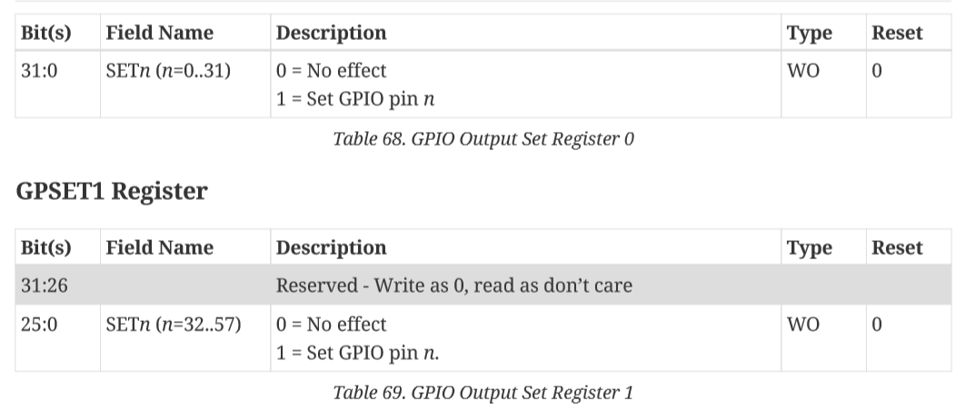
to set gpio9 high:
GPSET1 |= 1<< 9

gpclr works the same
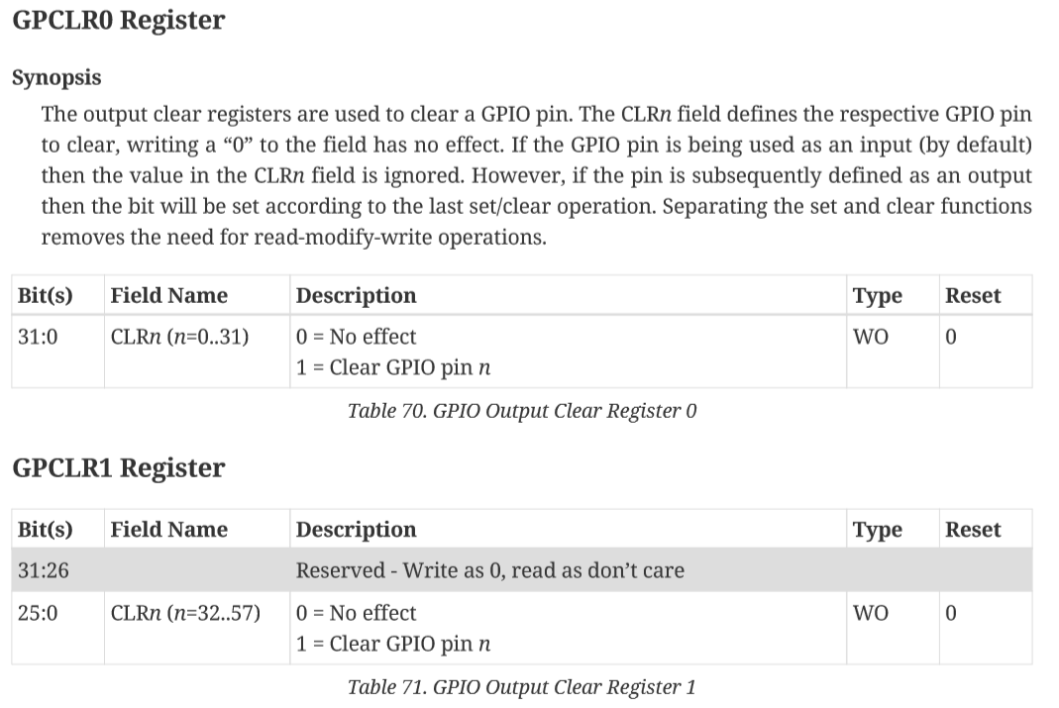

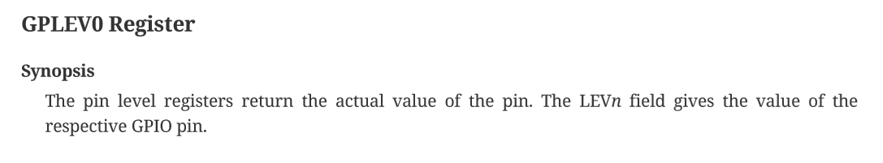
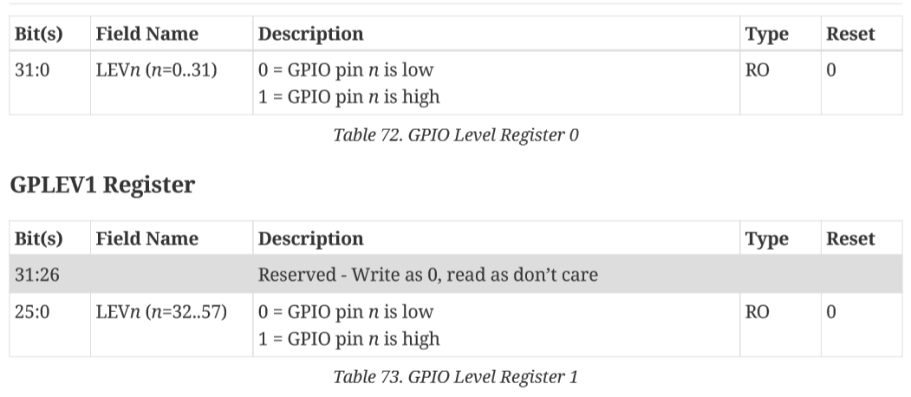
to read input on gpio pin: GPLEV
SUM UP:
#define INP_GPIO(g) *(gpio.addr + ((g)/10)) &= ~(7<<(((g)%10)*3))
#define OUT_GPIO(g) *(gpio.addr + ((g)/10)) |= (1<<(((g)%10)*3))

#define GPIO_SET *(gpio.addr + 7) // sets bits which are 1 ignores bits which are 0
#define GPIO_CLR *(gpio.addr + 10) // clears bits which are 1 ignores bits which are 0

#define GPIO_READ(g) *(gpio.addr + 13) &= (1<<(g))

//fuction which detect button is pressed, parameter gpiopin number, return true if pressed else false
bool button_pressed(int button)
{
if(GPIO_READ(button))return false;
return true;
}

// set buzzer as output, 5 buttons as input
void setup_gpio()
{
INP_GPIO(BeepPin);
OUT_GPIO(BeepPin);
INP_GPIO(UP);
INP_GPIO(DOWN);
INP_GPIO(LEFT);
INP_GPIO(RIGHT);
INP_GPIO(ENTER);
}
- I2C Display
write to i2c device
void Display::writeI2C(unsigned char* data, int bytes)
{
int i2cHandle;
int i2cAddress = OLED_I2C_ADDRESS;
char deviceName[40];
sprintf(deviceName, "/dev/i2c-1");
if ((i2cHandle = open(deviceName, O_RDWR)) < 0)
{
printf("error opening I2C\n");
}

else
{
if (ioctl(i2cHandle, I2C_SLAVE, i2cAddress) < 0)
{
printf("Error at ioctl\n");
}
else
{
write(i2cHandle, data, bytes);
}
}
close(*deviceName);
}

display command to set start line
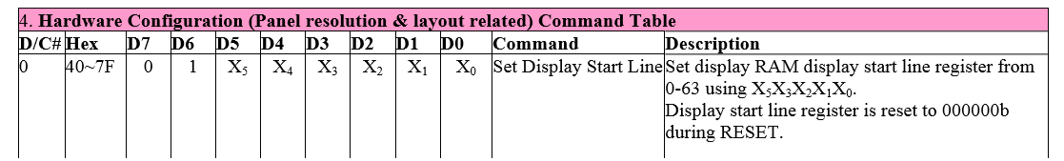

#define WIDTH 128
#define HEIGHT 64

#define OLED_I2C_ADDRESS 0x3C
#define OLED_SETSTARTLINE 0x40

init display
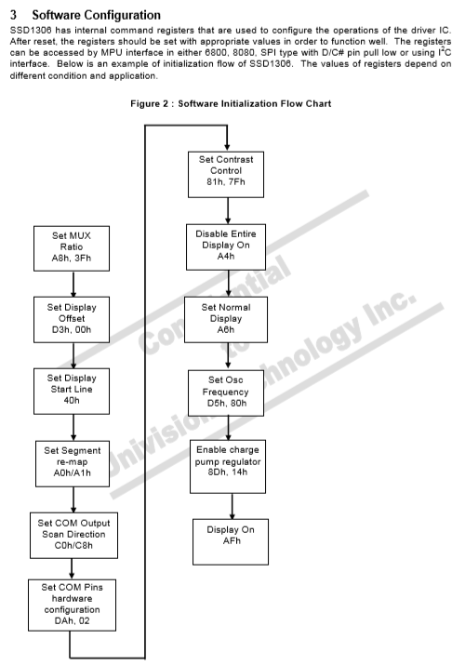
void Display::display_init()
{
unsigned char initSequence[26] = { 0x00, 0xAE, 0xA8, 0x3f, 0xD3, 0x00 ,0x40, 0xA1, 0xC8, 0xDA, 0x12, 0x81, 0x7F, 0xA4, 0xA6, 0xD5, 0x80, 0x8D, 0x14, 0xD9, 0x22, 0xD8, 0x30, 0x20, 0x00, 0xAF };
writeI2C(initSequence, 26);

unsigned char setFullRange[7] = { 0x00, 0x21, 0x00, 0x7F, 0x22, 0x00, 0x07 };
writeI2C(setFullRange, 7);
}

pixel map
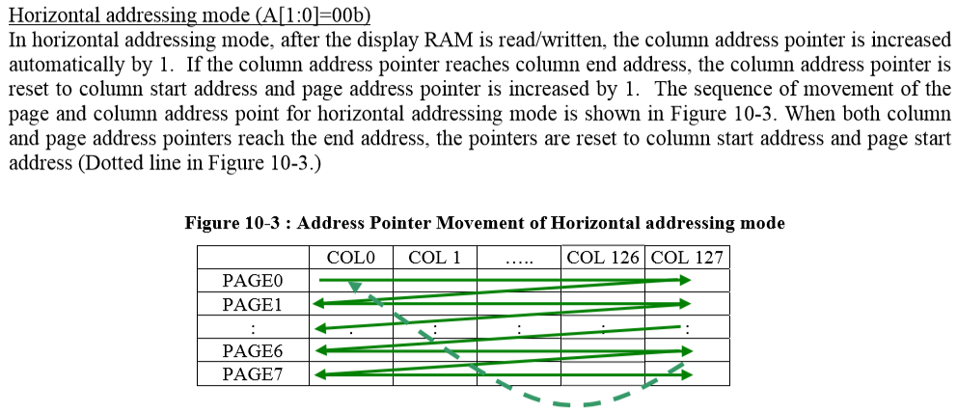
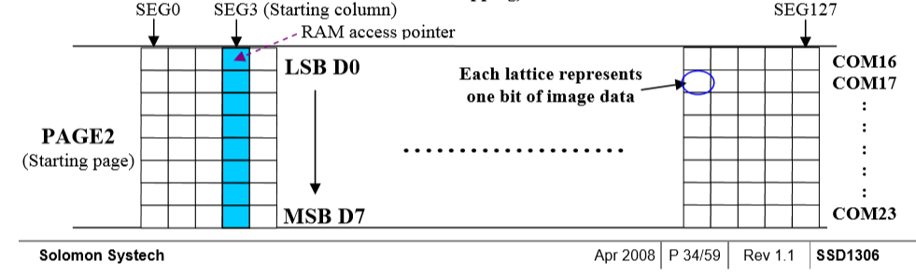

to display a full image to display we need 128 * 64/8 = 1024 bytes + 1 command byte to set startline = 1025 bytes buffer
static unsigned char img[1025];
unsigned char Display::img[1025] = {0};
img[0] = OLED_SETSTARTLINE;

to set pixel on we need to write 1 to the bit in buffer then write to display.
to find the bit of pixel(x, y)
#define nth_byte_pixel(x, y) ((x) +(y)/8*128 + 1)
#define nth_bit_pixel(x, y) ((y)%8)

void Display::draw_pixel(int x, int y, int color)
{
if (x >= 0 && x < WIDTH && y >= 0 && y < HEIGHT)
{
img[nth_byte_pixel(x, y)] |= color << nth_bit_pixel(x, y);
}
}

void Display::display(bool should_close)
{
writeI2C(img, sizeof(img), should_close);
}
- Pong

ball_position is array of 2 element that contains x and y position of the ball
p1_position for player 1
p2_position for player 2
and ball_velocity stores velocity of the ball in x and y axis

class Pong:
def __init__(self):
self.ball_position = [(DISPLAY_WIDTH - BALL_SIZE)/2, (DISPLAY_HEIGHT - BALL_SIZE) / 2]
self.p1_position = [BALL_SIZE, (DISPLAY_HEIGHT - BAT_LENGTH) / 2]
self.p2_position = [DISPLAY_WIDTH - 2 * BALL_SIZE, (DISPLAY_HEIGHT - BAT_LENGTH) / 2]
self.ball_velocity = [random.choice((-4, 4)), 0]

with position and velocity of the ball we can always predict the movement of the ball
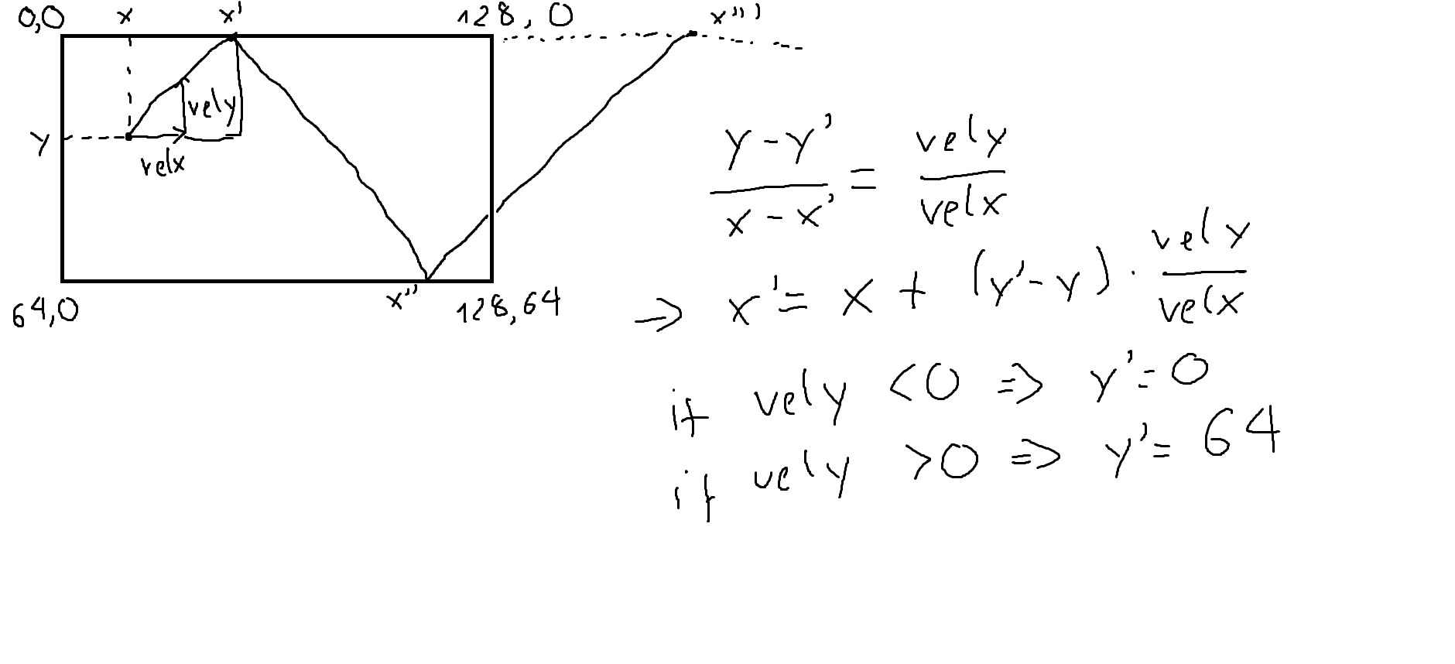
def calc_ball_positions(game):
x = game.ball_position[0] + BALL_SIZE / 2
y = game.ball_position[1] + BALL_SIZE / 2
velx = game.ball_velocity[0]
vely = game.ball_velocity[1]

result = [(x, y)]
for i in range(20):
if vely > 0:
x += (DISPLAY_HEIGHT - BALL_SIZE / 2 - y) / vely * velx
vely *= -1
y = DISPLAY_HEIGHT - BALL_SIZE / 2
result.append((x, y))
elif vely < 0:
x += (0 + BALL_SIZE / 2 - y) / vely * velx
vely *= -1
y = 0 + BALL_SIZE / 2
result.append((x, y))
else:
if velx > 0:
result.append((128, y))
break
else:
result.append((0, y))
break
if x > 128 or x < 0:
break
return result

bot:
from the list of predicted positions of ball we have atleast two point. We can draw from these two point a linear f(x) = ax + b then we can calculate
position we have to move our bot to

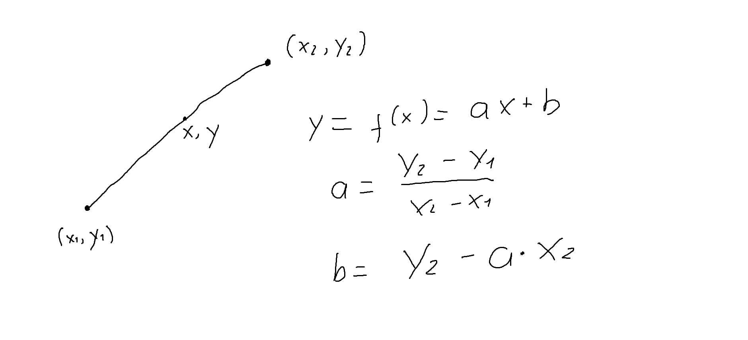

def bot(game):
if game.ball_velocity[0] > 0 and game.ball_position[0] > DISPLAY_WIDTH / 5:
y = game.ball_position[1] + BALL_SIZE // 2
if game.ball_velocity[1] != 0:
positions = calc_ball_positions(game)
a = (positions[-1][1] - positions[-2][1]) / (positions[-1][0] - positions[-2][0])
b = positions[-1][1] - a * positions[-1][0]
y = a * game.p2_position[0] + b + BALL_SIZE // 2

if y <= game.p2_position[1] + BAT_LENGTH / 2:
game.move_player(2, -PLAYER_SPEED)
if y >= game.p2_position[1] + BAT_LENGTH / 2:
game.move_player(2, PLAYER_SPEED)

- Network
sending raw data via socket, on the raspberry pi with c++ we send char(0-255) format
on pc side with python data is being send in 'utf-8' format (0 – 127)
so for each byte of data, it need to be splitted in two bytes and add up when received

def help_get_data(self, result, item):
if item >= 0:
item = int(item)
else:
item = int(256 + item)
result.append(chr(item//2))
result.append(chr(item - item//2))

def get_data(self):
result = []
self.help_get_data(result, self.p1_position[1])
self.help_get_data(result, self.p2_position[1])
self.help_get_data(result, self.ball_position[0])
self.help_get_data(result, self.ball_position[1])
self.help_get_data(result, self.ball_velocity[0])
self.help_get_data(result, self.ball_velocity[1])
result = "".join(result)
return result

data is sent in unsigned format and when we received a byte that greater than 127 we know
it must be a negative data

def help_set_data(self, x, y):
if x + y < 200:
return x + y
else:
return x + y - 256

def set_data(self, data):
self.p1_position[1] = self.help_set_data(data[0], data[1])
self.p2_position[1] = self.help_set_data(data[2], data[3])
self.ball_position[0] = self.help_set_data(data[4], data[5])
self.ball_position[1] = self.help_set_data(data[6], data[7])
self.ball_velocity[0] = self.help_set_data(data[8], data[9])
self.ball_velocity[1] = self.help_set_data(data[10], data[11])

