**IMPLEMENTATION OF DIGITAL TWIN TECHNOLOGY FOR PREDECETIVE CROP DISEASE MONITORING**

**Sayali Milind Vanjare, Jitendra Musale, Pranjali More, Tuba Ashfaque Sayyad, Yashita Gupta, Sphurti Suryabhan Shikre**

Department of Computer Engineering

ABMSP’S Anantrao Pawar College of

Engineering and Research Pune,India

Email:

[sayalimvanjare@gmail.com](mailto:sayalimvanjare@gmail.com)

[Jitendra.musale@abmspcoerpune.org](mailto:Jitendra.musale@abmspcoerpune.org)

[pranjali.more@abmspcoerpune.org](mailto:pranjali.more@abmspcoerpune.org)

[tubasayyad2124@gmail.com](mailto:tubasayyad2124@gmail.com)

[yashitag2@gmail.com](mailto:yashitag2@gmail.com)

[sphurtishikre4@gmail.com](mailto:sphurtishikre4@gmail.com)

**Acknowledgement**

Therefore, the team is truly obliged to have the best teachers Dr. Jitendra Musale, Dr. Pranjali More and Head of Department Prof. Rama Gaikwad guiding the team with constant support and encouragement throughout this journey of research. Their insightful feedback and invaluable knowledge have immensely shaped the direction of research work.The team is deeply grateful for their guidance.

The team also feels deeply grateful to Dr. Sunil Thakare**,** Principal of Anantrao Pawar College of Engineering and Research for an excellent academic environment, necessary facilities, and opportunities provided that helped the team carry out this research. The support that the team received from the institution and the faculty has been of great importance to the team’s intellectual development and completion of this research study.

**IMPLEMENTATION OF DIGITAL TWIN TECHNOLOGY FOR PREDICTIVE CROP DISEASE MONITORING**

**ABSTRACT**

With the population of animals and humans cultivating rates of crops and plants are increasing. Thus, demand also increases. The science of agriculture innovates several techniques to improve the cultivating sector to improve production. When it comes to production there is harvesting losses are considered. During cultivating farmers face problems like diseases and insects which aid production rate decreases and ultimately increase the rate of those crops. For several years science agriculture tried to make a quick medication system for detecting plant disease. For this problem, we come up with a solution that features a combination of hardware and software-created models that help to predict diseases. Crops like potatoes and tomatoes are an everyday need in Indian homes. From few years rate of potato and tomato are goes high. To prevent these losses and deal with this problem this paper uses the digital twin concept which creates a replica of a farm and with the help of CNN detects disease, this CNN model is trained by a dataset that takes images from the farm to analyze it with time to time and give early prediction of the disease.

**Keywords**

Machine-learning, CNN, Digital-Twin, precision farming, early prediction, Azure platform.

**INTRODUCTION**

Agricultural activities have been part and parcel of the culture of India for thousands of years. Agriculture is not just a source of survival but is also a closely integral part of their culture, tradition, and way of life. India is among the largest producers in the world, and the sector is involved with more than 50% of the country's work force. However, despite its importance, Indian agriculture is mostly encountered with many problems that include poor productivity, low exposure towards modern technologies and infrastructural deficits, and unpredictable weather conditions .Smart agriculture, which produces a high yield with optimal usage of resources has become a need all over the world due to a rise in population and scarcity and increasing cost of resources such as water, fuel, and fertilizers. According to the latest studies it is expected that increase in population will raise the demand of increase crop production by 25-70 % to meet the global food needs according to the analysts. (Youl-moon sung, 2022)

To overcome these challenges, the Indian government and private sectors are now moving towards digital farming. Such advanced technologies in the field of agriculture should be used more comprehensively in the areas where the agriculture sector constitutes a significant portion of the economy, and the rate of increase of population is sustained so that the balance between supply and demand for food gets disturbed .An even more interesting term is the Digital Twin, defined as a digital replica of physical assets, processes, and systems that can be applied for various purposes. In turn, the digital twin conceptual model contains three major parts: a) the real-world products in real space, virtual products in virtual space, and the links of data and information that bind the virtual and real products together. DT reflects its behavior and statements over its lifecycle in a virtual space. In the Industry 4.0 framework, related aspects may be addressed using adjacent terms like Cyber-Physical Systems (CPS). In many areas including product development, manufacturing, supply chains and even in agriculture, CPS can be applied based on the thought of the digital twin. (Anglin, 2020)

DT promises the best physical response via real-time digital awareness for smart farm tasks. The Internet of Things, as realized, is the epitome of making connectivity ubiquitous. Thus, most of the processes in the smart farm can be tracked in real time not just agricultural product but also tasks, weather condition, satellite information and supply chain process etc. In the IoT vision, therefore, very high level of interoperability must be attained not only on the communication level but also on service and even knowledge levels along various platforms established on a common grounding. Digital Twin Smart Farm (DTSF) changes everything-from soil, water, air, and fertilizers to the farm building, LED illumination, digital technology, and data analytics. Thus, DT eradicates fundamental restrictions based on place, time, context, and human touch. Generally, a DT architecture essentially is a physical object within real space, a digital representation of that object in virtual space and the bridge between the virtual and real spaces for the transfer of data and information. In bringing this research, the main contributions and significance narrowed down to suggesting the concept of a digital twin smart farm architecture and bringing it into life through implementation in the laboratory environment from a practical standpoint. It thus demonstrates how the smart farm architecture can be realized based on the technology of digital twin. The approach is also implemented in the real environment of a smart farm that demonstrates the possibility of a case of commercial success.

This paper is to discuss recent developments in the trend of digital twin modeling prevalent in the in a smart farm context. Literature review carried out, conceptual framework of DTSF is Conceptual Model of Digital Twin for Smart Farm is proposed. The paper concludes by summarizing and providing directions for further research. (Wang, 2024)

**BACKGROUND**

Traditional Agriculture is nothing, but traditional Knowledge passed down from generation to generation. As we know climate change occurs in the early years and affects every industry including Agriculture. In this condition, farmers face problems harvesting which raises year by year. Harvesting season factors like environmental changes, diseases, and lack of water can lead to the loss of the entire yield of the farm. (R, 2020) To ensure this condition digital twin technology introduces the technique which integrates with IoT. This helps to give information about diseases occurrence in an earlier stage of its growth to prevent the destruction of crops and helps achieve a low level of loss in the post-harvesting period to get maximum yield. Can significantly reduce the impact of climate variability on agriculture. This helps to give information about disease occurrence in an earlier stage of its growth to prevent the destruction of crops and helps achieve a low level of losses in the post-harvesting period to get maximum yield. Crops like Tomatoes and potatoes which have higher rates these days can be reduced with this technology. The above diagram shows harvesting losses from the Indian Journal 2022. The below diagram shows harvesting losses from the Indian Journal 2022.

**Figure 2**

**Graph of loss of harvesting of crops in 2020**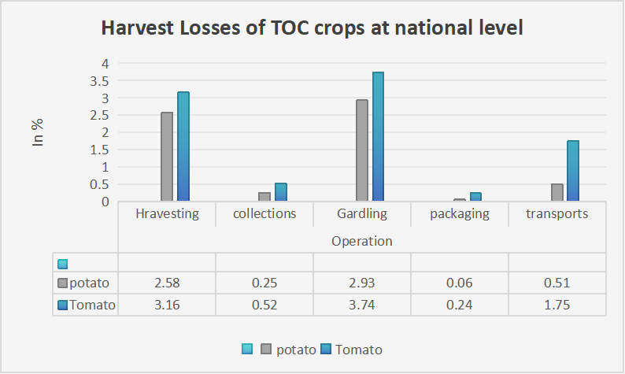

These factors are leading to significant losses during harvesting, a trend that is expected to worsen as climate change progresses. Digital Twin technology, when combined with IoT, offers a proactive solution by enabling real-time monitoring and simulation of farm conditions. This technology helps farmers detect diseases at an early stage, preventing the destruction of crops and minimizing post-harvest losses. [1] Studies have shown that climate smart technologies, such as those employed in DT systems, can significantly reduce the impact of climate variability on agriculture. (R, 2020).

**LITERATURE REVIEW**

Rafel Gomes Alves and his teammates (R, 2020) proposed a system for crop monitoring using digital twin technology in which they delved into IoT system integration to connect different assets and (cit) parameters that have an impact on the farm's behavior. Its crucial feature which makes farmers make better decisions and decreases effects on water, soil resources and land.

Youl-Kim and his teammate Taioun Ki (Kim, 2021) studied the concept of digital twins in agriculture, in which they proposed that digital twins ease monitoring and even decision-making in framing, and they studied prototypes for monitoring crop growth while the purpose of their use in specific branches of different areas like the dairy sector, etc., and integrated them. This transforms the tradition of farming into new dimensions. They delved into a DT model that has been implemented at the laboratory level, in which they checked all aspects of the crops at several levels with the help of sensors. (Laith Alzubaidi, 2021)

Pelin-Angin and his team (Anglin, 2020) proposed the digital twin architecture for crop disease with the help of a machine learning algorithm. They used the CNN algorithm and achieved 0.95 accuracy for the detection of crop defects. They proposed DT technology for exciting research on IOT sustainable smart agriculture. By developing a framework that represents a farm with constant monitoring of soil moisture, water level, crop disease detection, and the recommendation of fertilizer treatment. while they focused on internet connectionless /framework. as they highlighted vital considerations in monitoring and crop detection.

Devvrat Verma and his team (Verma, 2021) propose new aspects that analyze images and recognize patterns, and research recently created new techniques. using only images of plant leaves, the deep CNN model that has been proposed can accurately categorize 38 varieties of healthy and unhealthy plants.

Esker and colleagues (Esker, 2006) developed models to predict Stewart’s disease which is commonly found in mazes using three predictor models. which are Stevens, Stevens-Boewe, and Lowa states. Their work highlights the importance of using a predictive model for early crop disease detection which helps timely intervention and reduce losses.

The use of the quinalizarin strategy was shown by Umar Ayub and colleagues (Ayud, 2018) upon their study. Data mining technique to foresee the crop disease in Masaga Pakistan To do this, the employed several machine learning models i.e. neural networks, SVM, i.e. Support Vector Machine, decision trees, and KNN. The authors state that DT needs sizeable datasets to predict unseen data and to train the models This paper elaborates need for large datasets. Although machine learning transitions slowly to semi-supervised and unsupervised. Which helps to manage practical data without the need for manual human labeling.

**FACTORS**

**1.Soil**

1.1 Soil suitable for Potato Cultivation:

The potato cannot be grown on alkaline and saline soils other than these two types of soils it can be grown on any kind of soils. Naturally loose soils are preferred because they provide least resistance to the enlargement of tubers (Elisha, 2022). The soil which have pH of about 5-6 is ideal for the growth of potatoes. Soil rich in organic matter such as sandy and loamy soils are suitable for the cultivation of potato crops. Potatoes require moderately cool climate for its growth, its growth is at peak when the temperature ranges between 20’C to 24’C and the tubers grows its best at 20’C. During summer season potatoes are grown in hills and during winter it is grown in subtropical area.

It can also be grown at the altitude of 3000m above sea level, heavy clay soils quality can be enhanced by adding sharp sand and lots of primal matter in autumn of the year thus soil mixture can be uncovered to frost which will break up the soil structure and make it simpler to work with. The nutrients needs of potatoes are quite tremendous and the demand of fertilizer and organic compost are considered important to obtain budgeted and high yields. Green manuring is useful in light soil and places where organic manure is not present. The fertilizer dose varies greatly depending upon the soil fertility, climate and variety length of growing season.

***Figure 3.***

***Ideal soil for potatoes cultivation***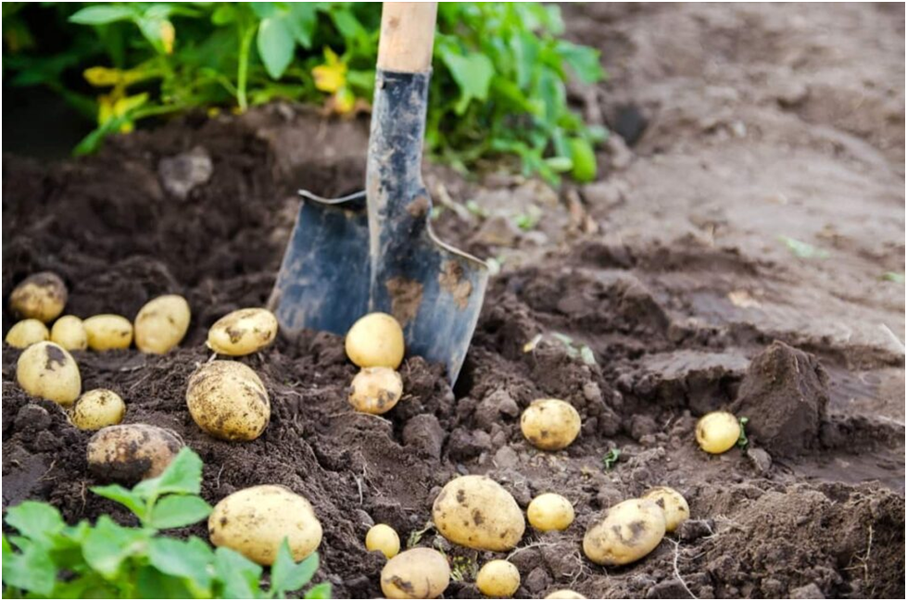

1.2 Soil suitable for tomato cultivation:

Tomatoes are best to cultivate in loam or sandy soil. Solid soil structure is essential to permit proper water and airflow supply into the soil, which could elevate plant development. The hardy plant prefers loose, well-drained soil, clay-heavy soil is avoided for the growing tomatoes. Kryptonite is used because it sets limits for roots to develop. (Krishak, TomatoCultivation, n.d.)The pH ranges between 6.2 to 6.8 is required by tomatoes for best nutrients absorption and tomatoes need continuous supply of minimal and major plant nutrients.

***Figure 4.***

***Ideal soil for tomatoes cultivation***

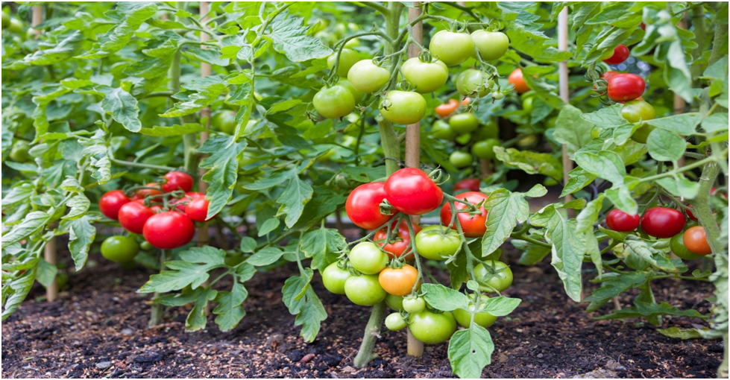

Fertilizer are added into soil 2 weeks prior the planting. Surplus amount of nitrogen can result in plants with luxuriant, vigorous foliage but with small fruit production.

**2.Diseases**

2.1 Late blight disease:

Pathogen description -Phytophthora Infestans the pathogen was first described by M.J Berkeley and named it Phytophthora infestans by Anton De Bary in the 1870s. It is member of the oomycetes; they are true fungi but closely related to brown algae. It reproduces Sexually as well as Asexually. In Asexual reproduction Phytophthora infestans produces Sporangia on the plant. In cool or wet condition zoospore will form and emerge from the sporangia after about two hours. In Sexual reproduction two mates comes in contact, Fusion of the two nuclei in the oogonium, a thick-walled diploid spore is formed. Phytophthora infestans, which causes dark lesions on leaves and tubers. (Heitman, 2014)

Disease Cycle -The sporangia or zoospore infect the plant of potato and tomato. it attacks the leaf, stem and tuber. the phytophthora infects newly tuber growth and spread fast. hyphae reach to the aerial parts and produces sporangiophores through the stomata of leaves and branches. sporangia get detached from the sporangiospores and easily carried by air and water. sporangiospores is landed on new healthy leaf, tubers and germinate there and cause disease. it often strikes in cool, wet weather.

Symptom - Disease infect almost all parts of plant like leaves, stem and tubers. initially water-soaked lesion develops on tip and margin of leaves, it increases rapidly. there is brown/black or pale green spot-on leaves. theses area become large brownish/ black lesion. Stem become weak and collapse causing death of above lesion. tomato or potato develop irregular brown to purplish skin, greasy spot inside the fruit, in tomato there is concentric ring developed on fruit.

Control- Farmers used pesticides(fungicides) to control the light blight disease. apply copper-based fungicides before dry weather foliar sprays of organic coating agent can also prevent the infection some gardeners prefer chemical fungicides, the best of which for tomato is chlorothalonil. bordeaux mix((fungicide) is effective to control the infection. No fungicides are proved completely resistant to the disease. resistant varieties can be used (S.demissum and S.phureja).

2.2 Early Blight Disease

(Kemmitt, 2002)Pathogen description - Early blight disease caused by Alternaria solani(fungi) belonging to the class Deuteromycetes. It reproduces Asexually, Sexual reproduction is not seen in Alternaria solani. It affects stems, leaves, tomato and potato itself. It occurs in cold as well as hot weather. It appears on new plant mostly. The mycelium of the fungus consists of septate and sparsely branched hyphae, which affect the plant.

Disease Cycle - It reproduces Asexually, the Asexual spores formed are conidia. The conidia are produce at the tip of the hyphae, which are short and dark colored called conidiosphores. The tubers contaminated with conidia developing on primary spots. Host penetration of the fungus occurs through the stomata but direct penetration through the epidermis is not frequent.

Symptom - It occurs on leaf, stem, foliage, fruit of tomato and leaf, stem, foliage, and tuber of potato. There are small brown spots on leaf which turns into enlarge concentric ring giving them bull’s eye pattern it can affect tomato fruit when it attacks on calyx and stem. The potato tuber sunken lesion, which is often surrounded by purple border, the tuber tissue is leathery or corky with a brown discoloration.

Control – Farmers used pesticides(fungicides) to control the early blight disease. There are many fungicides present in the market to control early blight. Some of the chemical fungicides are azoxystrobin, pyraclosteobin, trifloxystrobin and fenamidone. The protectant fumgicides such as mancozeband chlorothalonil. The biological fungicides used are Pseudomas – P.fluorescene, P.putida and P.cepacian. Trichoderma and Bacillus spp. are also used.

**3.Climate**

3.1 Climate suitable for Potato cultivation

Potato growth is at peak when the temperature ranges between 20’C to 24’C and the tubers grows its best at 20’C. During summer season potatoes are grown in hills and during winter it is grown in subtropical area. In the Indo-Gangetic Plain the potato crop duration has decreased due to climate change. There is increase in evapotranspiration while the water use efficiency for potato growth is projected to decrease in future climates as outcome of low threshold temperatures for decrease in water use efficiency and growth than the evapotranspiration. Results shows that upper threshold for water use efficiency decline is 15 ‘C at the same time that for evapotranspiration is 23 ‘C. The best possible temperature for tuber growth is 17 ‘C and for that reason the reduction in water use efficiency in upcoming climate is perceivable. Potato yields are predicted to decline by 2.5% in 2020(2010-2039),6% in 2050(2040-2069) and 11% 2080(2070-2099) time intervals. The only option which may result in yield gains is change in plantation timing. (H.Pathak, 2016)

3.2 Climate suitable for Tomato cultivation:

(M L Bhardwaj, 2012)Tomato growth is at peak when the temperature ranges between 22’C to 29’C Temperature bounds the yield and range of tomato crop. High temperature condition is frequently prevailing during growing season in tropical region. Climate trends in tomato growing area indicates that temperature is rising and severity and occurrence of above-ideal temperature will elevate in future. Tomatoes are strongly affected by temperature and other environmental factors also effects its production. It firstly effects the photosynthetic operation of higher plants. High temperature disturbs the biochemical reaction basics for normal cell function in the crop. High temperature can cause significant reduction in tomato productivity and lower quality fruits. Water availability is supposed to be extremely sensitive to climate change and acute water stress circumstances will affect production of tomato.

**METHODOLOGY**

The DT concept has been incorporated into smart agriculture at both the laboratory and field levels. All field crops need soil, light (sunlight), warmth, air, water and nutrients to grow. Soil provides stability to plants and stores water and nutrients that plants can absorb through their roots. Light (sunlight) provides the energy plants need to grow. Air allows plants to “breathe”. Water provides moisture and nutrients. Components in Proposed System:

In the proposed system digital twin technology is based to develop a farm model by integration of sensor within field. Crucial 4 components. Anything more or less than this would cause failure.

***Figure 6.***

***Key elements of agriculture***

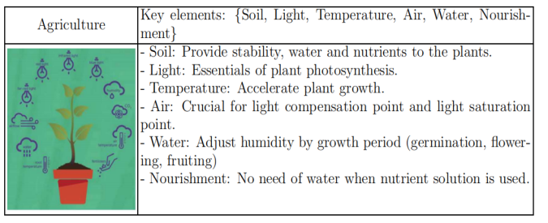

1. IoT: IoT includes integrated sensors and Raspberry Pi controller. In the proposed system, we have used many sensors such as soil moisture, temperature, humidity, water level, nutrients, camera module and others connected to Raspberry controller. The system is connected to the agricultural fields and monitors every aspect of the crop according to the standards. To monitor the health of the crops, we need to monitor the following: Soil moisture sensor to measure the moisture in the soil, Water level sensor to control the amount of water needed, Humidity sensor to monitor the moisture in the soil or around the crop, Nutrient sensor Control, camera module to capture images, carbon dioxide sensor and pH sensor to check the copy to make sure the pH percentage in the soil is correct. The above-mentioned sensors are used to monitor the crops but a module is also connected to Raspberry Pi which is used to send data from the GFM module body to the data layer. Recent advances in wireless sensor networks can be integrated into planning systems to facilitate real-time monitoring of large farms. Decreases the latency: In real life applications delay-less data transfer can make timely decision and WSN do exactly this.

2. The Azure platform has An IoT hub: This is automatically collects and responds to data in the cloud powered by azure. This also facilitates the creation and development of digital twins based on digital models of the entire environment, such as housing, agriculture, etc. It also integrates IoT devices with existing twins using powerful data processing. This simplifies design and provides an excellent platform for integrating data storage layers into the process layer. The Azure platform also has app deployment facilities to create an app for the interaction layer for farmers they can monitor their Virtual replica of the farm by only using the same platform. (Verma, 2021)

***Table 1.***

***Accuracy and loss comparison between CNN architecture***

| Architecture | Accuracy (%) | Loss |
| --- | --- | --- |
| Baseline | 84.58 | 0.47 |
| Alex-Net | 91.52 | 0.51 |
| Google-Net | 86.68 | 0.3 |
| VGGNet | 95.24 | 0.26 |
| Yolo | 95.50 | 0.2 |

Source: (Suryawati, Sustika, Yuwana, Subekti, & Pardede, 2019)

3. Machine Learning Algorithm: In this proposed system we studied several algorithms like RNN, Random Forest, and CNN we conclude on CNN as it works with a wide range of data sets and ensures the secure and precise accuracy of crop detection via image-based detection which requires real-time data access.

3.1 Convolution Neural Networks: -

This algorithm is a supervised machine learning algorithm and thus needs an input dataset as well as an output data set from which it flows, we are using the CNN algorithm for crop diseases as it is efficient for real-time detection of diseases. Within the framework of the CNN paradigm, there exist several Architecture types to building the algorithms since this model is dependent on an architecture-based assumptions or rather on accuracy and losses as is the case in Google Net, Alex Net, VGG Net. A well-designed implementation of a CNN architecture has several advantages and benefits to the system performance. Research regarding the analysis and comparison of the CNN architectures for the detection of the plant disease has been carried out. (Kim, 2021) This algorithm is a supervised machine learning algorithm and thus needs an input dataset as well as an output data set from which it flows, we are using the CNN algorithm for crop diseases as it is efficient for real-time detection of diseases. In the CNN algorithm, there are serval types of Architecture to construct algorithms as this model has their accuracy and losses on that base from architecture like Google Net, Alex Net, VGG Net, and Yolo. The choice of CNN architecture significantly impacts the system's performance. Research comparing CNN architectures for plant disease detection indicates that. Yolo is known as a neural architecture that refers specific design of the neural network Which is implemented as the Yolo algorithm. Yolo architecture is a Full CNN that synchronises images in a single phase which emphasises real-time detection. It helps specific localization. (Eman Abdullah Aldakheel, 2024)

***Figure7.***

***Yolo Architecture***

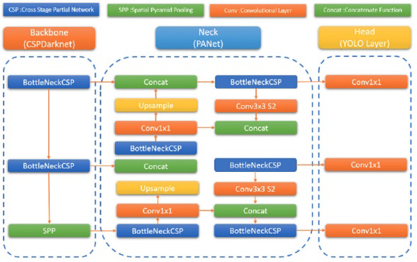

3.2 Working of Yolo:

Rectangular bounding is generated in a box-like structure which targets the portion of the leaf which is affected while the data set has images of crucial parts of plants like steam, leaf and fruit The green hue for these bounding accumulates the segmentation of leaves and facilitates the visual differentiation of annotated region. Then this segmentation divides the image into smaller species and allocates the labels to identify the diseases and normal leaf region. The presence of green color bounding boxes on leaves clarifies the segmentation process, emphasizing the accurate detection of ill regions on plants. (Anusha Varges Anthony, 2023)

**Figure 8.**

**Detection using Yolo**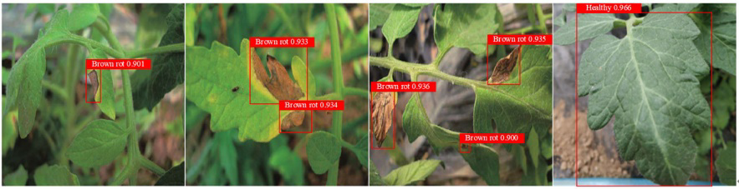

4.Data Set: The data set plays a very important in this whole system as it gives DT model training for decision-making processes. Data set Plant-Village has a wide range of 50000+ images of several crops that are healthy and unhealthy. (Pylinds, 2021) The data set is very important in this whole system as it gives DT model training for decision-making processes. Data set Plant-Village has a wide range of 50000+ images of several crops that are healthy and unhealthy. Each image in the data set is annotated with corresponding plant species whether a disease is present. Plant Village data set helps to develop computer vision algorithms for plant disease identification automatically. (Anusha Varges Anthony, 2023)

***Figure8.***

***Availability of images in the Plant-Village dataset***

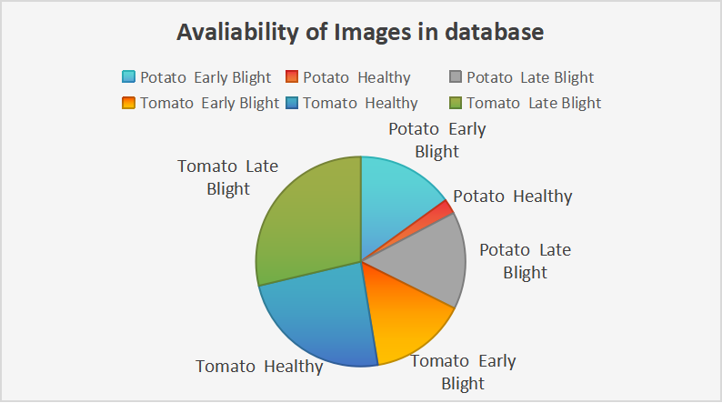

**ARCHITECTURE**

In this system, there are several layers which are as follows:

Physical layers have sensors connected to the field and sensor data travels to the data transmission layer. This layer transmits data to the Azure cloud which is the cloud integration layer. There is a layer called the data management layer which images historical data and real data that comes from sensors. Then this data is preprocessed and analyzed in the data preprocessing and analytic layer. this layer is the heart of the proposed system as its analysis images come from the camera module and apply the CNN algorithm which identifies diseases which trained by the dataset. Next is the predictive layer which uses CNN and data to predict. (Esker, 2006) After this layer decision-making layer comes to the image which Generates alerts if it detects the disease. then the last and final layer i.e. the Interaction layer visualize digital twins and data. displays alerts, predictions, and recommendations.  the following flowchart shows the architecture of the proposed system. These sensors Gathers real-time data on various aspects such as soil moisture, temperature, humidity, nutrient levels, CO2 concentrations, and crop images. The devices, including Raspberry Pi controllers, act as the interface between the physical environment and the digital system, transmitting data to higher layers for further processing. According to Calvaresi the integration of IoT devices in agriculture is crucial for real-time data collection, which forms the foundation of any smart farming system. These devices enable continuous monitoring of environmental factors that directly influence crop health and yield. The transmission layer is responsible for securely transmitting the data collected by the physical layer to the cloud. This is typically done using wireless communication protocols like Zigbee, LoRaWAN, or Wi-Fi, depending on the range and bandwidth requirements of the farm set-up. In their study, (Alzubaldi, 2021) Manogaran and Lopez emphasized the importance of reliable and efficient data transmission in IoT systems. They suggested the use of hybrid communication protocols to ensure data integrity and reduce latency, which is critical for real-time applications like disease detection in crops. Chen noted that cloud platforms like Azure provide scalable and secure solutions for managing large datasets generated by IoT systems. The importance of efficient data management is highlighted in research by Dutta who argued that the ability to effectively manage and analyze large datasets is key to deriving actionable insights in precision agriculture (A. Shukla, 2023).

***Figure8.***

**Flowchart of the system**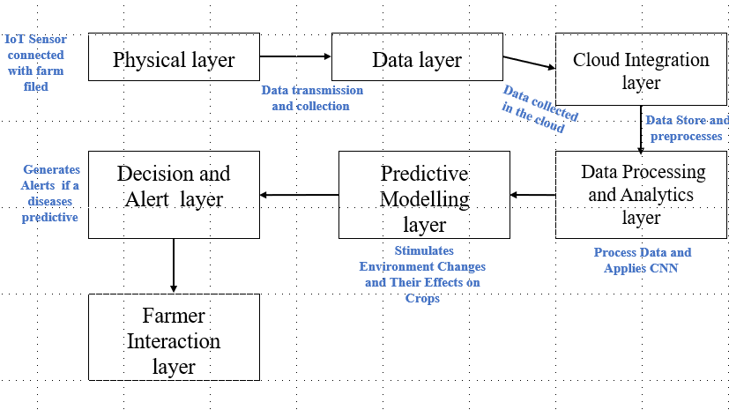

This layer also plays a critical role in feeding clean and relevant data to the analytic and predictive layers of the system. The use of predictive analytics in agriculture is well-supported by studies such as those by Khaki & Wang, who demonstrated importance of machine learning models in forecasting crop health and yield. Deng highlighted the importance of user-friendly interfaces in smart farming systems. Advanced visualization techniques, including augmented reality (AR) and 3D modeling, can be integrated into this layer to provide a more immersive and informative user experience. (S. J.C. Musale, 2023).

**ADVANTAGES AND DISADVANTAGES**

**Advantages:**

1.DT provides the precise prediction of crop diseases which enhances productivity.

2.As the diseases are already predicted the precautions can be taken accordingly.

3.The use of fertilizers or pesticides can be done properly.

4.DT is cost-saving as we can decide what fertilizers, and pesticides, to use for the crop so that it won't affect it negatively.

5.DT supports sustainable agriculture by reducing chemical use and reducing water consumption.

6.It increases crop yield; it is profitable to farmers. Healthy crops are grown with the help of DT.

**Disadvantages:**

1.Its initial cost is high.

2.After installing the system maintenance is also needed.

3.According to every crop we have to give data to the system managing data is a task.

**RESULT AND DISCUSSION**

In this, the system will interact with cloud data which is fetched from IoT integration where it creates a virtual representation of crop images which will be received after particular intervals of time and are analyzed. If diseases are detected then it formulates its result and results will be displayed as below:

***Figure9.***

**Results on interacting devices**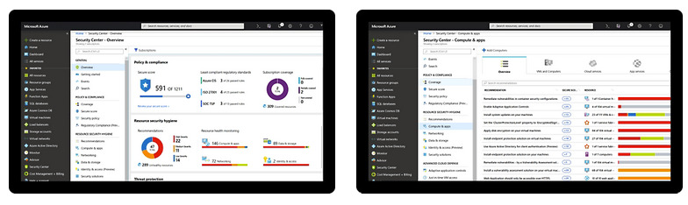

**Future Scope:**

In this proposed system crop disease detection is implemented on potatoes and tomatoes while we can create it on a wide range like maze and onions which are essential crops which also have high production rates in India. Considering the weather is also a big factor play which we can implement further as farming has a wide range. Each factor can change according to crop type well it needs algorithm changes. Besides we can integrate several systems in this farm watering and spraying pesticides using an Iot system etc. can developed in the digital Twin technology.

**CONCLUSION**

The integration of Digital Twin (DT) generation into agriculture affords a transformational method to predictive crop disease tracking. By leveraging IoT, device getting to know algorithms, and cloud systems like Azure, Digital Twins offer actual-time insights into crop fitness, permitting early detection and intervention for illnesses together with blight in potatoes and tomatoes. It decreases crop losses, increases production, and ensures improved usage of the aid as well. DT is now not most effectively used effectively in agriculture to help farmers manipulate risks, however, also guarantees sustainable farming. Continued demanding situations from climate trade and escalating demand for meals call for make agriculture stay demanding, yet this holds the important thing for meals systems during the use of superior applied sciences like Digital Twins.

**REFERENCES**

A. Shukla, K. Seethalakshmi, P. Hema and J. Musale. "An Effective Approach for Image Denoising Using Wavelet Transform Involving Deep Learning Techniques." 2023.

Alex Khang, Kali Charan Rath, Surabhika Panda, Pokkuluri Kiran Sree, Santosh Kumar Panda. "Handbook of Research on AI-Equipped IoT Applications in High-Tech Agriculture." (IGI GLOBAL ) 2023.

Alzubaldi, J. z. H. D. A.-S. M. F. M. A.-A. M. A.-a. a. l. F. Laith. "Review of Deep learning CNN architecture, challenges, applications, future direction." 2021: 74.

Anglin, M. H. A. G. G. a. A. B. Pelin. "AgriLora: A Digital Twin Framework for Smart Agriculture." 2020: 20.

Ayud, S. A. M. Umair. "Predection Crop diseases using data mining Apporaches: Classification." 2018.

C.D. "The challenges of real-time Al in the IoT Domain: Lesson learned from smart agriculture, Amident intelligence and humanized computing." 2020.

Esker, P. H. A. N. "Comparison of models for forecasting of Stewart's diseases of corn." 2006.

Indolia, A. K. G. M. A. Sakshi. "Conceptual Understanding Of Convolutional A deep learning approach." 2018.

Jitendra .c. Musale, Manju Rathod, Mayur Koli, Yandesh Haribhakta and Sharwari Surve. "Hybrid Features Extraction for emotion detection using deep Convolutional Neural Network." *International Journal for Reasearch in Applied Science and Engineering Technology* 11, no. 05 (2023).

Jitendra Musale, Shrushti Thingle, Swapnil Shinde, Swamini Deshmane and Harshad Kale. "Deep Learning model for Anomaly Detection in Video Surveillance." *Journal Article Publisher Zenodo Embedded System* 07, no. 02 (2024).

Kim, Y. M. S. a. T. "Smart Fram Realization Based on Digital Twin." 2021.

M. Rathod, P. J. Musale, Y. Haribhakta, M. Koli and S. Surve. "Hybrid Features Extraction for Emotion Detection using Deep Convolutional Neural Network." 2023.

P, D. "Smart Farming Application of Big Data and IoT in Agriculture." 2018.

Pylinds, S. O. N. A. Christos. "Introducing digital twin architecture." 2021.

R, D. M. Sreedevi T. "Digital Twin Smart Farming: A Categorical Literature Reviwe and Exploration Possibilities in Hydroponics." 2020.

S. J.C. Musale, k. Seethalakshmi and P. Hema. "An Effective Approach for Image denoising using wavelet transforms Involving Deep learning Techniques." 2023.

Tiwari, S. B. A. a. V. K. Abhishek. "Market Vulnerabilities And the potential of Horticulture crops in India: With Speacial Reference to top crops." September 2021: 21.

Verma, D. B. T. Devvvet. "Plant Leaf Disease Detection Using mobilenet." 18 (2021): 6.

A. Shukla, K. Seethalakshmi, P. Hema and J. Musale. "An Effective Approach for Image Denoising Using Wavelet Transform Involving Deep Learning Techniques." 2023.

Alex Khang, Kali Charan Rath, Surabhika Panda, Pokkuluri Kiran Sree, Santosh Kumar Panda. "Handbook of Research on AI-Equipped IoT Applications in High-Tech Agriculture." (IGI GLOBAL ) 2023.

Alzubaldi, J. z. H. D. A.-S. M. F. M. A.-A. M. A.-a. a. l. F. Laith. "Review of Deep learning CNN architecture, challenges, applications, future direction." 2021: 74.

Anglin, M. H. A. G. G. a. A. B. Pelin. "AgriLora: A Digital Twin Framework for Smart Agriculture." 2020: 20.

Ayud, S. A. M. Umair. "Predection Crop diseases using data mining Apporaches: Classification." 2018.

C.D. "The challenges of real-time Al in the IoT Domain: Lesson learned from smart agriculture, Amident intelligence and humanized computing." 2020.

Esker, P. H. A. N. "Comparison of models for forecasting of Stewart's diseases of corn." 2006.

Indolia, A. K. G. M. A. Sakshi. "Conceptual Understanding Of Convolutional A deep learning approach." 2018.

Jitendra .c. Musale, Manju Rathod, Mayur Koli, Yandesh Haribhakta and Sharwari Surve. "Hybrid Features Extraction for emotion detection using deep Convolutional Neural Network." *International Journal for Reasearch in Applied Science and Engineering Technology* 11, no. 05 (2023).

Jitendra Musale, Shrushti Thingle, Swapnil Shinde, Swamini Deshmane and Harshad Kale. "Deep Learning model for Anomaly Detection in Video Surveillance." *Journal Article Publisher Zenodo Embedded System* 07, no. 02 (2024).

Kim, Y. M. S. a. T. "Smart Fram Realization Based on Digital Twin." 2021.

M. Rathod, P. J. Musale, Y. Haribhakta, M. Koli and S. Surve. "Hybrid Features Extraction for Emotion Detection using Deep Convolutional Neural Network." 2023.

P, D. "Smart Farming Application of Big Data and IoT in Agriculture." 2018.

Pylinds, S. O. N. A. Christos. "Introducing digital twin architecture." 2021.

R, D. M. Sreedevi T. "Digital Twin Smart Farming: A Categorical Literature Reviwe and Exploration Possibilities in Hydroponics." 2020.

S. J.C. Musale, k. Seethalakshmi and P. Hema. "An Effective Approach for Image denoising using wavelet transforms Involving Deep learning Techniques." 2023.

Tiwari, S. B. A. a. V. K. Abhishek. "Market Vulnerabilities And the potential of Horticulture crops in India: With Speacial Reference to top crops." September 2021: 21.

Verma, D. B. T. Devvvet. "Plant Leaf Disease Detection Using mobilenet." 18 (2021): 6.

Abhishekh Tiwari, Saad Bin Afroz and vinod Kumar. “Market vulnerability and potencial of horticulture crops in India.” *Indian journal of Agriculture marketing* 35, no. 2021 (2021): 1-21.

Anusha Varges Anthony, Sivaprasad Kaippallil, Rohan James Ramesh. “Crop Leaves Disease Detection Using Yolo and Machine Learning .” *Research gate publication* , no. 2023 (2023): 1-14.

Christos Pylinads, Sjouke Ostinga, IonaninsN. Athanasiadis. “Introduction digital Twin to agriculuture.” *Elseiver B.V.*, 2020: 1-25.

Devvrat Verma, Dibyahansh Bordolaoi, Vikas Triparthi. “Plnat Disease Detection using mobilenetv2.” *Webology* 18, no. 5 (2021): 1-6.

Eman Abdullah Aldakheel, Mohammed and Zakariah. “Detection and identification of plant leaf disease susing YOLOv4.” *frontiers*, no. 2024 (2024): 1-22.

H.Pathak, Akhilesh Gupta. *Climate Change and Agriculture in India.* New Delhi: Government of India New Delhi , 2016.

Heitman, Joseph. “Mining Herbaria for Plant Genomes: Back to the Future.” *plos pathogens*, no. 2014 (2014).

Islam, Md. Tariqul. “Plant Diseaes Detection using CNN Model and Image Processing.” *International Jouranl of Engineering Research and Technology (IJERT)* 9, no. 10 (2020): 1-7.

J.C.Musale. “Deep Learning model for Image Desoinsing Using Wavelet Transform Involing Deep, Learning Techinque,.” *4th international Conferenceon smart Electronics And Communication (ICOSE)*, 2023.

Kemmitt, Greg. “Early blight of potato and tomato .” *The plant health instructor* 2, no. 2002 (2002).

Laith Alzubaidi, Jinglan Zhang ,Amjad J. Humaidi. “Review of deep learning: concepts, CNN architectures, challenges, applications, future directions .” *springer*, no. 2021 (2021): 1-74.

M L Bhardwaj, H Dev, Manish Kumar, Sandeep Kansal, Kuldeep Thakur, Shiv Pratab Singh, Dharminder Kumar, Santosh Kumari, Meenu Gupta, Vipin Sharma. “Vegetable production under changing climate scenario.” no. 2012 (September 2012): 1-242.

Mohit Agrawal, Abhishek sigh, Siddhart Arjaria, Amit Sinha, Suneet Gupta. “ToLed: Tomato disease Detection using CNN.” *Procedia Computer Science*, no. 2020 (2020): 1-9.

Musale, J. C. “An Effective Approach for Image Denoising Using Wavelet Transform Involving Deep Learning Techniques.” *4th International Conference on Smart Electronics and Communication (ICOSEC)*, 2023.

Nabarun Dawn, Souptik Ghosh,Aloke Saha, Soumya Chatterjee, Tania Ghosh, Sagnik Guha, Subhajit Sarkar, Pronoy Mukherjee and Tanmay Sanyal. “A Review on Digital Twin Technology: A New Frontier in Agriculture.” *Artificial Intelligence and Applications*, 2023: 1-14.

Nikolas Pleadarios, Dimitrios priomalis,Vaselleios Cheimaras, Efthy Tserepas and Paragitios papageogas. “Enchancing smart agriculture by implementing Digtal Twins: A Comphrehensive Reviwe.” *MDPI*, no. 2023 (2023): 1-38.

Pelign Anglin, MOhammad Hossien Anisi, Furkan Gokesel And Asaf Buykgulcu. “Agrilora A digital Twin Framework for Smart Agriculture.” *Journal of wireless Mobile networks*, no. 2020 (2020): 1-20.

Sakshi Indolia, Anil Kumar Goswami, S.p. MIshra, Pooja Asopa. “Conceptunal UNderstandig of Convolutional Neural Network- A Deep Learning Apporach.” *Procedia Computer Science*, 2018: 1-18.

Wang, Li. “Digital Twin Architecture A reviwe of Recent Progress and Open Issues.” *Electronics MDPI* 13 (2024): 1-26