**Question 1: Machine Learning Classification**

This simple diagram illustrates the relationship between different types of learning. Supervised and unsupervised learning are fundamental Machine Learning.

1. Supervised Learning:

Supervised learning is a type of machine learning in which models are trained on labeled datasets, which means it learns from input and output pairs. Algorithms generalize patterns from labeled examples to predict or classify unseen new data.

2. Unsupervised Learning:

Unsupervised learning involves training models on unlabeled data to discover patterns, structures, or relationships in the data without explicit guidance. Common tasks include clustering, dimensionality reduction, and density estimation.

3. Reinforcement Learning:

Reinforcement learning is a model in which an agent learns to make decisions by interacting with its environment. The agent receives feedback in the form of rewards or punishments and thus learns the best strategy through trial and error. It is often used to train AI models to test games.

4. Transfer Learning:

Transfer learning is a technique that takes a model trained in one task and adapts or fine-tunes it for a different but related task. It uses knowledge gained from one domain to improve performance in another, often reducing the need for large amounts of labeled data.

5. Semi-supervised Learning:

Semi-supervised learning is a method that combines labeled and unlabeled data for training. While some of the data has labeled examples, the model can be generalized from both labeled and unlabeled instances to improve performance when labeled data is scarce.

6. Generative Adversarial Networks (GANs):

Generative Adversarial Network (GAN) is an unsupervised learning model that trains two neural networks (generator and discriminator) simultaneously through adversarial training. The generator creates synthetic data, and the discriminator evaluates it to generate increasingly realistic data.

**Question 2: Terminology review and non-neural ML algorithms**

**Part 1: High-level term distinction**

1. Artificial Intelligence (AI):

Artificial intelligence is the science of making machines that can think like humans. It can do things that are considered "smart." AI technology can process large amounts of data in ways, unlike humans. The goal for AI is to be able to do things such as recognize patterns, make decisions, and judge like humans.

2. Machine Learning (ML):

Machine learning is a branch of artificial intelligence (AI) and computer science that focuses on using data and algorithms to mimic the way humans learn and progressively improve the accuracy of learning. Instead of the traditional classical programming model, machine learning programming uses a data-driven approach to recognize patterns and make predictions or decisions without human intervention.

3. Neural Networks:

A neural network is a method in artificial intelligence that teaches computers to process data in a way that is inspired by the human brain. It is a type of machine learning process, called deep learning, that uses interconnected nodes or neurons in a layered structure that resembles the human brain.

4. Deep Neural Networks (DNNs):

Deep Neural Networks are a specific type of neural network with multiple hidden layers between the input and output layers. The term "deep" refers to the depth of these networks, which enables them to learn hierarchical representations of data. DNNs excel in capturing intricate patterns and have been particularly successful in tasks such as image recognition, natural language processing, and speech recognition.

Part 2: Machine Learning vs Neural Networks

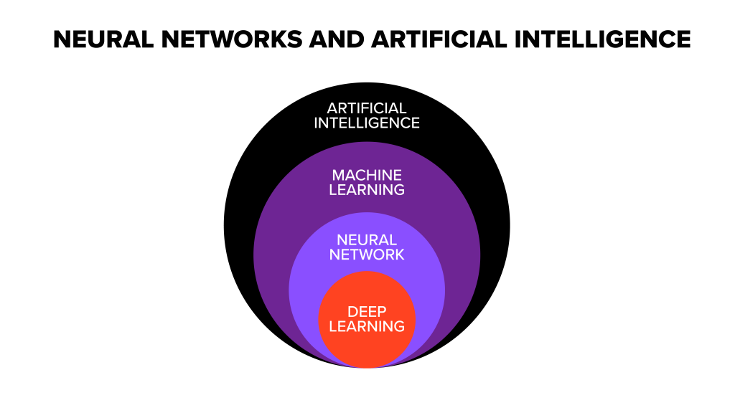

**Similarities:**  
1. Learning Capability:

Both machine learning and neural networks can learn from data. Whether training a machine learning model or adjusting neural network weights, these systems typically improve their performance through exposure to relevant data.

2. Adaptability:

The common goal of both is to make systems adaptable to new information and improve performance over time. This adaptability is a fundamental characteristic, allowing these technologies to handle a variety of tasks and scenarios.

3. Task Automation:

The overarching goal of both machine learning and neural networks is to automate tasks that typically require human intelligence. Whether it's recognizing patterns in data, making predictions, or solving complex problems, these technologies aim to perform cognitive functions without explicit programming.

Differences:

1. Machine Learning uses advanced algorithms that parse data, learn from it, and use those learnings to discover meaningful patterns of interest. Whereas a Neural Network consists of an assortment of algorithms used in Machine Learning for data modeling using graphs of neurons.

2. While a Machine Learning model makes decisions according to what it has learned from the data, a Neural Network arranges algorithms in a fashion that it can make accurate decisions by itself. Thus, although Machine Learning models can learn from data, in the initial stages, they may require some human intervention.

Neural networks do not require human intervention as the nested layers within pass the data through hierarchies of various concepts, which eventually makes them capable of learning through their errors.

3. Machine learning models can be categorized under two types – supervised and unsupervised learning models. However, Neural Networks can be classified into feed-forward, recurrent, convolutional, and modular Neural Networks.

4. An ML model works in a simple way – it is fed with data and learns from it. With time, the ML model becomes more mature and trained as it continually learns from the data. On the contrary, the structure of a Neural Network is quite complicated. In it, the data passes through several layers of interconnected nodes, wherein each node classifies the characteristics and information of the previous layer before passing the results on to other nodes in subsequent layers.