**Validation**

**Index.html**

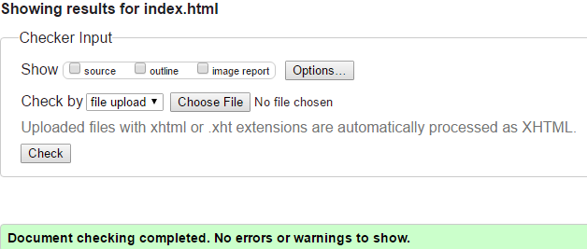

**Ourdogs.html**

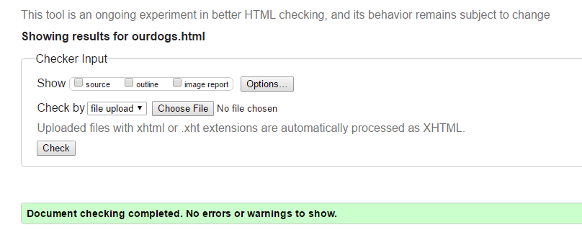

**Howtohelp.html**

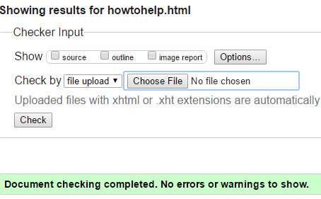

**Stories.html**

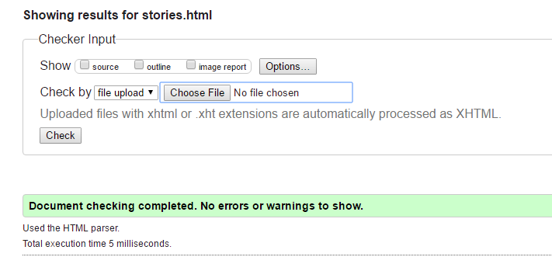

**Contact.html**

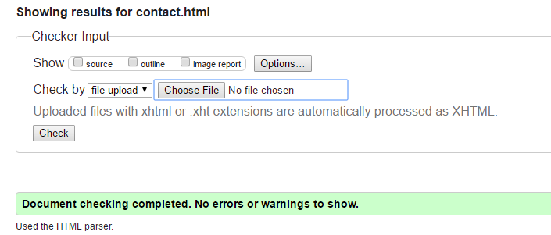

**Login.html**

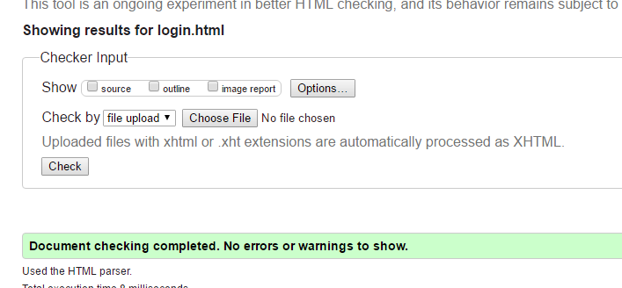

**Foster.html**

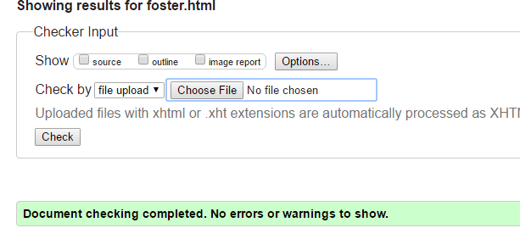

**Donate.html**

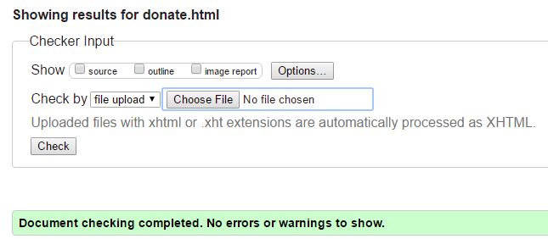

**Volunteer.html**

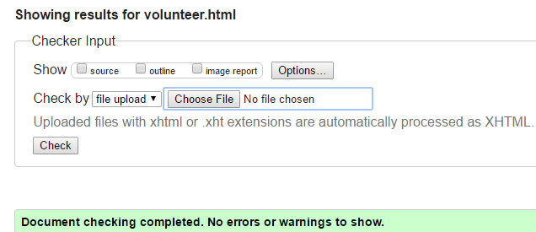

**Dog.html**

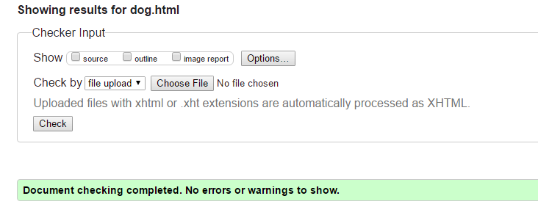

**Adoptadog.html**

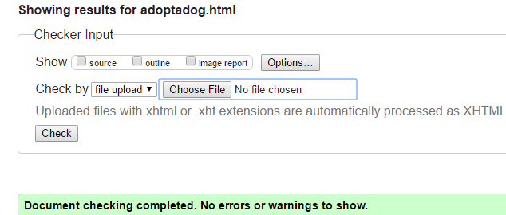

**CSS**

**Article.css**

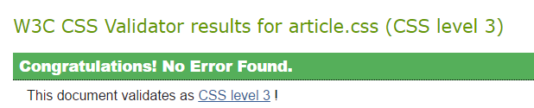

**Aside.css**

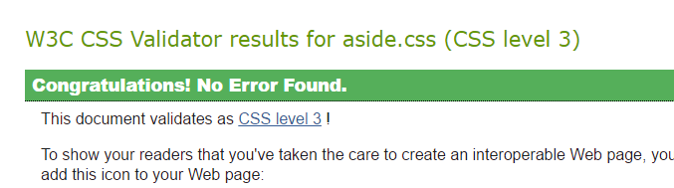

This is on jigsaw, css-validator returns error.

**asideSearch.css**

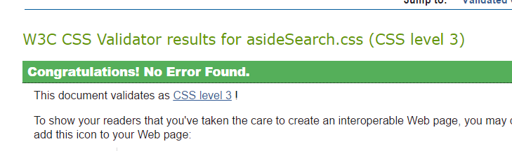

**customizeSearch.css**

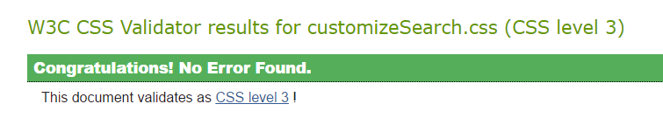

This is on jigsaw, css-validator returns error.

**Dog.css**

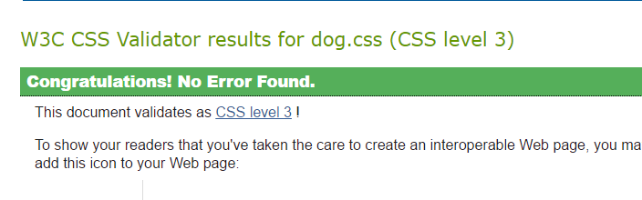

This is on jigsaw, css-validator returns error.

**Login.css**

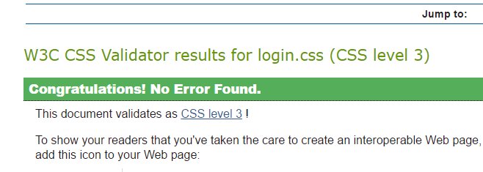

This is on jigsaw, css-validator returns error.

**Nav.css**

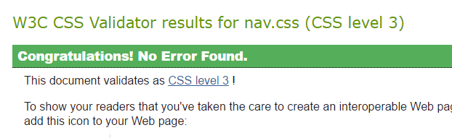

**ourDogs.css**

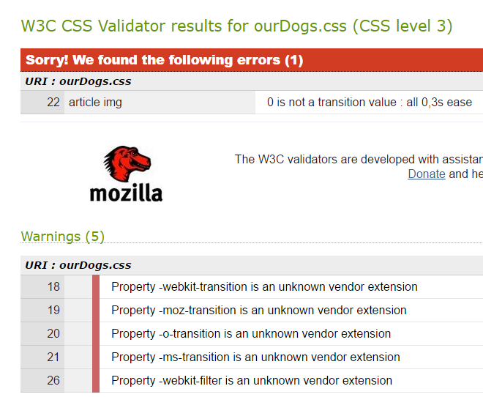

**Stories.css**

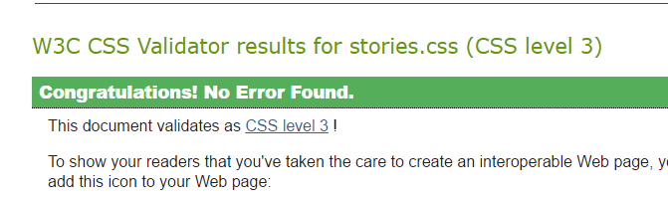

**Testing in browsers**

Difference is small in some forms, in fonts and appearance (example dropdown).

Example:

Edge:

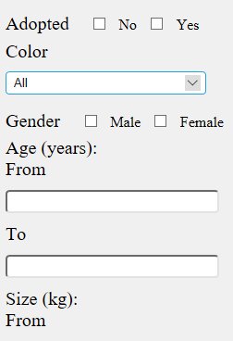

Chrome:

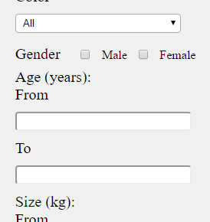

Mozilla:

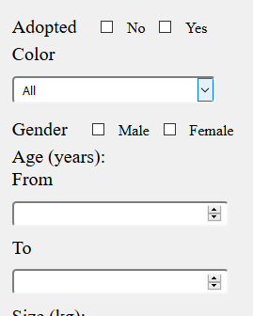

Opacity is not working in Mozilla, transition is not working in Chrome and they both work in Edge.

Chorme:



Mozilla



Edge – it is transforming for 3 seconds



JavaScript work with DOM – filtering with js

Edge: (works)

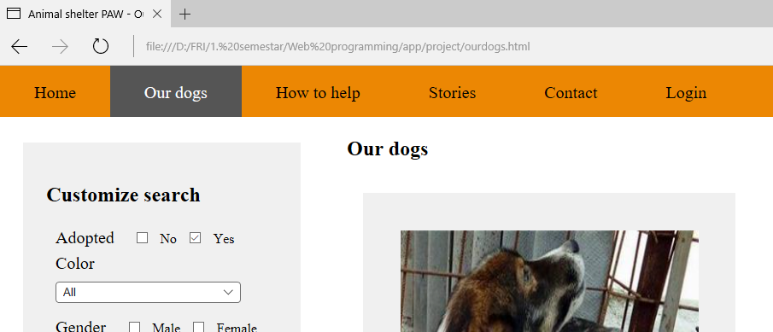

Chrome (works)

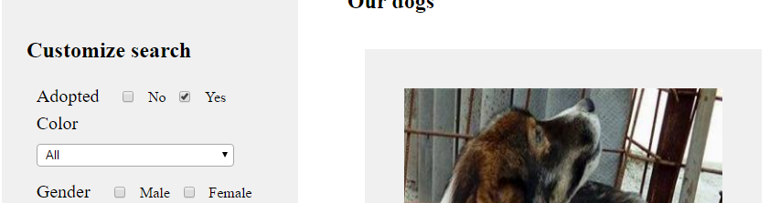

Mozilla

